Hot and Crowded
Izak Odendaal, Old Mutual Wealth Investment Strategist
Congratulations! You are now one of eight billion humans. According to number crunchers at the United Nations, this milestone was passed last week. This matters, not just because the world is quite crowded these days, but also because economies ultimately revolve around people. Abstractly, we might think of an economy as consisting of farms, machines, factories, mines, ships, banks, office buildings and so on. But it is ultimately all about meeting the needs and desires of human beings. The more people there are, the greater demand for food, shelter, clothing, entertainment, communication services and healthcare. As the population grows, so does the demand for those goods and services.
A growing population also supplies the workers to produce those things. Therefore, population growth is a key ingredient in economic growth. It is not the only factor; however, productivity growth is absolutely crucial, allowing us to do more with less. Indeed, it is growing productivity that has allowed for the world’s population to grow so rapidly over the past century. The world produces more food than ever, even though the share of the labour force engage in agriculture has declined. The nightmarish scenario predicted by Thomas Malthus in 1798 – that overpopulation would lead to persistent famine since population growth is exponential while food production growth is linear – never came to pass on global scale. Meanwhile, advances in science and medicine led to a decline in infant mortality and expansion of life expectancy. The fact that we live longer today, on average, compared to our ancestors is probably humanity’s greatest achievement, but it’s something that gets little attention compared to, say, the first moon landing.
Consider UK as an example (this is where actuarial tables were first compiled). According to the UK’s Office for National Statistics, a girl born in 1841 could expect to live to 42 years old. A hundred years later, female life expectancy at birth was 62 and today it is 82. Initially, the increase in life expectancy was largely due to improvements in healthcare for children and particularly infants such as immunisation. More recent improvements are largely due to better disease treatment among older people.
Chart 1: Global life expectancy at birth
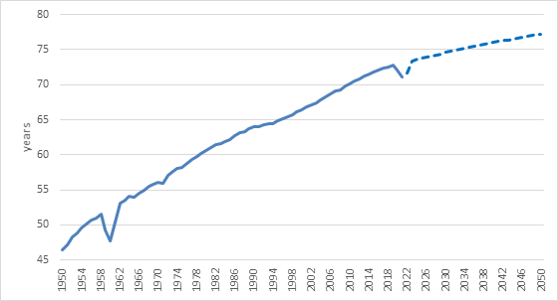
Source: United Nations
When this process is repeated across the globe, population sizes initially increase with lower mortality. This is the first stage of the demographic transition. The UN estimates that there were 2.6 billion people in 1950. This doubled to 5 billion by 1987 and increased to 6 billion by the turn of the century. In October 2011, it estimated the global population at 7 billion. Most of the world’s population live in Asia. In fact, if you drew a circle on a map with a radius of 3 300 kilometres, centred on the city of Mong Khet in Myanmar – the Valeriepieris circle – it would contain half of humanity on only 7% of the earth’s surface.
The second stage of the demographic transition is declining fertility rates as the average number of children born to each woman declines. This slows the overall growth rate of the population, but also allows families to invest more in each child than previous generation. There is a strong correlation between declining fertility rates and higher incomes, and the causation runs in both directions. Richer, more educated families have fewer children on average and the same is true at the level of countries.
Chart 2: Global population growth and average fertility rate
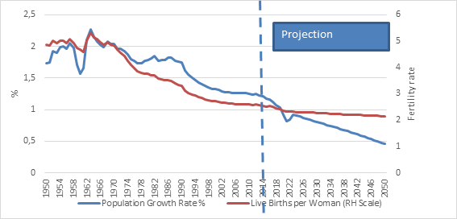

Source: United Nations
Different countries are at different stages of these demographic transitions, but overall global population growth is declining from around 2% in the 1950s to less than 1% today. This as the fertility rate declined from around 5 to 2.3 over the same timeframe. It is set to continue declining with UN expecting the total global population to peak in 2086 at 10.4 billion. Of course, nothing can be predicted with accuracy so far out, but demographic projections are typically more precise than other forms of long-term forecasting.
Shades of grey
With life expectancy rising and birth rates falling, the UN projects the share of the global population aged 65 years or above to rise from 10% today to 16% by 2050. They will outnumber children under age five by two to one. 61 countries are expected to experience population decline in between now and 2050. This is already true of Japan and Italy, with other European countries like Germany likely to join the list soon, as will Korea. Because of the one child policy in place between 1980 and 2016, China’s population has stopped growing and will start declining as early as next year. It will also lose its position as the world’s most populous nation to India in the next year or two.
The fact that China implemented the one child policy in the first instance is indicative of a widespread view at the time that overpopulation was the major risk to humanity. Two hundred years on, Malthusian thinking was still prevalent.
Today we know that it is not overpopulation that is the big problem, since the world easily produces enough food for everyone, (fairly distributing it is a whole other story) but rather emissions of greenhouse gasses that cause climate change. However, climate change could still affect food production in negative and unpredictable ways.
Aging and shrinking populations are new terrain. Most economic analysis and planning is based on growing populations requiring more of everything. A country like Japan throws this into reverse. There are an estimated 11 million empty homes in Japan, mostly in rural villages, a surplus that is bound to keep growing and create several problems for authorities. Fewer homes mean less demand for furniture, less work for estate agents and renovators and fewer properties to insure.
Ageing societies also means more spending on healthcare and social care in general. This increases the burden on the state to ensure the provision of these services, but also means there are not necessarily enough workers to do so.
A particular problem for countries with ageing populations is pay-as-you-go social security systems. In these systems, current workers effectively pay pensions for current retirees. In other words, pension payments do not come out of accumulated savings but from tax contributions. As the population ages, the number of retirees rises relative to the number of workers, and this becomes unsustainable. Fortunately, many governments have taken steps to improve the sustainability of their pension systems, notably by increasing labour force participation, raising current contributions and lifting retirement ages. They’re also reducing retirement benefits in various ways. These actions are rarely popular but are necessary.
Young at heart
The global demographic story is not just one of greying. Several countries are still very young and continue to experience rapid population growth. This is particularly true of the African continent where the average fertility rate is still above 4 and projected to decline relatively slowly. Therefore, of the projected global population growth to 2050, half will come from Africa. While the median age in Europe and Japan is in the high forties, in many African countries is it in the high teens. The youngest county on earth is Niger with half the population under the age of 15.
Chart 3: Population projections for each continent
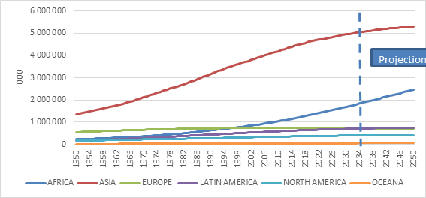
Source: United Nations
While having a young and expanding workforce can be good for economic growth and dynamism for all the reasons described above – known as a demographic dividend – this is only the case if there are economic opportunities available for everybody. It can also be the case that a growing population puts unbearable pressure on the natural and economic resources of a country, leading to deep frustration and conflict. Whether it is a blessing or a curse will depend on the strength of the economic, social and political institutions of each country. For some, there is little hope that these institutions can cope. For instance, the UN projects that the Democratic Republic of the Congo, already one of the poorest countries on earth, will be one of the ten most populated by 2050 with 215 million people, more than double today’s number.
Chart 4: Most populous countries in 2022 and 2050
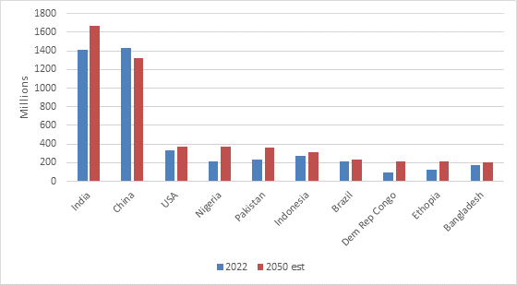
Source: United Nations
Migration can be a release valve. When Europe’s population size exploded in the late 19th and early 20th century an estimated 60 million people moved to the Americas and the Antipodes, and some also ended up in South Africa. But such a massive movement of people still seems unlikely today even as climate change is likely to lead to more and more people being displaced.
Some countries are very open to immigrants. In Canada, Australia and New Zealand, between a fifth and a third of the population is made up of immigrants, but the preference is always for educated workers. At the very extreme, in the United Arab Emirates and Qatar, 8 out of 10 people come from elsewhere. Other countries like China and Japan have relatively few immigrants.
South Africa is already home to an estimated 4 million migrants, most from the rest of the African continent. This contributes to overall population growth staying around 1% – slower than other African countries but faster than developed nations – lifting the overall population size to an estimated 73 million by 2050 from 60 million currently.
Investing in a hot and crowded world
Globalisation cheerleader Thomas Friedman’s book Hot, Flat and Crowded was released in 2008, with flat being a reference to how globalisation levelled the commercial playing field for everyone. This flatness is increasingly being questioned both in terms of its durability but also its desirability. Safe to say that several globalisation trends have been disrupted in the recent bumpy years.
The climate and demographic trends are clear, however. There are several investment implications, but three are noteworthy. The world is getting more crowded, with many more mouths to feed and backs to clothe each year. But the slowing pace and ultimately decline in population growth in the rich countries, probably imply slower economic growth, lower inflation and lower interest rates over time. Since Japan is ahead of other developed countries in terms of aging and decline, it provides important clues about the future, and its long battle with deflation is telling. The present reality of high inflation and rising rates is unlikely to last forever but can unfortunately last longer than is comfortable.
Technology will have to play an ever-increasing role to make up for the shortfall in workers, and this remains fertile territory for investors. The so-called care economy will continue to grow substantially in rich countries (and China), even if other sectors experience much slower growth.
Secondly, for poorer countries, there is a lot of work to be done to accommodate expanding populations. Social and economic infrastructure will have to be improved dramatically, inclusive economies and political systems to accommodate the aspirations of young populations. Plugging into the global economy will be extremely important. Some countries will get this right, but others won’t. Distinguishing between the two will be increasingly important and viewing emerging markets as a single asset class will make even less sense than it does today.
For South African businesses, the burgeoning population north of our borders will continue to provide immense opportunities that come with substantial risks. Proper implementation of the African Free Trade area in the years ahead will address some of these challenges, but others will require substantial improvements in logistics infrastructure and also better management of foreign exchange. Many local businesses have struggled to repatriate earnings from African countries due to a lack of hard currency,
Thirdly, most of us invest to be able to retire in comfort one day. In South Africa, the burden of retirement provision largely falls on individuals beyond the small government pension. As longevity increases, so does the importance of saving enough and delaying retirement as long as possible. Having the right appropriate asset allocation at key points is crucial. Saving a lot but leaving it under the mattress will not do, but neither will concentrating the savings in risky ventures. The most difficult part is often sticking to the plan when markets are volatile as they’ve been this year.

