Another year of surprises
Old Mutual Wealth Investment Strategist Izak Odendaal
Right up to the quarter final stage, the 2022 FIFA World Cup in Qatar has delivered more upsets and unexpected results than most previous editions. This is fitting, perhaps, for a year that was full of surprises. As we look back on 2022 in our final note for the year, we highlight a few of these surprises and the lessons they’ve taught us.

Long Covid
Getting ready for a hot, sweaty and crowded South African summer holiday, Covid feels like a distant memory to many. It is not. It wasn’t that long ago that carrying a mask and vaccination certificates was de rigueur. This is still the case in China.

From the outside, China’s strict approach to Covid has been unexpected, but the country has suffered very few Covid-related deaths compared to other countries and it makes perfect sense that they would want to keep it that way. The bigger mystery is why they did not do a better job of vaccinating vulnerable groups.

The harsh lockdowns have taken an economic and psychological toll. A tipping was reached in recent weeks and widespread protests broke out, something very few thought could happen in such an authoritarian state. Even more unexpected is that they seem to have worked.

Beijing is softening, though not abandoning, Covid containment rules. While a return to normality is likely to be a gradual process, it does raise the prospect of a reopening bounce for the Chinese economy, which would be handy at a time when the rest of the world slows down. However, as in the West, the pandemic is likely to have a lasting economic impact. While the Chinese people will be understandably happy for life to return to normal, this does not necessarily imply a spending spree. The whole experience might make many more cautious about the future, also bearing in mind that the key property sector remains under considerable pressure while youth unemployment has risen to alarming levels. A survey of depositors by the People’s Bank of China, the central bank, shows that preferences for more saving has increased, with a corresponding decline in preference for more spending.

Chart 1: Chinese depositors’ preferences
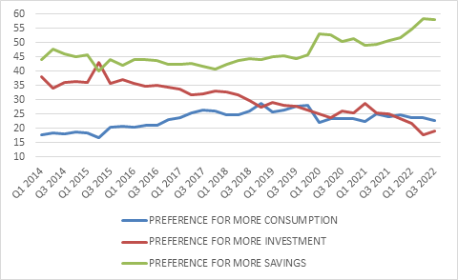

Source: People’s Bank of China

War
No doubt, the biggest shock of the year was Russia’s invasion of Ukraine. Perhaps as surprising was how inept Russia is militarily, and how strongly the Ukrainian people have fought back against a much larger enemy.

Ten months later, there are two key take-outs. Firstly, nobody can take security of supply for granted anymore. If Covid-related supply chain disruptions did not land the message, the war has. The pre-Covid, pre-war era was one of cheap energy, outsourcing, just-in-time inventory management and a deep belief that somewhere, someone in a globalised economy will have what I need and can deliver on short notice. From now on, governments and business leaders will increasingly think about mitigating supply risks. Having a Plan B will be non-negotiable, but this comes at a cost.

Chart 2: Eurozone economic surprise index
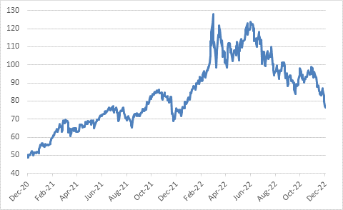

Source: Refinitiv Datastream

The second lesson is not to underestimate adaptability. It was clearly a mistake for Europe to rely so heavily on Russian gas, but through a combination of finding alternative supplies and reducing demand – which is what high prices do – the economic damage has not been as bad as feared. Nonetheless, a long cold winter still lies ahead, and Europe benefited from Chinese lockdowns as energy demand there declined. It is too soon to declare victory. But it is also clear that Russia’s attempts to turn energy prices into a weapon against the West has largely failed. Notably, the oil price is lower today than before the invasion.

Chart 3: Brent crude oil price, dollars per barrel
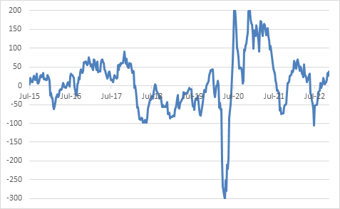

Source: Refinitiv Datastream
What goes up, does come down
This was not the first year that Bitcoin suffered an epic collapse. But 2022 was the year when the broader crypto universe suffered an existential crisis with the implosion of several high-profile firms that were involved in managing crypto investments for clients. Many of these cases have exposed crypto for what it has always been, an unregulated speculative Wild West with limited commercial value and even less societal worth. True, not all firms were as spectacularly badly managed as FTX, who simply lost track (or worse) of clients’ funds. But FTX was supposed to be the grown-up face for crypto, the poster child for bringing it into the mainstream. Fortunately, the fall-out has been largely contained to within the crypto world, though of course many ordinary investors have suffered big losses. Importantly, there has been no contagion to the broader financial system, which also shows that crypto never went mainstream to begin with.
FTX was ultimately brought down by the equivalent of a bank run. When rumours about its soundness started circulating, customers predictably and rationally wanted to get their money out. FTX did not have the cash on hand to meet redemptions, having lent it to other entities (or worse). The more such an entity struggles to pay, the more customers join the queue to get their money out before it is too late. Eventually it has to seek bankruptcy protection.
The risk of a bank run always exists when a financial entity borrows short term while making long-term loans or investments. It does not have to be a bank, but banks are clearly vulnerable since they take in deposits that can be called at short notice but make loans that can run for months or years. This process of maturity transformation can be very profitable to banks and non-bank financial institutions. To deal with its obvious shortcoming, there are two crucial regulatory interventions. The first is deposit insurance, whereby bank deposits up to a certain level are covered against loss, thereby discouraging bank runs by retail depositors. The first deposit schemes were launched in the 1930s after the devastating bank runs of the Great Depression. Ninety-plus years later, South Africa is finally in the process of setting up similar arrangement that should cover up to R100,000 of bank deposits.
The second intervention is the presence of a lender of last resort. A bank or quasi-bank struggling to make redemptions is not necessarily insolvent if it still has solid assets (the loans it made to businesses and households). Therefore, it makes sense for someone to lend the cash to tide it over. In most systems, this is the central bank that can provide essentially unlimited liquidity and thereby soothe nerves. This was the case in 2008 and again during the Covid panic of March 2020. Sometimes, the mere promise of stepping in is enough to calm things down without the central bank having to spend a cent. This was famously the case in 2012 with then-European Central Bank President Mario Draghi’s “whatever it takes” speech.
Needless to say, crypto has neither a lender of last resort nor deposit insurance. The freedom from regulatory intrusion was a plus-point for many crypto enthusiasts. It clearly isn’t.
Down in Downing Street
Where we did see a central bank stepping in successfully this year to calm things down was in the UK. Prime Minister Liz Truss and Kwasi Kwarteng, her Chancellor of the Exchequer (finance minister), recklessly tried to ram through a massive package of tax cuts and spending increases at a time when markets were very jittery. Bond yields jumped and this almost blew up the private pension system. Several pensions had hedged themselves against adverse interest rate moves and were forced to sell bonds to make margin calls, driving bond yields even higher and resulting in more margin calls.
The Bank of England had no choice but to intervene with liquidity injections to stabilise the bond market even though, like most of its peers, it had been going the other direction to fight inflation. Truss resigned after a mere 44 days in office, making her the shortest-serving prime minister ever.
The one thing the UK pensions debacle and the crypto-pocalypse have in common is that when global interest rates surge and liquidity is drained from the financial system, the risk of an accident increases dramatically. We should not be surprised if more occur in 2023.
Political uncertainty returns
The other key insight from the whole episode is that political uncertainty is not only an emerging market phenomenon. South Africans who spent the past week wondering if we’ll get a new president can take some comfort. But more importantly, it shows that financial markets have a way of pulling wayward politicians into line. It was ultimately the market that forced Truss and Kwarteng out, just as it was the market that forced Jacob Zuma to reverse course when he fired his finance minister, Nhlanhla Nene, for utterly nefarious reasons almost exactly seven years ago.
Whether deliberate or not, the market angst brought about by Ramaphosa’s resignation rumours would have sent a clear message to friends and foes alike over the need for stability and policy continuity. Though the Phala Phala mystery remains unresolved and will continue to be the buffalo in the room, as it were, for some time, broad policy continuity is what we are likely to get in 2023. This includes further gradual governance improvements, economic structural reforms to increase private sector participation in key network industries, and fiscal consolidation.
Chart 4: South Africa real GDP growth
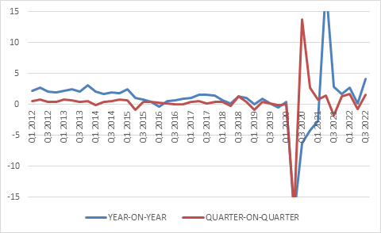
Source: StatsSA
South Africa’s economy also proved to be more adaptable and resilient than widely thought. It recovered from the Covid slump much sooner than expected and has stayed afloat despite record levels of loadshedding in 2022. The local economy grew by 1.6% in the third quarter, an outcome that surprised the consensus forecast. Amid the global energy crunch, it helps that South Africa is a major coal exporter. The economy is also still benefiting from a post-Covid normalisation. For instance, this summer will be the first in three years when we can expect a sizeable influx of foreign tourists. Local consumers are under pressure, however, owing to a cost-of-living squeeze and rising interest rates, with the SA Reserve Bank taking the repo rate back to 7% where it peaked before the pandemic broke out.
While the economy is likely to post growth above 2% in 2022, repeating this performance over the medium term will be a challenge. At the same time, South African assets have long priced in muted economic growth and high levels of political uncertainty.

Valuations matter
It is therefore notable that South African asset classes have outperformed their corresponding global benchmarks this year, despite the weaker rand. Indeed, the weaker rand helped prop up global returns. Commodity prices are one explanation, but another is simply that valuations matter. And as the old saying goes, the higher the climb, the harder the fall.
This is illustrated neatly by the case of bonds. The SA All Bond Index lost 6% this year in terms of price movements, but this is offset by the 10% interest income investors will earn this year (equivalent to the yield of the index of 10% at the start of the year). In contrast, the FTSE World Government Bond Index’s 0.7% interest income investors will earn this year will not nearly offset the double-digit price declines.
In the end
Returning to the World Cup, in the end luck tends to run out and pure footballing firepower prevails. We’ll see what happens this week, but giant-killing minnows only go so far, and the tournament final is usually contested between teams that were heavily favoured to begin with. Only 13 countries have reached the final, and only eight have ever lifted the trophy.
This recalls Benjamin Graham’s quote “In the short run, the market is a voting machine but in the long run, it is a weighing machine.” (Graham is known as the father of value investing, with Warren Buffet being his most famous student and disciple). What he implies is that short-term market movements are driven by sentiment, popularity, fear, or excitement. Over the long term, fundamentals matter and the market recognises the true value of an investment based on its underlying cash flows. Put slightly differently, an investment can fool some of the people some of the time, but not everybody all the time. Things that are overhyped and therefore expensive, will eventually deliver returns that are inversely correlated to the level of hype. In contrast, things that are cheap relative to fundamentals, where too much bad news is priced in, tend to deliver the best returns over time. At the end of a bruising year for many investors, we can take comfort that a lot of bad news is now priced in, setting the stage for better returns ahead.

