The more it changes, the more it stays the same

Old Mutual Wealth Investment Strategist Izak Odendaal

If there is a unifying theme for the year that is almost over, it is uncertainty. In fact, it has been the theme of the past three years. From the pandemic, which is still very much a reality in China, to tight elections in the US, policy bungling in the UK, an inflation surge and corresponding increase in interest rates and of course, Russia’s brutal invasion of Ukraine. We can now also add domestic political unease to this list. Some of these events matter more for markets, as we’ll see below. Often it is not the big screaming headlines that cause portfolio damage, but more subtle shifts. More often than not, it is the investor’s own reaction to such events that causes the most damage.

Resignation anxieties
President Ramaphosa’s future is now in question. While the Phala Phala affair has been simmering for a while, last week an independent panel recommended that Parliament commence impeachment proceedings against him for potentially abusing his power and violating the Constitution. Just a week prior, Ramaphosa won the overwhelming number of nominations from branches, putting him in pole position to secure another term as ANC leader. But, as the saying goes, in politics a week is a lifetime.

After the panel’s findings were released, news reports broke that his resignation was imminent and financial markets reacted sharply. It now appears as if Ramaphosa will instead challenge the allegations against him. However, he has indicated in the past that he will step down if needed to avoid a constitutional crisis, where one branch of government goes against the others. What happens next is unclear, but political uncertainty is likely to remain elevated for several months at least.

Policy, not politics
From an investment point of view, what matters most is policy, not politics. The one thing Ramaphosa has been criticised for consistently is the consensus-building approach that has considerably slowed down making key decisions and implementing them. But the benefit of this approach is that the policies of his administration should broadly remain in place if he is replaced, at least until the 2024 elections. Thereafter, we may well enter the era of coalition politics with all the potential risks and benefits that might entail.

Probably, the most important reform Ramaphosa instituted was deregulating the electricity market and allowing private generation. This genie is now firmly out of the bottle and will not be put back. An end to loadshedding is in sight, not because Eskom has been fixed, but because private businesses and households (and a few municipalities) can take matters into their own hands.

Amid the uncertainty, there are two important things to remember. Being able to hold leaders accountable is a good thing, not a bad thing, even if the leader in question is very popular. It is a core part of what democracy is about. Secondly, global dynamics ultimately matter more for domestic bonds, equities and the rand than local events. The latter can cause major short-term fluctuations but are typically priced in and out very quickly as investor perceptions change.

Chart 1. Rand-dollar exchange rate
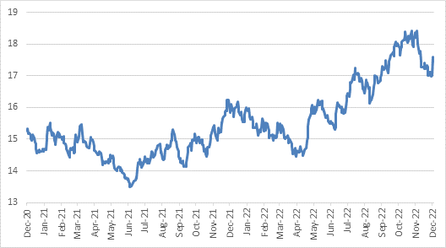

Source: Refinitiv Datastream

Living la Vida lockdown
In contrast to the many problems of South Africa’s messy democracy, China’s approach to Covid highlights the drawbacks of authoritarianism. Unusually widespread street protests have broken out as anger over persistent lockdowns has reached boiling point. This naturally caused a degree of nervousness on markets, but the mood soon shifted as investors hope the protests will hasten the end to the economically damaging lockdowns. Even before the protests broke out, officials had been softening the language around Covid, somewhat downplaying its danger. This resulted in China’s equity market jumping an incredible 29% in November. The bounce in Chinese markets in turn supported the JSE as Naspers and Prosus also jumped, along with other China-exposed shares.

However, an immediate 180-degree turn seems unlikely given firstly how much zero-Covid is closely linked to President Xi Jinping himself, and secondly, because vaccination rates among vulnerable groups remain low. Letting the virus run free risks millions of deaths. Therefore, China’s economic health is likely to continue taking a backseat to the health of the population into next year, though a softening of lockdown rules has been announced by some cities.

War, what is it good for?
The other big source of uncertainty has been more or less priced out of markets. Russia’s invasion of Ukraine in February came as a massive shock. Equally surprising was the strength of the Ukrainian fightback and the ineptitude of Russia’s much-vaunted military. Russia had to surrender much of its initial territorial gains, though it still occupies much of east Ukraine in what appears to be a looming stalemate. Russia’s attempts to use its vast energy resources as a weapon against the West for supporting Ukraine initially looked successful. The oil price jumped, and natural gas prices surged even more. Unfortunately for the world’s poor, Ukraine and Russia are major exports of wheat and other foodstuffs and many food prices also spiked.

Fast forward to today, and commodity markets seem to be ignoring the war. At $85 per barrel, the price of Brent crude is lower than before the invasion. This is despite OPEC+ production cuts implemented along the way and a recently imposed European embargo on Russian imports. Although sunflower oil and wheat prices are also back below pre-invasion levels, gas and coal prices are not. Russia has more leverage with gas since Europe’s ability to import from elsewhere is limited by infrastructure, unlike with oil. However, gas prices are well off their mid-year peak, and so is the coal price that moved in sympathy as the closest alternative. As a result, the extremely bleak European winter that was widely expected might not be quite so bad, though the combination of high energy prices, core inflation at 5% and rising rates is certainly not pleasant.

Chart 2: Energy prices in US$, rebased to 100
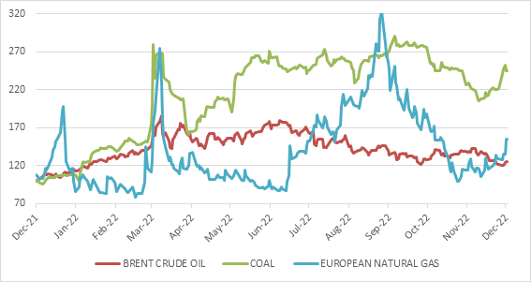

Source: Refinitiv Datastream

When faced with something as shocking as a war, it is easy to forget how adaptable economies can be, especially if markets are allowed to function. Meaningful price changes result in a demand and supply response and are therefore rarely permanent. Just as South African firms have more or less learned to live with loadshedding, the European industry seems to manage better without Russian gas than initially feared. Overall Eurozone industrial output is higher than at the start of the year.

Nonetheless, we don’t know how this plays out. Perhaps only Russian President Vladimir Putin knows what the endgame is, and even he might be unsure. A Russian withdrawal or negotiated peace will certainly cheer markets. But escalation can’t be ruled out either. Worst of all, the possibility of a nuclear war, until recently seen as a relic of the past, is not zero. Markets are good at pricing knowns, but cannot accurately price in such a low probability, high impact event (also sometimes called tail risk).

Mr Danger
But the most dangerous individual as far as your portfolio is concerned is not Putin or Xi or Ramaphosa, but US Federal Reserve Chair Jerome Powell. His interest rate increases to tame inflation caused deep and widespread damage to asset classes, wiping trillions of dollars off market values. And he is not done yet.

In a widely-followed speech last week, he reiterated a simple message: Inflation has eased somewhat but remains unacceptably high. Further interest rate increases will be necessary to contain inflation, but the pace of hikes will slow in the months ahead. And once the Fed stops hiking to assess the situation, it is likely to maintain rates at high levels. The bar for cutting rates will be very high, namely clear and convincing evidence that inflation is under control and will stay under control even when rates are eventually reduced. This evidence will not only come from the inflation data, but also from the Fed’s reading of the labour and housing market. If the imbalance between job openings and available workers remains too large, wage growth could remain elevated and feed into sustained services inflation, including rental inflation.

Markets have probably absorbed and discounted higher interest rates. The uncertainty is around the economic impact of these higher rates, because this impact takes time to materialise. The fact that economies have performed better than expected heading into the final month of the year should be of little comfort. The stronger consumer spending is now, the less likely inflation is to decline meaningfully by itself, and the more likely central banks will have to maintain the pressure. Next year is likely to be challenging from a global economic growth perspective.

But for now, markets have cheered the looming end of the rate hiking cycle. Equities have rallied and bond yields have stabilised at somewhat lower levels.

Global equities have jumped 15% from the early-October low, when the MSCI All Country World Index was down 25% from its peak at the start of the year in dollars. South African equities have also gained 15% from its worst point this year, also in mid-October, and are now in positive territory for the year.

Chart 3: Equities in 2022 in US$, rebased to 100
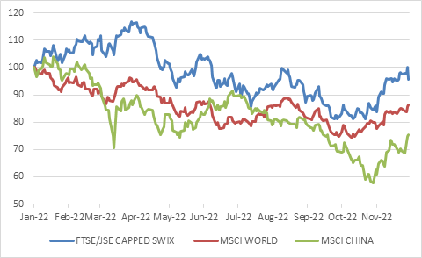
Source: Refinitiv Datastream

Living with uncertainty
It is too early to know if the worst is over. Bear market rallies are common. But since we will ever only know with hindsight when the market bottomed, it makes sense to remain invested. The October-November rally has already delivered multiples of what cash can do in a year, highlighting that while there are risks to investing in equities, there are also risks to sitting on the side-lines, waiting for the dust to settle. Missing such rallies can be very detrimental to long-term wealth creation. In fact, that has been the lesson of three very uncertain years (longer, if you want to include former US President Trump’s anti-China trade wars, which at the time seemed to be potentially game-changing events). Whether measured from the start of 2018, 2019 or 2020, an old-fashioned balanced portfolio has had enough parts moving in opposite directions to result in positive real returns overall. In contrast, more hyped investments such as crypto and other exciting technologies have failed to deliver.

Therefore, the more the world changes, the more the message stays the same: Building and protecting wealth through investing is about patience, taking a long-term view, and appropriate diversification. We cannot predict the future, and therefore building a portfolio around a single outcome is risky. For instance, it will be a mistake to assume that the rand is a one-way bet even if the local political scene is unsettled. If global conditions are favourable, the rand usually appreciates, especially if it was weak to begin with.

Living with the current uncertainty is obviously difficult, but it is also easy to forget how uncertain things were at several other points during history. Think about the Cuban missile crisis, the 1970s oil embargoes, the Rubicon speech, the fall of Communism, the transition from apartheid to democracy, 9/11 and the subsequent wars, and Brexit to name but a few. For everything that went wrong, millions of small things went right every day that resulted in companies growing their earnings and bondholders receiving interest. With enough time, these returns could compound in ways that seem magical but are entirely mathematical. There is no reason to believe the future will be any different.

