Looking for Policy Pivots

Old Mutual Wealth Investment Strategist Izak Odendaal

Policy often has a major influence on financial markets, usually much more than wars or disasters or other headline news events that appear more dramatic. Most people don’t pay much attention to policy developments since it is often pretty boring stuff. At the moment, however, it is front and centre for all investors.

Economic policies come in various forms and employ various instruments. Trade policy uses tariff and non-tariff barriers to encourage or discourage the flow of goods and services across borders. Regulatory policies tend to be industry specific and rely on changing rules for businesses. Fiscal policy refers to the spending and taxation decisions of the economy and can be very political. Tighter fiscal policy typically means the government takes more out of the economy and puts less in. Loose fiscal policy – funded by borrowing - is the opposite. Monetary policy is usually the preserve of technocratic independent central banks, who set interest rates free from political interference to achieve low and stable inflation. Increasingly in the aftermath of the 2008 global financial crisis, central banks also have a greater focus on maintaining the stability and functionality of the overall financial system. We recently saw an example of the financial stability goals coming into conflict with the inflation targeting objective in the UK when the Bank of England stepped in to prevent a bond market meltdown and curtail the sharp increase in bond yields even as it continues to raise the Bank rate. We are likely to see more such cases as pressures build across the global financial system with the widespread and sharp hikes in interest rates everywhere.

One would hope that when authorities change policies they do so for well thought-out logical reasons, but often it can be irrational, self-serving and short-sighted. At worst, they can be completely counterproductive.

However, even at the best of times, changes in economic policies have unintended consequences. It is virtually impossible to think of and avoid every single outcome when changing a key input in a complex economic system. There are also always winners and losers. Sometimes, the losses are concentrated and immediate while the gains are diffused and gradual.

Moreover, policymakers often have very blunt instruments to deal with specific problems. The current global inflation surge is due to a combination of supply-side and demand-side forces, but interest rates only work to affect demand. Higher interest rates cannot increase the flow of gas into Europe or produce more food or replace the “missing” workers in many developed economies.

Rates still rising
As fiscal and particularly monetary policies have tightened worldwide, investors are now looking for pivots towards easing. Since much of the pressure on financial markets comes from relentless interest rate increases, any signs of things going the other way will be greeted with cheer. One of the more aggressive central banks in the developed world has been the Bank of Canada. There was a flurry of excitement when it hiked by 50 basis points instead of 75 basis points last week. However, this hardly counts as a pivot. It is still tightening.

In the case of Canada’s southern neighbour, there is also optimism that the pace of rate increases will slow in the coming months. While possible, the Federal Reserve is still likely to take its policy rate to around 5% early next year. This level is likely to be maintained for some time until inflation is on a clear and convincing path towards the 2% average target and staying there. The Fed’s preferred inflation measure, the core PCE deflator, registered a 5.1% gain for the year to September. While the pace of price increases is slowing levelling off, it is still a long way from 2%. One of the key inputs in the Fed’s decision-making framework is the strength of the labour market. When workers are scarce, they can bid up wages which forces companies to raise prices, particularly in the service sector. With unemployment near 50-year lows, the signals from the job market also point to higher-for-longer interest rates.

Chart 1: US inflation
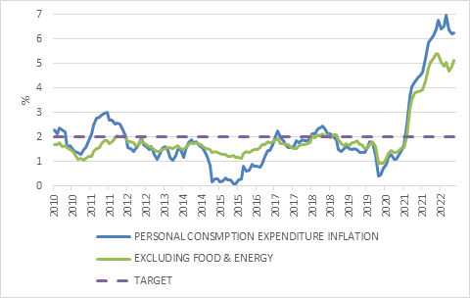

Source: Refinitiv Datastream

No Xi pivot
Elsewhere, there was a big market reaction to a set of unchanged policies. Chinese markets slumped on Monday following the conclusion of the 20th National Congress of the Communist Party. Xi Jinping became the first leader since Mao Zedong to secure a third term as party head, and by implication, head of state. Given that the top leadership structure of the Party is now made up entirely of Xi allies and acolytes, the third term might not be the last. The fact that so much power is concentrated in one person’s hands can lead to all kinds of problems over time. One doesn’t have to look further than Russia for a recent example.

But for now, not much has changed, to the disappointment of many. Notably, the zero-Covid policy will remain even though some hoped it would be abandoned after the Congress. Authorities will continue to implement lockdowns wherever the virus emerges, impeding economic activity, though the policy has softened around the edges somewhat.

There also wasn’t any change in stance towards the troubled property sector. A large-scale bailout of teetering property developers remains unlikely since that could just encourage more bad behaviour in future (economists call this “moral hazard”). A broad range of real estate metrics, from construction to sales to house prices continue to register declines. Since the broader property market ballooned to becoming a major contributor to China’s economic growth, it implies slower growth in the years ahead.

Normally, the response in a case like this would be sharp interest rate cuts, but the double-digit decline of the yuan against the dollar means the People’s Bank of China’s hands are largely tied. It has tweaked interest rates lower, but further cuts could spur capital flight and further yuan weakness.

The overarching message from the Congress is that national security concerns, self-reliance and greater equality are the key goals for the next five years. Economic growth, along the primary objective, will take a backseat.

Budget time
South Africa also had a big week for policy, with Finance Minister Enoch Godongwana presenting the Medium-Term Budget Policy Statement (MTBPS). The contrast with the ill-fated UK mini-Budget from a month ago that ultimately cost Liz Truss her prime ministership and brought Rishi Sunak into office is stark. Sunak and his Chancellor, Jeremy Hunt, might end up having to go to extreme lengths to regain the market’s trust, including painfully tightening fiscal policy. The South African government is similarly trying to regain the fiscal credibility that was squandered during the Zuma years.

This is not easy but has been helped by a commodity price windfall leading to a tax revenue overrun for the current fiscal year that is expected to come in R83bn ahead of the February 2022 projections. This will largely be applied to reduce debt.

A small primary surplus (the difference between non-interest spending and revenue) is pencilled in for the next fiscal year, the first such surplus in 15 years. This will allow the debt-to-GDP ratio to start stabilising. From next year onwards, if things go according to plan, the budget deficit of 4.1% of GDP will consist entirely of interest payments.

As a quick aside, budget numbers are very large, to give them proper context, they are expressed as a percentage of total nominal national income (GDP). Nominal GDP is expected to be R6.5 trillion this year. The government will collect around R1.7 trillion in taxes and spend R2 trillion on salaries, services, goods, capex and interest payments. Around R323 billion (4.9% of GDP) will have to be borrowed.

Chart 2: South Africa government debt-to-GDP ratio, actual and projection
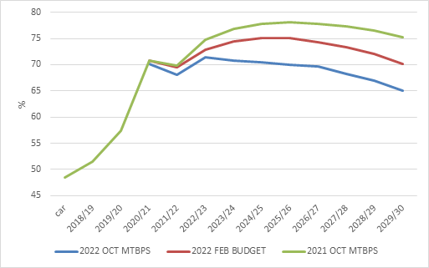

Source: National Treasury

Excluding any absorbed Eskom debt, the gross debt-to-GDP ratio is forecast to peak at 71.4% in the current year, two years earlier than previously expected. It is worth remembering how dire the fiscal forecasts were in 2020 when Covid hit. A debt-to-GDP ratio of 100% seemed possible back then.

There was no firm announcement on Eskom debt, despite promises that it would be addressed in the MTBPS. The details are still being worked out, including strict conditions. The minister noted that between one third and two thirds of Eskom’s debt will be absorbed by national government.

Growth outlook
Fiscal policy relies on a forecast of economic growth, but fiscal policy also influences economic growth. The direct impact, described above, is that changes in taxation and spending impact economic activity. The indirect impact is that a lack of fiscal credibility leads to investors demanding a risk premium in the form of very high bond yields. This raise borrowing costs throughout the economy and is the exact problem SA faces and is trying to solve.

Persistent loadshedding, bottlenecks in ports and rail and a slowing global economy means real economic growth is expected to slow from 1.9% in 2022 to 1.4% in 2023 before improving somewhat to 1.7% in 2024 and 1.8% in 2025. These are not overly optimistic forecasts, but the short-term risks are firmly to the downside.

Tax changes are typically not announced in the October MTBPS, but none have been pencilled in for the three-year fiscal framework. This is good news for taxpayers. But with real non-interest spending expected to decline in the next two years before rising slightly, fiscal policy will be a drag on economic growth. With the Reserve Bank firmly in hiking mode, monetary and fiscal policy are tightening at the same time.

Chart 3: Real non-interest spending, actual and projection
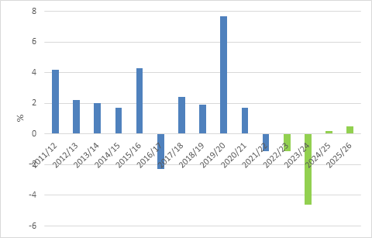

Source: National Treasury

Risks
While the numbers presented were well received, there are a number of things that can derail this positive story.

Firstly, the demands for social spending will remain high. The R350 per month SDR grant will be extended for another year, with no news on a permanent increase in social grants or introduction of basic income grant. Minister Godongwana reiterated that any permanent increase in social spending will have to be paid for by a permanent increase in tax revenue (i.e. a tax hike) or cuts in other areas of spending.

Secondly, struggling State-Owned Enterprises continue to bleed the budget, and another R30 billion was set aside for a cash injection (and this excludes Eskom). R23 billion of this will go to paying down SANRAL debt in an attempt to resolve the long-running e-tolls stand-off.

Thirdly, wage negotiations have not been finalised for the current fiscal year, and could still result in additional spending, though the government seems to have drawn its line in the sand. Moreover, these wage deals are likely to run on a one-year cycle in future, rather than the three-year cycles of the past. This will make budgeting for wage increases more difficult.

Ultimately, as has often been said, faster economic growth is necessary to put government’s finances on a firm footing. Both the Minister’s speech and the accompanying documentation place a large emphasis on the need to achieve sustained faster rates of economic growth. South Africa’s economic underperformance is largely because of government’s policy choices and woeful implementation. There has been some progress but unfortunately responsibility for implementing many key economic reforms sits with other government departments, not Treasury.

Prudent policy for an unpredictable environment
Broadly speaking, the MTBPS is a market-friendly budget, with a focus on reducing borrowing and raising economic growth rates. Given the highly uncertain global environment, this is extremely important. The UK example showed how ill-conceived policy pivots can backfire when investors are extremely jittery.

Despite all the social challenges and the national election looming in 2024, it was not a populist policy statement. On the contrary. Nonetheless, the market is not fully convinced. South Africa’s very high bond yields suggest investors still focus on what could go wrong, not what could go right. But as long as Treasury holds the line on fiscal discipline and the Reserve Bank remains committed to achieving its inflation target, bond valuations remain very attractive.

However, global events are likely to continue to dominate local financial markets. The key thing remains whether inflation can return to reasonable levels fast enough to prevent central banks from having to hike more than what is currently priced in.

