The different faces of risk
Guiding our perception of risk is crucial to achieving our financial goals

By Roné Swanepoel, Business Development Manager at Morningstar Investment Management SA

Like a pen and paper, soap and water and salt and pepper, so too risk (and reward) goes with all investments. Carl Richards points out in his blog1 - “Risk is what’s left over after you think you’ve thought of everything”. He goes on to explain that investors are good at managing and dealing with risk by looking backwards and preparing themselves to deal with a situation they have already seen, only better this time. But we’re not good at preparing for something we can’t imagine.

If we could count on riskier investments to produce higher returns, would that not mean that it would not be risky in the first place?

Consider this example: If you buy something for R10 and sell it a year later at R20. Was it risky or not? Some might argue that the profit you made proves it was safe, while the academics would say it was clearly risky since the only way to make a lot of money (100% in this case) is to take a lot of risks. Both sides of the coin could be true – it could either have been a very safe investment that was sure to double or a very risky lottery bet.

We all have to deal with the fact that we just don’t know how the future will play out, especially when it comes to financial markets. All investments have risk but these risks come in many shapes and forms, and guiding our perception of risk when it comes to investing is crucial to achieving our financial goals.

What is risk?

“Investment risk is the possibility that an investment’s actual return won't match its expected return.”2 Risk means different things to different people. Some investors could see risk as a drawdown, as we saw in March 2020. For others, risk could be underperforming the index or even underperforming a peer group average. Investors also have different levels of risk tolerance.

The most common definitions of investment risk are rooted in uncertainty. What is the likelihood of the returns on my investment deviating from the expected returns, and by how much? There are a variety of ways to measure this likelihood, the most common measure being volatility or the standard deviation of returns.

Volatility (standard deviation) helps investors understand how extensively returns could fluctuate from their average. It is a metric that is simple, widely accepted—but not helpful at all.

Standard deviation falls short in several ways –
- It treats downside risk (the bad kind) and upside risk (the good kind) as equals.
- Standard deviation doesn’t measure the shape of the distribution of returns. Meaning, if we look at all the return observations of a certain asset and/or asset class, how frequent are these return observations positive and/or negative
- It does not directly size the magnitude of unexpected events—those episodes that result in the greatest euphoria or fear.

There are a host of other definitions of risk that are far more important when we want to achieve our financial goals, let’s unpack some of these below.

- The risk of opportunity cost

Opportunity cost creates the possibility that the return on a selected investment is lower than the return on an investment not chosen.

The below graph illustrates –
- A hypothetical stock/bond portfolio, with different asset allocation weightings, over the past 20 years
- For example, the 80-20 portfolio indicates an 80% investment in equity (FTSE/JSE All Share Index) and a 20% investment in bonds (FTSE/JSE All Bond Index).
- The blue bar showcases the returns
- The red bar showcases the volatility
- The grey line illustrates the risk-reward ratio. The lower this ratio – the less volatile a portfolio has been in comparison to the return generated from the portfolio.

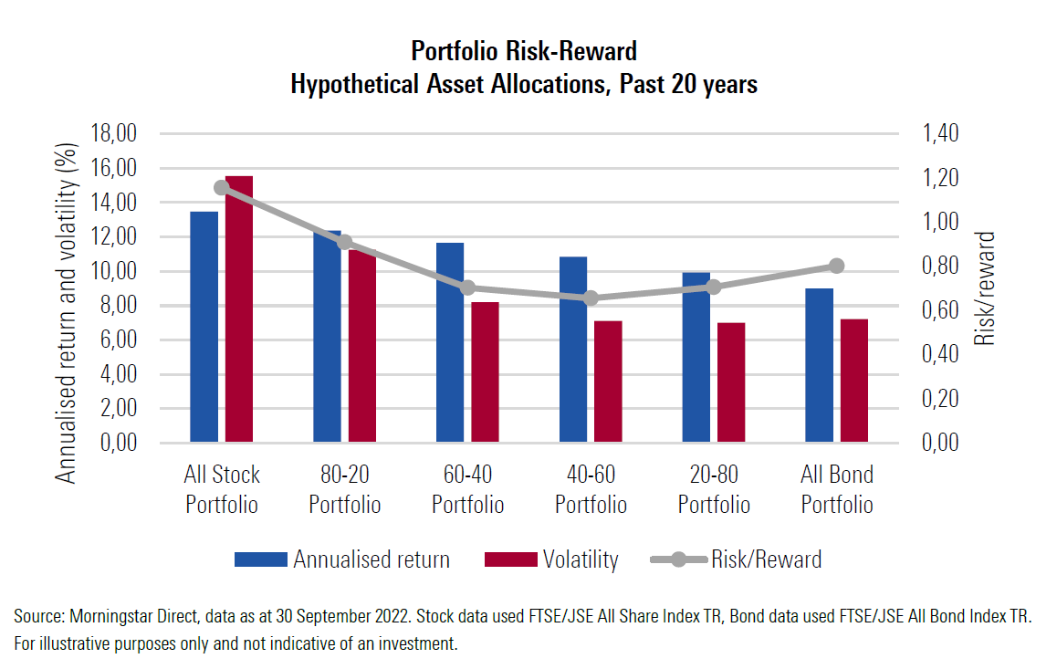

A couple of observations:
- An all-stock portfolio has the highest risk/reward ratio but also produces the highest annualised return over the 20-year horizon.
- The 60/40 and 40/60 portfolios have a very similar risk/reward ratio.
- The risk/reward ratio increases as you move to an all-bond portfolio.
- An investor would have benefitted from having at least 40 – 60% in equities as opposed to having no exposure to equities.

Although equities introduce volatility to a portfolio they also bring additional returns which is needed when there is a target to outperform inflation over time. The risk of not having enough risk in a portfolio can be detrimental to a long-term financial plan.

- Concentration risk

This is likely where the phrase “don’t put all your eggs in one basket” is most appropriate – due to concentration risk in investments. No asset class has a perfect strike rate and performs well all the time. It is also very unlikely that every asset class will perform well at the same time. It is for this exact reason that diversification within a portfolio is key.

The most important rule of trying to manage risk is to have different assets and/or asset classes that are drivers of return in an investment portfolio at different times and in different market environments. This strategy is designed to capture opportunities in strong market environments and provide downside protection in weaker ones (in other words, when one asset under-performs, returns are protected and achieved by other asset classes that perform well when others might not).

The graph below shows asset class returns on a calendar year basis, and it is evident by looking at this chart that it is very difficult to predict which asset classes will outperform each year. Let’s use the first asset class “Global bonds” as an example – it most certainly wasn’t a sure bet and a fairly bumpy ride.

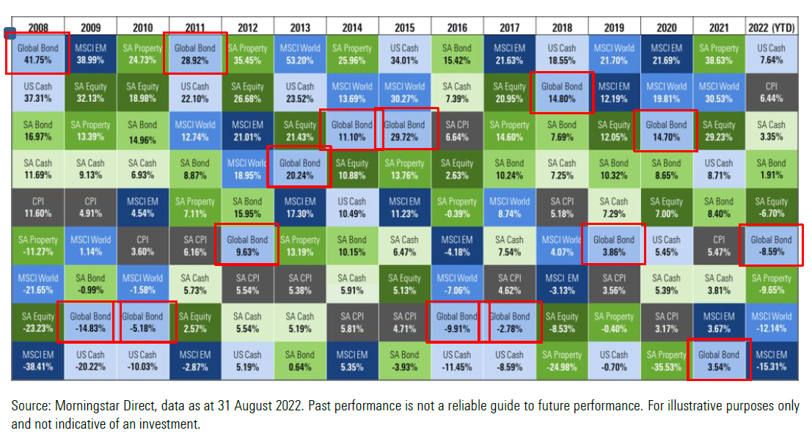

Similarly, when we look at managers within an investment portfolio it is very important to have different styles and managers who perform differently. As with asset classes, no manager has a perfect strike rate.

The below graph shows the top four performing general equity managers for 2022 (excluding FoF’s) ranked by year-to-date returns. It then shows the four bottom-performing general equity managers (excluding FoF’s) ranked by year-to-date returns. In addition, it also indicates their corresponding rank in the last six calendar years.

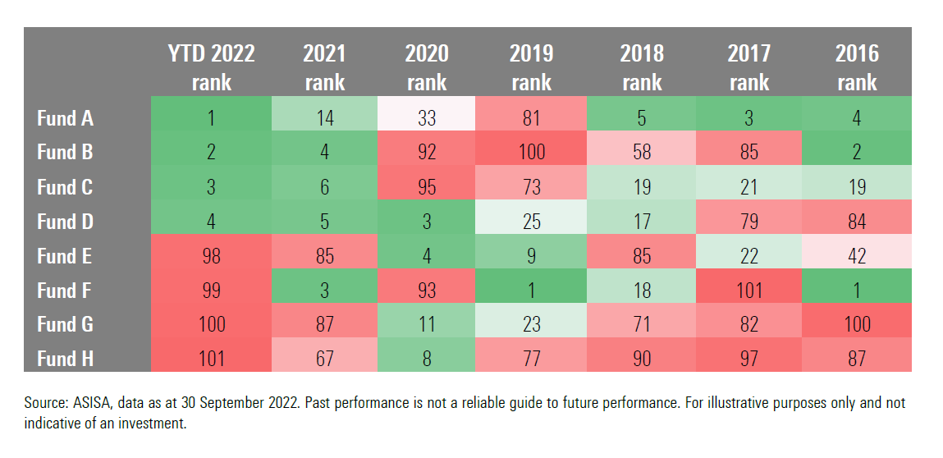
Let’s put these rankings into context.
- Within the ASISA Equity General category, there are 101 funds.
- If we look at Fund B as an example,
- This fund is the second-best-performing equity fund in 2022 and 2016. It was the fourth-best-performing fund in 2021.
- It was one of the worst-performing funds in 2020 and 2019.
- Similarly, when we look at Fund F,
- This fund was the best performer in both 2016 and 2019 and the third best in 2021.
- It was also the worst-performing in 2017 and the third-worst in 2022.

Blending managers with diverse styles who perform differently over time, rather than trying to pick the best-performing manager each year adds a lot of value to client portfolios.

- The risk of falling short

The last risk is the one investors should be most concerned with because the risk of not reaching your financial goals has a much larger impact on your life and well-being than the volatility (standard deviation) of your returns ever could.

High risk, high reward is a widely used phrase when it comes to investing. To be able to generate higher returns you need to be able to accept higher risk. The risk of falling short of your financial objectives is real and this can get amplified by investors being in the wrong strategy over their investment horizon.

Consider the example of an investor that has been invested in the wrong strategy for a long period of time.

The table below shows –
- An investor who contributed R1 000 per annum for 30 years in different strategies.
- These strategies range from targeting inflation (assumed to be 4,5% for this example) to inflation + 5% (your typical balanced portfolio strategy).

- A very simple calculation will show you that over a period of 30 years –
- If you underperform by 1% - you end up with 17% less retirement capital.
- Increasing that to 3% (i.e. achieving inflation +2% rather than inflation +5%) equates to 43% less retirement capital.
A more practical example would be the difference between investing in a cautious portfolio and being invested in a balanced portfolio.
- Ultimately, the proof is illustrated in the numbers – as can be seen in the bottom row.

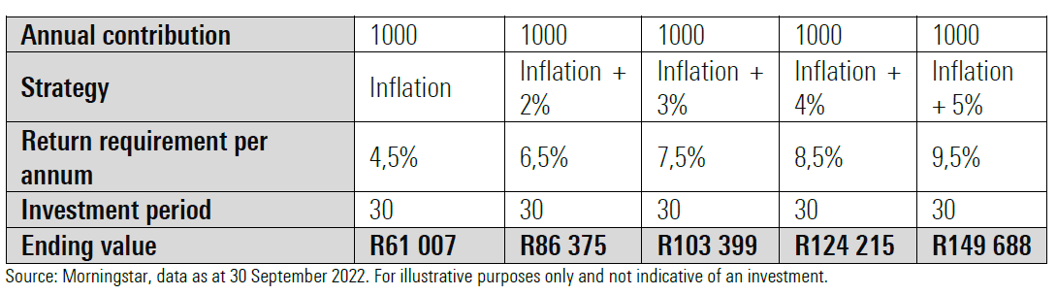

Key takeaways

When thinking about risk you want to identify the thing that worries you and demands the most compensation for bearing and/or beating it.

What we know to be true is that:

- Risk in financial markets is unavoidable
- Having equity in a portfolio brings about volatility
- Having only cash brings about the risk of opportunity cost and not managing to keep up with inflation
- Being in the wrong strategy out of fear brings about the risk of falling short of your financial goals.

Don't think about risk as something to be avoided altogether. A fundamental premise of investment theory is that to get returns beyond the risk-free rate, we must embrace some level of risk.

A longer time horizon does not excuse us from the shorter-term volatility we experience over time but, riding out shorter-term volatility will give you a greater chance of overcoming your biggest risk which is not meeting your goals.

