How do local equities stack up in the current environment?

By Sean Neethling, Portfolio Manager at Morningstar Investment Management SA

To say that 2022 has been volatile would probably be somewhat of an understatement. South African equities can no longer be discussed without the impact of global events. The global tide of easy money has turned, and the inevitable spillover to the local market is becoming more apparent. Foreign investors remain net sellers of local equities and the investable universe continues to shrink through companies delisting from the JSE. Recent changes to Regulation 28 have also widened the opportunity set for fund managers looking to ramp up global exposure. How do local equities stack up in the current environment? Where are the pockets of opportunity and how do investors balance risk and reward in these turbulent markets?

At this year’s Morningstar Investment Conference, hosted in Cape Town on 19 October, I had a panel discussion with Gail Daniel (Portfolio Manager, Ninety One), Piet Viljoen (Executive Director & Portfolio Manager, Counterpoint Asset Management) and Evan Walker (Portfolio Manager, 36ONE) to tackle these questions.

So, how do local equities stack up?

As was highlighted by the speakers, this year has been especially turbulent with virtually no place to hide. We have seen broad declines in both equity and bond markets being driven by multiple headwinds. While local valuations are attractive there appears to be greater uncertainty around the different risks that are being discounted by the market. Piet Viljoen, however, suggested that South African equities are currently pricing in particularly negative outcomes, which could provide scope for a potential uplift should these outcomes turn out to be less dire than expected. The panel agreed that from a valuation perspective, on an absolute and relative basis, South African equities are cheap. This can be seen in the graph below showing the South African Shiller Cyclically Adjusted Price to Earnings ratio (CAPE).

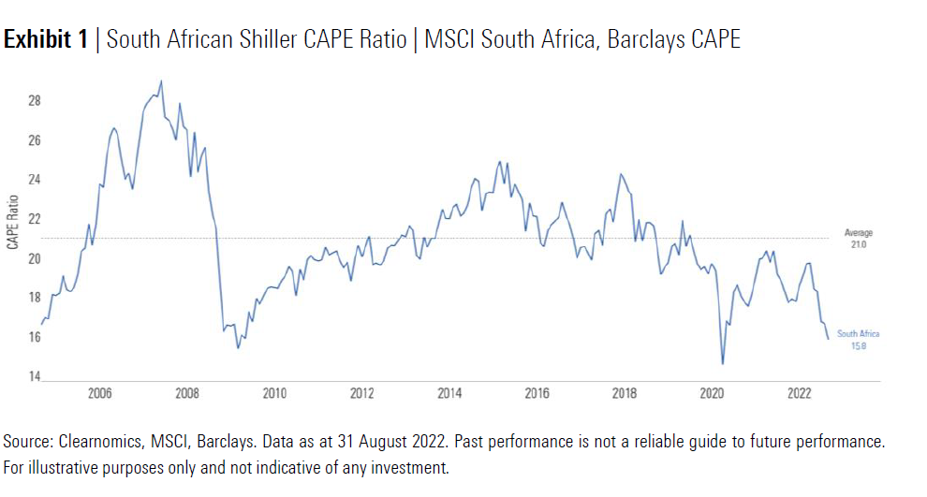

The chart shows that valuations on local equities are approaching levels last seen during the COVID-19 induced market decline in 2020 and before that the Global Financial Crisis (GFC) in 2008. Both of these were sharp, pronounced drawdowns, started by specific tail risks that led to contagion effects spreading across markets.

What could potentially go wrong and derail the South African equity thesis?

While valuations on South African equities are compelling, they do face significant headwinds in terms of growth. The current environment has multiple geopolitical, financial and economic risks which are all contributing to an especially uncertain period for investors.

Gail Daniel highlighted that the growth outlook for local equities remains constrained by economic and political policies. The operating environment for South African companies was cited as a specific concern. In addition, there could also be increased competition from incumbent firms refocusing their operations after unsuccessful offshore ventures.

Historically, South African companies benefitted from a more cushioned environment, with good growth opportunities allowing them to invest in value-accretive projects and generate increased revenue at high margins. This contributed to these businesses seeking further growth opportunities to expand their operations offshore. Many of these companies were unsuccessful as increased competition from incumbent global firms put pressure on revenue and margins. The local market is now seeing these companies being more focused on their local operations, which is likely to increase competition and increase revenue and cost pressures.

There was also agreement from the panel around the relatively wide range of potential outcomes that could play out in the current environment. As part of the broader emerging market complex, it would be very difficult for South Africa to be insulated from the spillover effects of the multiple global risks evident in markets today.

Rising global inflation and interest rates, the ongoing Russian invasion of Ukraine, zero-COVID policies in China, and political instability in both the emerging and developed world are all risks which are especially difficult to price. Although South Africa is not directly affected, the first and second-round effects of these risks have a significant impact on local markets. The economic slowdown in China, and, more specifically, the reliance on the country to fuel demand for South African-produced commodities was cited as an example of a headwind that could adversely affect the outlook for local equities.

What about diversification?

Evan Walker agreed that South African equities are cheap and have great earnings visibility but come with various idiosyncratic challenges. He cautioned that managers should be mindful of allocating overweight positions to South African equities given the size and breadth of the global opportunity set.

The panel also viewed the adjustment to Regulation 28 allowing offshore allocations to be increased from 30% to 45% as positive. Fund managers can now access a broader global opportunity set that should improve portfolio diversification by better balancing the mix between local and global positions. The increased flexibility was also cited as an opportunity for local managers to mitigate some of the concerns around the number of delistings from the JSE and a shrinking local investment universe.

The inherent currency risk when investing outside of South Africa was stressed as an especially important consideration when constructing portfolios with a wider global opportunity set. Currency can add significant volatility in the short term and some currencies can often trade at levels which differ meaningfully from fundamental fair value.

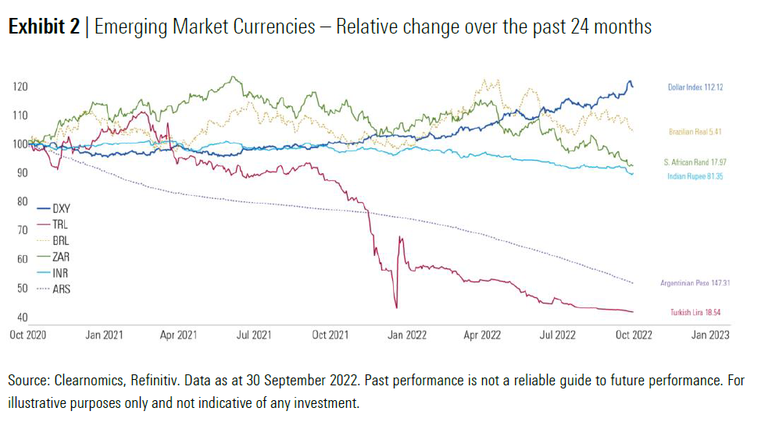

The graph above shows that the US dollar has strengthened substantially against most emerging market currencies this year. Investors have retreated to the US dollar in a risk-off environment where they expect the traditional safe-haven status of the currency to provide downside protection in an exceedingly volatile market. Rand-based investors should be mindful of sizing offshore positions in the current environment, where currency effects could potentially offset any asset allocation decisions. The panel agreed that building diversified portfolios tilted towards asset classes expected to be more resilient should be a key focus, given how markets are trading today.

In conclusion

South African equities continue to screen as attractive, with current market prices discounting an especially poor outcome. There are, however, both broader global and South African-specific risks that could derail the investment thesis. Investors should expect a relatively “bumpy ride” in the current investment environment, with a wide range of potential short-term outcomes. While the environment remains tough, valuations on local equities are not particularly demanding.

