There’s no free lunch, the bill is coming

Saleh Jamodien, Research and Investment Analyst at Glacier by Sanlam, examines the past three quarters of 2022, and the current state of markets.

By the end of the third quarter of 2022, equity and bond markets were down for the year, with major headwinds throughout the year being widespread across developed and emerging markets. Geopolitical tension, inflation at unsustainably high levels, rising interest rates to combat inflation and concerns about a global recession looming, dominated headlines. With nowhere to hide as both equity and bond markets sold off, investors fear that there is more pain on the horizon. In order to contextualise the current state of the market and how we got here, we need to understand the catalyst and series of events as a whole. Sometimes we need to go back in order to move forward. A lot of what we are experiencing now is an aftermath of events of the past.

Annus horribilis
2020 was a year synonymous with the COVID-19 pandemic, lockdowns and loss of life. It was not only a public health crisis but a pandemic that was felt across the global economy. As infectious diseases spread more rapidly in open economies, governments stepped in by implementing lockdown measures to curb the spread whilst long-term solutions, such as vaccinations, were in development. The impact of this, however, caused a halt in productivity, leading to business closures and rising unemployment. Furthermore, a slowdown in the transportation and manufacturing industries led to supply chain disruptions around the globe. In an effort to cushion these effects, global central banks adopted a dovish stance on monetary policy, slashing interest rates to encourage spending and stimulate economic growth – a decision which would later contribute to inflationary pressures. With that came inflated asset prices and irrational exuberance in equity markets.

Inflation 101 – too much money chasing too few goods
Against this backdrop, fiscal stimulus in the form of encouraged spending, stimulus checks and very easy monetary policies followed, to cushion the hardship and loss of jobs. This started to stimulate demand (specifically for goods), while, from a supply perspective, things began to grind to a halt. Higher prices in the form of inflation were always going to occur, but it was underestimated how significant that would be. Add to that the geopolitical tensions, under-investment in energy, and we are where we are today.

Fast-forward to 2022, a post-pandemic world, where communities are vaccinated, economies have opened up, tourism is on the rise and a hybrid, work-from-home-and-office is now the norm. These highlights have been eclipsed by the inflationary pressures and the Russia-Ukraine war. Economics 101 taught us that lowering the inflation rate makes it more attractive for businesses and consumers to spend on goods and services. This higher demand and increased spending results in higher prices. Additionally, headwinds have been encountered in China through their zero-COVID policies which demand quarantine and continuous testing. This has impacted the number of truck drivers on the road distributing goods to Chinese ports for export, which has stalled global supply chains. The narrative of inflation being ‘transitory’ began to change as central banks gradually became more hawkish.

The war over there
The Russia-Ukraine war has further exacerbated the inflation situation, given its impact on energy and commodity prices, with Russia and Ukraine being major energy and soft commodity producers. Europe is highly vulnerable to the war through the country’s reliance on Russian energy imports. The region has been experiencing a problem with its energy supply which began last year when power grid issues in Texas reduced cargoes of liquefied gas to Europe. Furthermore, a colder-than-average winter, and the country increasing its energy consumption by 25%, led to a surge in energy prices. Energy, in the form of fuel and electricity, is used to produce goods and services, and therefore is an input cost. Consequently, the rise in energy prices directly leads to a rise in the cost of these goods and services. Rising food prices have also been a contributor to the inflation print, as Russia and Ukraine are global suppliers of agricultural staples and fertilisers.

Figure 1: Inflation rate in US, EUR, UK and SA

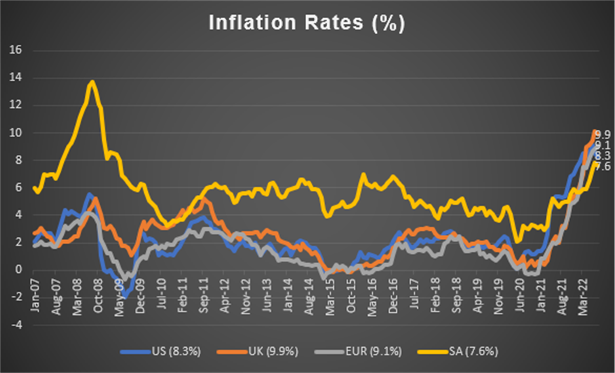
Source: Iress & Trading Economics

This perfect storm has resulted in global inflation rates coming in at multi-decade highs. At the end of the third quarter, US inflation, as measured by headline CPI was at 8.3%. In Europe, headline CPI reached a new record high of 9.1%. In the UK, headline CPI came in at 9.9%. Locally, South Africa’s inflation print came in at an uncomfortable level of 7.6%, which is above the upper limit of the South African Reserve Bank’s (SARB) target band of 3% - 6%. Markets have now priced in a more aggressive path for rate hikes with the expectation that rates will rise to 4.5%, 3.5% and 5.75% by next year in the US, Europe and UK, respectively, as central banks are confronted with the biggest inflation shock since the 1970s. The SARB has also recently hiked rates by 75 basis points with room to continue their hawkish stance.

Market daze
Global central banks have been faced with the challenging dilemma of taming inflation through implementing rate hikes or supporting growth. Clearly, the priority is to tame the unsustainably high inflation levels – most central banks have a mandate to protect the value of currencies. With a hawkish stance adopted by central banks throughout the year and further being reiterated at the recent Jackson Hole Summit, a sharp rise in bond yields and a sell-off in equity markets were experienced. In addition, concerns over a potential global recession also played on investors’ emotions as the US’s GDP contracted by 0.6% in the second quarter, following a 1.6% contraction in the first quarter of 2022. Two straight quarters of declining economic growth signals that the US economy fell into a technical recession, further adding to the risk-off sentiment and contributing to a sell-off in equity markets. Another interesting point is the fact that global bonds have sold off to the same extent as global equities year-to-date (YTD), reflecting a very precarious economic and market environment, and one that has a semblance of a recession. In recessionary environments asset correlations tend to be high.

Figure 2: GDP growth in US, EUR, UK and SA

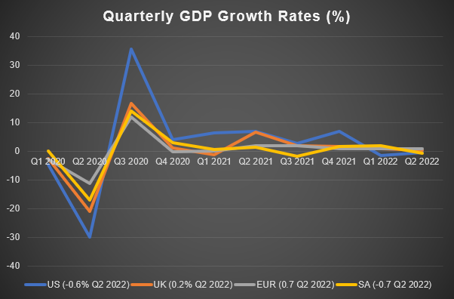
Source: Iress & Trading Economics

Figure 3: Table of indices performance

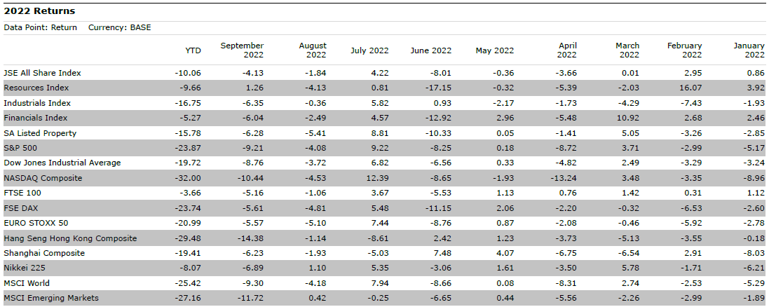
Source: Morningstar Direct

As at 30 September 2022, all major indices were in negative territory as equities faced valuation compressions brought about by higher discount rates. Furthermore, greater uncertainty meant that investors were hesitant to buy or hold risky assets, thus leading to a sell-off as seen above. In the US, the S&P 500 is down 23.87% YTD, the Dow Jones is down 19.72% and tech-heavy Nasdaq is down 32%, selling off significantly because of their long-duration nature and lofty valuations. In the eurozone, the German DAX is down 23.74% YTD, while the EURO STOXX 50 declined 20.99%, YTD. In the UK, blue-chip FTSE 100 is down 3.66% YTD, on the back of significantly weaker pound. All these performance measures are depicted in base currency.

The story at home
The South African market was not insulated from these global macro challenges as it tracked global peers lower due to the impact of high inflation, geopolitical pressures, rate hikes and growth concerns. Notwithstanding South Africa’s own challenges of Eskom and loadshedding, the high unemployment rate, low economic growth and a mounting debt burden, the JSE was relatively more resilient than global peers. The JSE All Share Index declined 10.06% YTD, with major indices – industrials, resources and financials – down 16.75%, 9.66% and 5.27%, respectively. In the midst of this chaos, however, some local counters offered handsome returns. This proves that investment opportunities are available even during the gloomiest of times. One favourable stock in particular was Thungela Resources whose stock price rallied 294% YTD, through the increased gas-to-coal switching. The Russia-Ukraine war has driven the price of coal to record high levels as Russia is a major gas supplier. Sanctions placed on Russia have resulted in supply crunches in regions of Europe, China, Australia and Indonesia, driving the price of coal higher, to the benefit of Thungela Resources.

Figure 4: Table of SA fixed income performance

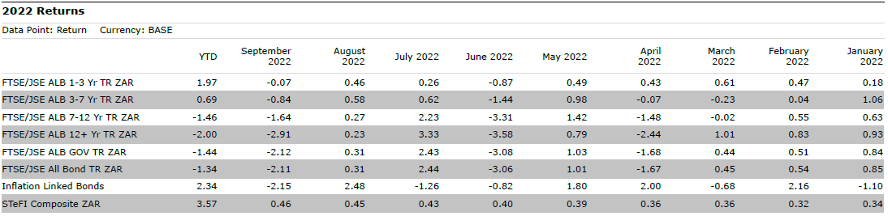
Source: Morningstar Direct

On the fixed income side, SA bonds declined 1.34% YTD, as yields were driven upwards by rate hikes and pricing in of the aforementioned macroeconomic risks (implying significant capital losses at high starting yields). The front end of the curve fared much better than the seven- to 12-year and 12 years+ area of the curve as these are more sensitive to increasing rates. Inflation-linked bonds were the best-performing fixed income asset class, gaining 2.34% YTD, as the rise in inflation was supportive. Macro risks notwithstanding, SA bond yields remained at attractive levels, especially on a real-yield basis and more so relative to developed market bonds.

Investing is a long-term exercise
The year thus far has been extremely difficult for markets, and investors have been increasingly concerned about the volatility of their portfolios. When uncertainty prevails, it’s easy to let emotions run high, which sometimes leads to irrational decisions and reactions, such as panic-selling or sitting in cash and not deploying the funds into growth assets. This could be detrimental in the long run. While these major world events have far-reaching short-term consequences on investment performance, when one adopts a long-term investment view, these events tend to be less harsh. While the growth outlook remains challenging, asset prices have already sold off significantly and valuations for both stocks and bonds now look more attractive. This presents investors with relatively attractive entry points and may even be offering once-in-a-lifetime investment opportunities. It’s times like these that remind us that building a well-diversified portfolio and staying invested for the long run, instead of trying to time the market, are more constructive principles for success.

This article first appeared on Glacier Insights

Glacier Financial Solutions (Pty) Ltd is a licensed financial services provider.
Sanlam Life is a Licensed Life Insurer, Financial Services and Registered Credit Provider (NCRCP43).

