Is a 60/40 benchmark fit for purpose in a high inflation environment?
It seems unlikely that a 60/40 benchmark will continue to meet the same “inflation plus” performance targets as the past. Schroders looks at the reasons why and what institutional investors can do about it.

Lesley-Ann Morgan – Head of Multi-Asset Strategy at Schroders
Ben Popatlal – Multi-Asset Strategist at Schroders
6 October 2022 : Many institutional investors set 60/40 benchmarks with the intended aim of delivering performance in excess of inflation. Often this is in the hope that this might bring returns of more than 3% (often 5%) per annum (p.a.) above inflation.
But is this realistic in the current environment? Should investors change their benchmarks or their return expectations (or both)?
- What has a 60/40 benchmark delivered in the past?
In figure 1, we show rolling five-year performance of a typical 60/40 benchmark, and compare it to rolling five-year CPI .
(Throughout this article, we use Bloomberg Barclays Global Aggregate Bond Index (hedged to USD) for global bonds, and MSCI AC World USD for global equities unless stated otherwise).
We also show the median five-year returns for the 60/40 benchmark. This shows that while the five-year p.a. returns of the 60/40 benchmark are variable through time – and indeed more variable than CPI – the benchmark has on average been equivalent to around CPI+4.2% p.a. over rolling five-year periods (the blue line represents the median 60/40 return which over time has averaged 4.2% more than CPI).
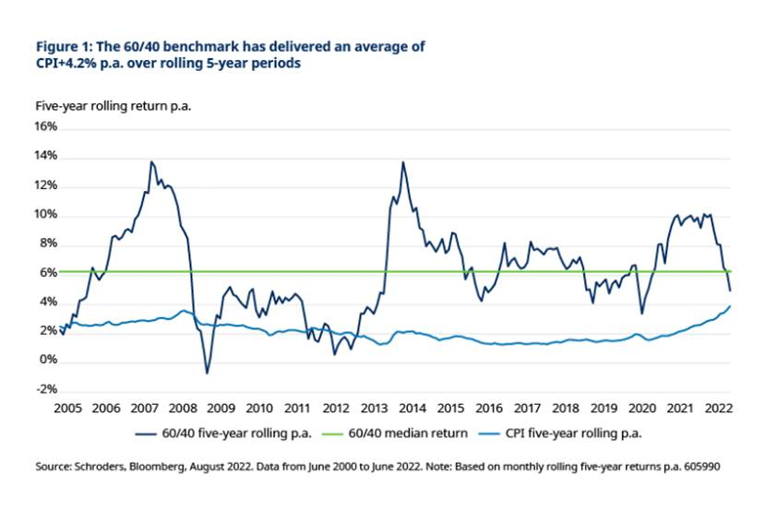
Conclusion from looking at past data:
A 60/40 benchmark achieved inflation + 4.2% p.a. on average over the last 22 years.
2. What is a 60/40 benchmark likely to deliver in the future?
The link between a benchmark and likely returns involves making assumptions about the future returns for asset classes and for inflation. Forecasting future returns and inflation is clearly not straightforward and no-one is likely to get this 100% correct. One way to mitigate for this is to use a range of different assumptions and to model likely outcomes using different possible assumptions around a central view. We discuss this further in the next section.
At Schroders, we have grappled with this decision for our own multi-asset investment strategies. When we launched a diversified growth strategy in the UK in 2006, we set our targets on the basis that inflation+5% would be similar to the return of global equities over the long term.
This remained in place until 2021, when we changed the target from inflation plus to cash plus. This was primarily because we believed that market conditions made it very difficult to achieve inflation+5% p.a. in the future.
Looking ahead, for a central view, we have used our economists’ 30-year return forecasts for global equities and G4 (US, UK, Japan and Europe) government bonds.
(Our economists’ forecasts use MSCI World for global equities and a composite G4 (US, UK, Japan, Europe) index for bonds.)
Figure 2 shows the expected return of different equity/bond combinations, in nominal and real terms. The real return forecast uses our economists’ 30-year forecast for US inflation of 2.2%.
The table shows that a 60/40 benchmark would deliver a forward-looking return of around CPI+1.9%. Importantly, however, the shortfall is driven not by elevated long-term inflation, but instead by reduced nominal return forecasts for equities (5.7%) and bonds (1.8%). So, while the return potential for the 60/40 benchmark looks less attractive in the period to come than it was in the past, over a 30-year horizon the problem is not that inflation will be structurally higher.
To achieve a return in the future of CPI+3% p.a. using these assumptions, would require a change from 60/40 to 90/10 but clearly this would come with higher volatility along the way. It should be noted that using these assumptions, not even 100% equities is likely to deliver CPI+5% p.a.
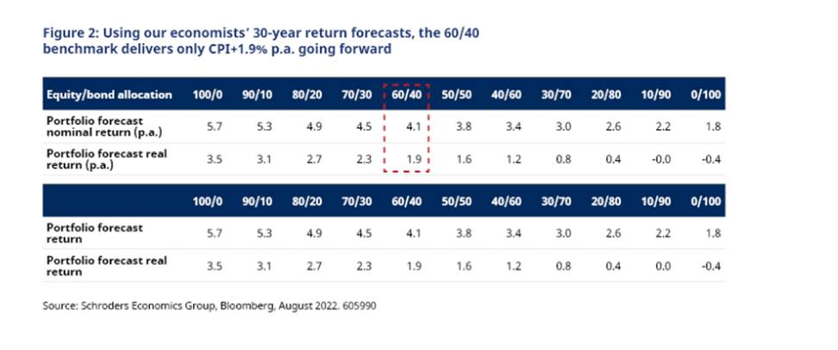
Conclusion from looking at future data based on our 30 year assumptions:
A 60/40 benchmark is likely to deliver less than 2% above inflation.
3. How will structurally higher inflation affect expectations of returns for 60/40?
In figure 3, we show how the 60/40 benchmark performed under different inflation backdrops historically. We have created the box-and-whisker diagrams to illustrate the distribution of returns in excess of inflation (i.e. real returns), for each inflation environment, with the average real return represented as the cross in each of the boxes. Further detail on the data represented is included in the chart’s footnote.
If we are indeed at the start of a period of structurally higher inflation, such that it averages 3-5% (pink) or >5% p.a. (yellow), then there would likely be a deterioration in the real return of the 60/40 benchmark. The average real return, as well as the maximum and minimum returns, are somewhat lower, especially for the highest inflation environment. Interestingly, it is not just the highest inflation environment which is challenging, but the average return in the lowest inflation environment is also below the CPI target.
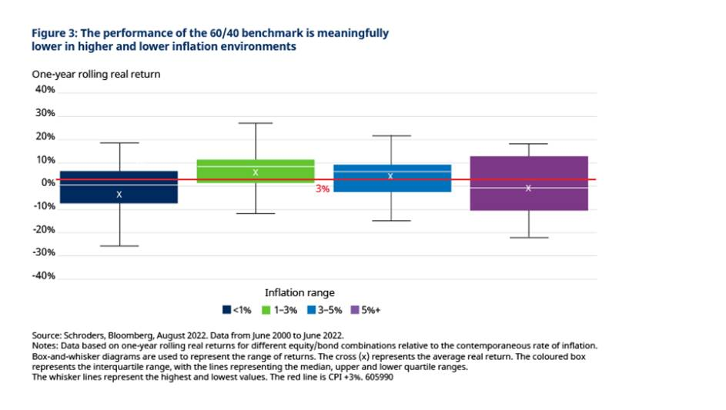
This result suggests that investors (or those that set benchmarks for them) should consider a change to the strategic benchmark in order to target CPI+3% p.a. if they believe that inflation will be anything but the ‘sweet spot’ of 1-3% going forward. However, this is contradicted when we look at different benchmark mixes. In figure 4, we repeat figure 3 and then compare it with other combinations of equities and bonds to observe how they performed under different inflation environments.
The shape of performance is similar for all four major benchmark combinations. Changing the combination creates a trade-off whereby a higher average performance (for higher equity weights) also results in a wider range around that performance. This is not a surprising result, but it does confirm that even with a structural view on inflation for the period to come, changing the strategic benchmark does not appear to improve forward-looking performance.
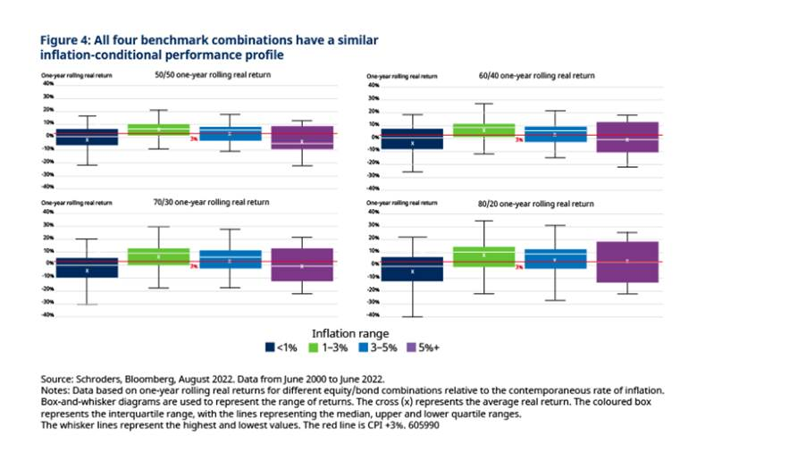
If the inflation backdrop meaningfully changes the relationship between equities and bonds, such that the correlation between the benchmark components is much higher or lower, then we could see slightly different results than those in figure 4. A paper written recently by our strategic research unit investigated the effect of inflation on equity/bond correlations. History suggests that higher inflation regimes have typically been associated with positive equity-bond correlations.
Higher interest rate volatility has also been associated with weaker equity-bond correlations. We do, however, recognise that predicting future correlations is very difficult, particularly with both inflation and growth concerns in play and the current uncertainty around central bank pathways.
Rather than embedding a long-term inflation view into the benchmark, we think investors should retain the flexibility to dynamically adjust their views. Specifically, they should consider adapting their asset allocation in line with market valuations, their short to medium-term inflation outlook and the impact this has on asset class returns.
Re-creating figure 1 using one-year returns for the 60/40 benchmark and CPI, in figure 5 we overlay the inflation cycle, grouped by the level of inflation. The pattern of 60/40 performance across inflation groupings is not clear, and even within inflation groupings, the performance of the benchmark is variable. We believe this is an argument for dynamic inflation management as opposed to adjusting the strategic benchmark.
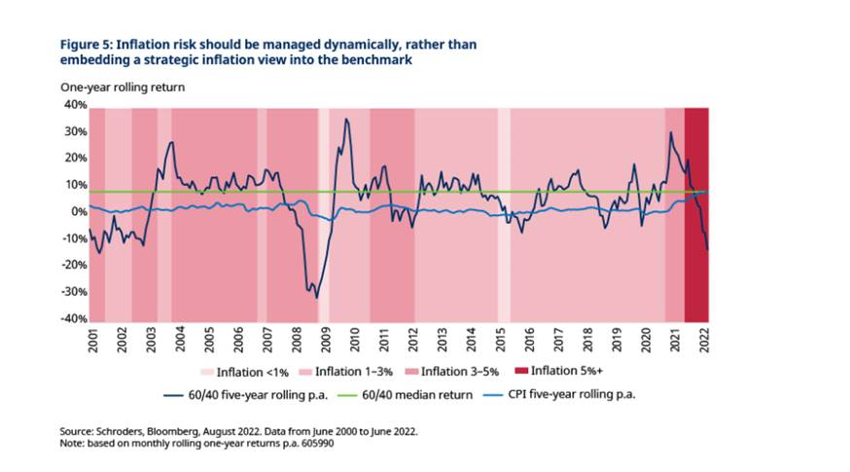
Conclusion from looking at future data based on various inflation scenarios:
The shorter-term relationship between benchmark returns and inflation is unstable. This suggests that dynamic inflation management may be more appropriate to target higher returns, rather than a change to the strategic benchmark
4. Are the current thematic shifts likely to make inflation higher longer-term and impact future returns?
Inflation is on every investor’s mind today, but is there a broader set of thematic shifts happening in the world economy, that we need to factor into long-term investment decision-making?
Across Schroders we have been thinking about what the future looks like for financial markets and what may cause or contribute to patterns of growth and inflation globally. Here are a few of those themes and our view on how they might impact inflation. Most are included in our current 30-year return assumptions (and energy transition will be included in our next 30-year assumptions to be published in early 2023).
Energy transition – inflationary pressures are likely to increase amid measures to discourage high-carbon energy sources, although much depends on how policymakers intervene to tackle global warming and the inflationary impact is likely to be concentrated in the near-term. The impact will also be more pronounced for economies that still largely rely on energy from fossil fuels. Overall we expect energy transition to be inflationary.
What net zero means for inflation
Technology - a greater use of technology (accelerated during the Covid-19 pandemic) will contribute to an improvement in productivity growth over the medium term. While technology can bring greater efficiency in production, certain traditional jobs may become obsolete, worsening problems of inequality and populism risk. We expect improvements in productivity to result in lower inflation.
Could technology trigger a lasting boost to productivity
Climate change – the effect of climate change will vary significantly around the world. Some literature on climate change economics suggests natural disasters could actually boost corporate productivity and promote growth in the long term. This is because firms that survive the disasters will update their capital stock and adapt new technologies. Although not everything supports this positive view, there is strong evidence to suggest climate change will have a large impact on global growth whether for the better or worse. We have incorporated the impact of climate change into our long-term growth forecasts. Lower productivity on the back of higher temperatures is likely to be inflationary.
How climate change could impact returns over the next 30 years
Heightened geopolitical tensions – Tensions over the war in Ukraine are likely to lead to a more fragmented or regionalised world economy. This means less efficiency, higher costs and slower growth (stagflation). Global supply will be more disrupted and harder to control. The challenge for central banks in keeping inflation to target will be greater, making interest rates higher and more volatile. The bright spot is the greater adoption of local technology. This is not something we factor into our 30-year assumptions. Typically, heightened geopolitical tensions lead to higher costs and this has an inflationary effect if companies pass on these higher costs on to consumers.
What a new world order might mean for the global economy
Demographics - Ageing populations mean that the growth in working populations will slow over the next decade and decline in Japan, parts of Europe (Germany and Italy) and China. Unless offset by stronger participation rates or productivity, the decline in workers will weigh on growth. We adjust our productivity numbers by working population and therefore this is accounted for in our 30-year forecasts.
Inescapable Truths update: which trends have been strengthened or challenged by Covid-19?
Conclusion: adaptability is key
We set out to evaluate whether investors with 60/40 benchmarks are likely to deliver returns of inflation +3% p.a. going forward. We found that:
- It seems unlikely that a 60/40 benchmark will deliver inflation +3% p.a. in the future, based on our 30-year assumptions.
- Different equity/bond combinations do not materially improve forward-looking returns under different inflation environments. Hence there is not a strong rationale for changing the benchmark.
- However, we recognise that the future may look very different to the past. We believe that it is important for asset owners to be adaptable to different market environments.
- We also believe that structural economic trends need to be accounted for in return assumptions and in investment decision-making. Our economists at Schroders are already factoring such themes, including climate change, into their forecasts.

In addition, embracing a broader set of asset classes outside the benchmark, and incorporating private assets, will give asset owners a greater chance of achieving their desired target return.

