The ornithology of monetary policy

Old Mutual Wealth Investment Strategist Izak Odendaal

Since ancient times, doves have symbolised peace and hawks aggression. During the Vietnam War, “hawks” became a widely used term to describe those who argued for increased military intervention, whereas the “doves” were those in favour of de-escalation and negotiation. It is not clear when this language spilled over to the decidedly less animated world of central banking, but today it is common to describe monetary policymakers – either in their individual capacity or as a policymaking collective - as hawks or doves. Hawks are tough on inflation, while doves tend to focus more on unemployment and economic growth.

Birds of a feather, flocking together
Central banks were decidedly dovish when Covid hit, slashing rates and injecting liquidity into markets on an unimaginable scale. They then opted to be lenient on nascent signs of inflation last year, hoping that it would prove transitory. No more. Central banks have turned hawkish en masse, with World Bank data showing more central banks hiking interest rates this year than at any time in the past. In other words, in the space of two years we’ve gone from extraordinary monetary easing to record tightening as deflationary fears have been replaced by fears of persistently high inflation.

The pace of increases has been accelerating in many cases. For instance, Sweden’s Riksbank kicked off a busy week of central bank decisions by raising its policy rate by 100 basis points, the biggest increase in 30 years. Whereas 25 basis point increments had been standard practice in many countries for many years, in 2022 that quickly gave way to 50, then 75 basis point moves. For some, 100 might be the new 75.

What is even more remarkable is that Sweden maintained negative interest rates until very recently, while the European Central Bank also had sub-zero rates as late as June this year. The Swiss National Bank also joined the negative interest rate club in 2015, a move that many considered to be bizarre. It moved back into positive territory last week with a 75 basis points increase. The Bank of England also hiked its rate last week by 0.5%.

Chart 1: Number of central banks changing interest rates
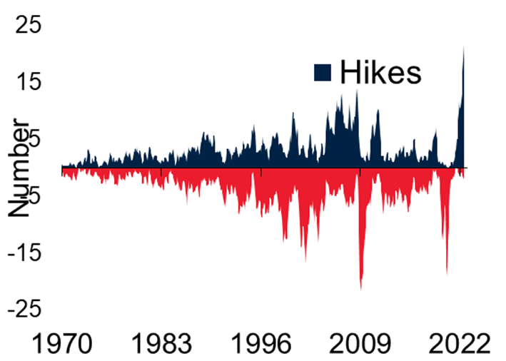
Source: World Bank

American eagle
Central banks are not equal. Most important by far is the US Federal Reserve given the dominance of the dollar in global trade and finance. When the Fed changes rates, global markets shift since all assets price directly or indirectly off the US yield curve. The dollar also tends to react to Fed policy, forcing a response from other central banks. Not all countries face the same degree of inflation pressure as the US economy, but with higher rates boosting the dollar to 20-year highs, many now face intense pressure on their currencies, which can lead to higher inflation down the line. Hiking rates can attract capital inflows that stabilise the currency, at least that is the theory. In practice, the dollar has steamrolled all other currencies this year almost irrespective of what their central banks have done.

As former IMF chief economist Maurice Obstfeld noted in a recent article, this synchronised but uncoordinated hiking cycles risks tipping the world economy into recession if each central bank does not take into account the actions of all the others. If everyone is hiking at the same time, the global economy could end up much weaker that each individual bank believes due to the spill-overs from weakness in one country to the next.

“Now is the time for monetary policymakers…to look around,” Obstfeld writes, arguing that central bankers should not be like ostriches with their heads in the sand. “They should take into account how the forceful actions of other central banks are likely to reduce the global inflationary forces they jointly face.”

Lesser spotted dot plot
But for the time being this argument is falling on deaf ears. The Fed raised the fed funds rate by 75 basis points for the third consecutive time, taking the upper limit of its range to 3.25%, the highest level since December 2007.

The Fed also updated its quarterly dot plot, an anonymous summary of the forecasts of various Fed officials. The median dot on the plot now shows the fed funds rate rising to 4.4% by the end of the year, a full percentage point higher than the June projection. Further rate increases are projected in 2023, and importantly, the expectation is that rates will remain elevated throughout the year, only starting to decline in 2024. In other words, there is no pivot on the immediate horizon. Higher interest rate projections in turn result in lower growth forecasts, and an expectation that unemployment will have to rise.

US bond yields have increased in line with higher expected policy rates. The 10-year yield hit 3.5%, the highest level in a decade. However, shorter-dated yields have been rising even faster and further. The two-year yield is now near 4% and higher than longer-dated yields. This is known as a yield curve inversion and carries ominous connotations since it has a good track record as a recession predictor. Notably, US mortgage rates are at 6.3%, a level that will further constrain the key housing market.

A wild card remains the Fed’s ongoing unwinding of its balance sheet, selling off some of the bonds that it bought in its quantitative easing programmes. This quantitative tightening process is set to speed up this month, further draining liquidity from the bond market.

Chart 2: US interest rates, %
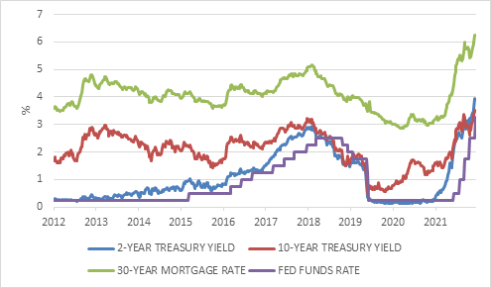

Source: Refinitiv Datastream

Turkeys and the lame ducks
There are a few central banks who have not been hiking rates. Turkey’s is one, under pressure from its strongman President Erdogan who believes that higher interest rates cause inflation. Erdogan fired successive central bank chiefs until he found someone who is prepared to toe the line and cut rates. Turkey’s currency has slumped, and inflation is running around 80%. Interestingly, the economy seems to be doing quite well and there is no sign of recession yet.

Russia’s central bank doubled interest rates overnight following the invasion of Ukraine to prevent a bank run and currency implosion but has since been cutting. The rouble has strengthened substantially against the dollar, unique among currencies, given strict capital controls and imports that have ground to a halt while export revenues from oil and gas have increased.

The People’s Bank of China has been easing rates as the world’s number two economy is battered by zero-Covid lockdowns and the imploding property market. The rate reductions have been small to date, partly because the Chinese monetary system functions on quantities of credit, rather than the price of credit. Moreover, the PBOC is probably also keeping one eye on the currency. The yuan has already fallen substantially (by its standards) against the dollar this year, and the last thing authorities in Beijing want is further disorderly declines.

The last lame duck is Japan, where despite the yen trading at 30-year lows against the dollar, the central bank remains committed to keeping short-term rates low and maintaining the yield on the 10-year government bond near zero (so-called yield curve control). Policymakers in Japan spent much of the past two decades trying to raise inflation towards 2%, and therefore are possibly unique in welcoming the recent jump in inflation though it is still mostly due to energy costs (Japan is a net energy importer) and not necessarily domestically generated underlying inflation, such as the robust wage growth and service inflation we’ve seen in the US and elsewhere.

Hawks in blue crane country
South Africa’s own central bank has also taken a hawkish turn. The Reserve Bank’s Monetary Policy Committee raised the repo rate by 75 basis points for the second time in this quarter, taking it to 6.25%. Two of the five committee members wanted to hike by 100 basis points.

This is despite inflation moderating. Headline inflation dipped in August to 7.6% due to lower petrol prices, suggesting that the inflation peak was July. Food inflation rose further, but core inflation, excluding volatile food and energy prices surprised by pulling back to 4.4%. This suggests that inflation in South Africa is still primarily supply-driven, rather than the demand-pull inflation the Fed is now battling in the US. While interest rate increases are warranted based on an inflation rate that is well outside the Reserve Bank’s target range, the extent of the increases primarily reflects the global situation. With most other central banks and many emerging markets, in particular, hiking aggressively, the MPC does not want to fall too far behind and risk a disorderly depreciation of the rand.
The Reserve Bank’s own forecast suggests that inflation will return to the target range in the second half of next year, and in fact slightly reduced its forecast for the average 2023 inflation from 5.7% to 5.3%. Inflation is expected to average 4.6% in 2024, which is close to the midpoint of the range.

With the weakening global outlook, as well as the likelihood of persistent loadshedding in the months ahead, it is no surprise that the Reserve Bank’s growth forecasts were lowered. The economy is now projected to growth 1.9% in 2022 (from 2% previously), 1.4% in 2023 and 1.7% in 2023.

Chart 3: SA inflation and repo rate
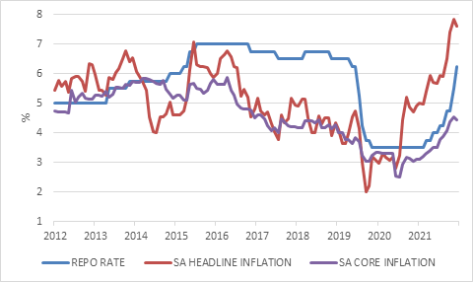

Source: Refinitiv Datastream

Vultures circling
The highly uncertain macro environment has implications for asset allocation. The most important consideration is that we are now firmly in a higher-for-longer global interest rate environment, a stark contrast compared to the decade before the pandemic. This makes interest-bearing assets more attractive, which can weigh on equity valuations. Crucially, higher interest rates also impact earnings, as companies now face higher borrowing costs and, typically, lower sales. The exact impact remains to be seen. Markets are forward-looking and after a 20% decline a degree of economic weakness is already priced in. We are just not sure if the full extent is already discounted. Consensus company earnings are still forecast to show reasonable growth, but typically fall in a recession.
It is also important to remember that timing the equity market is virtually impossible. By the time you think you’ve received the all-clear, perhaps when central banks have stopped tightening policy and start easing, it will be too late. The vultures will have swooped in to pick up bargains and the equity market will have rallied. Missing these rallies can be seriously detrimental to long-term returns. Therefore, even though the next few months might be very volatile, part of an appropriately diversified portfolio is to remain invested in equities. Patience and perseverance are still called for.

