Bringing down the house

Old Mutual Wealth Investment Strategist Izak Odendaal

The inflation dragon is yet to be slayed. The latest reading of US consumer prices shows the positive impact of lower global oil prices, but other items in the inflation basket continue to push higher. So, while US inflation has peaked at a headline level, underlying inflation remains too high and the road back to low and stable inflation is potentially long and uncertain. Market optimism in this regard was harshly dashed last week. Equities slumped, bond yields rose, and the dollar resumed its upward march.

Gimme shelter
A big part of the inflation story in the US is housing, since housing (or shelter as it is called) is the biggest single component of the US consumer price index with a 33% weight. Since the consumer price index measures consumption not investment, the shelter component is the rent people pay to landlords as well as the imputed rent homeowners owe themselves (known as owner’s equivalent rent). In the case of the US, both actual and owners’ equivalent rent have been increasing at a rapid pace at 6.7% and 6.3% respectively. This is a long way from the Federal Reserve’s target of 2% average inflation over time.

Chart 1: US housing inflation
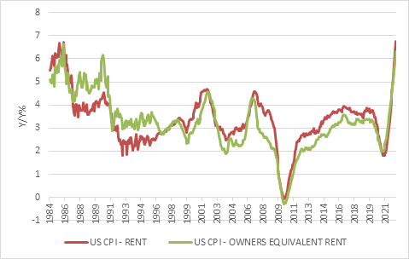

Source: Refinitiv Datastream

Rent, as is the case with most prices, is clearly determined by supply and demand. If prices are rising rapidly, it means demand is exceeding supply. The decline in interest rates and shift to remote working created a surge in demand for housing. As with the commodity market, supply was not only restrained by Covid-related disruptions, but also by a preceding decade of underinvestment as the market worked through the overhang of the pre-2008 bubble and households deleveraged. Rental growth also depends on the financial ability of households, and therefore cannot grow out of line with overall wage growth for long periods of time. House prices can deviate from incomes, since the gap can be filled by borrowing, but borrowing to pay rent is not sustainable. That is why South Africa has a sluggish housing market despite the obvious need for more housing units: where the need is greatest, people don’t have money and the demand is not ‘true’ demand. Therefore, the outlook for rental inflation in the US and elsewhere depends on the supply response – how many units are being built – as well as demand that in turn depends on changes in preferences, but importantly, also wage growth.

Transmission channel
Housing is also a key channel through which central banks try to influence the economy. After all, most homes are bought and built with borrowed money. Changes in interest rates can therefore leave homeowners with more or less disposable cash at the end of each month to spend on other items. Rate changes also make housing more or less affordable for new borrowers. Since there is a broad range of sectors that are directly or indirectly linked to housing activity, including bankers, architects, builders, realtors, conveyancers and furniture retailers, the housing cycle has a big influence on the broader business cycle. Some economists have gone as far as to say that the housing cycle is the business cycle.

There is a bit of a wrinkle in this story, however. In the US, interest rates are usually fixed for the duration of the mortgage, typically 30 years. If rates rise, borrowers are shielded. If rates fall, they have the option of refinancing the loan at a lower rate, and indeed many did when rates plunged in 2020. It can be quite lucrative to refinance if rates fall while house prices rise, and many households cash out the difference as a lump sum.

The other complication in the US is that mortgage rates are linked to long-bond yields, and therefore adjust rapidly to changes in expectations of monetary policy. Mortgage rates already reflect higher Fed interest rates, long before the Fed gets there. The average US 30-year mortgage rate doubled from 3% to 6% since the start of the year, well before the Fed really got going.

In South Africa, mortgage rates move in lockstep with the prime overdraft rate, which itself is simply a fixed spread over the Reserve Bank’s policy rate, the repo rate. Therefore, the interest payment on a home loan adjusts every time the Reserve Bank increases or decreases the repo rate. Mortgage rates can be fixed for short periods of time, but often at great expense, so few do. The UK and Australia have similar models. Japanese mortgages tend to be a mixture of variable, short-term fixed and long-term fixed rates. In Canada, many mortgages have fixed rates initially, converting into floating rates after a while.

In Europe, some countries have predominantly fixed rate mortgages (including France, Germany and the Netherlands), while others have mostly variable rate mortgages (including Italy, Portugal and Spain). This means the European Central Bank has uneven monetary policy transmission channels throughout the Eurozone, which can be problematic.

There is another category of mortgages that comes with its own set of problems: foreign currency loans. These were particularly popular in Eastern Europe where home buyers would take out mortgages denominated in euro or Swiss Franc, benefiting from lower interest rates than in their home currencies. These mortgages were highly vulnerable to exchange rate variability, and proved to be calamitous when currencies crashed in the 2008 crisis

Home ownership rates also differ across countries in the Eurozone, being much higher in Spain (around 75%) than in Germany (around 50%). Elsewhere, Australia, the UK and US have home ownership rates of around 65%. How many households choose to buy versus rent will depend on cultural preferences, but also policy. Countries like Germany incentivise renting, while tax-deductibility of interest payments is a big incentive to being a homeowner in the US.

The upshot is that the Fed’s interest rate increases must impact the housing market, even if there are long and variable lags at play. The sharp increase in borrowing costs, combined with high prices, has made buying a house very expensive. Therefore, the first domino to fall is sales activity and associated borrowing. Next up, planned developments are scaled back or cancelled. Building activity then slows down, with fewer new construction projects starting. Price changes tend to be the last domino to fall.

Chart 2: Selected US housing market indicators
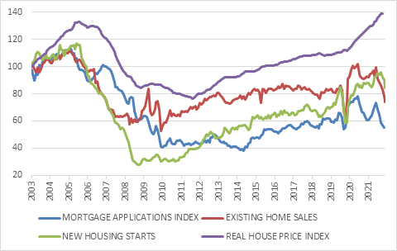

Source: Refinitiv Datastream

Looking at the US market, sales activity has already plunged while building activity is also slowing. Price growth is declining and is likely to continue slowing but remains high. There is no sign at the moment of nationwide price declines, as was the (unthinkable) case from 2006 to 2013. Indicators of rental growth from private rental platforms show that these have also peaked. Interest rates are doing what they are supposed to be doing. However, as long as the labour market remains tight and the shortage of workers persists, wage growth (currently around 6%) can sustain rental growth rates at uncomfortably high levels. It is therefore hard to escape the conclusion that only a rise in unemployment, in other words a recession, will really rid the US of its inflation problem even if commodity prices fall further and supply chains normalise.

Structures
Apart from short-term cyclical factors, it is also useful to think about longer-term structural changes, since housing is such a big player in most economies. These factors are often underpinned by demographics, but also by big debt cycles. In the case of the US for instance, the big household debt cycle peaked in 2007 and has largely been on the decline ever since. This was a persistent headwind for housing that could yet turn into a tailwind. Demographics is also a longer-term support in the US since the largest generational cohort, the much-maligned millennials, is entering peak home-buying years.

Chart 3: Household debt-to-GDP ratios of selected countries
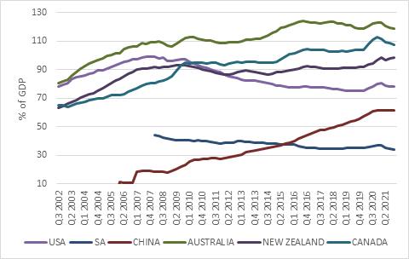

Source: Bank for International Settlements

Countries like Australia, Canada and New Zealand are magnets for immigrants, potentially supporting long-term demand for housing. However, all three have seen household debt levels rise to uncomfortably high levels in recent years. In other words, it is not just a growing population but also an expansion in debt that sits behind the rising prices. And the more prices rise, the more people are willing to borrow and the more the banks are willing to lend. Will the sharp increase in interest rates turn this process into reverse? Time will tell, but the possibility is real.

In a place like Japan, the shrinking population means that there are too many homes, especially in rural areas. One estimate puts the number of abandoned homes in Japanese villages at more than 8 million. Of course, Japan’s epic real estate bubble burst as long ago as 1990, and the level of house prices has not recovered since. The aftermath of the bubble’s bursting cast long shadows over the finances of Japanese banks, households and corporations, contributing to the lost decades that plagued its economy. This is often the case when property booms end. A popping real estate bubble is far more damaging than any other asset class.

This brings us to China, where both cyclical and structural problems collide. With the economy under pressure from Covid-lockdowns, it is no wonder that the property market is struggling. However, the bigger problem is that vast overbuilding combined with a declining population and excessive debt among property developers has all the ingredients for a Japan-style implosion. The only good news is that Chinese authorities are acutely aware of what happened next door, and the current weak patch in the property sector was indeed brought on by attempts to force developers to scale back risky behaviour. Also, unlike in most other property bubbles, the debt mostly sits on the balance sheets of developers, not households. Household borrowing has increased in recent years, but is nowhere near the dangerous levels seen in the US before 2008 and the Antipodeans currently.

Back home
In South Africa, housing inflation is also a substantial component of the consumer price index, carrying a 15% total weight. But housing inflation has been low and is likely to remain so, contributing to lower overall inflation rates compared to other emerging markets and even many developed economies. Stats SA put the year-on-year growth in actual rent at 2.4% in July and owners’ equivalent rent at 3%. PayProp, a private rental management firm, also publishes estimates of rental growth, with the latest survey showing 2.7% year-on-year in the second quarter.

There has been some life in the local property market, fuelled by the same decline in interest rates in 2020 and shift to remote work we’ve seen elsewhere. A range of indicators show improved activity, but the picture is not clear and consistent. None of them are near the levels seen at the peak of the pre-2008 boom when adjusted for inflation. Transfer duties are at the highest level in a decade, indicating fairly robust sales activity but building activity indicators remain muted while house prices have barely budged in real terms over the last 12 years. These aggregates do hide regional and city-specific variations, but economists care less about location, location, location than estate agents do.

Chart: Selected housing market indicators for South Africa]
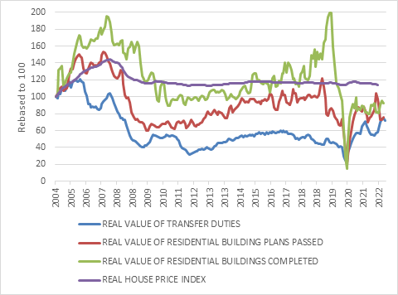

Source: Refinitiv Datastream

With rates now rising and the shift to remote working (including semigration) probably largely a one-off, these supports are fading. Faster economic growth and rising incomes will be needed to sustain “real” demand for housing, building activity, rising house prices and by implication, rental inflation.

Therefore, while inflation in South Africa is well above the Reserve Bank’s target range, it is mostly due to fuel and food prices that are set in global markets, and that the Reserve Bank can do nothing about. Inflation rates of items that are sensitive to domestic demand and interest rates, such as housing, remain muted. This is not the case in the US.

Although domestic inflation is not as high as in many other major economies, the SARB doesn’t operate in a vacuum. As other central banks hike, the SARB will not want to be left too far behind. In the case of the Fed, the most important central bank of all, it is now expected to hike rates north of 4% in the next few months, having started the year at 0%. This sharp increase in the world’s base interest rate is not only influencing housing in the US, but virtually every asset class across our interconnected world. For some investors, this means the return of a crucial missing ingredient over the past decade or so: yield. For others, it means the unwelcome return of volatility. Just remember that volatility also brings opportunities. Trying to time the market by waiting for good news on the economic front and for calm to return has historically meant that investors missed out on the strong rebound, impairing their long-term returns to below what most financial planning principles are based on.

