Report: To accompany the press release
Date: 31 August 2022

Take-home pay slips further in July, but salaries data suggests some more job creation
While the impact of rising inflation should start to moderate towards year-end

The economic realities of both households and businesses were quite challenging in the past few months. Consumer inflation reached a 13-year high at 7.8% in July, the South African Reserve Bank hiked interest rates by a further 75bps, while ongoing electricity supply issues have become part of the ‘new normal’ in South Africa. In light of this background, the nominal BankservAfrica Take-home Pay Index (BTPI) slipped further, indicating that the average nominal South African salary (after deductions) moderated to R14 340 in July, compared to R14 618 in June 2022 and down from the 2022 high of R15 593 reached in February, while still 0.9% lower compared to a year earlier.
Average salaried workers remain strained in this economic environment, especially given the extent of increases in basics like food items and fuel. This is also reflected in the notable 7.6% y/y drop in the real average salary recorded in the BTPI in July. However, as we forecasted that July’s 7.8% headline CPI print will be in the upper turning point of the current inflation cycle, the pressure should start to alleviate somewhat as inflation moderates towards year-end. We forecast that inflation could be around 6.6% by year-end.
Graph 1: Growth in real BTPI vs headline CPI

Sources: BankservAfrica, StatsSA

While the BTPI does suggest that consumers’ average earnings are under severe pressure, we have flagged in recent reports that the BankservAfrica data signalled that more people have been receiving salaries compared to a year ago. The actual data, as reflected in StatsSA’s latest Labour Force Survey, published on 23 August, surprised to the upside, reported a notable 648 000 jobs were created in Q2 (vs Q1’s 370 000), despite the challenging economic environment. The gradual relaxation of COVID-19 restrictions on gatherings, initially from 30 April, and the final removal of all remaining lockdown restrictions, effective from 23 June, clearly provided much-needed support to the local economy and fostered a further recovery in employment opportunities. After adjusting for weekly workers, the BankservAfrica data suggests that this trend is likely to prevail into Q3, though July’s data indicates that the pace of new job creation is likely to moderate somewhat. Thus, although the average nominal salary has been moderating in recent months, probably due to the bulk of new job opportunities evident in the lower income categories, earning a salary in South Africa is still a lot better than being part of the unemployment statistics.

Graph 2: Estimate of number of people receiving salaries (<R100K per month)
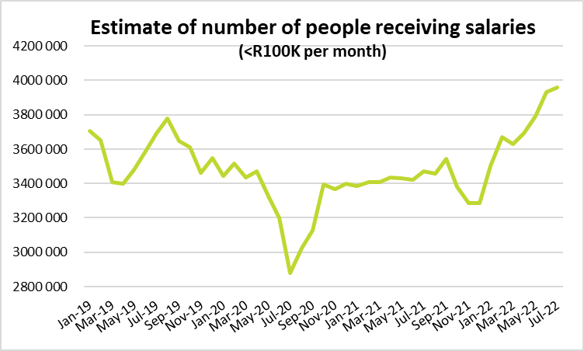
Source: BankservAfrica
While the BTPI and BPPI data are monthly and analysed as such, the focus on rising living costs has accentuated the question of whether salaries in South Africa have kept up with inflation. To answer the question, we have compared the BankservAfrica BTPI data from 2017 to July 2022 to consumer inflation. From graph 3 it is evident that South Africans’ take-home pay (after tax and other salary deductions) managed to keep up with inflation between 2017 and 2021. However, in the first seven months of 2022 (actual data), BankservAfrica’s take-home pay data has lagged on the year-to-date average headline CPI (at 6.4%) and this is the reality that households are currently experiencing.

Graph 3: Headline CPI vs average nominal BTPI (2017=100)
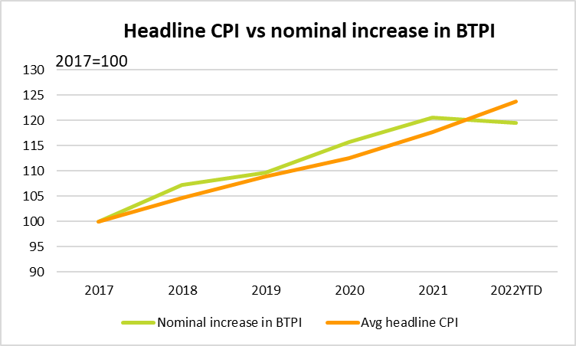
Source: BankservAfrica

Average private pensions have held up well despite rising inflation
The BankservAfrica Private Pensions Index (BPPI) showed that the average nominal private pension reached R10 000 per month for the first time in June and remained above this level in July, representing a 10.9% growth on a year-on-year basis. In real terms, the average real private pension was R9 773 per month, 2.8% higher than a year earlier. Although there were a few monthly real declines recorded in the first half of the year, average real pensions have held up well despite rising inflation, preserving the purchasing power of pensioners. The total take-home pay and private pensions processed in value terms increased by 3.8% in real terms and by 12.0% in nominal terms compared to a year earlier, not seasonally adjusted.

Table 1: The BankservAfrica Take-home Pay Index data
Month | Nominal average take-home pay | Real take- home pay | Nominal BTPI % change YoY | Real BTPI % change YoY | Nominal average pensions paid | Real private pension | Nominal BPPI % change YoY | Real BPPI % change YoY
Jan-21 | 15371 | 16115 | 2.9% | -0.2% | 9072 | 9516 | 12.0% | 8.5%
Feb-21 | 15380 | 16136 | 4.7% | 1.7% | 9064 | 9546 | 8.9% | 5.9%
Mar-21 | 15083 | 15817 | 3.8% | 0.7% | 9023 | 9511 | 8.6% | 5.2%
Apr-21 | 15290 | 16041 | 6.7% | 3.1% | 9083 | 9560 | 10.5% | 5.8%
May-21 | 15003 | 15721 | 4.4% | 0.1% | 8939 | 9411 | 11.5% | 6.0%
Jun-21 | 14879 | 15584 | 4.3% | -0.5% | 9237 | 9542 | 11.7% | 6.5%
Jul-21 | 14473 | 15145 | 4.9% | 0.0% | 9219 | 9503 | 10.8% | 5.8%
Aug-21 | 14905 | 15332 | 8.1% | 3.1% | 9733 | 9713 | 10.1% | 4.9%
Sep-21 | 15395 | 15590 | 9.1% | 4.1% | 9721 | 9712 | 9.7% | 4.5%
Oct-21 | 15415 | 15354 | 1.7% | -3.1% | 9614 | 9600 | 9.5% | 4.3%
Nov-21 | 15299 | 15237 | 0.2% | -4.7% | 9499 | 9447 | 6.6% | 1.1%
Dec-21 | 15520 | 15416 | -0.1% | -5.2% | 9570 | 9484 | 7.1% | 1.1%
Jan-22 | 15522 | 15399 | 1.0% | -4.4% | 9566 | 9493 | 5.4% | -0.2%
Feb-22 | 15593 | 15467 | 1.4% | -4.1% | 9625 | 9594 | 6.2% | 0.5%
Mar-22 | 15055 | 14928 | -0.2% | -5.6% | 9522 | 9474 | 5.5% | -0.4%
Apr-22 | 15301 | 15168 | 0.1% | -5.4% | 9412 | 9355 | 3.6% | -2.1%
May-22 | 14855 | 14672 | -1.0% | -6.7% | 9681 | 9570 | 8.3% | 1.7%
Jun-22 | 14618 | 14365 | -1.8% | -7.8% | 10073 | 9687 | 9.1% | 1.5%
Jul-22 | 14340 | 13990 | -0.9% | -7.6% | 10226 | 9773 | 10.9% | 2.8%
Source: BankservAfrica
About the BTPI
The BankservAfrica Take-Home Pay Index (BTPI) is calculated on a monthly basis by dividing the total value of salaries paid into the bank accounts of employees (excluding salaries greater than R100K per month) by the total number of salary payments. We measure salary payments that are loaded onto the National Payment System (NPS) and paid by an EFT message that gets processed via our systems. These take-home payments typically exclude UIF contributions, as well as personal income tax and employee pension payments (a portion of medical insurance premiums and even debt repayments could be subtracted before earnings are paid into an employee’s bank account). The BankservAfrica salaries data gets adjusted for weekly payments in order to prevent double counting on the number of salaries used to determine the average take-home pay amount. Given that most weekly payments take place on Fridays, Mondays and Thursdays, our process takes note of the number of these particular days, in any given month. Weekly payments are estimated using NPS data as well as the South African Quarterly Labour Force Survey, as published by Statistics South Africa. We have estimated weekly payments at 9.6% of the total number of salaries that gets processed by the NPS. The BTPI reflects the trend in almost 4 million monthly salary payments, which represents about 37% of all non-farm employees (or formal sector) in the South African labour market The BTPI is published as a smoothed seasonally adjusted index, with 2013 as base year.
About BankservAfrica
BankservAfrica is the trusted payments partner and Financial Markets Infrastructure (FMI) to the financial services industry. As the largest automated payments clearing house in Africa we clear and process billions of low value card, ATM and EFT transactions annually. Our role in the South African National Payments System (NPS) is to facilitate interoperability between the banks and ensure regulatory compliance with our regulators against international banking security best practice and standards and reduces risk and complexity in the industry.

We continue to strive to be a world class and pre-eminent payments operator, innovator and payments partner of choice in Africa, by simplifying our worlds through combining trusted transactions with sensitive information.

BankservAfrica’s national responsibility is to provide safe financial payment services for 60.6 million South Africans, irrespective of their location in partnership with our shareholders and partners.

With a 50-year history in South Africa, BankservAfrica operates 24/7, 365 days a year and delivers on very strong SLAs.

