
July 2022 BETI report to accompany press release
Date: 17 August 2022

BETI SIGNALS THE SA ECONOMY WEAKENED IN JULY 2022

The BankservAfrica Economic Transactions Index (BETI) moderated further in July 2022 to an index level of 134.5, notably lower than the all-time high reached just two months ago in May (143.0) and the lowest since February (133.8). On an annual basis, the BETI still increased by 5.6% in July 2022 vs a revised 5.0% in June. However, the annual comparison is partly influenced by a low base of calculation, as the riots in KwaZulu-Natal and Gauteng in July 2021 (while the economy was still subject to some COVID-19 restrictions), depressed the BETI at the time, before recovering again in August 2021.
On a monthly basis, the BETI declined for a second consecutive month by 1.3% in July vs the revised drop of 4.7% in June, signaling strain in the broader economy. The moderation in the BETI on a monthly basis is not unexpected in light of the many headwinds that have surfaced in the local economy over the past few months - from recurring load shedding (particularly intense in July) to the significant rise in fuel, food and general inflation increases. While the index still suggests that the underlying momentum in the economy might have been stronger than generally perceived in Q2 2022, the moderation in July signals a weak start to the third quarter.
Other nowcasting indicators continue to present a mixed picture of the economy. The Absa Purchasing Managers’ Index (PMI) plummeted to 47.6 in July, the lowest since July 2021, and notably lower than June’s 52.2 (a far cry from the 60.0 recorded in March). This dramatic decline suggests that the manufacturing sector is proportionately harder hit by the headwinds compared to the broader economy, as reflected in the BETI and other indicators. The S&P Global South Africa PMI, which reflects activity in the private sector, picked up for a third successive month in July, helped by improving new orders, output and employment numbers. All three metrics signalled the quickest rates of growth since mid-2021, amid reports of improving market demand despite rapid inflationary pressures.
Total new vehicle sales also powered ahead, rising by a significant 31.8% year-on-year in July 2022, partly influenced by a low base, but also reflecting ongoing pent-up post-COVID demand. With the strong July outcome, year-to-date new vehicle sales are 13.9% higher than a year ago. On the confidence side, the SA Chamber of Commerce and Industry’s (SACCI) Business Confidence Index (BCI) stood at 110.3 in July, 1.8 index points higher than in June and 6.1 points higher than in May. The improved sentiment is reportedly a result of increased merchandise export and import volumes and more new vehicles sold. The business confidence index for June and July 2022 indicates that the negative medium-term (year-on-year) business sentiment of May 2022 was replaced by positive developments compared to the same period last year.
Many different and often conflicting signals from high frequency indicators are typical of an economy in a ‘stop-start mode’, unable to gain synchronised momentum across sectors, as the next round of load shedding or some or other headwind, is probably waiting around the next corner. In light of the severity of load shedding and its ongoing negative impact on the economy, the comprehensive interventions announced by President Ramaphosa on 25 July to address the country’s energy crisis is indeed good news and could boost economic growth notably, if implemented with the needed urgency. Furthermore, the notable moderation in international oil prices in recent weeks, have resulted in sizeable fuel price declines already seen in August. Further significant declines forecasted for September (>R2/l) should trigger a much-needed moderation in inflation. As such, July’s forecast headline CPI of around 7.6% should be the upper turning point of the current inflation cycle, trending towards 6.3% in December 2022.

Strong growth in the number of transactions
The standardised nominal value of transactions cleared through BankservAfrica in July 2022 were recorded at R1.127 trillion, while the number of transactions increased to 130.4 million, 6.4% higher than a year ago.
Graph 1: BETI vs SARB Coincident Indicator (q/q growth rates)
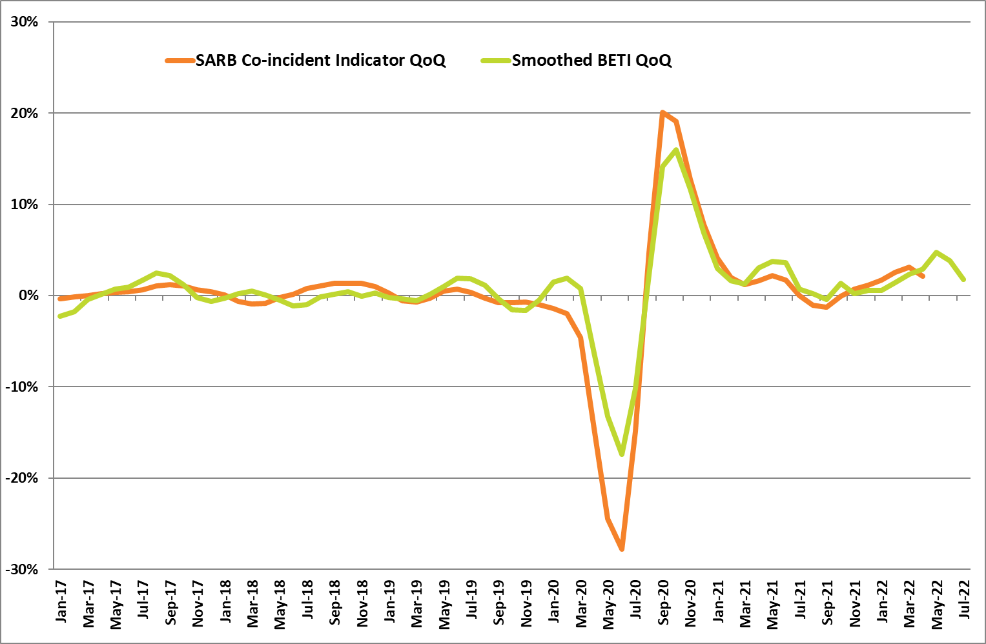
Source: BankservAfrica and Carpe Diem Research

Table 1: The BankservAfrica Economic Transaction Index
 | The BETI Index | The headline BETI % change | BETI quarterly % change | BETI monthly % change
Jan-21 | 124.5 | -1.2% | 2.9% | -0.6%
Feb-21 | 126.2 | 1.6% | 1.6% | 1.4%
Mar-21 | 127.7 | 5.8% | 1.3% | 1.2%
Apr-21 | 131.4 | 26.5% | 3.0% | 2.9%
May-21 | 130.7 | 31.4% | 3.7% | -0.5%
Jun-21 | 129.9 | 26.1% | 3.6% | -0.6%
Jul-21 | 127.4 | 15.0% | 0.7% | -1.9%
Aug-21 | 133.4 | 13.5% | 0.2% | 4.7%
Sep-21 | 129.6 | 6.7% | -0.4% | -2.9%
Oct-21 | 130.1 | 4.7% | 1.3% | 0.4%
Nov-21 | 132.0 | 6.2% | 0.2% | 1.5%
Dec-21 | 130.5 | 4.2% | 0.5% | -1.1%
Jan-22 | 132.8 | 6.7% | 0.6% | 1.8%
Feb-22 | 133.8 | 6.1% | 1.4% | 0.8%
Mar-22 | 135.2 | 5.8% | 2.4% | 1.0%
Apr-22 | 137.8 | 4.9% | 2.9% | 1.9%
May-22 | 143.0 | 9.4% | 4.7% | 3.8%
Jun-22 | 136.4 | 5.0% | 3.8% | -4.7%
Jul-22 | 134.5 | 5.6% | 1.8% | -1.3%
Source: BankservAfrica and Carpe Diem Research

Table 2: The volume and average value of transactions and the standardised BETI in nominal terms
 | Nominal standardised value of transactions | Number of transactions | Average transaction value | Change in transaction volume
Jan-21 | 830 431 229 519 | 99 046 275 | 8084 | 0.5%
Feb-21 | 985 568 635 898 | 105 369 295 | 8671 | 3.6%
Mar-21 | 1 016 197 489 145 | 121 094 342 | 8603 | 17.2%
Apr-21 | 1 034 989 208 808 | 114 992 885 | 8301 | 27.7%
May-21 | 999 971 999 135 | 114 860 839 | 8652 | 24.4%
Jun-21 | 1 000 598 759 677 | 115 994 019 | 8464 | 16.3%
Jul-21 | 971 405 321 598 | 122 534 840 | 8083 | 14.3%
Aug-21 | 1 079 970 334 333 | 139 115 440 | 7738 | 34.3%
Sep-21 | 1 016 856 555 771 | 122 463 947 | 8379 | 16.0%
Oct-21 | 1 036 674 654 205 | 126 082 582 | 8171 | 11.1%
Nov-21 | 1 129 846 454 138 | 127 206 375 | 8715 | 20.6%
Dec-21 | 1 147 364 076 089 | 128 960 377 | 8842 | 9.6%
Jan-22 | 960 782 863 732 | 114 988 683 | 8304 | 16.1%
Feb-22 | 1 122 350 186 710 | 118 715 952 | 8765 | 12.7%
Mar-22 | 1 150 548 182 261 | 131 212 659 | 8965 | 8.4%
Apr-22 | 1 168 029 601 917 | 126 214 672 | 8246 | 9.8%
May-22 | 1 229 315 269 279 | 127 591 161 | 8585 | 11.1%
Jun-22 | 1 121 151 326 630 | 127 572 169 | 8623 | 10.0%
Jul-22 | 1 127 335 386 315 | 130 429 591 | 8590 | 6.4%
Source: BankservAfrica and Carpe Diem Research
*A note on the revisions
The BETI reflects the standardised value of all economic transactions in the South Africa economy at seasonally adjusted real constant prices (2005=100). On an ongoing basis, there are always small differences between previously published index numbers and most recent, given the processes of deflating (to strip out the impact of inflation from the data) and seasonally adjustment (to strip out any seasonal behaviour in the data).
The July 2022 BETI release has been subjected to the usual adjustments that result in revised index and growth numbers.
- Inflation forecasts have been updated with actuals to June 2022
- Seasonal factors were revised and updated to July 2022
Deflating nominal values: The total PPI - or otherwise defined as the PPI for final manufactured goods (25% weighting) in combination with the CPI for all urban areas excluding homeowners rent (75% weighting) - are used to deflate the nominal values to reflect real values. There is a one-month lag period before the inflation data gets released for a certain month, which has the implication that the most recent BETI data point gets deflated by forecast numbers for PPI and CPI excluding homeowners rent. Then in the next month, when the actual PPI and CPI data are available, it impacts the BETI in so far as there are discrepancies between the forecasts used and the actual outcomes of the relevant inflation numbers.
Inflation numbers have been updated to June 2022. The June PPI figure came out notably higher than expected at 16.2% y/y (vs 14.7% in May); market consensus on the day was 15.6%. The June headline CPI figure also came out higher than expected at 7.4% y/y (vs 6.5% in May); market consensus on the day was 7.2%. The higher-than-expected inflation outcomes had an impact on the deflator used in the BETI calculation for June.
Revised seasonal factors: Seasonal adjustment takes place monthly, with seasonal factors been adjusting slightly with each new actual data point becoming available. Revisions impact marginally on historical index values.

