
June 2022 BETI report to accompany press release
Date: 13 July 2022

BETI SIGNALS THE SA ECONOMY MODERATED SOMEWHAT IN JUNE 2022

After a strong reading in May 2022, the BankservAfrica Economic Transactions Index (BETI) moderated somewhat to 5.3% in June 2022 compared to a year ago (vs a revised 9.4% in May). On a monthly basis, the BETI declined by a notable 4.4%, which could be an early indication of further and impending strain on the economy.
Following revisions to the seasonal factors*, the actual index level moderated to 136.7 in June, after an all-time high of 143.0 (revised lower from 143.5) reached in May. The moderation in the BETI is not unexpected in light of the many headwinds that have surfaced in the local economy over recent weeks - from the recurring load shedding (as high as stage 6) to the significant rise in fuel, food and general inflation increases. However, the index still suggests that the underlying momentum in the economy might have been stronger than generally perceived in Q2 2022 as a whole. The BETI still increased by 3.9% compared to the previous quarter.
Other nowcasting indices represented a mixed bag for June. Similar to the BETI, the Absa Purchasing Managers’ Index (PMI) moderated to 52.2 index points compared to 54.8 in May (still lower than the 60.0 recorded in March), suggesting a partial recovery in the manufacturing sector following the impact of the devastating flooding in KwaZulu-Natal in April and ongoing load shedding, among other headwinds. On the other hand, the S&P Global South Africa PMI, which reflects activity in the broader economy, recovered in June, from 50.7 in May to 52.5, the highest index level in just more than a year. New passenger car sales powered ahead, rising by a significant 20.6% year-on-year in June 2022, probably reflecting pent-up post-COVID demand. With the strong June outcome, total new vehicle sales are still 7.6% higher than a year ago. The latter two indicators confirm the BETI’s forecast that the country’s GDP growth in Q2 could indeed emerge stronger than the market’s expectations, when it is published in September.
While the intensity of load shedding hit the economy hard towards the end of June and into July, a number of factors acted as mitigating factors (especially in Q2) and have been cushioning the South African economy from growing negative forces. Although off its peaks, many commodity price levels have remained elevated given the impact of the ongoing conflict between Russia and Ukraine. These high price levels continued to support the mining sector and others such as transport. Furthermore, there has been some job creation in Q1 2022 with the number of employed people increasing by 370 000. This will likely boost consumer spending in subsequent quarters, in combination with the extension of the R350-a-month social relief of distress grant to the FY23 fiscal year.
The relaxation of COVID-19 restrictions on gatherings, from 30 April, already benefitted the sporting, cultural and entertainment industries. In addition, it is likely the tourism, hospitality and accommodation sectors are improving from the continued opening of the economy through the further easing of international travel regulations. With all remaining COVID-regulations repealed on 20 June, a further recovery towards pre-COVID activity levels in some sectors (where restrictions still applied), will support general economic activity in the coming months.
Thus, despite the moderation in the BETI in June, on a quarterly basis, the BETI still increased by 3.9%, signaling a continuation of the strong growth performance of Q1 (note: real GDP growth was recorded at 1.9% q/q, higher than the market consensus and the fastest rate since Q2 2021).

Strong growth in the number of transactions
The standardised nominal value of transactions cleared through BankservAfrica in June 2022 were recorded at R1.121 trillion, while the number of transactions remained elevated at 127.57 million, 10% higher than a year ago.
Graph 1: BETI vs real GDP growth rate (q/q seasonally adjusted)
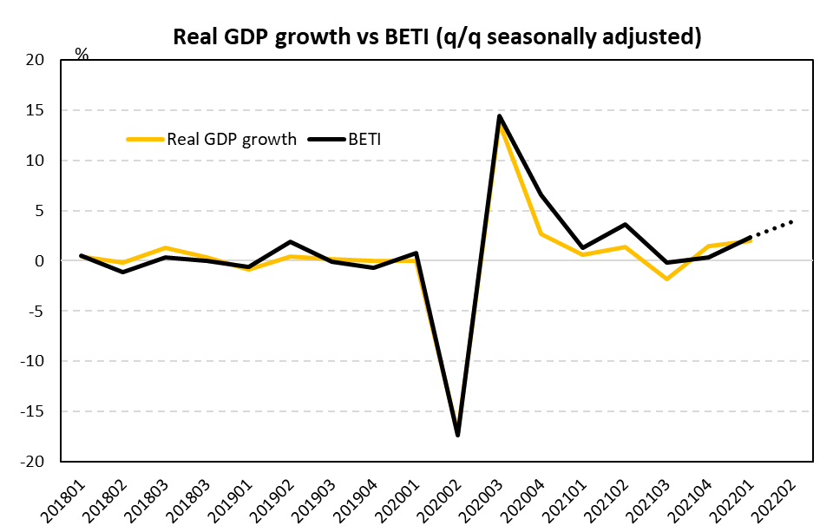
Source: BankservAfrica and Economists.co.za

Table 1: The BankservAfrica Economic Transaction Index
 | The BETI Index | The headline BETI % change | BETI quarterly % change | BETI monthly % change
Jan-21 | 124.4 | -1.2% | 2.8% | -0.6%
Feb-21 | 126.1 | 1.6% | 1.6% | 1.4%
Mar-21 | 127.7 | 5.8% | 1.3% | 1.2%
Apr-21 | 131.3 | 26.5% | 3.0% | 2.9%
May-21 | 130.6 | 31.4% | 3.7% | -0.5%
Jun-21 | 129.8 | 26.1% | 3.6% | -0.6%
Jul-21 | 127.9 | 15.0% | 0.8% | -1.5%
Aug-21 | 133.6 | 13.5% | 0.4% | 4.5%
Sep-21 | 129.7 | 6.7% | -0.2% | -2.9%
Oct-21 | 130.0 | 4.7% | 1.3% | 0.2%
Nov-21 | 131.9 | 6.2% | 0.1% | 1.5%
Dec-21 | 130.4 | 4.2% | 0.3% | -1.1%
Jan-22 | 132.7 | 6.7% | 0.5% | 1.8%
Feb-22 | 133.7 | 6.1% | 1.4% | 0.8%
Mar-22 | 135.1 | 5.8% | 2.4% | 1.0%
Apr-22 | 137.7 | 4.9% | 2.9% | 1.9%
May-22 | 143.0 | 9.4% | 4.7% | 3.8%
Jun-22 | 136.7 | 5.3% | 3.9% | -4.4%
Source: BankservAfrica and Economists.co.za

Table 2: The volume and average value of transactions and the standardised BETI in nominal terms
 | Nominal standardised value of transactions | Number of transactions | Average transaction value | Change in transaction volume
Jan-21 | 830 431 229 519 | 99 046 275 | 8084 | 0.5%
Feb-21 | 985 568 635 898 | 105 369 295 | 8671 | 3.6%
Mar-21 | 1 016 197 489 145 | 121 094 342 | 8603 | 17.2%
Apr-21 | 1 034 989 208 808 | 114 992 885 | 8301 | 27.7%
May-21 | 999 971 999 135 | 114 860 839 | 8652 | 24.4%
Jun-21 | 1 000 598 759 677 | 115 994 019 | 8464 | 16.3%
Jul-21 | 971 405 321 598 | 122 534 840 | 8083 | 14.3%
Aug-21 | 1 079 970 334 333 | 139 115 440 | 7738 | 34.3%
Sep-21 | 1 016 856 555 771 | 122 463 947 | 8379 | 16.0%
Oct-21 | 1 036 674 654 205 | 126 082 582 | 8171 | 11.1%
Nov-21 | 1 129 846 454 138 | 127 206 375 | 8715 | 20.6%
Dec-21 | 1 147 364 076 089 | 128 960 377 | 8842 | 9.6%
Jan-22 | 960 782 863 732 | 114 988 683 | 8304 | 16.1%
Feb-22 | 1 122 350 186 710 | 118 715 952 | 8765 | 12.7%
Mar-22 | 1 150 548 182 261 | 131 212 659 | 8965 | 8.4%
Apr-22 | 1 168 029 601 917 | 126 214 672 | 8246 | 9.8%
May-22 | 1 229 315 269 279 | 127 591 161 | 8585 | 11.1%
Jun-22 | 1 121 151 326 630 | 127 572 169 | 8623 | 10.0%
Source: BankservAfrica and Economists.co.za
*A note on the revisions
The BETI reflects the standardised value of all economic transactions in the South Africa economy at seasonally adjusted real constant prices (2005=100). On an ongoing basis, there are always small differences between previously published index numbers and most recent, given the processes of deflating (to strip out the impact of inflation from the data) and seasonally adjustment (to strip out any seasonal behaviour in the data).
The June 2022 BETI release has been subjected to a number of adjustments that resulted in revised index and growth numbers.
- Inflation forecasts have been updated with actuals to May 2022
- Seasonal factors were revised and updated to June 2022
Deflating nominal values: The total PPI - or otherwise defined as the PPI for final manufactured goods (25% weighting) in combination with the CPI for all urban areas excluding homeowners rent (75% weighting) - are used to deflate the nominal values to reflect real values. There is a one-month lag period before the inflation data gets released for a certain month, which has the implication that the most recent BETI data point gets deflated by forecast numbers for PPI and CPI excluding homeowners rent. Then in the next month, when the actual PPI and CPI data are available, it impacts the BETI in so far as there are discrepancies between the forecasts used and the actual outcomes of the relevant inflation numbers.
Inflation numbers have been updated to May 2022. The May PPI figure came out notably higher than expected at 14.7% y/y (vs 13.1% in March); market consensus on the day was 14%. The May headline CPI figure also came out higher than expected at 6.5% y/y (vs 5.9% in March); market consensus on the day was 6.2%. The higher-than-expected inflation outcomes had an impact on the deflator used in the BETI calculation for May.
Revised seasonal factors: Seasonal adjustment takes place monthly, with seasonal factors been adjusting slightly with each new actual data point becoming available. Revisions impact marginally on historical index values.

