FINAL News Release
Is China about to become a source of global inflation?
With inflation riding high in many developed and emerging markets, we assess the potential risks emanating from China.
David Rees – Senior Emerging Markets Economist at Schroders
15 September 2022

The recent period of red-hot goods inflation has snapped decades of disinflationary pressure since China emerged as a low-cost manufacturer. The nature of the recovery from the Covid-19 pandemic has of course contributed to rampant goods inflation, given that lockdowns skewed demand into the goods sector and interrupted supply chains.

Goods inflation should come down in the near term as these frictions ease. However, it is hard to shake the nagging feeling that we may have reached a turning point and stand on the verge of a new inflation regime. After all, China’s workforce is becoming more expensive, and is set to shrink over the coming years. And supply chain disruptions as a result of China’s zero-Covid policy have only caused trade hawks to call even louder for a reshoring of production.

What could this mean for South Africa?

South Africa’s goods trade deficit with China has averaged about 1.5% of GDP over the past decade, the bulk of which has been made up of manufactured goods. This leaves South Africa vulnerable to a structural increase in the price of manufactured goods from China, as its workforce shrinks and wages increase. All else equal, higher goods import costs would see South Africa’s external position deteriorate, adding to pressure on the rand. Firms would face the tough decision of absorbing higher costs into their margins, or passing on price hikes to consumers and fuelling inflation. So, should we worry about a wave of higher prices from China unsettling South Africa’s economy and markets in the years ahead?

The evolution of inflation over the last century

The global economy has been through many regimes of high and low inflation over the past century as economic booms and busts, wars, and changes in policy regimes, have exerted pressure on prices (chart 1). The Covid-19 pandemic has brought to an end a particularly long period of low inflation that began in the 1990s as a confluence of factors weighed on price pressures.

Central banks made controlling inflation their primary goal, commodity supply shocks during the 1970s eased while tighter policy and the breakup of trade unions helped to stem second round effects from prior price increases. The global financial crisis was a major deflationary bust, while reforms in emerging markets (EM) have brought to an end periodic currency crises that often fuelled bouts of high inflation.

Chart 1: Global inflation, 1900 – 2022

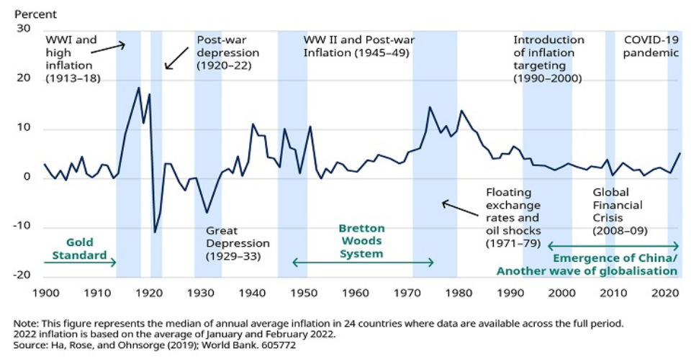

Globalisation also played an important role in snuffing out inflation, particularly the emergence of China as a major low-cost manufacturing hub. According to the World Bank, trade rose from about 25% of global GDP in 1970 to a peak of around 60% of GDP in the mid-2000s as global supply chains moved East to take advantage of a large pool of cheap labour.

In 1995, China had a working age population of 830 million people. This was almost double the combined working age population in the G7 at the time, which was increasing by about 10 million workers each year. And that labour was extremely cheap. Estimates by Oxford Economics show that workers in China’s manufacturing sector received an average wage of 40 cents per hour in 1995, equivalent to just 2% of the average hourly rate of US$17 paid across the G7.

Accession to the World Trade Organisation (WTO) in the early-2000s lowered traded barriers and proved to be the catalyst for a period of supercharged export-led industrialisation, as more and more firms relocated production to China in order to take advantage of low production costs. As charts 2 and 3 show, that put downward pressure on global goods prices. For example, until recently, US goods import prices have been very stable since the mid-1990s. As the world gorged itself on cheap imports, China was able to move to the centre of global supply chains as it hoovered up market share.

Chart 2: US import prices have been very stable in recent decades

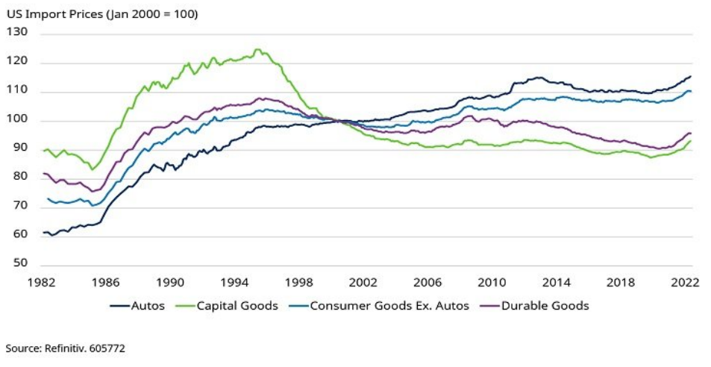

Chart 3: China has gained a large share of the world export market

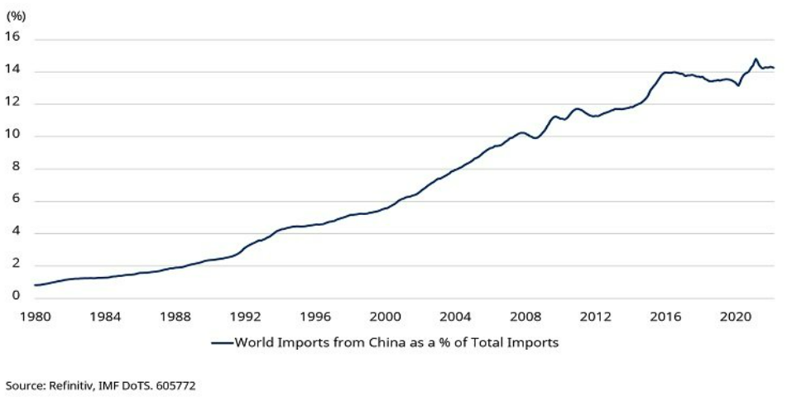

Looking ahead, though, there are concerns that this reliance on China will see the deflationary drag go into reverse. After all, China’s working age population is expected to shrink significantly in the coming years, while rapid wage growth means that labour is no longer as cheap as it once was, and the government’s policy of “common prosperity” threatens to drive wages even higher. Meanwhile, these structural changes are happening against a backdrop of more hawkish trade policies towards China that threaten to break up supply chains.

Should we worry about a new inflation regime driven by higher goods prices from China?

It is worth noting from the outset that labour market data tend to be poor in most EM and China is certainly no exception. However, there seems to be little doubt that wages in China have increased dramatically in recent years, meaning that it is no longer the ultra-cheap source of labour it once was. Indeed, estimates by Oxford Economics show that wages in manufacturing have risen by a staggering 1700% in US-Dollar terms in the past 25 years.

But as chart 4 shows, those headline figures are far less scary when viewed in a global context. Wages remain significantly lower than in developed markets and are not much higher than those in large EM such as India and Mexico that compete with China.

Chart 4: Wages in China remain relatively low despite rapid increases

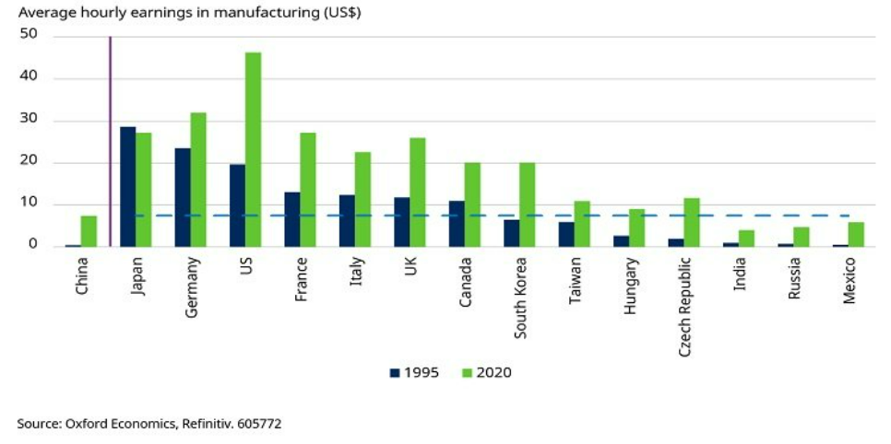

What’s more, in contrast to other EM such as Mexico that have seen similar increases in earnings, wage growth in China appears to have been justified in large part by rapid increases in productivity. We do not have reliable, long-run data on productivity in manufacturing across the emerging world. But if estimates of total economy productivity are anything to go by, then productivity growth in China has comfortably outstripped that seen in many other EM in recent decades (chart 5). In other words, workers in China have been paid more for producing more goods, keeping unit labour costs down and in the process becoming even more competitive relative to other EM.

Chart 5: Wage growth in China has been justified by higher productivity

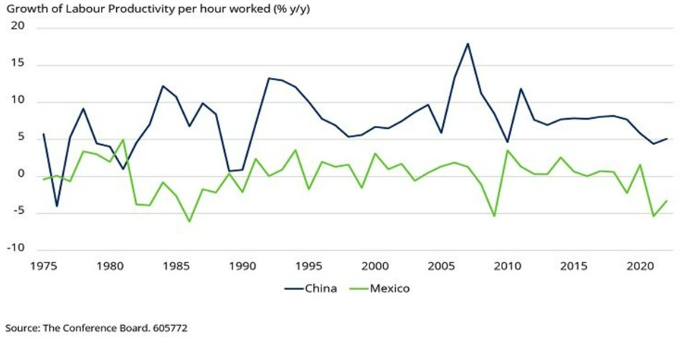

Data deficiencies make it hard for us to categorically verify this dampening effect on production costs, but the proof appears to be in the pudding. Despite rapid wage growth, China’s ultra-competitiveness has allowed it to hoover up an ever-increasing share of the world export market with no obvious inflationary impact on global goods prices.

Viewed another way, the household share of income has remained low relative to the rest of the world, helping to keep output costs down (chart 6). It is worth noting that this has been the key reason why government attempts to rebalance domestic demand away from investment and towards consumption have failed.

Chart 6: The household share of income in China remains relatively low

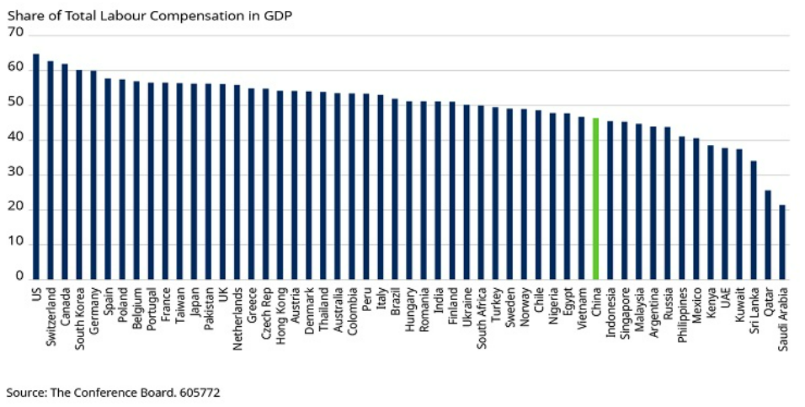

Prioritising external competitiveness and gaping income inequality ultimately gave rise to the government’s new policy of “common prosperity” that emerged during the large package of economic and regulatory announcements in 2021. And what common prosperity means in practice will have a major bearing on the outlook for global inflation.

Why common prosperity may be important for global inflation

If common prosperity leads to centrally-mandated increases in wage growth that far exceed productivity, then it could spell trouble. There are plenty of examples of EM, notably in Latin America, that have pushed wages higher than levels justified by productivity. Rising labour costs have historically tended to cause external competitiveness to deteriorate, resulting in import substitution and the destruction of domestic industry.

In the long run, such a scenario would be likely to cause production to shift to other, more competitive markets elsewhere such as Vietnam. We will come back to this later. However, in the short term, China’s dominance in many industries would make it difficult for consumers to quickly diversify their supply to other countries, resulting in higher global goods prices.

Beijing’s raft of reforms last year did include measures to improve working conditions and rates of pay in the gig economy. For example, the ride hailing company Didi increased its commission for drivers by 50%. Given that drivers are unlikely to be able to increase the number of trips they complete, this is exactly the kind of productivity-busting pay increases that could cause inflationary pressures to build.

The risk of rapid wage growth in excess of productivity clearly needs to be monitored closely, but it is not something we expect to happen. Recent reforms to the gig economy should be seen in the context of increased global regulation of new industries that is not necessarily an indication of the future direction of policymaking in China. Indeed, in the UK employees of ride-hailing companies have also won better employment conditions.

And if anything, most of the other recent reforms announced by the government have remained consistent with trying to raise income levels and living standards through economic development and the redeployment of capital away from unproductive sectors such as real estate into new and emerging industries. This is more consistent with past policies and slogans such as “dual circulation” and “made in China” which have all relied on maintaining external competitiveness and internalising more value-added in order to raise incomes. The jury is out on whether these policies will succeed in boosting disposable income and consumption in the future, but they are unlikely to result in a major inflationary impulse.

What about a shrinking labour force though? Surely if China runs out of workers, they will be able to bid-up their wages and override all these top-down policies?

There is little doubt that China’s working age population, defined as the number of people aged 15-64, will shrink in the coming years. Despite the lifting of the one child policy in 2016, China’s low birth rate means that we have a pretty good idea of how things will pan out and most projections anticipate that the workforce will shrink by more than 10% over the next two decades (chart 7).

Chart 7: China’s working age population will shrink in the years ahead

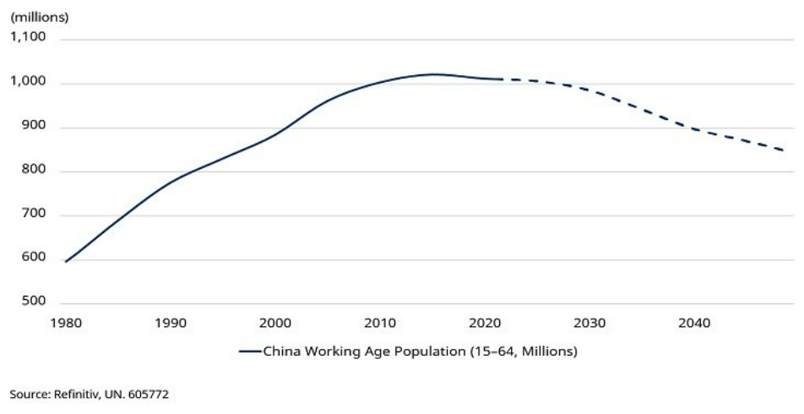

However, it is not clear that a decline in China’s working age population will mechanistically put upward pressure on local wages and global goods prices.

In the short run, if we look at the contributions to growth from the supply side of the economy it becomes clear that labour has not been an important input for some time (chart 8). Productivity has been key. If anything, labour has already been a slight drag on growth in recent years with no apparent impact on output prices and so some mild near-term declines in the number of workers shouldn’t make much of a difference.

Chart 8: Labour has not been driving China’s economy for some time

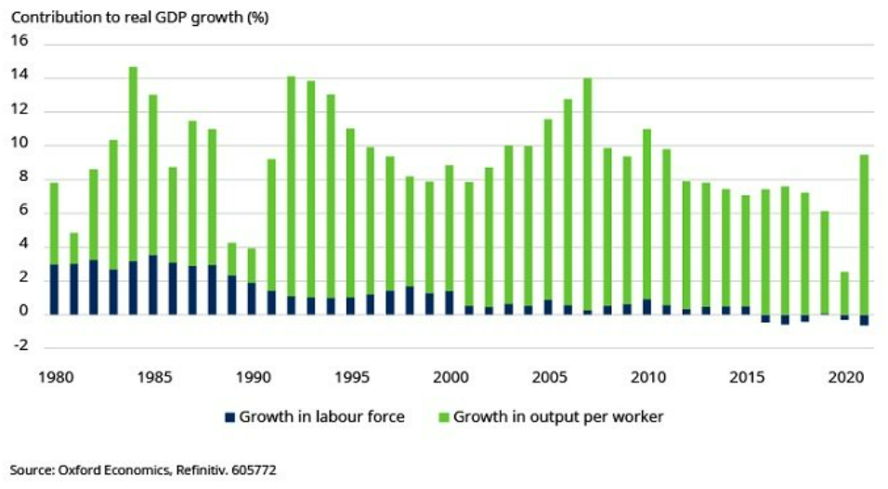

There is a lively debate about whether a more significant decline in the number of workers will drive-up output prices in the longer term. While some commentators such as Goodhart & Pradhan argue that declining populations will be inflationary, many argue that there will no impact on prices.

We are not going to get into the depths of that debate here. But it is worth noting that there are real world examples of economies that have suffered declines in the size of their working age populations without any apparent impact on output prices, or inflation, either at home or in the rest of the world. Japan is an obvious case for comparison given that it is a major exporter in Asia that has long suffered from a declining population.

We don’t know the counterfactual of the fact that Japan has been able to shift production to China of manufactured goods, something that China would struggle to do in great scale given its sheer size. However, what is clear is that a decline in the workforce has had no obvious impact on prices in Japan and that deflation remains a persistent threat. From the point of view of the workforce, hidden slack in the labour market has been one factor that has helped to offset the declining number of workers and prevent upward pressure on wages and output prices. In particular, as chart 9 shows, the participation rate of female workers rose substantially from around 55% through the 1990s and early 2000s to above 70% today.

Chart 9: Rising female participation offset Japan’s shrinking workforce

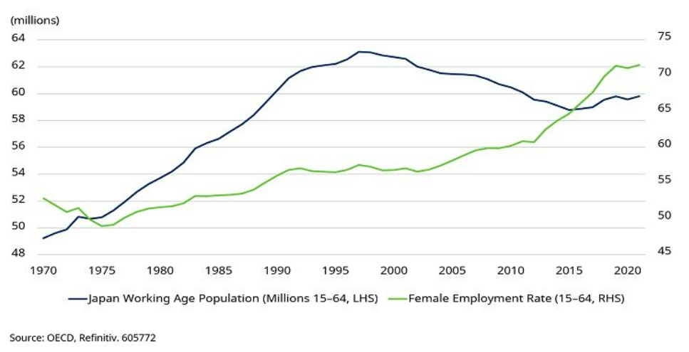

China is unlikely to be able to perform the same trick given that female participation is high relative to many of its peers (chart 10).

Chart 10: China already has high female participation

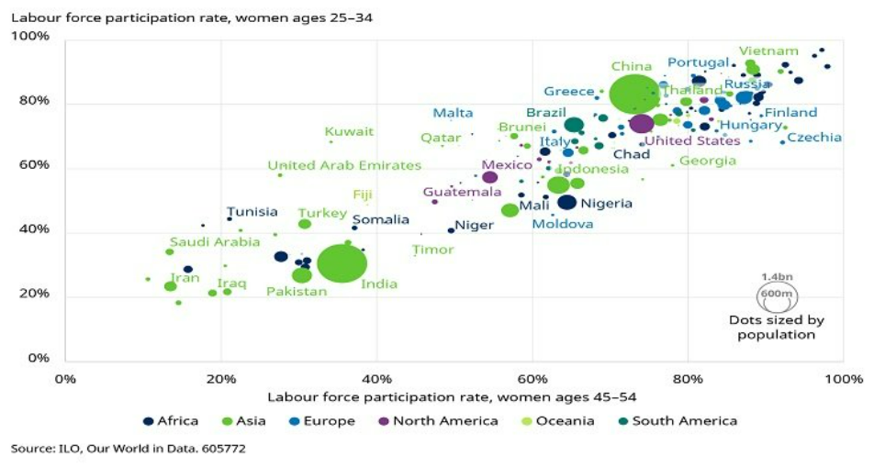

Could there be hidden slack in other parts of China’s labour market?

Construction has been a major source of employment in the past but seems destined to play a less important role in future growth after the recent change in direction of economic policymaking. Another consequence of a shrinking population is that China does not need to sustain rapid housebuilding, and this will free-up workers.

In addition, most estimates indicate a high degree of informality in China’s labour market with some reporting that as many as half of all workers operate in the shadow economy. Reallocating labour is never a smooth process. Not all workers are mobile or possess the required skills to enter new industries. However, absorbing these workers is likely to remain a downward pressure on earnings and could see labour shift into more productive sectors.

Chart 11: There is hidden slack in China’s large informal sector

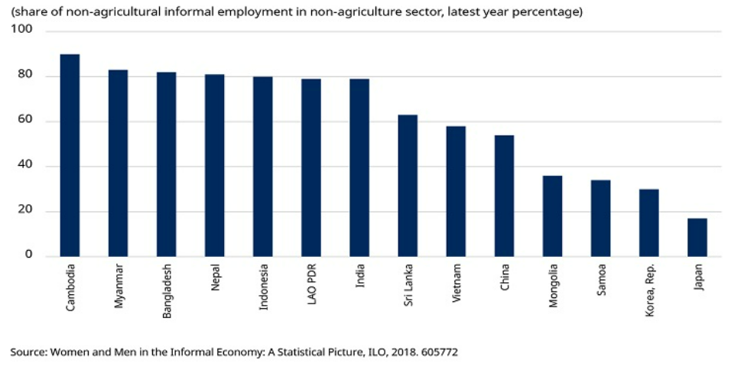
https://blogs.imf.org/2020/04/30/a-new-deal-for-informal-workers-in-asia/#post/0
Of course, all of this is at the aggregate level – surely there must be some threat to labour-intensive sectors that operate on thin margins and cannot easily be automated? It is hard to raise productivity in labour-intensive sectors and this could be exacerbated by a shrinking workforce. As it happens, this would be a long-term issue regardless of demographics as wages could be dragged up by gains elsewhere in the economy.
The clothing and footwear sectors are obvious labour-intensive industries that could be candidates for inflationary pressures to emerge in this regard but delving into the data shows that a transformation here is already happening. Indeed, as charts 12 and 13 show, China’s share of global textiles exports has already peaked, at around 40% in 2015, with other EM such as Vietnam and Bangladesh picking up market share ever since. A similar trend got underway even earlier in the footwear sector.

Charts 12 and 13: Labour-intensive industries have already been leaving China in search of cheaper labour
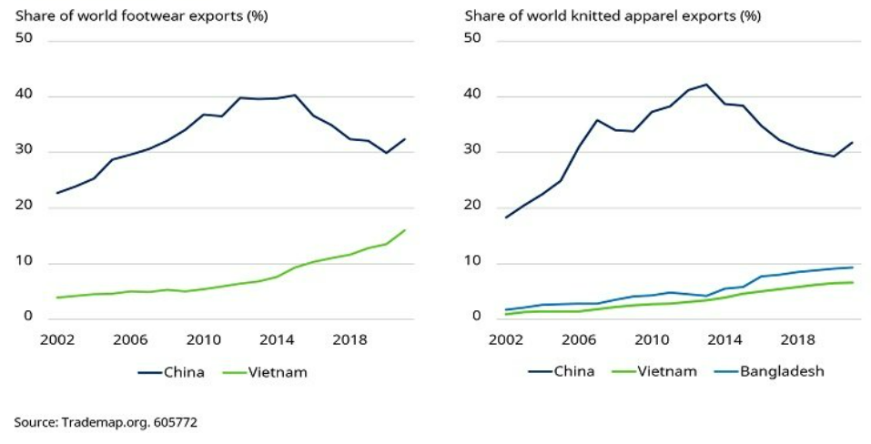
In other words, production in these labour-intensive sectors has already been shifting in reaction to higher labour costs in China. As chart 14 shows, this has kept global prices low – clothing and footwear prices have barely increased in recent decades – and as we discovered in our work on US-China decoupling there is still a huge, untapped supply of cheap labour around the emerging world that could continue to exert downward pressure on global goods prices for some time.

Chart 14: Clothing and footwear prices have barely changed in the US
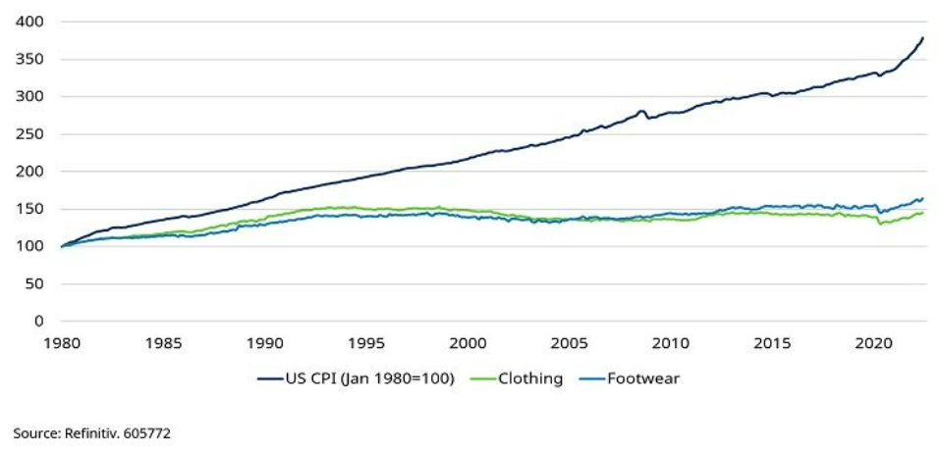
Why geopolitics remains the key global inflation risk
The obvious risk here is that geo-political tensions cause globalisation to go into reverse. US trade policy turned far more hawkish under President Trump as tariffs on Chinese goods were put in place in a bid to encourage firms to diversify their supply chains to other countries or bring production back onshore.
Trade tariffs do not appear to have been successful. However, disruption to global supply chains during the Covid-19 pandemic and the fault lines opened up by Russia’s invasion of Ukraine have only caused those calls for greater supply chain security to grow louder and there is some evidence that companies have begun to move out of China. Moving production, or even just setting up regional manufacturing hubs, comes with a cost that firms with pricing power could pass on to consumers. This is the big threat to global goods prices, not China’s labour market.
In summary, fears that rapid wage growth and shrinking population mean that China will drive a new global inflation regime are probably overdone. Past wage gains have been justified by increased productivity, meaning that China’s workforce remains extremely competitive. Unless common prosperity leads to large wage increases far in excess of productivity, this is unlikely to change. Hidden slack in the labour market should prevent wages from rocketing even as the working age population shrinks.
Labour-intensive industries where productivity cannot easily be increased are most vulnerable to rising wages. However, these sectors have been shifting production to even lower cost countries for some time and there remains a large pool of cheap labour across the emerging world. Instead, the bigger risk to global inflation is that hawkish trade policies mean that supply chains are broken up and relocated to less competitive markets for political reasons.
Important Information
For professional investors and advisers only. The material is not suitable for retail clients. We define "Professional Investors" as those who have the appropriate expertise and knowledge e.g. asset managers, distributors and financial intermediaries.
Any reference to sectors/countries/stocks/securities are for illustrative purposes only and not a recommendation to buy or sell any financial instrument/securities or adopt any investment strategy.
Reliance should not be placed on any views or information in the material when taking individual investment and/or strategic decisions.
Past Performance is not a guide to future performance and may not be repeated. The value of investments and the income from them may go down as well as up and investors may not get back the amounts originally invested. Exchange rate changes may cause the value of investments to fall as well as rise.
The views and opinions contained herein are those of the individuals to whom they are attributed and may not necessarily represent views expressed or reflected in other Schroders communications, strategies or funds.
Information herein is believed to be reliable but Schroders does not warrant its completeness or accuracy.
Issued in September 2022 by Schroders Investment Management Ltd registration number: 01893220 (Incorporated in England and Wales) which is authorised and regulated in the UK by the Financial Conduct Authority and an authorised financial services provider in South Africa FSP No: 48998

-ENDS-
For further information, please contact:
Melissa Man, PR Senior Account Manager | +2783 727 3988 | melissa.man@mslgroup.com
Jani Roodt, PR Account Director | +27 82 802 6110 | jani.roodt@mslgroup.com
Katie Hurwitz, PR Senior Account Director | +2776 427 5428 | katie.hurwitz@mslgroup.com
Schroders plc
Founded in 1804, Schroders is one of Europe’s largest independent investment management firms by assets under management. As at 31 December 2021, assets under management were £731.6 billion (€871.3 billion; $990.9 billion). The founding family remain a core shareholder, holding approximately 48% of the firm’s voting shares. Schroders has continued to deliver strong financial results. It has a market capitalisation of circa £8 billion and employs over 5,700 people across 37 locations.
Schroders has benefited from the most diverse business model of any UK asset manager by geography, by asset class and by client type. Schroders offers innovative products and solutions across their five business areas of solutions; institutional; mutual funds; private assets & alternatives; and wealth management. Clients include insurance companies, pension schemes, sovereign wealth funds, endowments and foundations. They also manage assets for end clients as part of their relationships with distributors, financial advisers and online platforms. Schroders’ Wealth Management offering reflects their strategic ambition to provide wealth management and financial planning services to clients across the wealth spectrum.
Schroders’ strategic aims are to grow their asset management business, build closer relationships with end clients and expand their private assets and alternatives business. Schroders’ purpose is to provide excellent investment performance to clients through active management. The business channels capital into sustainable and durable businesses to accelerate positive change in the world. Schroders’ business philosophy is based on the belief that if we deliver for clients, we deliver for Shareholders and other stakeholders.
Issued in September 2022 by Schroders Investment Management Ltd registration number: 01893220 (Incorporated in England and Wales) which is authorised and regulated in the UK by the Financial Conduct Authority and an authorised financial services provider in South Africa FSP No: 48998. For regular updates by e-mail please register online at www.schroders.com for our alerting service.

