
May 2022 BETI report to accompany press release
Date: 20 June 2022

BETI SIGNALS THE SA ECONOMY PICKED UP NOTABLY IN MAY 2022

The economy seems to have shrugged off the moderation evident in April 2022 and powered ahead in May 2022. The BankservAfrica Economic Transactions Index (BETI) increased by a significant 9.9% in May 2022 compared to a year ago (vs a revised 4.9% in April). This is the highest level since August 2021.
Following revisions to the seasonal factors*, the actual level reached an all-time high at 143.5. The strong number was unexpected in light of the many headwinds that surfaced in the local economy over recent weeks. However, the BETI suggests that the underlying momentum in the economy might be stronger than generally perceived.
Other nowcasting indices also recovered in May, off the low base of April, with the Absa Purchasing Managers’ Index (PMI) increasing to 54.8 index points compared to 50.7 in April (but still lower than the 60.0 recorded in March), suggesting a partial recovery in the manufacturing sector, a sector particularly hard hit by disruptions following the devastating flooding in KwaZulu-Natal in April. The S&P Global South Africa PMI, which reflects activity in the broader economy, also recovered marginally in May, from 50.3 in April to 50.7, while new car sales rose by 13.8% y/y in May 2022. By the end of May, the total new vehicle sales in SA stood at 212 537 units, 12.2% higher than a year ago.
Factors that have probably been cushioning South Africa’s economy from negative forces (among others intermittent load shedding, higher fuel prices and rising inflation and interest rates) include:
- Commodity price levels remaining elevated for a longer period given the impact of the ongoing conflict between Russia and Ukraine. These high price levels have supported the mining sector and other related sectors like transport.
- Some job creation in Q1 2022, with the number of employed people increasing by 370 000, this will boost consumer spending in subsequent quarters.
- The recent lifting of stringent lockdowns in China, which placed global supply chains under renewed strain during April.
- The relaxation of COVID-19 restrictions on gatherings - from 30 April - which benefitted the sporting, cultural and entertainment industries. In addition, the continued opening of the economy through the further easing of international travel regulations should benefit the tourism, hospitality and accommodation sectors.
- The extension of the R350-a-month social relief of distress grant to the FY23 fiscal year, effectively placing about R44 billion into the hands of low-income households.
- A gradual uptick in gross fixed capital formation with Q1 2022 being the second consecutive quarter that real growth was recorded (3.6% q/q seasonally adjusted vs 1.6% in Q4 2021), leading to the likely multiplier effects via higher demand for manufactured goods and transportation services, higher employment and a potential lift in the economy’s growth potential.

The BETI has indeed correctly signalled the strong Q1 GDP growth outcome. Quoting from the March BETI report, released on 13 April: The quarter-on-quarter seasonally adjusted increase for the BETI was 2.4%, indicating that the first-quarter GDP will be a strong positive. “Based on these figures, we believe that South Africa’s economic GDP figures for Q1 2022 will increase at its fastest rate since Q2 2021,” said the late BETI economist, Mike Schüssler.
Indeed, the Q1 real GDP growth at 1.9% is higher than the market consensus and the fastest rate since Q2 2021. The economy has also in Q1 2022, at last, recovered to its pre-COVID production level, but is notably lagging in comparison to the other emerging and developing countries.
The strong May 2022 BETI does signal a continuation of the strong growth performance of Q1, which would be an encouraging outcome for an economy in dire need of sustained growth that could, in time, lead to more job opportunities and a dent in the highest unemployment rate in the world.

Strong growth in the number of transactions
The standardised nominal value of transactions has reached an all-time high of R1.229 trillion in May 2022. Meanwhile, the number of transactions remained elevated at 132.9 million, the third-highest number yet recorded in a month and 15.7% higher than a year ago.
Graph 1: BETI vs real GDP growth rate (q/q seasonally adjusted)
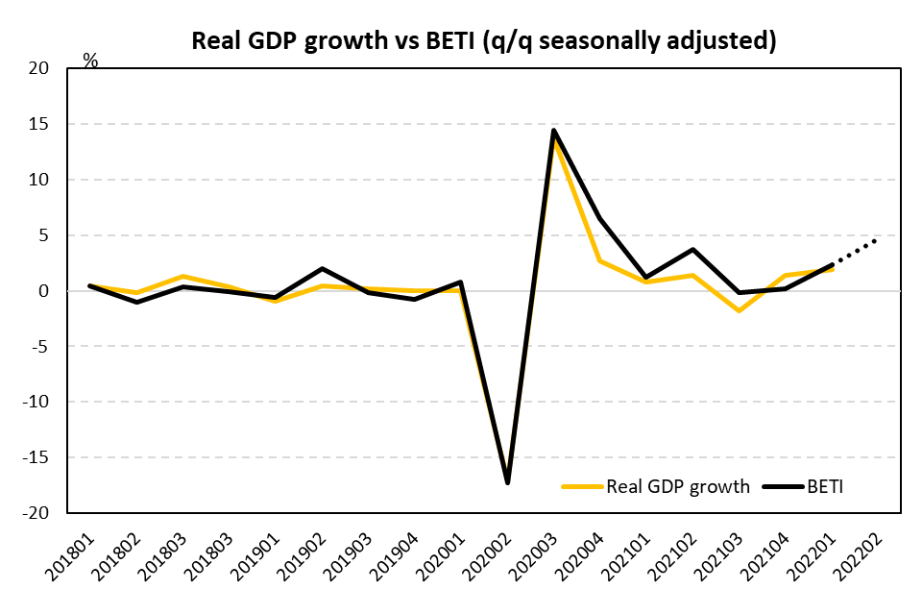
Source: BankservAfrica and Economists.co.za

Table 1: The BankservAfrica Economic Transaction Index
 | The BETI Index | The headline BETI % change | BETI quarterly % change | BETI monthly % change
Jan-21 | 124,3 | -1,2% | 2,8% | -0,6%
Feb-21 | 126,0 | 1,6% | 1,6% | 1,4%
Mar-21 | 127,6 | 5,8% | 1,3% | 1,2%
Apr-21 | 131,2 | 26,5% | 3,0% | 2,9%
May-21 | 130,5 | 31,4% | 3,7% | -0,6%
Jun-21 | 130,2 | 26,0% | 3,7% | -0,2%
Jul-21 | 128,0 | 15,0% | 1,0% | -1,7%
Aug-21 | 133,6 | 13,5% | 0,7% | 4,4%
Sep-21 | 129,6 | 6,7% | -0,2% | -3,0%
Oct-21 | 129,9 | 4,7% | 1,1% | 0,2%
Nov-21 | 131,8 | 6,2% | -0,1% | 1,5%
Dec-21 | 130,3 | 4,2% | 0,2% | -1,1%
Jan-22 | 132,7 | 6,7% | 0,4% | 1,8%
Feb-22 | 133,7 | 6,1% | 1,4% | 0,8%
Mar-22 | 135,0 | 5,8% | 2,4% | 1,0%
Apr-22 | 137,6 | 4,9% | 2,9% | 1,9%
May-22 | 143,5 | 9,9% | 4,9% | 4,3%
Source: BankservAfrica and Economists.co.za

Table 2: The volume and average value of transactions and the standardised BETI in nominal terms
 | Nominal standardised value of transactions | Number of transactions | Average transaction value | Change in transaction volume
Jan-21 | 830 431 229 519 | 99 046 275 | 8084 | 0,5%
Feb-21 | 985 568 635 898 | 105 369 295 | 8671 | 3,6%
Mar-21 | 1 016 197 489 145 | 121 094 342 | 8603 | 17,2%
Apr-21 | 1 034 989 208 808 | 114 992 885 | 8301 | 27,7%
May-21 | 999 971 999 135 | 114 860 839 | 8652 | 24,4%
Jun-21 | 1 000 598 759 677 | 115 994 019 | 8464 | 16,3%
Jul-21 | 971 405 321 598 | 122 534 840 | 8083 | 14,3%
Aug-21 | 1 079 970 334 333 | 139 115 440 | 7738 | 34,3%
Sep-21 | 1 016 856 555 771 | 122 463 947 | 8379 | 16,0%
Oct-21 | 1 036 674 654 205 | 126 082 582 | 8171 | 11,1%
Nov-21 | 1 129 846 454 138 | 127 206 375 | 8715 | 20,6%
Dec-21 | 1 147 364 076 089 | 128 960 377 | 8842 | 9,6%
Jan-22 | 960 782 863 732 | 114 988 683 | 8304 | 16,1%
Feb-22 | 1 122 350 186 710 | 123 706 370 | 8411 | 17,4%
Mar-22 | 1 150 548 182 261 | 137 174 266 | 8575 | 13,3%
Apr-22 | 1 168 029 601 917 | 132 751 465 | 7840 | 15,4%
May-22 | 1 229 315 269 279 | 132 928 553 | 8240 | 15,7%
Source: BankservAfrica and Economists.co.za
*A note on the revisions
The BETI reflects the standardised value of all economic transactions in the South Africa economy at seasonally adjusted real constant prices (2005=100). On an ongoing basis, there are always small differences between previously published index numbers and most recent, given the processes of deflating (to strip out the impact of inflation from the data) and seasonally adjustment (to strip out any seasonal behaviour in the data).
The May 2022 BETI release has been subjected to a number of adjustments that resulted in revised index and growth numbers.
- Inflation forecasts have been updated with actuals to April 2022
- Seasonal factors were revised and updated to May 2022
Deflating nominal values: The total PPI or otherwise defined as the PPI for final manufactured goods (25% weighting) in combination with the CPI for all urban areas excluding homeowners rent (75% weighting) are used to deflate the nominal values to reflect real values. There is a one-month lag period before the inflation data gets released for a certain month, which has the implication that the most recent BETI data point gets deflated by forecast numbers for PPI and CPI excluding homeowners rent. Then in the next month, when the actual PPI and CPI data are available, it impacts on the BETI in so far as there are discrepancies between the forecasts used and the actual outcomes of the relevant inflation numbers.
Inflation numbers have been updated to April 2022. The April PPI figure came out notably higher than expected at 13.1% y/y (vs 11.9% in March); market consensus on the day was 12.2%. The higher-than-expected PPI had an impact on the deflator used in the BETI calculation for April.
Revised seasonal factors: Seasonal adjustment takes place monthly, with seasonal factors been adjusting slightly with each new actual data point becoming available. Revisions impact marginally on historical index values.

