
March 2022 BETI report to accompany press release
Date: 13 April 2022

BETI indicates a strong Q1 2022 for SA’s GDP growth despite higher inflation

The BankservAfrica Economic Transaction Index (BETI) reached a new all-time high in March 2022 of 135.9 index points. The BETI figures correspond to the robust new vehicle sales, the record Absa Purchasing Managers’ Index (PMI), and other well-performing economic sectors.
It would appear that many of the country’s main sectors in the South African economy – except for entertainment, travel and tourism – have recovered from the long-term impact of the Covid-19 pandemic. The local economy has been given a boost by the high commodity prices and large-scale government spending, as some confidence seemingly returns for businesses and consumers.
Moreover, the global rating agencies have recently lifted the negative outlooks for South Africa back to stable. Although the country’s ratings are still below the investment grade, the recent developments mark an end to the downgrading of the country’s ability to pay back debt.
The 6.5% headline BETI change over the last year is very strong, especially when considering that by March 2021, most of the restrictions had been lifted except for some events and capacity restrictions and the late evening curfew. To put the March 2022 BETI into perspective, one notes that March 2021 already saw a 5.8% improvement in the BETI from the year before. Therefore, the March 2022 BETI improvement is not off the low base effect.
While the higher fuel and food prices are expected to hamper consumer and business confidence, the BETI figures for March 2022 suggest economic role players may have pre-empted the increases and made provisional plans for these in February and March.
On a monthly basis, the BETI for March was 1.5%, which was lower than the monthly change of 2.2% in February 2022. The quarter-on-quarter seasonally adjusted increase was 2.4%, indicating that the first-quarter GDP will be a strong positive.
The BETI, which has a very strong correlation with South Africa’s GDP growth and the co-incident indicator of the South African Reserve Bank, forecasts South Africa’s economic GDP for Q1 2022 to have increased at its fastest rate since Q2 2021.
While some sectors could still struggle, the high commodity prices have certainly brought good news for South Africa. Additionally, the country’s inflation rate, at present, is about 200 basis points below that of the world average. This is the first time in 18 years that this has been the case.
While not every sector has benefitted from the high commodity prices, the broader economy is growing strongly. The longer the commodity prices are high, the more the associated sectors will benefit.

With that being said, the Ukrainian crisis has led to a commodities crisis and higher prices. Additionally, inflation is rising above the upper inflation target of 6%. These will slow down the economy and hurt local consumers’ pockets.
But, with the termination of the State of Disaster and most of the Covid-19 restrictions lifted in South Africa, more sectors could start contributing to the country's growth efforts.
Strong growth in the number of transactions
The standardised nominal value of transactions in the BETI reached a new record high of R1.16 trillion in March 2022. The volume of transactions increased to 137.2 million, which is the second-highest number yet recorded in a month in the history of the BETI.
The number of transactions grew by 13.3% which, from a relatively high base, is again an indication of a strong economy.
Graph 1: Quarter-on-quarter percentage change in the BETI and SARB Co-Incident Index
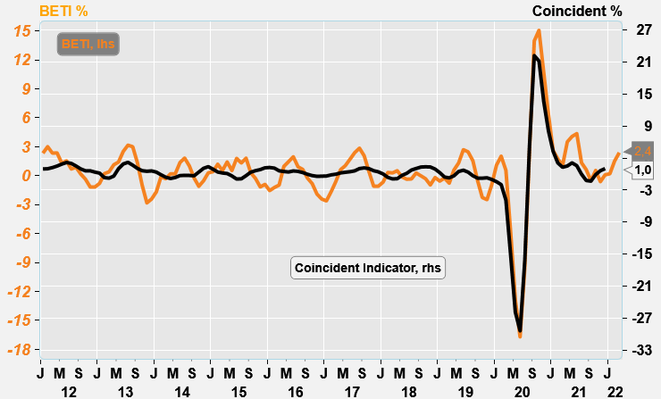
Source: Economists.co.za and BankservAfrica

Graph 2: The BETI and SA’s GDP: quarterly % changes
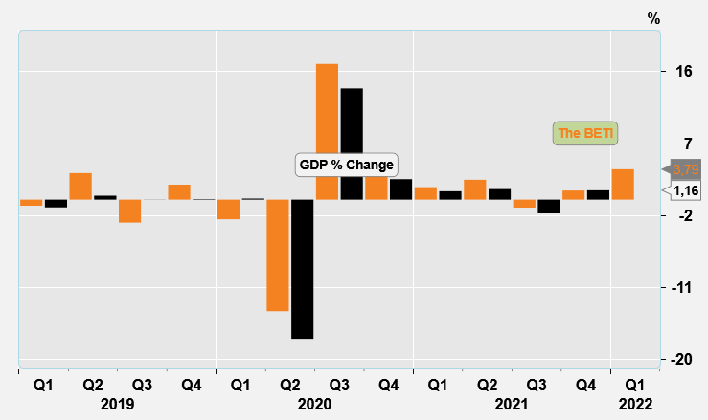
Source: Economists.co.za and BankservAfrica

Table 1: The BankservAfrica Economic Transaction Index
 | The BETI Index | The headline BETI % change | BETI quarterly % change | BETI monthly % change
01-Jan-20 | 124,4 | 3,6% | 1,1% | 0,6%
01-Feb-20 | 124,3 | 2,1% | 2,0% | -0,1%
01-Mar-20 | 120,6 | -0,3% | 0,6% | -3,0%
01-Apr-20 | 103,8 | -15,7% | -5,8% | -13,9%
01-May-20 | 100,0 | -19,6% | -12,9% | -3,7%
01-Jun-20 | 103,8 | -16,9% | -16,7% | 3,8%
01-Jul-20 | 111,4 | -11,2% | -9,6% | 7,4%
01-Aug-20 | 117,6 | -4,9% | 2,6% | 5,6%
01-Sep-20 | 121,4 | 0,0% | 14,0% | 3,2%
01-Oct-20 | 123,6 | 2,0% | 15,1% | 1,8%
01-Nov-20 | 123,5 | 1,0% | 10,7% | -0,1%
01-Dec-20 | 125,7 | 1,7% | 6,4% | 1,8%
01-Jan-21 | 122,9 | -1,2% | 2,6% | -2,2%
01-Feb-21 | 126,3 | 1,7% | 1,7% | 2,8%
01-Mar-21 | 127,7 | 5,8% | 1,1% | 1,0%
01-Apr-21 | 131,2 | 26,4% | 3,5% | 2,8%
01-May-21 | 131,3 | 31,4% | 4,1% | 0,1%
01-Jun-21 | 130,8 | 26,0% | 4,4% | -0,4%
01-Jul-21 | 128,2 | 15,1% | 1,3% | -2,0%
01-Aug-21 | 133,5 | 13,5% | 0,6% | 4,1%
01-Sep-21 | 129,5 | 6,7% | -0,5% | -3,0%
01-Oct-21 | 129,5 | 4,7% | 0,5% | 0,0%
01-Nov-21 | 131,2 | 6,2% | -0,6% | 1,3%
01-Dec-21 | 131,0 | 4,2% | 0,1% | -0,2%
01-Jan-22 | 131,1 | 6,7% | 0,2% | 0,1%
01-Feb-22 | 134,0 | 6,0% | 1,5% | 2,2%
01-Mar-22 | 135,9 | 6,5% | 2,4% | 1,5%
Source: BankservAfrica and Economists.co.za

Table 2: The volume and average value of transactions and the standardised BETI in nominal terms
 | Nominal standardised value of transactions | Number of transactions | Average transaction value | Change in transaction volume
01-Jan-20 | 827 069 468 236 | 98 568 174 | 8339 | 3,2%
01-Feb-20 | 921 749 299 725 | 101 662 462 | 8522 | 4,9%
01-Mar-20 | 891 197 747 730 | 103 280 758 | 8822 | 3,3%
01-Apr-20 | 679 399 945 727 | 90 027 122 | 6960 | -12,9%
01-May-20 | 703 813 457 711 | 92 353 231 | 7348 | -9,1%
01-Jun-20 | 795 028 150 576 | 99 747 038 | 7821 | 6,5%
01-Jul-20 | 842 860 988 641 | 107 166 184 | 8258 | 2,4%
01-Aug-20 | 894 409 284 562 | 103 606 195 | 8388 | -0,7%
01-Sep-20 | 931 179 397 577 | 105 595 111 | 8653 | 5,9%
01-Oct-20 | 948 772 152 278 | 113 464 522 | 8549 | 11,7%
01-Nov-20 | 973 059 693 766 | 105 494 728 | 9051 | 0,7%
01-Dec-20 | 1 039 056 126 408 | 117 705 373 | 8773 | 13,0%
01-Jan-21 | 830 431 229 519 | 99 046 275 | 8084 | 0,5%
01-Feb-21 | 985 568 635 898 | 105 369 295 | 8671 | 3,6%
01-Mar-21 | 1 016 197 489 145 | 121 094 342 | 8603 | 17,2%
01-Apr-21 | 1 034 989 208 807 | 114 992 885 | 8301 | 27,7%
01-May-21 | 999 971 999 135 | 114 860 839 | 8652 | 24,4%
01-Jun-21 | 1 000 598 759 677 | 115 994 019 | 8464 | 16,3%
01-Jul-21 | 971 405 321 598 | 122 534 840 | 8083 | 14,3%
01-Aug-21 | 1 079 970 334 333 | 139 115 440 | 7738 | 34,3%
01-Sep-21 | 1 016 856 555 770 | 122 463 947 | 8379 | 16,0%
01-Oct-21 | 1 036 674 654 205 | 126 082 582 | 8171 | 11,1%
01-Nov-21 | 1 129 846 454 139 | 127 206 375 | 8715 | 20,6%
01-Dec-21 | 1 147 364 076 089 | 128 960 377 | 8842 | 9,6%
01-Jan-22 | 960 782 863 733 | 114 988 683 | 8304 | 16,1%
01-Feb-22 | 1 122 350 186 711 | 118 715 952 | 8765 | 12,7%
01-Mar-22 | 1 156 350 924 486 | 137 174 267 | 8619 | 13,3%
Source: BankservAfrica and Economists.co.za

