Report: To accompany the press release
Date: 28 February 2022

Average take-home pay hits pre-pandemic records
BankservAfrica’s salary index catches up to January 2020 levels

The average South African salary in January 2022 increased at its fastest rate since January 2020, according to the BankservAfrica Take-Home Pay Index (BTPI). Salaries were given a boost by the temporary payments from the November local government elections and payments to December’s seasonal casual workers, which signalled some economic recovery.
Our data estimates show that the number of casual workers in December amounted to around 190 000 – the highest in 33 months – compared to the January 2022 estimate of 112 000. The extra weekly payments in December was also a good indication that some of the previously impacted industries were able to resume business over this period.
As the demand for additional casual workers typically slows down after the December holidays and busy shopping season, the monthly focus for the BTPI returns to the higher-paid permanent and long-term contract workers wages.
The average take-home pay in January 2022 increased by 13% in nominal terms and by 6.6% in real terms. In nominal terms, take-home pay increased to over R17 000 for the first time to reach R17 410. One must, however, remember that the three months from October to December 2021 recorded real declines in take-home pay.
Using the new CPI index (released by StatsSA recently) as a deflator where December 2021 is equal to a hundred, the real BTPI was R17 102, representing a 10.2% increase between January 2022 and December 2021.
The typical take-home pay increased by 3.2% in January 2022 on the back of low-income wages paid in December. The median salary rose to its highest level since February 2021.
BankservAfrica Private Pensions Index decreased slightly in real terms
Banked private pensions declined for the first time in 19 months but by only 0.5% on a year-on-year basis, according to the BankservAfrica Private Pensions Index (BPPI). Incredibly, there have only been eight months where private pensions recorded real declines on an average of 116 months!
The typical private pension measured by BankervAfrica increased by 1% in real terms.
Total salary and private pensions paid reflects strong underlying income trends
The total amount of money paid to South African employees and private pensioners increased by a nominalised 8.9% year-on-year. This suggests a strong start for consumer spending in 2022.
Banked salaries and private pensions increased by a real 3% on a year-on-year basis in January 2022. However, this was off the low January base and declined by 2% in January 2021 on the same annual change basis.
The previous months reflected substantial improvements, but it was only in September 2021 when the real total money paid for salaries and pensions increased above the previous month’s record. This was repeated in December 2021 and again in January 2022.
The overall payments are clear indications for the macroeconomy that consumers are back to receiving pre-pandemic levels of real income. There is one proviso – fewer people are receiving the total amount of their take-home pay than before the pandemic.
Again, we do not wish to make pronouncements on unemployment but our data shows there are fewer people in paid formal sector employment. Although the number of casual payments has improved, the decline in the number of monthly payments is becoming more apparent for reasons such as retrenchments and salary payment declines to airlines, hotel and State-Owned Entity employees where operations have not normalised.
In our opinion, the commodity price boom has greatly helped the country’s employment as the knock-on impact of nearly R300 billion inflows into the economy over the last year has certainly had a positive impact.

Graph 1: Three month rolling average of real take-home pay and private pensions paid
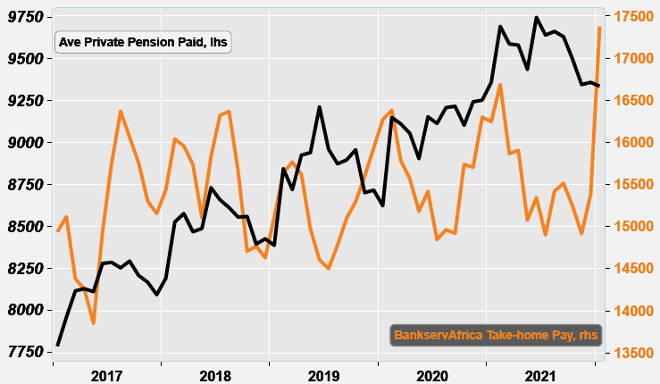
Source: BankservAfrica and economists.co.za

Graph 2: Total take-home pay and private pensions vs retail sales for 2015 – 2021
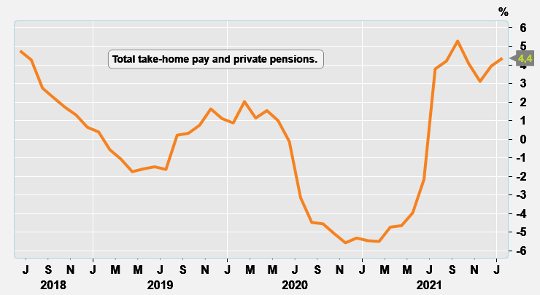
Source: BankservAfrica and economists.co.za

Table 1: The BankservAfrica Take-home Pay Index data
Month | Nominal average take-home pay | Real take- home pay | Nominal BTPI % change YoY | Real BTPI % change YoY | Nominal average pensions paid | Real private pension | Nominal BPPI % change YoY | Real BPPI % change YoY
Jan-20 | 14954 | 16082 | 12,6% | 8,3% | 7925 | 8753 | 7,5% | 3,4%
Feb-20 | 15201 | 15785 | 9,7% | 5,1% | 8492 | 9113 | 8,4% | 3,6%
Mar-20 | 14695 | 15594 | 4,3% | -0,4% | 8483 | 9094 | 8,8% | 3,9%
Apr-20 | 14415 | 15602 | 2,6% | -1,4% | 8386 | 9038 | 4,5% | 0,4%
May-20 | 13969 | 15707 | 3,4% | 0,3% | 8192 | 8914 | 1,6% | -1,4%
Jun-20 | 14262 | 15636 | 7,9% | 5,3% | 8468 | 9088 | 1,6% | -0,4%
Jul-20 | 13911 | 15081 | 5,7% | 3,2% | 8541 | 9153 | 5,0% | 2,7%
Aug-20 | 14050 | 14858 | 4,4% | 1,5% | 8648 | 9220 | 7,0% | 3,7%
Sep-20 | 14026 | 15032 | 1,7% | -1,3% | 8664 | 9243 | 6,7% | 3,5%
Oct-20 | 14840 | 15940 | 6,3% | 3,0% | 8585 | 9147 | 5,0% | 2,0%
Nov-20 | 14810 | 16086 | 3,9% | 0,7% | 8717 | 9319 | 9,6% | 6,1%
Dec-20 | 15386 | 16368 | 5,4% | 2,1% | 8736 | 9326 | 9,4% | 6,1%
Jan-21 | 15402 | 16047 | 3,0% | -0,2% | 8873 | 9509 | 12,0% | 8,6%
Feb-21 | 15919 | 16053 | 4,7% | 1,7% | 9249 | 9622 | 8,9% | 5,6%
Mar-21 | 15248 | 15701 | 3,8% | 0,7% | 9216 | 9610 | 8,6% | 5,7%
Apr-21 | 15381 | 16090 | 6,7% | 3,1% | 9266 | 9675 | 10,5% | 7,1%
May-21 | 14594 | 15723 | 4,5% | 0,1% | 9136 | 9519 | 11,5% | 6,8%
Jun-21 | 14883 | 15556 | 4,4% | -0,5% | 9456 | 9645 | 11,7% | 6,1%
Jul-21 | 14620 | 15078 | 5,1% | 0,0% | 9460 | 9668 | 10,8% | 5,6%
Aug-21 | 15191 | 15326 | 8,1% | 3,1% | 9520 | 9694 | 10,1% | 5,1%
Sep-21 | 15313 | 15645 | 9,2% | 4,1% | 9508 | 9669 | 9,7% | 4,6%
Oct-21 | 15090 | 15447 | 1,7% | -3,1% | 9403 | 9542 | 9,5% | 4,3%
Nov-21 | 14827 | 15330 | 0,1% | -4,7% | 9291 | 9460 | 6,6% | 1,5%
Dec-21 | 15382 | 15510 | 0,0% | -5,2% | 9360 | 9480 | 7,1% | 1,7%
Jan-22 | 17410 | 17102 | 13,0% | 6,6% | 9356 | 9465 | 5,4% | -0,5%
Source: BankservAfrica and economists.co.za

Note to the editor about the BTPI
There have been revisions to the BTPI due to a change in the South African National Payment System (NPS), which now excludes all salary payments from other Southern African Customs Union member countries in the Common Monetary Area (CMA). This occurred for the period from June 2018 onwards. Under the request by the South African Reserve Bank, the CMA payments were removed, and, as such, this needed to adjusted accordingly in the BTPI data set. This means the historical data that included these countries were removed and adjusted. This took place over more than a month. We have therefore undertaken a review of the massive decline in average wages in July 2019 – August 2019. Please also note that due to this, the September 2018 – September 2019 data has been revised and has resulted in minor changes to the 2019 data.

About BankservAfrica
BankservAfrica is the trusted payments partner and Financial Markets Infrastructure (FMI) to the financial services industry. As the largest automated payments clearing house in Africa we clear and process billions of low value card, ATM and EFT transactions annually. Our role in the South African National Payments System (NPS) is to facilitate interoperability between the banks and ensure regulatory compliance with our regulators against international banking security best practice and standards and reduces risk and complexity in the industry.

We continue to strive to be a world class and pre-eminent payments operator, innovator and payments partner of choice in Africa, by simplifying our worlds through combining trusted transactions with sensitive information.

BankservAfrica’s national responsibility is to provide safe financial payment services for 56.7 million South Africans, irrespective of their location in partnership with our shareholders and partners.

With a 49-year history in South Africa, BankservAfrica operates 24/7, 365 days a year and delivers on very strong SLAs.

