Report: To accompany the press release
Date: 23 March 2022

Salary data highlights continuing job recovery for casual and weekly workers
But, the ever-rising inflation rate and Ukraine war impact will reflect in salaries in coming months

The average real take-home salary for February 2022 decreased by 4.1% as the share of casual and weekly workers in the BankservAfrica database continued to climb after the massive 2020/21 Covid-19 pandemic shock.
According to the BankservAfrica Take-home Pay Index (BTPI), the average salary for February was R15 517 on a seasonally adjusted basis in real terms. This is in line with the revised BTPI base, adapted to the CPI in December 2021.
The nominal average take-home pay was 1.3% up and reached R16 022 in February 2022.
The return of cash and weekly workers as inflation takes a toll on salaries
While the BTPI focuses more on the average salary, it makes sense to point out that after the double-digit declines in the casual and weekly wage data estimates for a long period, both these salary bands have now had double-digit growth on a year-on-year basis.
Thus, the actual decline in the average real take-home pay signals a return to work for the more vulnerable groups of lower-paid employees.
We have also adjusted the CPI basis in the BTPI to the new changes by Statistics South Africa, which came into effect in February 2022, which means that the real salary is linked to December 2021. On the subject of CPI, we estimated that the February inflation rate would be 5.7%, which is line with the announcement by Statistics SA this morning. We believe this increase will further aid the decrease in the real take-home pay of formal sector employees paid via the BankservAfrica system.
We expect inflation will stay elevated at over 5% - and even over 6% - for several months. It may mean that take-home salaries will face more than only a few months of declines for a lengthy period, like closer to a year.
The current war between Ukraine and Russia has also impacted major commodity prices - from oil to wheat prices - which will impact inflation in South Africa and globally. As most salary agreements are done retrospectively, take-home pay will take a while to catch up to these developments.
Owing to the higher inflation rate and the crisis in the Ukraine – which has led to soaring oil prices - many are expecting the South African Reserve Bank to hike interest rates at tomorrow’s MPC meeting. Although household borrowing among South Africans has eased to below the inflation rate, the hike could lead to higher mortgage repayments. Together with the escalating food prices and rising fuel costs, this could put South African salaries under even more pressure.
We expect that consumer expenditure, such as retail sales, will continue to grow moderately for the time being and as the economy drives employment again.

Moderate increase expected for consumer expenditure as most jobs recover
While the average take-home pay decreased, the overall take-home totals paid into all the bank accounts of employees increased by 0.6%.
February 2022 was the first time since September 2019 that the total monthly equivalent payments increased to over 4 million again. While this data is very volatile in our database, it tells us that most (probably not all) of the employment from the Covid-19 shock has recovered.
The average private pension increased again above inflation
The average private pension, as tracked by BankservAfrica, increased by 0.5% in real terms to R9 667. This index has also been adjusted to the base period in December 2021, per the CPI base change.
The number of private pensions banked via this system remains relatively stable at around the 650 000 mark.
The seasonally adjusted nominalised private pension in South Africa, as measured by BankservAfrica, was R9 821 from a 6.2% year-on-year increase.

Graph 1: Three month rolling average of real take-home pay and private pensions paid
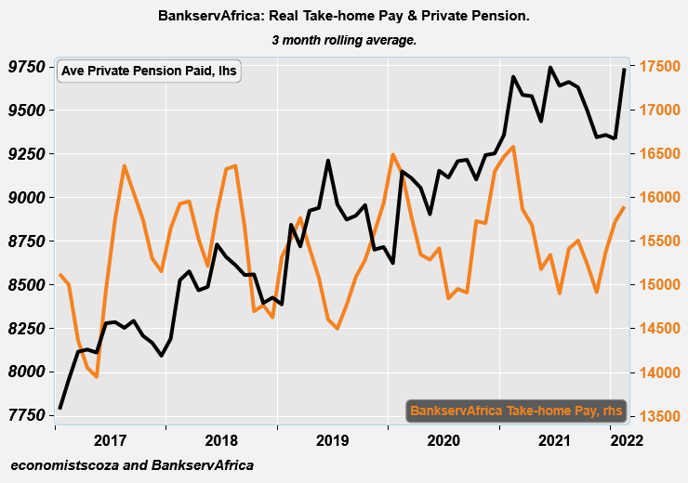
Source: BankservAfrica and economists.co.za

Graph 2: Total take-home pay and private pensions vs retail sales for 2015 – 2022
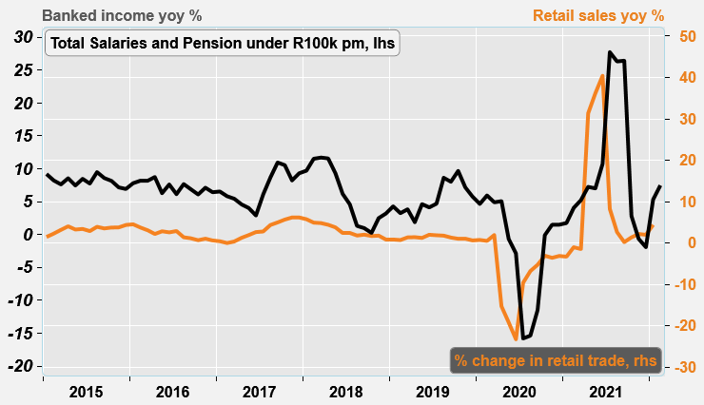
Source: BankservAfrica and economists.co.za

Table 1: The BankservAfrica Take-home Pay Index data
Month | Nominal average take-home pay | Real take- home pay | Nominal BTPI % change YoY | Real BTPI % change YoY | Nominal average pensions paid | Real private pension | Nominal BPPI % change YoY | Real BPPI % change YoY
Jan-21 | 15610 | 16167 | 3,0% | -0,2% | 8873 | 9509 | 12,0% | 8,6%
Feb-21 | 15814 | 16188 | 4,7% | 1,7% | 9249 | 9622 | 8,9% | 5,6%
Mar-21 | 15244 | 15837 | 3,8% | 0,7% | 9216 | 9610 | 8,6% | 5,7%
Apr-21 | 15170 | 16059 | 6,8% | 3,1% | 9266 | 9675 | 10,5% | 7,1%
May-21 | 14695 | 15678 | 4,5% | 0,1% | 9136 | 9519 | 11,5% | 6,8%
Jun-21 | 14883 | 15512 | 4,4% | -0,5% | 9456 | 9645 | 11,7% | 6,1%
Jul-21 | 14620 | 15035 | 5,1% | 0,0% | 9460 | 9668 | 10,8% | 5,6%
Aug-21 | 15182 | 15282 | 8,1% | 3,1% | 9520 | 9694 | 10,1% | 5,1%
Sep-21 | 15305 | 15601 | 9,2% | 4,1% | 9508 | 9669 | 9,7% | 4,6%
Oct-21 | 15081 | 15403 | 1,7% | -3,1% | 9403 | 9542 | 9,5% | 4,3%
Nov-21 | 14827 | 15286 | 0,1% | -4,7% | 9291 | 9460 | 6,6% | 1,5%
Dec-21 | 15382 | 15466 | 0,0% | -5,2% | 9360 | 9480 | 7,1% | 1,7%
Jan-22 | 15755 | 15449 | 0,9% | -4,4% | 9356 | 9465 | 5,4% | -0,5%
Feb-22 | 16022 | 15517 | 1,3% | -4,1% | 9821 | 9667 | 6,2% | 0,5%
Source: BankservAfrica and economists.co.za

Note to the editor about the BTPI
There have been revisions to the BTPI due to a change in the South African National Payment System (NPS), which now excludes all salary payments from other Southern African Customs Union member countries in the Common Monetary Area (CMA). This occurred for the period from June 2018 onwards. Under the request by the South African Reserve Bank, the CMA payments were removed, and, as such, this needed to adjusted accordingly in the BTPI data set. This means the historical data that included these countries were removed and adjusted. This took place over more than a month. We have therefore undertaken a review of the massive decline in average wages in July 2019 – August 2019. Please also note that due to this, the September 2018 – September 2019 data has been revised and has resulted in minor changes to the 2019 data.

About BankservAfrica
BankservAfrica is the trusted payments partner and Financial Markets Infrastructure (FMI) to the financial services industry. As the largest automated payments clearing house in Africa we clear and process billions of low value card, ATM and EFT transactions annually. Our role in the South African National Payments System (NPS) is to facilitate interoperability between the banks and ensure regulatory compliance with our regulators against international banking security best practice and standards and reduces risk and complexity in the industry.

We continue to strive to be a world class and pre-eminent payments operator, innovator and payments partner of choice in Africa, by simplifying our worlds through combining trusted transactions with sensitive information.

BankservAfrica’s national responsibility is to provide safe financial payment services for 56.7 million South Africans, irrespective of their location in partnership with our shareholders and partners.

With a 49-year history in South Africa, BankservAfrica operates 24/7, 365 days a year and delivers on very strong SLAs.

