
November 2021 BETI report to accompany press release
Date: 14 December 2021

BETI indicates SA economy is still (slowly) shrinking

The recorded economic transactions, measured by BankservAfrica, decreased from 127.3 to 125 points in November, the lowest actual level since February 2021.
While we refer to this decrease in the main BankservAfrica Economic Transactions Index (BETI), the annual change in the headline BETI reveals very little of the current circumstances. Meanwhile, there was a 1.7% quarterly decline while the seasonally adjusted real monthly change for the value of transactions shrank by 1.8%.
With four of the last six months recording monthly real declines on a seasonally adjusted basis and with one month recording no change, the current South African economy seems to be declining again.
The actual level of the BETI is the lowest in nine months. The highest point in the BETI level was in August 2021 – a very strong, unusual month featuring a healthy rebound after the July unrest and riots in KwaZulu-Natal and Gauteng. Since August, the overall BETI level has declined by 4.7%.
Possibly, a better way to compare the BETI level is in the six months between May 2021 - November 2021, when the value of transactions declined by 3.2%. This decline from 129.2 to 125 index points illustrates the loss of momentum in recorded economic transactions recorded by BankservAfrica.
The BETI also recorded a quarterly decline in September 2021, when South Africa’s economic GDP data registered a 1.5% fall as reported by Stats SA. The BETI is a good nowcast of the direction of the South African economy. Overall, the BETI indicates that 2021 has been a year of two halves: the first half recording an increasing GDP and the second half reflecting a declining economy.

BankservAfrica processes and settles millions of interbank transactions daily, and therefore provides a good indication of the movements in the South African economy. With this, the BETI September 2021 data predicted the economy's decline in Q3 2021.

The reason for the decline: load shedding
Load shedding is a major drain on the South African economy, along with other issues such as water outages and cable theft. In November 2021, load shedding reared its ugly head again - but the economic transactions slow down was already there in October. Although the transactions were still robust at the end of October 2021, the more the load shedding prolonged, the greater the pressure on economic activity.
The Municipal Elections on 1 November 2021 provided some relief, however, the load shedding before and after the elections played a role in increasing inactivity in the economy.
While we note that the local Purchasing Managers Index (PMI) numbers have improved for November 2021, these are not reflected in the BETI or the seasonally adjusted vehicle sales. New car sales showed a higher level of sales in May 2021 and June 2021 than in October 2021 or November 2021, which is very similar to the BETI trend.

The number of transactions rises yet again
The number of transactions tracked by the BETI in November 2021 was 125.8 million. This tells the story of the growing use of digital payments in South Africa.
Meanwhile, the average value per transaction was 8% lower year-on-year in nominal terms, due to the higher inflation. The standardised nominal value of transactions remains above R1 trillion and stood at R1 061 trillion in November 2021 – the second-highest on record.
We believe that at least some of the transactional increases are due to the full implementation of the DebiCheck system in November 2021. This replaces the Early Debit Order system that sunset on 31 October 2021.
DebiCheck seems to have contributed to the 14.4% annual growth in transactions. However, Real Time Clearing (RTC) volumes increased by 63.3%, signalling the ongoing growth in digital payments.
Another reason for the November transactional growth could be the Black Friday specials that ran throughout the month of November 2021, as well as Cyber Monday.
Graph 1: Quarter-on-quarter percentage change in the BETI and SARB Co-Incident Index
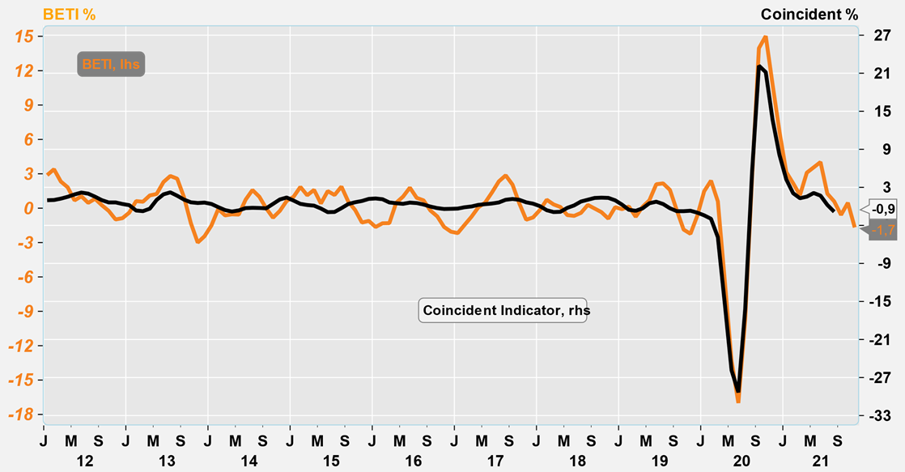
Source: Economists.co.za and BankservAfrica

Graph 2: Quarterly percentage change of South Africa GDP and BETI (2019 – 2021)
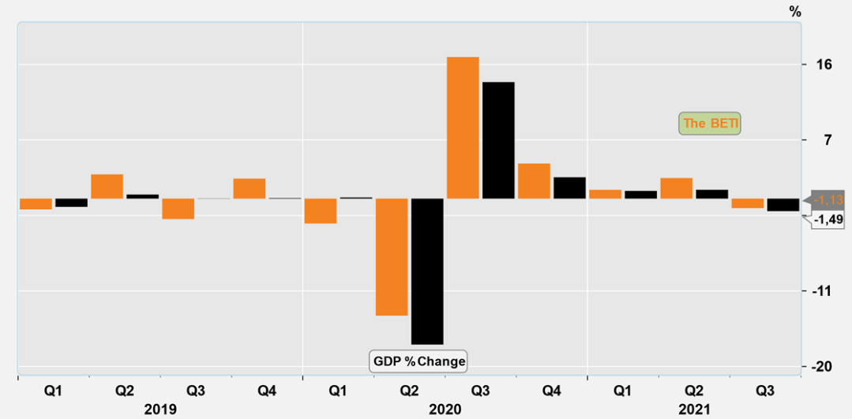
Source: Economists.co.za and BankservAfrica

Table 1: The BankservAfrica Economic Transaction Index
 | The BETI Index | The headline  BETI % change | BETI quarterly % change | BETI monthly %  change
01-Jan-20 | 123,1 | 3,7% | 1,5% | 0,7%
01-Feb-20 | 122,5 | 2,1% | 2,4% | -0,5%
01-Mar-20 | 118,6 | -0,3% | 0,6% | -3,2%
01-Apr-20 | 102,0 | -15,6% | -6,2% | -14,0%
01-May-20 | 98,3 | -19,4% | -13,3% | -3,7%
01-Jun-20 | 102,1 | -16,6% | -17,0% | 3,9%
01-Jul-20 | 109,6 | -11,0% | -9,7% | 7,4%
01-Aug-20 | 115,6 | -5,2% | 2,6% | 5,5%
01-Sep-20 | 119,3 | -0,1% | 14,0% | 3,2%
01-Oct-20 | 121,6 | 1,9% | 15,0% | 1,9%
01-Nov-20 | 121,8 | 1,0% | 10,8% | 0,2%
01-Dec-20 | 124,3 | 1,7% | 6,7% | 2,1%
01-Jan-21 | 121,7 | -1,2% | 3,1% | -2,1%
01-Feb-21 | 124,6 | 1,7% | 2,2% | 2,4%
01-Mar-21 | 125,6 | 5,9% | 1,1% | 0,8%
01-Apr-21 | 129,0 | 26,4% | 3,1% | 2,7%
01-May-21 | 129,2 | 31,4% | 3,6% | 0,1%
01-Jun-21 | 128,7 | 26,1% | 4,0% | -0,4%
01-Jul-21 | 126,1 | 15,0% | 1,3% | -2,0%
01-Aug-21 | 131,2 | 13,5% | 0,6% | 4,1%
01-Sep-21 | 127,2 | 6,6% | -0,6% | -3,0%
01-Oct-21 | 127,3 | 4,7% | 0,5% | 0,0%
01-Nov-21 | 125,0 | 2,7% | -1,7% | -1,8%
Source: BankservAfrica and Economists.co.za

Table 2: The volume and average value of transactions and the standardised BETI in nominal terms
 | Nominal standardised value of transactions | Number of transactions | Average transaction value | Change in transaction volume
01-Jan-20 | 827 069 468 236 | 98 568 174 | 8339 | 3,2%
01-Feb-20 | 921 749 299 725 | 101 662 462 | 8522 | 4,9%
01-Mar-20 | 891 197 747 730 | 103 280 758 | 8822 | 3,3%
01-Apr-20 | 679 399 945 727 | 90 027 122 | 6960 | -12,9%
01-May-20 | 703 813 457 711 | 92 353 231 | 7348 | -9,1%
01-Jun-20 | 795 028 150 576 | 99 747 038 | 7821 | 6,5%
01-Jul-20 | 842 860 988 641 | 107 166 184 | 8258 | 2,4%
01-Aug-20 | 894 409 284 562 | 103 606 195 | 8388 | -0,7%
01-Sep-20 | 931 179 397 577 | 105 595 111 | 8653 | 5,9%
01-Oct-20 | 948 772 152 278 | 113 464 522 | 8549 | 11,7%
01-Nov-20 | 973 059 693 766 | 105 494 728 | 9051 | 0,7%
01-Dec-20 | 1 039 056 126 408 | 117 705 373 | 8773 | 13,0%
01-Jan-21 | 830 431 229 519 | 99 046 275 | 8084 | 0,5%
01-Feb-21 | 985 568 635 898 | 105 369 295 | 8671 | 3,6%
01-Mar-21 | 1 016 197 489 145 | 121 094 342 | 8603 | 17,2%
01-Apr-21 | 1 034 989 208 807 | 114 992 885 | 8301 | 27,7%
01-May-21 | 999 971 999 135 | 114 860 839 | 8652 | 24,4%
01-Jun-21 | 1 000 598 759 677 | 115 994 019 | 8464 | 16,3%
01-Jul-21 | 971 405 321 598 | 122 534 840 | 8083 | 14,3%
01-Aug-21 | 1 079 970 334 333 | 139 115 440 | 7738 | 34,3%
01-Sep-21 | 1 016 856 555 770 | 122 463 947 | 8379 | 16,0%
01-Oct-21 | 1 036 674 654 205 | 126 082 582 | 8171 | 11,1%
01-Nov-21 | 1 061 313 875 251 | 125 738 825 | 8282 | 19,2%
Source: BankservAfrica and Economists.co.za

