PwC focus on Societal Purpose: 20 October 2021

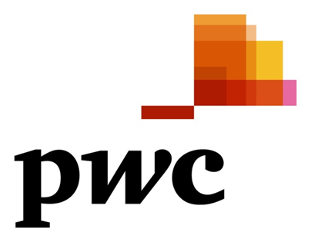

A community of solvers coming together to make a difference
By Shirley Machaba
PwC Southern Africa CEO

“As PwC Africa, we take seriously our responsibility for contributing to a better tomorrow. That’s why we have revisited our societal purpose strategy to ensure that we make an impactful, sustained contribution in the communities where we operate. We focus on not only what we are doing as a business, but also how we can help our clients to build trust and deliver sustained outcomes.”

In response to technological disruption, climate change, fractured geopolitics, and the continuing effects of the COVID-19 pandemic, amongst other challenges, many organisations need to refocus. There is a sense of urgency now, with regard to successfully responding to these challenges by building trust and delivering sustained outcomes that create value. The meaning of value has also shifted; organisations have had to take a step back and consider not only what value means for themselves, but also for a broader array of stakeholders, over a longer timeframe. This process has brought many organisations - including PwC - together in unexpected ways. Like us, these organisations now see themselves as having a greater societal purpose. As a community of solvers, PwC Africa has strengthened its societal purpose strategy in response to unprecedented change.

There are many ways to build trust and deliver sustained outcomes. However, it is becoming clear that organisations that address these interconnected needs successfully do so through a strategy that is guided by their societal purpose. They communicate their purpose clearly, including how the organisation will contribute to a better tomorrow, and define their core business activities as purpose-driven outputs. These outputs deliver value and sustained outcomes for stakeholders and contribute positively to society at large. Financial indicators are one measure of success, but certainly not the only one.

As PwC Africa, we take seriously our responsibility for contributing to a better tomorrow. That’s why we have revisited our societal purpose strategy to ensure that we make an impactful, sustained contribution, for our clients, our people, and the communities where we operate. We focus on not only what we are doing as a business, but also how we can help our clients and stakeholders to build trust and deliver sustained outcomes.

Using what we have, to make a difference

PwC Africa’s societal purpose strategy is aligned to the UN’s Strategic Development Goals (SDGs) and provides a framework for how we contribute to society by helping others thrive, using the skills and resources we have at our disposal. Aligning our strategy to the UN’s SDGs also ensures that we can contribute towards solving the important problems that governments around the continent have prioritised. There is no question that every SDG is important and necessary worldwide. Like many organisations, we have chosen several that are most aligned to our competencies and strengths as a business, so that we can have the greatest impact. We selected seven SDGs based on the needs in Africa, the materiality of the issues at hand and the expertise that we have within our business to contribute most effectively towards a better tomorrow.

The seven SDGs that we have selected are:

- SDG3: Good health and well-being - The pandemic has demonstrated the importance of good health and well-being to our economies, communities and organisations. We are committed to ongoing initiatives that keep our PwC people safe and well and supporting governments and communities to do the same, such as by delivering projects and engagements that draw upon our significant expertise in health systems management and operations.
- SDG4: Quality education - In Africa, inequality and exclusion, poorly resourced systems, a growing youth population and many other factors pose challenges to the quality of education. PwC is making a significant contribution through our expertise, partnerships and training initiatives to support this SDG.
- SDG5: Gender equality - Even though some countries in Africa have made good progress, there is still much more that can be done to ensure that girls and women can participate as equals in their political, social and economic systems. Gender diversity inspires different perspectives, fosters innovation and ultimately supports improved and sustained performance. Through our partnership with the UN Women's HeForShe initiative and other local organisations that embrace gender equality, we’re working towards achieving global gender equality in the workplace and beyond. A diverse and inclusive environment for all is a priority for us.
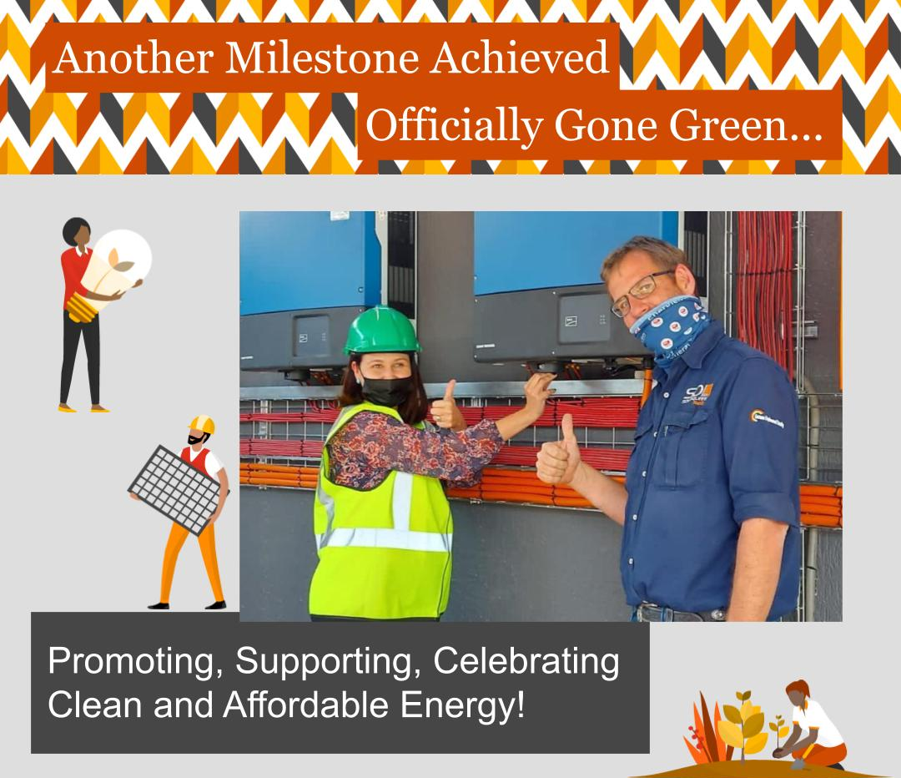
- SDG7: Affordable and clean energy - With a growing population and economic advancements, the demand for affordable, reliable energy in Africa has never been greater. Added to that challenge, it is now clear that we must work together - globally - to transition rapidly towards renewable energy sources, transforming our energy infrastructure and economies beyond a reliance on fossil fuels. PwC has committed to net zero emissions by 2030 at a global level. Part of that commitment includes transitioning towards renewable energy sources, as we have recently done at PwC Namibia with the installation of solar panels that generate power for our office in Windhoek. We are also committed to utilising our expertise with organisations, communities and governments to help deliver affordable, sustainable and renewable energy in Africa.
- SDG8: Decent work and economic growth - Decent work and economic growth is an important SDG itself, but is also influenced by a number of other SDGs (such as gender equality, quality education and reducing inequality). The pandemic has impacted employment worldwide, in different ways. In Africa, the pandemic has had a transformative impact on the nature of work and the workplace, and also contributed to unemployment. Meanwhile, the African Continental Free Trade Agreement (AfCFTA) is a tremendous opportunity for governments on the continent to facilitate growth by working together. We are dedicated to helping organisations, communities and governments repair, rethink, reconfigure and report more effectively going forward, in response to changes brought about by the pandemic, AfCFTA and other developments.
- SDG10: Reduce inequalities - Inequality continues to be a significant challenge in Africa, despite some progress in addressing various disparities. Many groups such as women, racial minorities and indigenous populations still face exclusion from business ownership and corporate decision making as well as discrimination related to wages, employment, procurement processes, and access to financial services. The process of reducing inequalities has been shown to support greater diversity of thought, boosting innovation and profitability and ultimately supporting economic growth. We value diversity and inclusion and remain committed to helping organisations, governments and communities to work together to reduce inequalities.
- SDG13: Climate action - Climate change is a growing threat in Africa and we must work together urgently to build resilience and reduce activities that contribute to it. Our most vulnerable people are at risk from the impact of climate change on water sources, food security and displacement; our businesses and governments also must deliver a sustained and unified approach to managing climate change. PwC’s net zero commitment is a focused, measurable effort to combat climate change. We are also helping governments, other organisations and communities to develop their own commitments, deliver operational transformations and manage systemic change.

No single organisation can deliver a greater societal purpose strategy on its own. We must work together to make a difference and reimagine the possibilities of tomorrow. As PwC, we are committed to this process, and to helping others on the same journey. Together, we can change the world for a better tomorrow.

The New Equation and societal purpose

PwC’s societal purpose strategy brings together our community of solvers to deliver sustained outcomes for the communities in which we operate, as well as our clients and our people. Our formula is simple: we deliver bold ideas, solutions that are human-led and tech-powered and meaningful experiences that deliver real-life results. These are just some of the great initiatives that we’re proudly involved in. Read more here.

It all adds up to The New Equation.

About PwC
At PwC, our purpose is to build trust in society and solve important problems. We’re a network of firms in 156 countries with more than 295,000 people who are committed to delivering quality in Assurance, Advisory and Tax & Legal services. Find out more and tell us what matters to you by visiting us at www.pwc.com.
© 2021 PwC. All rights reserved. PwC refers to the PwC network and/or one or more of its member firms, each of which is a separate legal entity. Please see www.pwc.com/structure for further details.
Media contacts for PwC South Africa

Sandy Greaves Campbell: Director, Change the Conversation, South Africa
Mobile: 083 408 3373
Email: sandy@changetc.co.za

Or

Jess Mokoena: Account Executive, Change the Conversation, South Africa
Mobile: 076 907 8017
Email: jess@changetc.co.za

Or

Sanchia Temkin: Media Relations, PwC Africa
Mobile: 082 550 5146
Email: sanchia.temkin@pwc.com

