Report: To accompany the press release
Date: 28 October 2021

September reflects the fastest increase in take-home pay in years
But this growth is expected to be short-lived

The BankservAfrica Take-home Pay Index (BTPI) for September 2021 reflected a 13.5% increase in the nominalised average salary. However, this growth is on the back of three factors that played a role in the fastest real take-home pay increase on record - which we believe will be short-lived.
The latest salary data held over 800 000 extra payments*, mostly from government departments. These reflect the delayed implementation of the Public Service Co-ordinating Bargaining Council’s salary adjustment for civil servants for a cash allowance that is payable back dated from 1 April 2021 to 31 March 2022, according to its media statement.
We believe the extra payments represent two payments – one for back dated payments and one for the most recent month's increase (i.e. an updated payment). Civil servants receive a cash allowance of at least R1 000 per month (based on a sliding scale). As these back date to April, our data showed 400 000 payments were made for the period April to August. According to our data, another 400 000 payments in September 2021. These contributed 80% of the increase in September’s take-home pay data.
Secondly, we noted overtime pay were made to the South African Police Service (SAPS) and the South African National Defence Force (SANDF) for their extended duty during the unrest in July, adding almost R1 billion to the BTPI’s overall salaries. Therefore, the overtime pay pushed up the average take-home pay in the BTPI. Overtime pay on this scale is unlikely to occur any time soon (we may see some overtime pay during the upcoming municipal elections on 1 November 2021 but not to this extent).
The third factor was the low base for the take-home pay in September 2020. Last year, when the economy began recovering, more casual employees – whose jobs were affected during the worst of the Covid-19 crisis - gradually returned to the workplace. As a result, the average take-home pay lowered from time to time during 2020.
As a consequence of these contributing factors, the nominal average BankservAfrica take-home pay reached R15 794 in September 2021. In real terms, the average salary was R13 047, which was 8.3% higher on a year-on-year basis.
All these factors indicate that the average take-home pay will not increase at September's rate in the next month or so. The worldwide supply chain issues and the shock from July’s unrest are likely to constrain economic growth and affect salary increases. We expect a downward adjustment in salaries in the coming months.
Private pensions remain robust
As noted in our recent index reports, the ability of private pensioners to withdraw all their pension savings once the capital amount is under R270 000 has prompted pensioners in the lower end of the income spectrum to withdraw their funds and leave the system.
This, along with the growth in banked private pensions, has contributed to a robust year for the BankservAfrica Private Pension Index (BPPI) growth.

In September 2021, the average private pension in real terms was R7 877, representing a new record. This was also 4.6% higher on a year-on-year basis.
Since the rule change for pensioners, the average real pension, still on our system, has increased by over 10%.
Graph 1: Annual change for take-home pay and banked private pensions for 2017 – 2021 (based on a three-month rolling average)
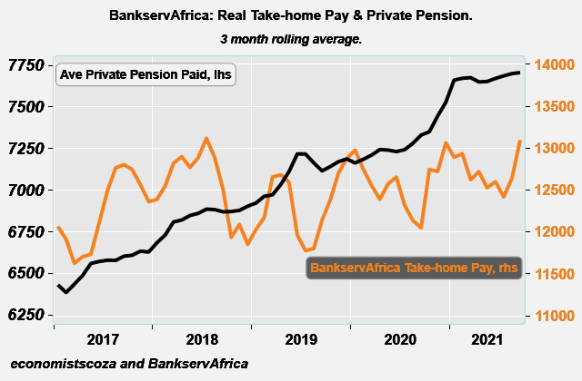
Source: BankservAfrica and economists.co.za

Graph 2: A comparison of the BTPI and BPPI for 2019 – 2021
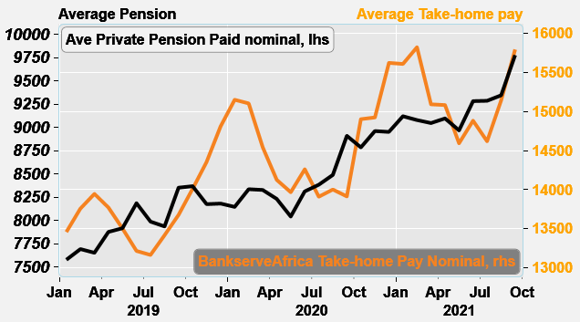
Source: BankservAfrica and economists.co.za

Graph 3: Total annual salaries and banked private pensions paid vs annual retail sales for 2015 - 2021
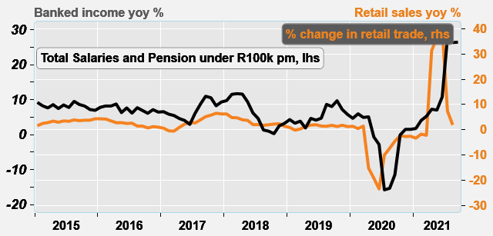
Source: BankservAfrica and economists.co.za

Table 1: The BankservAfrica Take-home Pay Index data
Month | Nominal average take-home pay | Real  take-home pay | Nominal BTPI % change YoY | Real BTPI % change YoY | Nominal average pensions paid | Real private pension | Nominal BPPI % change YoY | Real BPPI % change YoY
Jan-20 | 15150 | 13049 | 12,6% | 8,3% | 8146 | 7108 | 7,5% | 3,3%
Feb-20 | 15104 | 12829 | 9,8% | 5,1% | 8336 | 7292 | 8,4% | 3,7%
Mar-20 | 14543 | 12658 | 4,3% | -0,3% | 8327 | 7275 | 8,8% | 4,0%
Apr-20 | 14127 | 12553 | 2,6% | -1,4% | 8232 | 7229 | 4,5% | 0,4%
May-20 | 13969 | 12635 | 3,4% | 0,3% | 8042 | 7129 | 1,6% | -1,3%
Jun-20 | 14262 | 12576 | 7,9% | 5,3% | 8312 | 7265 | 1,6% | -0,5%
Jul-20 | 13911 | 12128 | 5,7% | 3,2% | 8384 | 7318 | 5,0% | 2,7%
Aug-20 | 14003 | 11950 | 4,4% | 1,5% | 8489 | 7371 | 7,0% | 3,7%
Sep-20 | 13915 | 12044 | 1,7% | -1,3% | 8909 | 7529 | 6,7% | 3,5%
Oct-20 | 14902 | 12754 | 6,4% | 3,0% | 8785 | 7434 | 5,0% | 1,9%
Nov-20 | 14924 | 12855 | 4,0% | 0,6% | 8960 | 7570 | 9,6% | 6,1%
Dec-20 | 15622 | 13147 | 5,5% | 2,1% | 8952 | 7579 | 9,4% | 6,1%
Jan-21 | 15608 | 13023 | 3,0% | -0,2% | 9120 | 7721 | 12,0% | 8,6%
Feb-21 | 15821 | 13043 | 4,7% | 1,7% | 9079 | 7699 | 8,9% | 5,6%
Mar-21 | 15092 | 12744 | 3,8% | 0,7% | 9047 | 7683 | 8,6% | 5,6%
Apr-21 | 15083 | 12944 | 6,8% | 3,1% | 9096 | 7741 | 10,5% | 7,1%
May-21 | 14594 | 12650 | 4,5% | 0,1% | 8968 | 7612 | 11,5% | 6,8%
Jun-21 | 14883 | 12514 | 4,4% | -0,5% | 9282 | 7714 | 11,7% | 6,2%
Jul-21 | 14620 | 12130 | 5,1% | 0,0% | 9286 | 7729 | 10,8% | 5,6%
Aug-21 | 15141 | 12329 | 8,1% | 3,2% | 9345 | 7755 | 10,1% | 5,2%
Sep-21 | 15794 | 13047 | 13,5% | 8,3% | 9776 | 7877 | 9,7% | 4,6%
Source: BankservAfrica and economists.co.za

Note to the editor about the BTPI
There have been revisions to the BTPI due to a change in the South African National Payment System (NPS), which now excludes all salary payments from other Southern African Customs Union member countries in the Common Monetary Area (CMA). This occurred for the period from June 2018 onwards. Under the request by the South African Reserve Bank, the CMA payments were removed, and, as such, this needed to adjusted accordingly in the BTPI data set. This means the historical data that included these countries were removed and adjusted. This took place over more than a month. We have therefore undertaken a review of the massive decline in average wages in July 2019 – August 2019. Please also note that due to this, the September 2018 – September 2019 data has been revised and has resulted in minor changes to the 2019 data.
*Please note that the estimate accounts for the double counting of state employees who received bonuses.
About BankservAfrica
BankservAfrica is the trusted payments partner and Financial Markets Infrastructure (FMI) to the financial services industry. As the largest automated payments clearing house in Africa we clear and process billions of low value card, ATM and EFT transactions annually. Our role in the South African National Payments System (NPS) is to facilitate interoperability between the banks and ensure regulatory compliance with our regulators against international banking security best practice and standards and reduces risk and complexity in the industry.

We continue to strive to be a world class and pre-eminent payments operator, innovator and payments partner of choice in Africa, by simplifying our worlds through combining trusted transactions with sensitive information.

BankservAfrica’s national responsibility is to provide safe financial payment services for 56.7 million South Africans, irrespective of their location in partnership with our shareholders and partners.

With a 49-year history in South Africa, BankservAfrica operates 24/7, 365 days a year and delivers on very strong SLAs.

