Report: To accompany the press release
Date: 24 November 2021

Take-home pay declines in October 2021
As expected, September’s massive salary increases were temporary

While some South African employees experienced the fastest take-home pay increases in more than a year in September 2021, October 2021 showed the steepest decline since September 2019.
The 3.1% year-on-year steep decline in real-take home pay, as recorded in the monthly BankservAfrica Take-home Pay Index (BTPI), follows the high base in October 2020 when casual employees were in the process of returning to work. In October 2021, however, a smaller number of casual workers were paid, resulting in the sharp decline in salaries paid between September 2021 – October 2021. This may have been due to the Municipal Elections Monday being declared a public holiday, with some receiving their pay after 1 November 2021. However, as the three-month moving average of the number of people paid stayed relatively stable, it suggests some of October payments occurred in September.
The September BTPI data has been adjusted to reflect this*. The average take-home pay in September increased by 4.1% - not the 8.3% previously reported (although the backdated bonus payments were included in the September numbers, we believe the payments were fewer). Therefore, the September take-home pay average is lower.
The nominal take-home pay for October 2021 was down to R15 042 compared to the R15 266 in September. The BTPI increased by 1.7% year-on-year in nominal terms.
In real terms, the average take-home pay was R12 412, which was 3.1% lower than October 2020.
Interestingly, take-home pay has remained between R12 000 – R13 150 over the last 25 months, which indicates salaries in the formal sector have not changed drastically. This is, in fact, similar to the 10-year trend in real terms (to note: our neighbouring countries in the Southern Africa Customs Union (SACU) were excluded from the BTPI data from the middle of 2018, therefore this comparison is not on a like-for-like basis. However, as the differences are not far apart, one could say that the overall real salaries, after-tax, did not show any major declines or increases over the last decade).
The median or typical take-home pay in real terms in October 2021 reflected the highest decline since 2018 when the SACU countries were excluded from the BTPI data. The 7% decline indicates fewer employees - who generally get paid more than the typical employees - were paid in October.
The median take-home pay was at its lowest level since July 2019 in real terms. Moreover, the typical take-home salary has remained below R11 000 for the last four months. This is the longest period of the typical pay being below R11 000 in the last two years.
This trend may indicate that South Africa has lost many high salary jobs as state-owned enterprises, such as Denel and SAA have faced challenges. High earners in the civil service or other private sector industries are also not getting fully compensated for the inflation rises. However, from November 2021 to January 2022, we expect this trend to reverse as the seasonal bonuses are paid. We will need to wait and see well into the new year if this reflects in the data.

Private pension increases slow down but is still positive in real terms
For the second consecutive month, the private pensions increase was under 10% in nominal terms. The real growth remained above 4% on a year ago, according to the BankservAfrica Private Pensions Index (BPPI).
After ten months of real private pensions increasing well above 5%, the last two months have seen increases below 5% in real terms. The rising inflation and lower number of pensioners – with less than R247 500 in their banked private pensions – may be the reasons for this.
Importantly, it appears the number of pensioners measured in the BPPI continues to be over the 650 000 mark. There have also been four months of the actual number of pensioners increasing (despite no real extra payments as seen in February 2021).
The average nominal pension paid into a bank account via BankservAfrica was R9 298 in October 2021. In real terms, the BPPI reached R7 652, the lowest level in five months and mainly on the back of rising inflation.
The BankservAfrica Private Pension Index is the only one in the world and the longest-running pension income indicator. By June 2022, we will have a 10-year history of pensions paid to pensioners.
For 14 consecutive months, private pensions have outperformed take-home pay, as recorded in the BankservAfrica data.

Graph 1: Annual change for take-home pay and banked private pensions for 2019 – 2021 (based on a three-month rolling average)
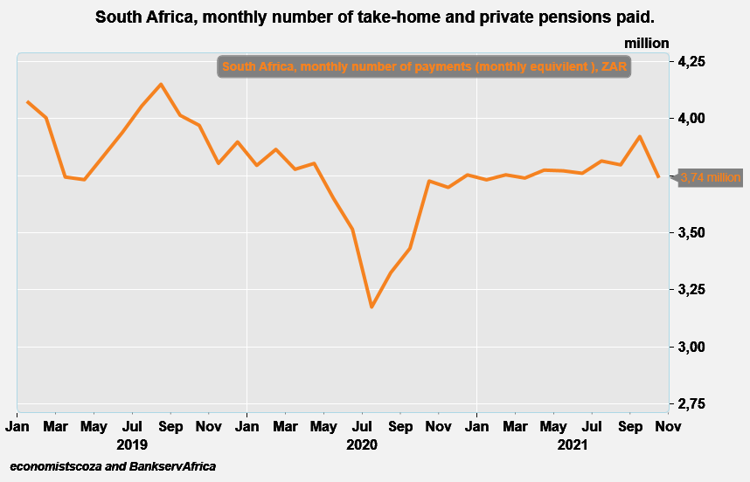
Source: BankservAfrica and economists.co.za

Graph 2: A comparison of the BTPI and BPPI for 2019 – 2021
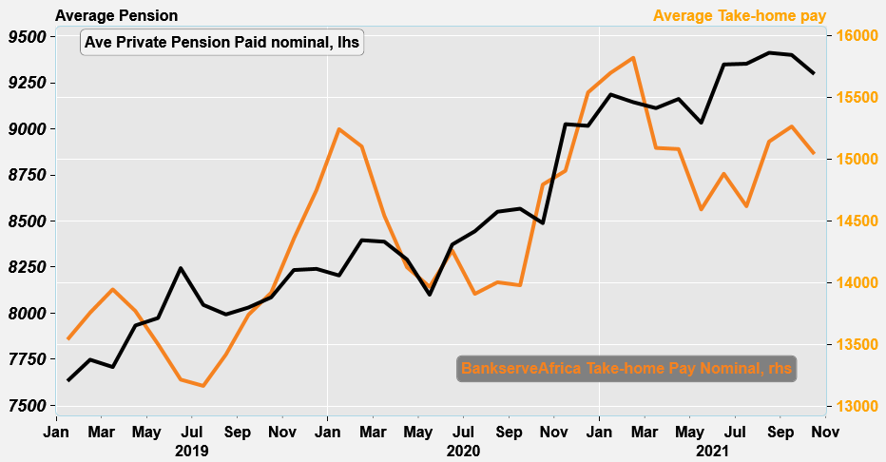
Source: BankservAfrica and economists.co.za

Table 1: The BankservAfrica Take-home Pay Index data
Month | Nominal average take-home pay | Real take- home pay | Nominal BTPI % change YoY | Real BTPI % change YoY | Nominal average pensions paid | Real private pension | Nominal BPPI % change YoY | Real BPPI % change YoY
Jan-20 | 15243 | 13032 | 12,6% | 8,3% | 8205 | 7129 | 7,5% | 3,3%
Feb-20 | 15104 | 12813 | 9,8% | 5,1% | 8396 | 7313 | 8,4% | 3,7%
Mar-20 | 14543 | 12642 | 4,3% | -0,3% | 8388 | 7296 | 8,8% | 4,0%
Apr-20 | 14127 | 12537 | 2,6% | -1,4% | 8292 | 7250 | 4,5% | 0,4%
May-20 | 13969 | 12618 | 3,4% | 0,3% | 8101 | 7149 | 1,6% | -1,3%
Jun-20 | 14262 | 12560 | 7,9% | 5,3% | 8373 | 7286 | 1,6% | -0,5%
Jul-20 | 13911 | 12113 | 5,7% | 3,2% | 8445 | 7340 | 5,0% | 2,7%
Aug-20 | 14005 | 11935 | 4,4% | 1,5% | 8551 | 7393 | 7,0% | 3,7%
Sep-20 | 13981 | 12074 | 1,7% | -1,3% | 8567 | 7413 | 6,7% | 3,5%
Oct-20 | 14795 | 12804 | 6,3% | 3,0% | 8489 | 7333 | 5,0% | 1,9%
Nov-20 | 14907 | 12905 | 3,8% | 0,7% | 9026 | 7592 | 9,6% | 6,1%
Dec-20 | 15541 | 13151 | 5,4% | 2,1% | 9017 | 7601 | 9,4% | 6,1%
Jan-21 | 15699 | 13006 | 3,0% | -0,2% | 9186 | 7743 | 12,0% | 8,6%
Feb-21 | 15821 | 13026 | 4,7% | 1,7% | 9145 | 7721 | 8,9% | 5,6%
Mar-21 | 15092 | 12728 | 3,8% | 0,7% | 9113 | 7705 | 8,6% | 5,6%
Apr-21 | 15083 | 12927 | 6,8% | 3,1% | 9163 | 7763 | 10,5% | 7,1%
May-21 | 14594 | 12634 | 4,5% | 0,1% | 9034 | 7634 | 11,5% | 6,8%
Jun-21 | 14883 | 12497 | 4,4% | -0,5% | 9350 | 7737 | 11,7% | 6,2%
Jul-21 | 14620 | 12114 | 5,1% | 0,0% | 9354 | 7751 | 10,8% | 5,6%
Aug-21 | 15143 | 12313 | 8,1% | 3,2% | 9413 | 7777 | 10,1% | 5,2%
Sep-21 | 15266 | 12571 | 9,2% | 4,1% | 9401 | 7756 | 9,7% | 4,6%
Oct-21 | 15042 | 12412 | 1,7% | -3,1% | 9298 | 7652 | 9,5% | 4,3%
Source: BankservAfrica and economists.co.za

Note to the editor about the BTPI
There have been revisions to the BTPI due to a change in the South African National Payment System (NPS), which now excludes all salary payments from other Southern African Customs Union member countries in the Common Monetary Area (CMA). This occurred for the period from June 2018 onwards. Under the request by the South African Reserve Bank, the CMA payments were removed, and, as such, this needed to adjusted accordingly in the BTPI data set. This means the historical data that included these countries were removed and adjusted. This took place over more than a month. We have therefore undertaken a review of the massive decline in average wages in July 2019 – August 2019. Please also note that due to this, the September 2018 – September 2019 data has been revised and has resulted in minor changes to the 2019 data.

*Note about the September 2021 adjustment
In September 2021, most civil servants received backdated increases. To understand this, we checked the system for more than one payment into the same accounts. This revealed that about 816 000 accounts had double payments. A further 366 000 accounts were also thought to have extra payments made but these were normal payments as many people receive salaries twice a month or more. This resulted in the nominal take-home pay being R15 974 in nominal terms and R13 047 in real terms. The reported 8.3% increase in real terms was also published.

The extra 366 000 payments should not have been subtracted, this error has been fixed. The result is that nominal BTPI for September is R15 266 and the real at R12 571. The increase remains 4.1% higher than a year ago with the trend still upwards, but lower than reported on at first.

The difficulty was in understanding the extra payments made by large employers, such as the state, when investigating the reasons behind the extra payments. There were unlikely to be over one-million backdated paycheques for increases. The author has subsequently relooked at the data, as a result of the lower payments made in October 2021, which showed that some of the extra payments made in September 2021 were meant for October 2021. With our normal smoothing it would not have been necessary to remove these payments as we work on a three-month cycle (or 13 weeks for weekly) to make the total payments and the BTPI smoother.

About BankservAfrica
BankservAfrica is the trusted payments partner and Financial Markets Infrastructure (FMI) to the financial services industry. As the largest automated payments clearing house in Africa we clear and process billions of low value card, ATM and EFT transactions annually. Our role in the South African National Payments System (NPS) is to facilitate interoperability between the banks and ensure regulatory compliance with our regulators against international banking security best practice and standards and reduces risk and complexity in the industry.

We continue to strive to be a world class and pre-eminent payments operator, innovator and payments partner of choice in Africa, by simplifying our worlds through combining trusted transactions with sensitive information.

BankservAfrica’s national responsibility is to provide safe financial payment services for 56.7 million South Africans, irrespective of their location in partnership with our shareholders and partners.

With a 49-year history in South Africa, BankservAfrica operates 24/7, 365 days a year and delivers on very strong SLAs.

