News Release

The dilemma facing emerging market investors
With the initial recovery rally likely peaking, is it time for some reshuffling in emerging markets?
23 July 2021:

By Nicholas Field, Global Emerging Market Equity Strategist at Schroders
Global economic growth is rebounding strongly. China has already completed its V-shaped recovery. The United States is now seeing the strength in the recovery come through and is well advanced in the upward leg of its V-shaped recovery. Meanwhile, Europe is only a few months behind the US and emerging markets (EM) ex north Asia will likely reach their strongest point in the recovery in Q4 of this year.
This is all positive but is now largely anticipated by markets. And it has been reflected in the strong performance of the most macroeconomically sensitive or cyclical stocks so far this year, both in emerging and developed markets. This raises the question, what could drive continued strength in cyclical and value areas of the market?
The obvious answer is more sustained inflation through the next economic cycle. And the reflation trade may yet have further momentum. But as the government bond market is signalling, there is growing consensus that current above target inflation in the US will be transitory. The US 10-year bond yield, for example, having rallied by close to 80bps in Q1 of this year to reach 1.72%, the third worst sell-off on a total return basis in history, has fallen back to below 1.50% at the time of writing.
So, if the initial recovery rally is indeed done, are growth areas ripe for a reassessment?
Which sectors have outperformed?
The chart below shows MSCI Emerging Markets sector performance over the last three years relative to the wider MSCI Emerging Markets Index. IT has been the clear standout. The materials sector has rallied strongly in the past six months and there are signs that financials may have bottomed. Energy, meanwhile, has underperformed and not recovered significantly.
MSCI Emerging Markets Index sector performance relative to broader index
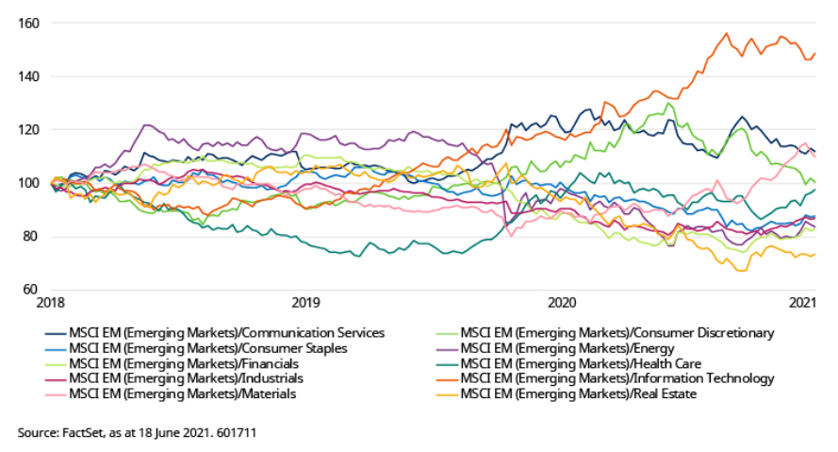
To put these moves into a longer term context, the chart below shows sector performance, again relative to the MSCI Emerging Markets Index, dating back to 1995. The important caveat to the following conclusions is that the underlying stocks in each sector have changed significantly over this period.
However, IT does appear to be peaking and on a relative basis is above where it reached in the dotcom bubble of the early 2000s. The recent rally in materials on the other hand looks far less extreme when seen in a historical context. That said, the peaks reached in 2008-10 were in the context of a commodity supercycle – to reach those levels one would have to believe we are beginning another such supercycle.
Consumer staples, having had a strong run from the global financial crisis until 2014, has since given back a lot of this outperformance. On the other hand, the industrials sector, which has historically been comprised of a broad range of stocks, has never outperformed.
MSCI Emerging Markets Index sector performance relative to broader index
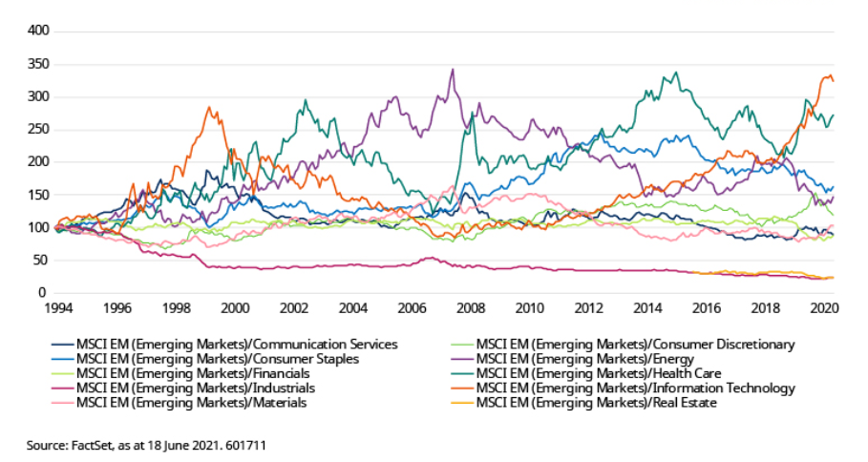

How to evaluate the outlook in growth
In emerging markets, growth stocks are spread across various sectors, notably consumer discretionary, IT and communication services. The key question to assess for growth stocks is the stage of the capital cycle.
As a new growth opportunity opens up early in a cycle it attracts capital. Given that perfect judgement is impossible, it will end up being over invested, with debt attached. Rising interest rates then end the cycle and do more damage to everyone’s favourite growth area than anything else; or to put it the other way around, excessive investment in the growth sector helps cause the recession.
The 1990s saw the internet bubble. When it popped, technology stocks spent the whole of the next cycle underperforming. That cycle was dominated by commodity stocks in emerging markets and banks in developed markets. Both have underperformed for most of the last cycle.
So will e-commerce and internet platform stocks underperform through the cycle we have just begun? Quite possibly, except that this cycle was brought to its end by a virus.

Could this cycle’s growth stocks still have room to run?
There is an analogy to the 2000s cycle. The commodity cycle actually ended in 2010 (check out the pink line in the chart above and see when it begins its real slide). The reason was this. Chinese nominal growth suffered a temporary interruption due to 2008, illustrated below, but only took a permanent step down in 2010/11. In that sense the developed market-curated financial crisis was an external shock to the emerging capital cycle which actually still had two years left to run.
China GDP growth
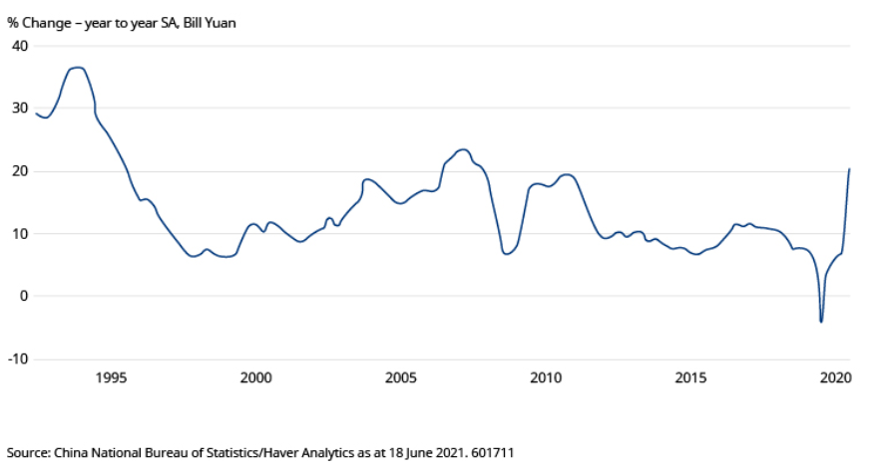
Perhaps Covid will have a similar impact – an external shock which interrupts but does not end a capital cycle. In which case maybe emerging growth stocks do have a bit more to run.
It is never possible to work out precisely when the capital cycle will end, and in any case that point is very unlikely to be synchronised globally. What is clear is that we have come a long way in this current cycle and are now much nearer the end than the beginning.

Why the capital cycle is key to growth
Different areas of growth are at different stages of their corporate capital cycle. Take e-commerce, for example, an industry which saw growth supercharged by the pandemic. Companies in some product areas are seeing a moderation in returns, albeit these remain positive and comfortably above their cost of capital, while others are still in the rapid growth phase.
For those stocks with a declining returns profile, these companies have historically still been able to make an economic profit. And this can counteract any impact from de-rating as the market factors in lower future returns. So these companies can still be profitable investment opportunities and growing businesses. It is typically only once a company’s returns fall close to the cost of capital that the share price drops, as there is nothing to offset the impact of the de-rating. China Mobile is a case in point – it experienced a period of declining returns from 2010-14, and yet its share price more or less tripled over the same period. For now, whether these stocks outperform the index may depend on the rest of the market and the degree of demand for safety.
While this roadmap may be applicable to “old growth” companies, “new growth” such as e-commerce is at a different stage. The problem is Amazon, which has defined the sector in many people’s minds. This is the idea that there can only be one dominant player and that scale is the name of the game. Amazon ran significant losses in the 1990s and early 2000s in order to generate the returns it is seeing today. This has been a free pass to other e-commerce companies to run large losses. But is it necessarily true that there will only be one main player in each market/region and if so, who will it be?

And what about defensive, quality stocks?
The hallmarks of a defensive stock are a stable return with some very modest growth. But these stocks can often be highly valued. In emerging markets, there are three sectors that offer the most interesting defensives: consumer staples, telecoms and healthcare.
The telecoms sector has not fulfilled its reputation as being defensive in the most recent cycle. Average returns have ben below the cost of capital. But that has weighed on valuations, which are now cheap, and if expectations are to be believed, returns are set to pick up.
The consumer staples sector in aggregate is generating high returns, well in excess of the cost of capital. And while valuations reflect this fact, should returns be sustained, the 10% real roll forward each year is attractive. And this overlooks any potential for a re-rating. Healthcare shows a similar picture.

What does this all mean?
One thing is clear, we are close to the peak of the early cycle value/recovery trade.
The end and beginning of a new economic cycle often involve a resorting of the capital focus. And this can mean clearing out the old before investment pours into the new.
However, while it is clear which stage of the economic cycle we are in, precisely where we are is not yet clear, and may not be for some time. While investors continue to absorb the different macroeconomic signals, the dilemma over positioning may persist.
-ENDS-

For further information, please contact:
Melissa Man, PR Senior Account Manager | +2783 727 3988 | melissa.man@mslgroup.com
Katie Hurwitz, PR Senior Account Director | +2776 427 5428 | katie.hurwitz@mslgroup.com
Schroders plc
As a global active asset manager, the way we direct capital not only shapes the financial returns we achieve for our clients but also the impact that the companies in which we invest on their behalf might have on society. The relationship between these two outcomes has rapidly evolved as we see a fundamental shift in how companies are viewed and valued. Understanding the impact that they can have on society and the planet is crucial in assessing their ability to deliver risk-adjusted profits.
Our ongoing success is built on a history of experience and expertise, whereby we partner with our clients to construct innovative products and solutions across our five business areas consisting of Private Assets & Alternatives, Solutions, Mutual Funds, Institutional and Wealth Management and invest in a wide range of assets and geographies. By combining our commitment to active management and focus on sustainability, our strategic capabilities are designed to deliver positive outcomes for our clients.
We are responsible for £574.4 billion (€641.7 billion/$785.1 billion) * assets of our clients, managed locally by 42 investment teams worldwide. As a global business with over 5,500 talented staff across 35 locations, we are able to stay close to our clients and understand their needs. We have over 200 years of experience in investment and innovation and remain committed to creating a better future by investing responsibly for our clients.
Further information about Schroders in South Africa can be found at https://www.schroders.com/en/za/intermediary/
Issued by Schroder Investment Management Limited. Registration No 1893220 England. Authorised and regulated by the Financial Conduct Authority.
*as at 31 December 2020

