IPSOS SOUTH AFRICA, JOHANNESBURG: 17 JUNE 2021
Right To Repair: Consumer sentiment and potential behavioural changes

Although only a small number of consumers currently know about the planned changes with the Right to Repair (RTR) guidelines, the overall feeling of control for consumers is driving a positive sentiment…

A new online study by Ipsos, conducted among car owners between 6 April to 10 May 2021, shows that respondents who are aware of the new RTR Guidelines, share a positive outlook on the implementation of these guidelines. This feeling was shared by respondents who were not aware of the RTR Guidelines, but were informed during the interviewing process.

Competition Commission

The Competition Commission has put out the final set of guidelines for “Right to Repair” that has the potential to completely shake up the automotive industry in terms of warranties and maintenance plans – coming into effect on the 1st of July 2021.

This ruling enables motorists to choose independent service centres, without their dealership warranties being affected. Not only will consumers be able to maintain a vehicle at independent service centres without voiding their warrantees, the way new vehicles are quoted on and sold for will also change. Dealerships will be required to split out the Warranty and Maintenance plan costs on the quote, thereby giving the customer the option to include or exclude these, as part of their vehicle purchase.

This is a win for consumers, but it will completely change the way the automotive industry operates and will elevate the competitive landscape across the industry, more so in the small to medium business sector.

The nuts and bolts of the project

The study used a multimodal approach, making use of qualitative and quantitative methodologies to gain a deep understanding of consumers’ sentiments and the potential behaviour changes due to RTR. Through the research, Ipsos was able to uncover the following behaviours and consumer viewpoints on RTR:

- Consumers’ current awareness levels of RTR;
- Emotional impact on consumers due to RTR;
- Advantages of RTR for consumers and the industry;
- Drawbacks of RTR for consumers and the industry;
- Consumer concerns of how RTR will affect them and what they expect from the industry;
- Consumers’ understanding of what service plans, maintenance plans and warranties cover;
- How and where consumers will service vehicles and the deciding factors for choosing between an independent service provider (ISP) or franchised dealer in future;
- Reasons consumers will stay with the franchised dealer and reasons they will switch to an ISP;
- What will motivate consumers to switch between ISP’s and Franchised dealers;
- Consumers’ view of “Genuine” parts vs Generic parts;
- How RTR impacts consumers’ purchasing decisions and how they will behave in terms of purchasing Service plans, Maintenance plans and Warranties (including extended warranties) in future.

Current low awareness

The current awareness levels of the new RTR guidelines amongst consumers are low - with only 17% of respondents saying they have heard of it and have a good grasp or thorough knowledge of what the new guidelines entail.

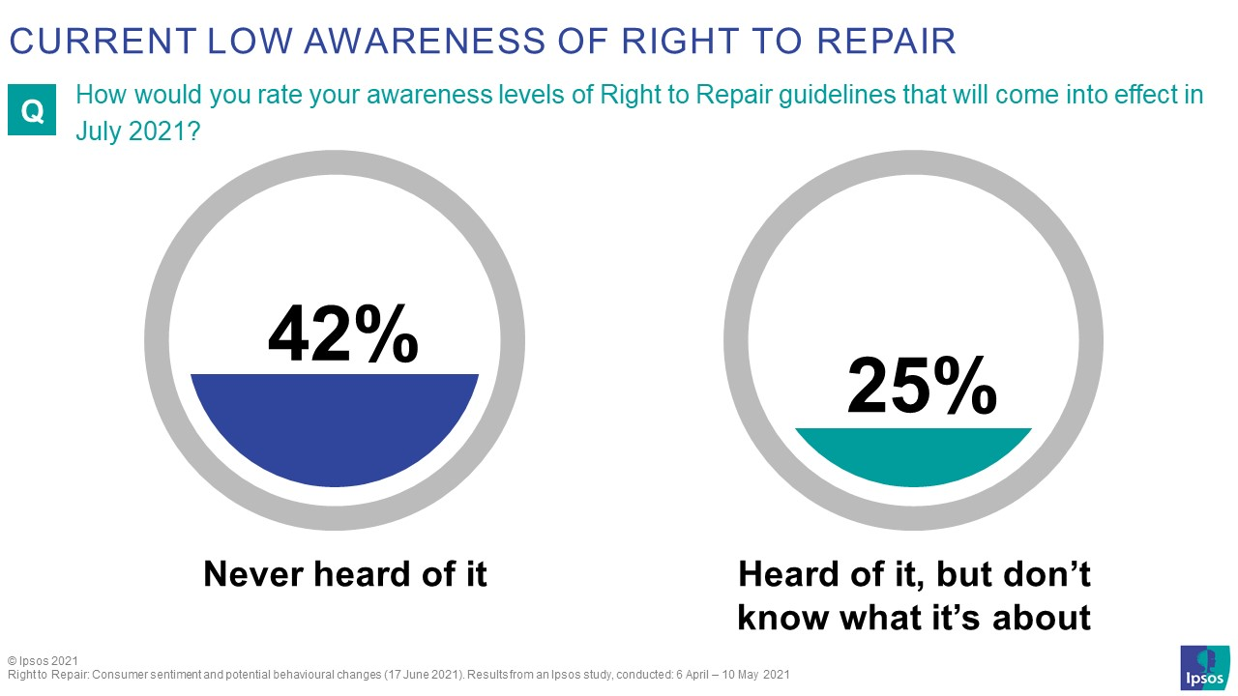

Positive reaction from consumers at first glance

The emotional impact was viewed in an extremely positive light amongst respondents after they were made aware of the RTR guidelines.

There exists a genuine level of discomfort from respondents that their warranties will be voided, should they choose to service or repair their vehicles at any place other than the franchised dealer. However, with the RTR guidelines, it is easing some of the discomfort they are experiencing and providing them with peace of mind. The sentiment from respondents was that the RTR guidelines will make them feel more empowered and in control of their finances.

Despite the RTR guidelines, respondents indicated that they are still not comfortable with how disputes between Original Equipment Manufacturers (OEM’s) and Independent Service Providers (ISP’s) will affect them. 70% of respondents indicated that, due to this fact they still believe there is a high potential risk of their warranties being voided.

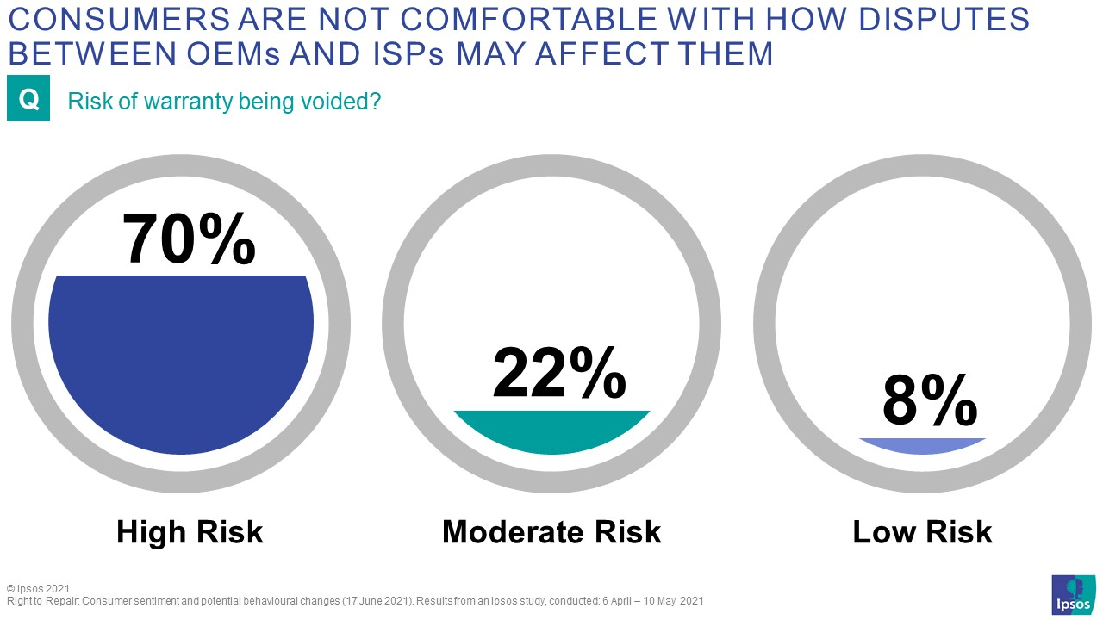

Effect on Franchised Dealerships

The perception is that consumers and the ISP’s have more to gain through the RTR guidelines, with the OEM’s having much more to lose.

The main advantages for consumers relate to “freedom of choice” when choosing which warranty and/or maintenance plan to purchase. This allows them to “shop around” and decide on where to service or repair their vehicles. Further to this, 50% of consumers feel that RTR will financially benefit them.

Taking a closer look at the advantages for the Industry, respondents stated that these guidelines will create some healthy competition in the market and empower smaller businesses to grow, leading to job creation.

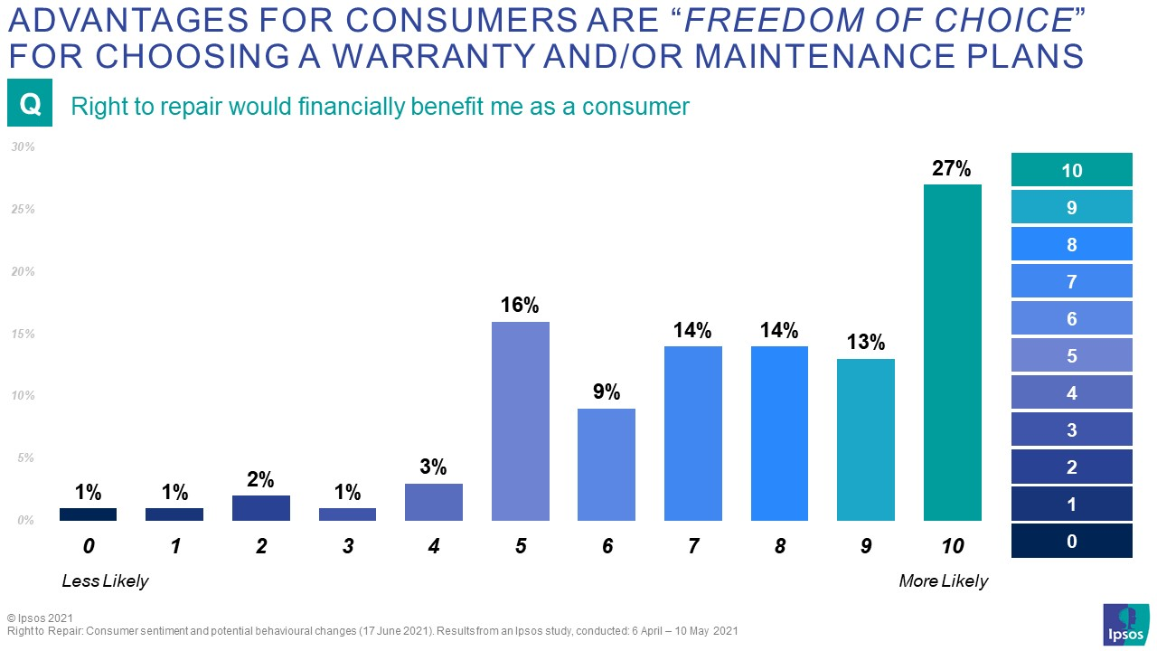

With consumers’ lack of knowledge and understanding of the guidelines as it stands now, only 33% indicated that they would continue servicing their vehicles at a franchised dealer, but that they are eagerly waiting to have the freedom of choice to choose where to send their vehicle, and possibly reaping the financial benefits.

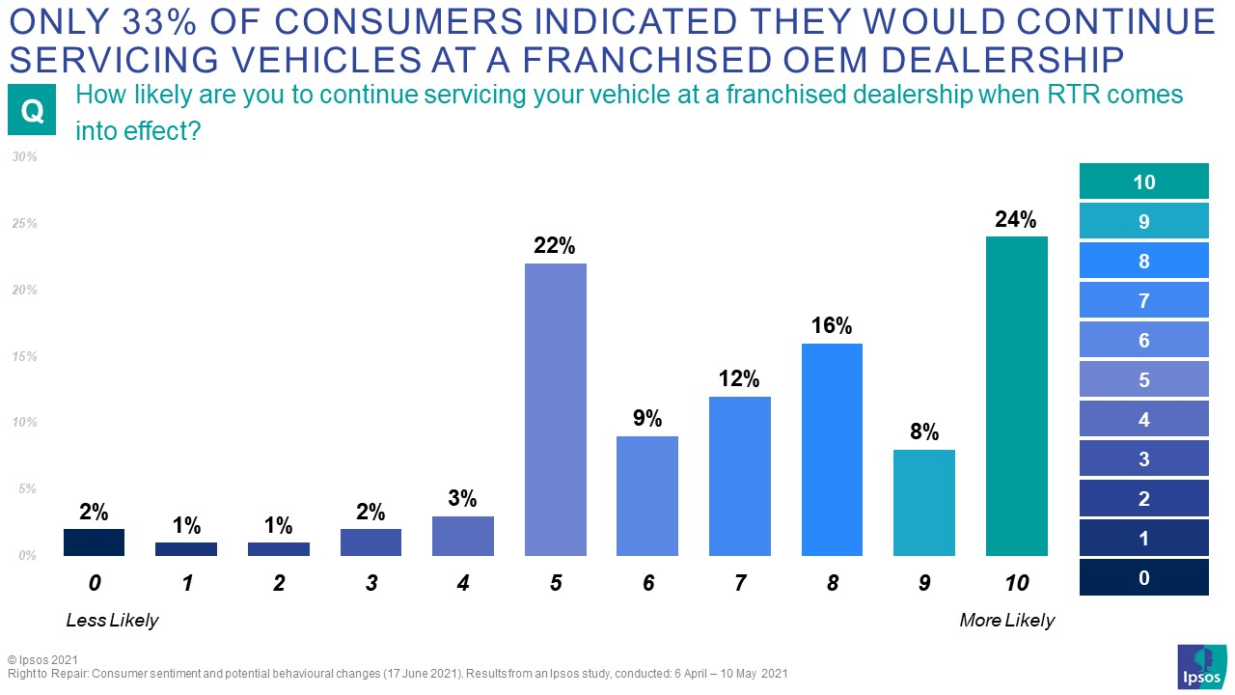

Technical Detail:
- These are the results of a survey conducted by Ipsos between 6 April – 10 May 2021.
- Surveys were conducted online using qualitative and quantitative methodologies.
- A total of 1,064 respondents were surveyed by way of online communities and online surveys.

For more information on this news release, please contact:
Robin Seed
Service Line Lead: CX, Ipsos South Africa
Mobile: +27 (0)84 578 6583
robin.seed@ipsos.com

About Ipsos
- Ipsos is the world’s third largest market research company, present in 90 markets and employing more than 18,000 people.
- Our passionately curious research professionals, analysts and scientists have built unique multi-specialist capabilities that provide true understanding and powerful insights into the actions, opinions and motivations of citizens, consumers, patients, customers or employees. We serve more than 5,000 clients across the world with 75 business solutions.
- Founded in France in 1975, Ipsos is listed on the Euronext Paris since July 1st, 1999. The company is part of the SBF 120 and the Mid-60 index and is eligible for the Deferred Settlement Service (SRD).
- ISIN code FR0000073298, Reuters ISOS.PA, Bloomberg IPS:FP | www.ipsos.com

