Hedge funds: a broader toolkit to capture market opportunities

Flexibility gives hedge funds greater opportunism
Meeting investment objectives in the future requires greater opportunism given challenging global growth outlooks and elevated volatility we see from traditional investments.
Preparation for uncertainty means being better positioned to protect during extreme conditions. The significant market changes witnessed, in a very short space of time, are a reminder of the benefits of asset allocation and prudent portfolio construction.
Investors are increasingly exploring other strategies in previously unexploited areas of the market. Hedge funds have a role to play.
What’s special about hedge funds?
A hedge fund is an investment fund aimed at achieving an absolute performance return. Hedge funds typically have a low correlation to traditional investment types, such as equities, bonds and other money market instruments traded in public capital markets. This is made possible by the wide range of investment strategies hedge funds employ to enhance returns or reduce risk, such as those brought about by the Covid-19 pandemic.
Hedge funds are classified in the category of alternative investments. This class of investment types includes private market investments (private equity and unlisted credit), hedge funds, commodities and managed futures.

Gyongyi King, chief investment officer at Alexander Forbes, speaking at the Alternative Investments Conference 2020, notes that, contrary to popular belief, South African registered hedge funds are relatively conservative when compared to global counterparts and generally seek to provide a steady return profile for investors. “Hedge funds aim to achieve positive returns at a reduced level of risk by using derivatives, short selling and leverage. This flexibility gives hedge funds greater opportunism, enabling them to extract positive performance in both upward or downward trending financial markets.” Ass
How hedge funds evolved
An Australian, Alfred Winslow Jones, was credited in 1949 for creating the first hedge fund structure.
- 1998: First South African single manager hedge fund is established.
- 2003: The first South African fund of hedge funds is created.
- 2007: The Financial Services Board (FSB) starts regulating hedge fund managers, requiring that they hold a CAT II A licence.
- 2011: Regulation 28 for pension funds introduces a 10% investment allocation limit to hedge funds. Previously the regulation did not explicitly refer to hedge funds.
- 2012: The FSB and National Treasury embark on a process to enhance and expand the scope of regulation and oversight over hedge funds. A proposed framework for regulating hedge funds in South Africa is released and after engagement with industry, draft regulation for public comment is released in April 2014.
- 2015: National Treasury and the FSB finalise the regulation of hedge funds and declare them as collective investment schemes (CIS) in terms of Section 63 of under the existing Collective Investment Schemes Control Act 45 of 2002 (CISCA).

et classes can focus on performance that is independent of traditional capital 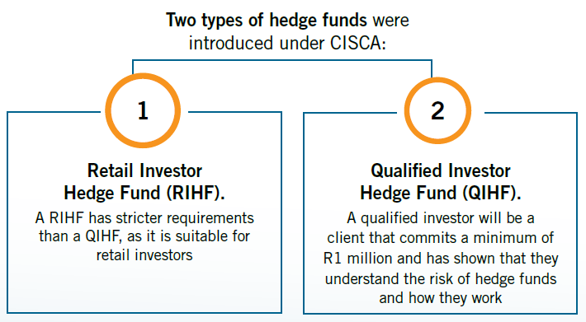

Type of hedge fund | RIHF for retail investors | QIHF for qualified investors
Disclosure to clients | Monthly | Quarterly
Maximum equity holdings | < 10% | Not defined
Investor liquidity | Calendar month | 90 days
Risk management | Daily | Daily
Marketing | Able to solicit investments from all investments | Only accept investors from a restricted pool of qualified investors

“The highly regulated environment improves client protection and transparency, with the intent of improving client confidence in hedge funds.” King explains important requirements of hedge funds include strict advertising and marketing, contractual aspects around repurchases and possible fines for offences.
Each hedge fund can vary according to the strategies employed and investment objectives, but hedge funds are united by fundamental goals:
- Portfolio diversification
- Risk management and
- Reliable returns over time
There are several factors prohibiting flows to hedge funds. “In 2018, hedge fund assets under management declined by 25% (compared to the 9.1% in the 2017 survey). This marked the largest decline in the history of South African hedge funds and the second consecutive decline since the industry peaked in 2016.”
“According to the survey findings, the main contributing factors that drove the decline include poor performance leading up to 201, consolidation of product offerings by managers and fund of funds outflows.”
The value of hedge funds
With this backdrop, it is becoming increasingly important for hedge fund providers to justify their value to investors. For some, this means evolving their business models or leveraging their unique capabilities more effectively. For others who have successfully delivered what is “on the tin”, it means creating more awareness by educating investors and familiarising them with the benefits hedge funds can offer.
CISCA is the legislation that governs CIS (collective investment scheme) funds (unit trusts). It does not currently allow investments in hedge funds, even though they are now regulated by the Financial Sector Conduct Authority under CISCA.
“This regulation could change in the future – and could open new investment opportunities and increase flows to hedge funds. However, nothing precludes retail investors from buying into qualifying investor funds directly,” concludes King.
Diversification is becoming increasingly important. Hedge funds, and the underlying strategies they employ, have a role to play in providing adequate protection during market weaknesses.
King recommends that when investing in a hedge fund, it is important to seek a provider who can offer the following on behalf of investors:
- Scale – buying power to negotiate competitive and fair fee structures
- Research – wide opportunity sets and strategies make selection important
- Relationships – leverage service and information needs to improve transparency
- Governance – carefully managed and governed by the right people, systems and processes

ENDS//

SPOKESPERSON: Gyongyi King, Chief Investment Officer, Alexander Forbes Investments

CONTACT INFORMATION: ALEXANDER FORBES
Consi Kalamaras, Head of PR & Media Relations: kalamarasc@aforbes.com; +27 11 505 6012 or +27 (0) 82 808 4440
Sheri Cohen, Corporate Image: sheri@corporateimage.co.za; +27 (0) 71 683 1888

INFORMATION ON ALEXANDER FORBES
Alexander Forbes is a specialised financial services group headquartered in South Africa focusing on employee benefits solutions for institutional clients, and financial wellbeing and retail financial solutions for individual clients, in particular employees of the Group’s institutional clients. Alexander Forbes is listed on the Johannesburg Stock Exchange (“JSE”), and its primary clients span both the private and public sector market segments, including employers, retirement, health, investment and other special purpose funds on the institutional side, and individual members and beneficiaries of these funds, as well as the wider individual market, on the retail side. The main services provided by the Group include retirement funds and asset consulting, actuarial, investment and administration services, employee risk benefits and healthcare consulting, individual financial advisory and multi-manager investment solutions. Alexander Forbes’ principal geographic focus is South Africa, where it has been operating since 1935, sub-Saharan Africa, the UK and other selected jurisdictions with employee benefits legislative frameworks similar to South Africa.
www.alexanderforbes.co.za

