COVID-19 - WHAT CAN WE LEARN FROM THE PAST?
18 March 2020



Mario Fisher

Chief Data Scientist and Head of Equities, Prescient Investment Management
The coronavirus outbreak has sent worldwide fear across financial markets amid concerns of a hit to the global economy. Although it is still too early to evaluate the full impact on the economy, it is prudent to assume that there are still more potential downside risks posed by the outbreak given its unknown magnitude and duration. Global markets have reacted with a classic risk- off response and perceived safe-haven assets have benefited from increased demand. The impact from concerns about the outbreak may have been partially offset by:

- Positive results in the current quarterly earnings season (so far these are in line with market expectations)
- Some reprieve in global trade tensions
- Mostly positive economic data

What can we learn from historical global outbreaks?
Financial markets have historically reacted with a V-shaped pattern. The short-term hit results in reserve demand, which eventually floods the market and helps drive the rebound in economic activity. However, in this instance the extent and pace of a rebound is still uncertain. This is normally led by a recovery in retail and manufacturing sectors, lost revenues are harder to recover in the services sector like tourism. The reduced flow of people and goods due to travel restrictions and quarantine measures will more than likely have a negative impact on demand in the short-term, pressuring economic activity in the most affected areas.

China’s larger role in the global economy is a further difference from historical outbreaks. China currently constitutes 15% of global GDP in purchasing parity terms, three times its size since 2003 when the world was hit by the SARS virus. The spread of the coronavirus beyond China has distressed global financial markets, as it has opened a new global element to the epidemic and potential for a severe economic drag from efforts to suppress it. We see the drag on economic activity threatening both developed and emerging economies. A key development to monitor in the near term is how successful China’s effort to restart its economic activity will be and whether it can avoid another round of mass infection as workers return. This may however provide measurable insight on the potential duration of the outbreak and its economic impact globally.

Many small-and medium-sized businesses could be vulnerable to a cash flow squeeze if the outbreak lasts for a protracted period. It may further force companies to reassess their supply chains, which are already
under pressure from global trade tensions. Over time, these supply shocks could slowdown growth, increase production costs, drive profit margins lower and influence inflation higher.

Impact on risk assets for the year to date as we approach the end of Q1 2020
Assume an investment of one US dollar in each of the following assets, MSCI Emerging Markets index (23 emerging economies), MSCI World index (23 developed economies), FTSE/JSE Top40 index (South Africa’s largest listed companies), MSCI All Country World Airlines sector (listed airlines across developed and emerging economies) and Brent crude oil.

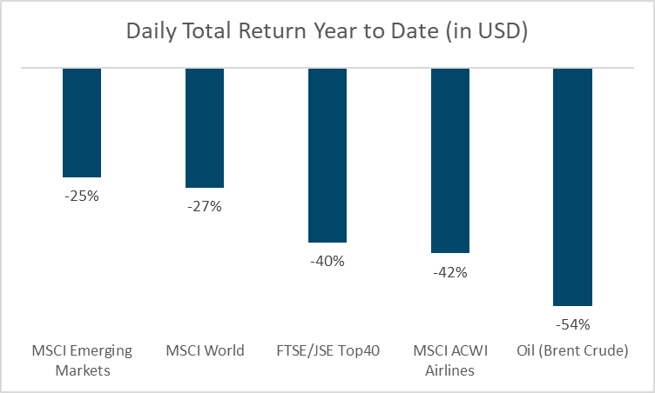
Chart 1
Source: Bloomberg and Prescient Investment Management

Year to date, all risk assets have lost value as the global economy is gripped by the coronavirus and the knock-on effects of the oil price war. Our one US dollar investment would have lost between 25 US cents in MSCI Emerging Markets to 54 US cents in Brent crude oil (Chart 1).

The growth required to get back to one US dollar invested in MSCI Emerging Markets is not the 25% that was lost year to date; our investment would require a 34% return to break even. In South Africa, we have experienced losses of 40% in US dollar terms with airlines being the most impacted due to travel bans increasing globally.
What return is required to get back to one US dollar in each investment?

Chart 2

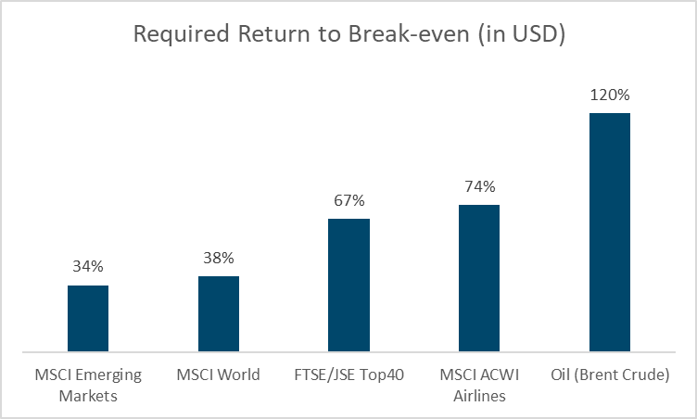

Source: Prescient Investment Management

The impact of the pandemic on global markets is vast and painful, requiring large double- digit returns to recover to the levels we started with in 2020. Looking back to 2003 when the SARS virus spread like wildfire, it only took a few months for markets to break into new all- time high levels.

As unique as the current economic and financial circumstances may be, one should never panic. We are confident that we will be able to ride out the storm by sticking to our robust and systematic investment processes. There have been several significant market disruptions during our 22-year history as an investment manager, but through it all we have been able to deliver on our commitment to generate positive and consistent returns over time for our clients.

Ends.

About Prescient:
- Prescient Holdings (Pty) Ltd is a diversified, global financial services group with a 21-year track record of providing solutions to our clients in Asset Management, Investment and Platform Administration, Retirement Solutions, Stockbroking and Wealth Management. As at 31 Dec 2019 the group had R98.4 billion client assets under management (AUM) and administered R478 billion client assets (AUA), split between asset admin (R328 billion) and unit holder admin (R150 billion). Prescient has established operating businesses in the following main jurisdictions: Prescient has successfully operated for 21 years in South Africa, 12 years in Ireland & the UK and 6 years in China.
- Prescient Management Company (RF) Pty Ltd (the manager) is approved under the Collective Investment Schemes Control Act (No.45 of 2002). Prescient Investment Management is an authorised Financial Service Provider (FSP 612) under the Financial Advisory and Intermediary Services Act (No.37 of 2002).

