ESG factors – the kingmaker in Covid-19
A corporates’ zero-hour moment

By: Premal Ranchod, Senior Manager Research Analyst, Alexander Forbes Investments
Milton Friedman, the economist, said that the only social responsibility a corporate has is to increase profits within the rules of the game. In simple terms “the role of business is to be in business”. One cannot think of a more germane time than now to puncture that theory. The virus is, without doubt, a social pandemic with corporate viability squarely in its clutches. Corporates are facing their zero-hour moment.
One may argue that environmental, social and governance (ESG) factors finally found resonance of late, after years of being challenged by mainstream finance. Has the virus provided a temporary pause on ESG and corporate sustainability assessments?
The answer is a resounding ‘no’; in fact research suggests it has further amplified the concept. Corporates have had sustainability thrust upon them by an act wholly outside of their control. Their response, albeit by accident, may be a boon for some and value destructive for laggards. ESG forces a company to wrestle with issues that aren’t black and white.
The impact, timing, and the value that the market attaches to these risks are often not aptly appreciated, thus making ESG risk management the kingmaker. In 2020, we have witnessed leadership being summoned across government, corporate, public health service, and of course the average citizen in society to take action. We collectively grapple with the new normal. We tap into emotional quotient balances and sharpen tool kits so that we are able to respond respectfully.
Who is taking note of corporate responses in this time?
In crises, traditional fundamentals of valuation is trumped by the markets’ assessment of reputation, loyalty, engagement, relevance and citizenship.
People | Employees measure up if employers are lethargic or proactive. Employee safety and well-being are important, for example equipping employees with safety kits and introducing flexibility in sick leave policies. Are they financially secure and is their job or salary at risk? Trust finds a niche connection between employer and employee.
 Customer | Customers look toward corporates to deliver on goods and services. Financial services companies are seen as the lighthouse of economies. Customers weigh up whether investments are guarded and payments are made, not being left to irrational acts. Clear and effective communication is paramount.
 Supplier | Suppliers are looking to stay afloat. They are balancing their business’ liquidity requirements. They need free cash float to withstand payment terms that might have to be deferred. They are seeking repayment flexibility from financiers.
 Investor | Healthier balance sheets are enduring. Our discussions with asset management firms suggest that resilient companies have cash reserves; diversified revenue streams, off-shore or local earnings mix, and strong assets that can withstand devaluation. Companies with excessive debt are vulnerable with operating margins and cash flows facing a threat of decline.
 Rating agency | Rating agencies came under significant pressure in 2008 for failing to signal the lending crisis. We note the ESG considerations of all three major global rating agencies, S&P; Moody’s, and Fitch through our interaction (7 April 2020).  The observable risks and opportunities impact the credit quality of companies. Ratings factor into account the response to strategic risks that emerge and management thereof. The “S” – social risk – considers workforce, diversity, safety, customer and community among other factors.  Emerging market countries are presenting vulnerability. These risks impact companies in first line of fire where complete disruption of business occurs such as travel, healthcare, retail and hospitality sectors. Second-line businesses are the rest within the economy that suffer, but are able to operate remotely, such as financial services and oil and gas.

What should a company have in its quiver?
  - Strong appreciation for ESG factors – Companies with stronger ESG credentials place value on externalities, link them to their strategy and operate accordingly. Whilst ESG track records are ripe for debate, evidence exists to show that well-governed, responsive businesses endure market troughs better than their riskier counterparts.

  - Capital allocation response plan – Companies that consider stakeholders more acutely now stand to have a stronger workforce, client base, commitment and so on. Intangible value add is preparation for recovery after Covid-19.

We chose to look at Gallup research based on data after the 2008 global financial crisis as a past lesson.

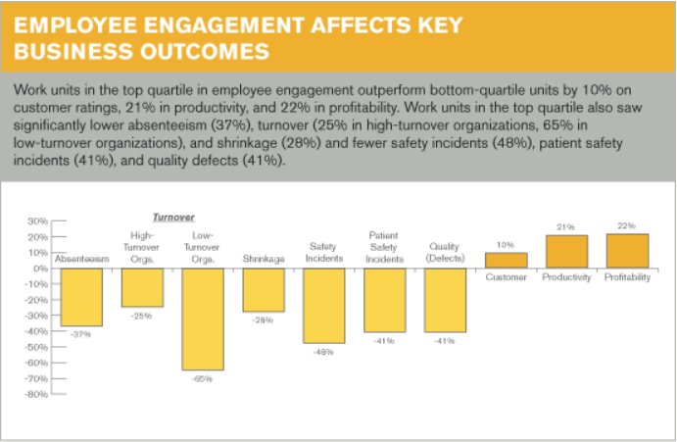

  - Dividends and share buybacks – Cash distributions should be used effectively in the management of operational expenses. In the short term, dividend or buyback cuts might suggest a pecking order between shareholder and stakeholder. In the longer term the market will place greater weight on the strength of a business model.

  - Business continuity plans (BCP) – A comprehensive, practical yet evolving plan that outlines a playbook in the event of business disruption.

  - Board balance – Effective corporate governance in the form of a balanced, diverse board may prove useful when addressing softer issues like employee engagement and morale. Stakeholders look for evidence when assessing if companies have window dressed their responses.

  - Retrenchments – Rehiring costs way more. Companies will have to weigh up retrenchments, salary adjustments, and executives’ compensation plans in light of the cash reserves in place and legislative environment in a country.

The value of a business post Corona
Companies will be measured by their agility at this inflection point. Flexible methods of work, embracing trust, and valuing employee loyalty become the norm. Business preparedness becomes an agenda item on management committees.
We think that whilst these are robust responses in the short term, there are two more nuggets to note: Firstly, the clarion call for climate change strategy and a company’s response to United Nations Sustainable Development Goals (SDGs). Secondly, the companies of tomorrow will add long-term value, not by marketing ESG and philanthropy but by linking their strategy intricately to externalities that affect the business. Consider Covid-19 your dry run. Business is unusual.
ENDS///
Premal Ranchod CA (SA) is a senior manager research analyst and ESG champion at Alexander Forbes
CONTACT INFORMATION: ALEXANDER FORBES
Consi Kalamaras, Head: PR & Media Relations: kalamarasc@aforbes.com; +27 11 505 6012 or +27 (0) 82 808 4440
Sheri Cohen, Corporate Image: sheri@corporateimage.co.za; +27 (0) 71 683 1888

ABOUT ALEXANDER FORBES
Alexander Forbes is a specialised financial services group headquartered in South Africa focusing on employee benefits solutions for institutional clients, and financial well-being and retail financial solutions for individual clients, in particular employees of the Group’s institutional clients. Alexander Forbes is listed on the Johannesburg Stock Exchange (“JSE”), and its primary clients span both the private and public sector market segments, including employers, retirement, health, investment and other special purpose funds on the institutional side, and individual members and beneficiaries of these funds, as well as the wider individual market, on the retail side. The main services provided by the Group include retirement funds and asset consulting, actuarial, investment and administration services, employee risk benefits and healthcare consulting, personal lines insurance, individual financial advisory and multi-manager investment solutions. Alexander Forbes’ principal geographic focus is in South Africa, where it has been operating since 1935, sub-Saharan Africa, the UK and other selected jurisdictions which have employee benefits legislative frameworks similar to South Africa.
www.alexanderforbes.co.za

