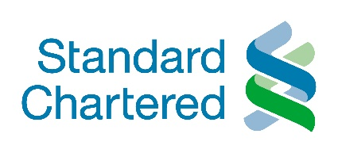
South Africa – More SARB easing to come
• We now see the year-end repo rate at 3.5% in 2020 (4.25% previously) and 4.5% in 2021 (5.0% previously)
• With demand exceptionally weak, we expect further SARB easing in May (50bps) and July (25bps)
• Negative real rates unlikely, barring a sustained breach of the lower bound of the inflation target • Structural loss of spare capacity would influence the timing of eventual SARB tightening
• We lower our CPI forecasts to an average of 3.4% in 2020 (3.9% prior), and 3.9% in 2021 (4.2% prior)
Policy support amid broad-based weakness
We now forecast a South African Reserve Bank (SARB) repo rate cut of 50bps to 3.75% at its May monetary policy committee (MPC) meeting, and a further 25bps easing to 3.5% in July. Previously, we had expected the SARB to wait until after World Government Bond Index (WGBI) rebalancing, and potential capital outflows, before resuming its easing cycle. We had expected a low in the cycle of 4.25% and had assumed that this low would only be achieved at the July MPC meeting.
The SARB surprised markets by cutting its repo rate by 100bps to 4.25% in April, even prior to the WGBI rebalancing, moving faster than the path implied by its own Quarterly Projection Model (QPM). In view of the weakness of the South African economy and limited outflows associated with the WGBI exclusion, we now expect even further SARB easing. We recently revised our 2020 GDP forecast to a contraction of 6.5% (see COVID-19 – Recovery scenarios for 2020, 11 May 2020).
We see 3.5% as the low in the current interest rate cycle. The SARB’s key concern will be the trajectory of South Africa’s negative output gap. The loss of additional spare capacity as a result of the COVID-19 downturn could limit space for policy accommodation once recovery gets underway, eroding the negative output gap even faster. Monetary policy, which post-crisis would still focus on the achievement of the inflation target, will need to be sensitive to this. We now see two SARB rate hikes in 2021, most likely at the March and July MPC meetings. However, the repo rate is likely to remain lower than we had previously assumed, even by end-2021.
We now forecast lower headline inflation in 2020 and 2021, given the COVID-19 shock, weak demand, weak oil prices, and only limited FX pass through into inflation.
Figure 1: We see SARB cuts in May and July 2020, with tightening in 2021 Headline CPI, % y/y; policy rate, %
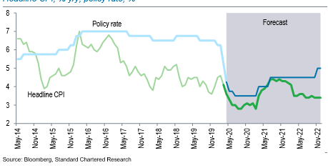
Outside of the SARB’s surprise intermeeting cut in April, a number of additional factors underscore our changed rate view:
1. The economy remains weak. Downside risks to our -6.5% growth forecast for 2020 still predominate and will depend on the COVID-19 trajectory. South Africa acted early to contain the virus, announcing a three-week, full-scale ‘level five’ lockdown, which started on 27 March. This was subsequently extended to the end of April, resulting in five weeks of a substantial economic shutdown. A less restrictive ‘level four’ lockdown was adopted in May. Under level four, South Africans may return to work in a phased manner where necessary, but an overnight curfew remains in place, with many businesses operating below capacity. Businesses in the services sector, including personal services, tourism and hospitality, remain shuttered. Restaurants may only re-open for takeaway, and the items that retailers may sell during a level four shutdown are still subject to regulation. Alcohol and tobacco sales are not permitted.
By the end of May, South Africa hopes for further easing of the lockdown, to ‘level three’, except where significant outbreaks of COVID-19 persist. As large metropolitan areas, including Cape Town, remain epicentres of the outbreak, we do not envisage a rapid recovery in activity. Metropolitan areas still account for a disproportionate share of South Africa’s economy. The risk is that a restrictive level four shutdown will remain in place in metropolitan areas, where economic activity is most concentrated.
2. Inflation is likely to remain subdued in the near term, helped by weak pass through from the softer South African rand (ZAR), subdued economic activity and demand, and weak oil prices. In addition, expectations of stronger harvests are likely to keep food inflation modest. During the lockdown period, South Africa enacted strict regulations aimed at preventing price gouging, especially for essential items. We lower our average CPI forecasts to 3.4% in 2020 (3.9% previously), 3.9% in 2021 (from 4.2% prior). Given the weaker base, we see inflation rising to 3.6% in 2022 (3.5% prior). The lower pace of inflation should allow South African monetary policy to become more accommodative.
3. The SARB is likely to tolerate a lower real interest rate, given economic weakness. However, we do not see the SARB adopting negative real interest rates unless there is a risk of inflation being sustained well below the lower bound of the 3-6% inflation target range. While our current inflation forecasts see a risk that headline inflation dips marginally below 3% in Q3-2020, we do not see this as sufficient reason for the SARB to adopt negative real interest rates, suggesting that the low in the current cycle is likely to remain at least 3.0%. (We forecast 3.5%, taking into account investors’ demand for a higher risk premia).
4. The announcement of a loan guarantee scheme of ZAR 200bn, as part of a package of fiscal measures amounting to ZAR 500bn, also drives our changed view. Under this scheme, the SARB will lend money to commercial banks at the repo rate plus a 0.5% guarantee fee. Banks will in turn lend to SOEs impacted by the COVID-19 crisis at the repo rate plus a spread of 350bps. While existing borrowers already benefit from earlier SARB easing, the launch of the loan guarantee scheme in mid-May suggests that monetary policy will be able to provide more stimulus if accompanied by further easing. SARB buying of bonds on the secondary market, on an unsterilised basis, will also add to money supply near-term. However, these purchases will eventually have to be reversed. From this perspective, we foresee the SARB preferring more conventional monetary stimulus, through lower interest rates.
5. Monetary policy to play a key stimulus role. Despite the announcement of a ZAR 500bn fiscal stimulus package, equivalent to c.10ppt of GDP, the measures outlined so far are unlikely to add significantly to current spending plans. Some spending will be reprioritised; other spending will be funded through an existing surplus in South Africa’s Unemployment Insurance Fund. South Africa does not have much fiscal room for additional spending. Any fiscal deterioration is likely to come from weaker revenue momentum instead. Given this, monetary policy will need to provide additional stimulus, supporting the case for more SARB easing.
A key focus at the May MPC meeting is likely to be South Africa’s eventual emergence from the current economic crisis, and the implications for any normalisation of interest rates. The SARB’s assessment of structural loss of capacity in the economy will be important for the future path of interest rates. Either a more pronounced economic recovery in 2021, or the negative output gap being closed at a lower growth rate, might argue for front-loaded tightening. Against consensus, we see the reversal of some of 2020’s monetary policy easing taking place as soon as March 2021, albeit at a gradual pace. Our end-2021 repo rate forecast is 4.5%, even lower than it was previously (5.0%).

Material changes to our views
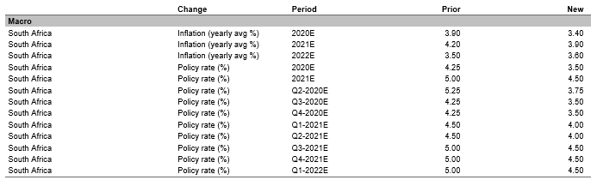

Razia Khan Chief Economist for Africa and the Middle East, Standard Chartered Bank

