PwC focus on CPI – 22 April 2020

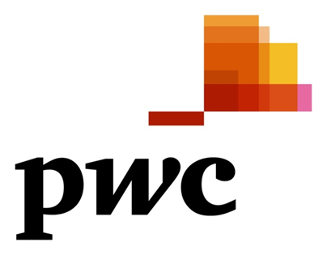

Inflation declines to 4.1% in March

Room for more interest rate cuts in the short term

Statistics South Africa (Stats SA) reported on April 22 that consumer price inflation decreased from 4.6% year-on-year (y-o-y) in February to 4.1% y-o-y in March 2020. Inflation averaged 4.4% during the first quarter compared to a South African Reserve Bank (SARB) forecast of 4.5%. Inflation is not a prominent point of analysis in South Africa at the moment wit greater emphasis on the outlook for the economy and employment. However, consumer price dynamics are still being considered by the central bank as it looks at monetary policy tools to support the local economy.
A major driver behind the decrease in March’s headline inflation was disinflation in the transport component of the consumer basket. Fuel costs were 1.6% month-on-month (m-o-m) lower, resulting in a 1.7% m-o-m decline in the overall cost of transportation. Petrol and diesel prices declined by 19c/litre and 5c/litre, respectively, on March 4. This was largely as a result of lower international products prices, with a weaker rand eroding some of the potential benefit to motorists. As a result of lower fuel prices, transport was only 3.4% y-o-y more expensive in March compared to a reading of 6.2% y-o-y in the preceding month.

Sources: Stats SA, SARB
The SARB Monetary Policy Committee (MPC) announced on April 14 it had reduced interest rates by another 100 basis points, following an identical move on March 19. The central bank commented that the extension of the national lockdown (until April 30) will result in a greater economic contraction in the short term as businesses stay shut for longer and households spend less. The central bank now expects the South African economy to contract by 6.1% in 2020 – a sharp deterioration from the 0.2% decline forecast just three weeks ago.
On the inflation front, the SARB commented that the much weaker economic growth outlook coupled with low oil prices have resulted in a downward revision in its inflation forecasts. (The central bank expects Brent oil to average $42 per barrel this year.) Consumer price inflation is forecast by the SARB to average 3.6% in 2020; this is close to the bottom end of the 3%-6% target range. Combined with the weak economic outlook, this low inflation outlook makes room for significant monetary stimulus to the broader economy. The MPC commented that the overall risks to the inflation outlook appear to be to the downside at present.
Looking ahead, the MPC statement indicated that the central bank’s internal modelling suggests room for a further five interest rates cuts of 25 basis points each over the coming 12 months. However, given the speed at which the local and global environment is changing at present, it is not impossible for the SARB to make another big (i.e. larger than 25 basis point) rate cut in the near future. Of course, as policymakers always warn, the outlook and current rate cut suggestions are highly dependent on economic data. The exchange rate, for example, is one of the factors that could pressure the cost of imported inflation in coming quarters.
Article by Lullu Krugel Chief Economist for PwC Strategy&, and Dr Christie Viljoen, PwC Strategy& Economist
At PwC, our purpose is to build trust in society and solve important problems. We’re a network of firms in 158 countries with over 250,000 people who are committed to delivering quality in assurance, advisory and tax services. Find out more and tell us what matters to you by visiting us at www.pwc.com.
PwC has a presence in 34 Africa countries with an office footprint covering 66 offices. With a single Africa leadership team and more than 400 partners and 9000 professionals across Africa, we serve some of the continent’s largest businesses across all industries.
PwC refers to the PwC network and/or one or more of its member firms, each of which is a separate legal entity. Please see www.pwc.com/structure for further details.
© 2018 PwC. All rights reserved
Media contacts
Bontle Mnisi: Account Executive, Change the Conversation, South Africa
Mobile: 076 2283796
Email: bontle@changetc.co.za
Or
Sanchia Temkin: Media Relations, PwC Africa
Mobile: 082 5505146
Email: sanchia.temkin@pwc.com

