Thinking fast and slow about valuations

Old Mutual Wealth Investment Strategist, Izak Odendaal

The world recently learned of the passing of Daniel Kahneman, the psychologist who revolutionised economics, along with Amos Tversky and other collaborators. He was awarded the economics Nobel Prize in 2002 for his studies on decision-making. He showed that, unlike the traditional models of very rational economic actors, humans are prone to making systemic judgement errors. People are biased in how they make decisions; they make the same mistakes repeatedly, across time and cultural context. This is not merely a matter of emotions – such as fear and greed – getting in the way. These biases consistently creep in due to the use of mental shortcuts and compartmentalisation. It is just the way our brains are wired.

Kahneman and his peers spawned the field of behavioural economics, and its investment-related offshoot, behavioural finance. This work is by now well known, and many good summaries of this field are available, including Kahneman’s most well-known book, Thinking Fast and Slow. Much has also been written about Kahneman’s life and work, so we don’t need to expand on it further here.

Rather, we can ask if there is anything behavioural economics can tell us about the current investment landscape.

One of the biggest cognitive mistakes people make – even highly paid professionals – is to extrapolate from recent trends, arguing that what has gone up, must keep going up.

To be clear, some trends don’t reverse. We get older every day, for instance. Consumer prices tend to rise over time (inflation), though the speed varies from year to year. But most economic processes have some mean reversion tendencies. Strong demand for a particular item tends to encourage higher supply. Excess profits invite competition. Very low prices attract bargain-hunters. The law of diminishing marginal returns applies in production and consumption. Booms are followed by busts, etc. In other words, when one economic variable moves strongly in relation to another, it usually invites some form of reversal.

American exceptionalism
So, let’s turn to perhaps the biggest question equity investors must grapple with. US equities have outperformed the rest of the world since the Global Financial Crisis. How long can this trend persist? This is not a trivial matter since US equities today account for 60% to 70% of global equity benchmarks. A related question is whether the underperformance of South African equities against the rest of the world (especially the world) will continue.

Chart 1: US vs. non-US equities in dollars

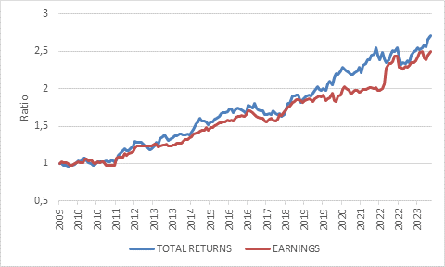

Source: LSEG Datastream

There are at least two approaches to answering this question. The first involves unpacking the reason for the trend, and the factors that could influence it in future. One reason has been a strong dollar. A strong greenback suppresses non-US returns when measured in dollars. It also tends to weigh on economic activity outside the US, including by making it more expensive to service dollar-denominated debt.

Another reason for US outperformance is the superior earnings growth of US-listed companies, as illustrated in chart 1. But a big part of the story is that investors have been prepared to pay more and more for each dollar of US earnings. In other words, the price: earnings ratio on US equities increased much more than in the rest of the world. In percentage terms, US equities are now 40% more expensive than non-US equities when measured using the forward PE ratio. It is not a perfect measure, but it is telling.

Chart 2: Forward price: earnings ratios

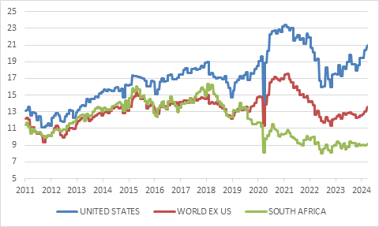

Source: LSEG Datastream

We can then try and make predictions or educated guesses about the future, for instance by making assumptions about the adoption of artificial intelligence, political and geopolitical shifts, or demographics. We could list the many relative strengths the US has: its unrivalled geography, energy independence, deep capital markets, culture of innovation and entrepreneurship, and world-beating universities that remain a magnet for global talent.

Kahneman himself was a case in point. Born in Israel and raised in France during the Nazi occupation, he ultimately settled in America as so many leading scholars do. Around 40% of all Nobel Prize winners are American citizens, of which around a third were born outside the US (including two South African-born laureates, the chemist Michael Levitt and biologist Sydney Brenner).

These are important things to think about. A behavioural approach, in contrast, does not require assumptions on these matters. It is simply a case of asking that, having already experienced a large multiple expansion in absolute and relative terms, how likely is this to repeat over the next decade or so?

The answer is surely: not very.

Kahneman once told Jason Zweig, the finance journalist, that the most important question to ask before making a decision is ‘What is the base rate?’ He meant that before an important decision is made, one should get an objective idea of the odds of success, such as looking at the historical range of outcomes in similar situations. For instance, half of marriages end in divorce. That is the base rate. Before marriage, every couple believes they will be happy, but the statistics tell a different story. Every marriage has only a 50/50 chance at the outset, including yours. Similarly, a certain percentage of new businesses will fail within a year. No one starts a business believing it will fail, but some will. This doesn’t mean you shouldn’t try, rather we should always be realistic on the probability of success in any given situation - and be aware of the pitfalls that usually lead to failure.

The “base rate” in this instance is that, usually, when a market trades at 20x forward earnings, the returns earned over the subsequent five to ten years are below par. PE multiples don’t move inexorably higher.

King Dollar
Similarly, we can ask whether the US dollar will strengthen substantially from current levels. As chart 3 shows, the dollar is well above its long-term average and in the 90th percentile of historic values on a real trade-weighted basis (in other words, it has only been stronger 10% of the time since 1971, when the link with gold was abandoned). A behavioural approach to this question does not require assumptions about the dollar’s status as global reserve currency, or whether fanciful ideas such as a BRICS currency can take off, or on the outcome of the upcoming US election, or the next Federal Reserve interest rate decisions.

It simply asks whether a decade-long trend can continue in what has historically been a mean-reverting series. On this basis, it seems unlikely that the dollar experiences another sustained upward move. If the dollar ends up hovering around current levels, it will not provide any further uplift for US returns relative to the rest of the world. If it falls, it should favour non-US markets.

Chart 3: Real Trade-Weighted US dollar

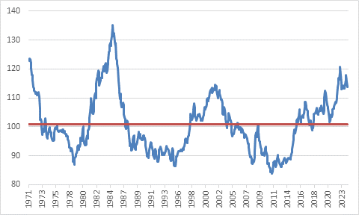

Source: LSEG Datastream

South Africa’s dismal decade
Finally, we can turn to the case of South Africa versus the rest of the world. South African equities have historically on average delivered attractive real returns. In fact, the well-known work of London Business School Professors Elroy Dimson, Paul Marsh and Mike Staunton suggests it is one of the top markets over the past century-plus, with an average annual real return of 7%. However, there were big cycles, and since 2013 we’ve seen a cycle of underperformance, not necessarily a “lost” decade but certainly a dismal one.

Chart 4: Five-year annualised total equity returns in rand

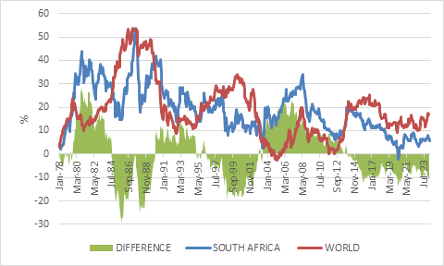

Source: LSEG Datastream

Chart 5 shows that since 2011, global equity returns have outpaced South African returns (in common currency) by more than the earnings growth outperformance.

Chart 5: World versus SA equities in dollars
As chart 2 above shows, SA equity valuations were in line with the rest of the world prior to 2016 but have derated substantially since then. Today it trades on a single digit forward PE ratio (along with the likes of Brazil and China). Again, the question is how likely it is that this trend continues?

One can get lost in arguments whether South Africa will ever get a grip on its myriad of social problems and whether its economy will ever get out of first gear. These are useful debates to have but are also a minefield of cognitive biases.

In fact, one of the biggest cognitive errors people make – one that can be very costly to investors – is confirmation bias, the tendency to seek out and believe information that supports a belief you hold, while ignoring information that contradicts it. We are all familiar with people (particularly salespeople and politicians) cherry picking data points to support an argument to the outside world. The problem is that we also tend to cherry pick facts even when we are quietly thinking about a topic. Both the SA-bashers and the SA-boosters can be guilty of this.

But once a market experiences a large and persistent derating in absolute and relative terms, it seems unlikely to suffer another similar decline.

To the extent that the underperformance of South African equities relates to the currency, (of course there is a strong rand-hedge element on the JSE), one makes a similar point about the rand. It is to some extent a mirror image of the dollar discussed above. We shouldn’t be surprised that the rand had such a torrid ride since 2011 since the dollar has been on a tear as chart 3 shows.

Approaching these questions with a behavioural mindset – e.g. how likely is it that a given trend persists – will never give us the full picture. The future is unpredictable, and all sorts of weird and wonderful things can happen. Importantly, this line of thinking can tell us nothing about when these trends reverse or what might be the catalyst for this to happen. Valuations can’t predict short-term returns. Over the next few quarters, the cheap can get cheaper and the expensive can get dearer since momentum is a powerful force in markets. But over longer periods – five to ten years – starting valuations have historically had a significant inverse relationship with returns.

Fortunately, in a balanced portfolio one does not need to take extreme, all-or-nothing views. It does not have to be the US or the rest or SA against the world. One can tilt allocations based on valuations and the probabilities that each asset class delivers a given return, but still remain diversified.

