Top 10 long-term stock picks for 2023
Chantal Marx, Head of Investment Research at FNB Wealth and Investments
Last year was yet another volatile year in global equity markets and another year in which the JSE underperformed most major international markets. The S&P 500 had a bumper showing after a difficult 2022 as the AI revolution gave impetus to the technology sector and saw a few new tech giants come to the fore. The Chinese market struggled as a much-anticipated reopening of that economy failed to materialise in the strong growth that was anticipated at the start of 2023.

This means that South African stocks remain attractively priced on a relative basis and so do Chinese companies. That said, there is very strong thematic thrust behind some of the US-based technology stocks, and with earnings expectations continuing to push higher, some of them (surprisingly) don’t look that expensive.

There should be some support for risk assets this year, particularly in the second half when it is widely anticipated that global central banks will begin to cut interest rates. However, there are major risks in 2024 that have been highlighted widely including geopolitical conflict, political risk as more than half of the world’s population heads to the polls, climate change and the possibility of further weather-related disasters, and macroeconomic uncertainty, to name but a few.

Against this backdrop, we prefer:
1) Stocks and ETFs that offer good value, in other words, are trading at low earnings multiples and offering good dividend yields.
2) Companies and ETFs that are defensive but could benefit in the event of a cyclical upswing.
3) Companies and ETFs with strong long-term thematic impetus.

Local picks

Compagnie Financière Richemont (CFR)

Richemont is a Swiss luxury goods group managed with a view to the long-term development of successful international brands. The company owns several of the world’s leading brands in the field of luxury goods, with particular strengths in jewellery, luxury watches and writing instruments. Brands include Cartier, Alfred Dunhill, Montblanc, Lancel, and Van Cleef & Arpels.

· Luxury goods, from a thematic perspective, remains attractive when considering an improvement in spending power of emerging market consumers.
· Richemont offers a unique and strong portfolio of brands, which is well-diversified from a product and geographic perspective.
· The group’s overall growth strategy is based on utilising central and regional support hubs to deepen market penetration in fast growing markets while seeking targeted acquisitions.
· Richemont also boasts a solid balance sheet and profitability measures, supported by low gearing levels, high cash generation, strong ROA, as well as robust ROE.
· The company’s cash position remains strong and is key to its defensive investment case. This also allows for large investment, which will support growth into the future.

Notwithstanding a continued uncertain macroeconomic and geopolitical environment, the group beat top-line expectations over the third quarter (to December 2023) amid solid growth across most business areas (Jewellery Maisons continued to generate the strongest performance) and regions (primarily driven by Japan, Asia Pacific, and the Americas). Year-to-date revenue growth is also tracking ahead of full-year expectations despite a tough comparable period, which was another key highlight.

All distribution channels, besides online, recorded a positive performance with double-digit retail sales growth being bolstered by a positive performance in all regions (except Europe) – notable strength was seen in mainland China, Hong Kong and Macau combined, as well as in the US. Retail also recorded the strongest relative channel performance, led by the Jewellery Maisons and Specialist Watchmakers, and further raised its contribution to 71% of group sales. Positive wholesale growth was sustained by strong sales at the Jewellery Maisons which more than offset a softer performance across the rest of the group, partly due to further targeted closures of external points of sale.

While the share price popped after the trading update, the group’s forward PE of 17.6 times is still well below its average rating historically and at a larger-than-normal discount to peers. We continue to see long-term potential in the sector.

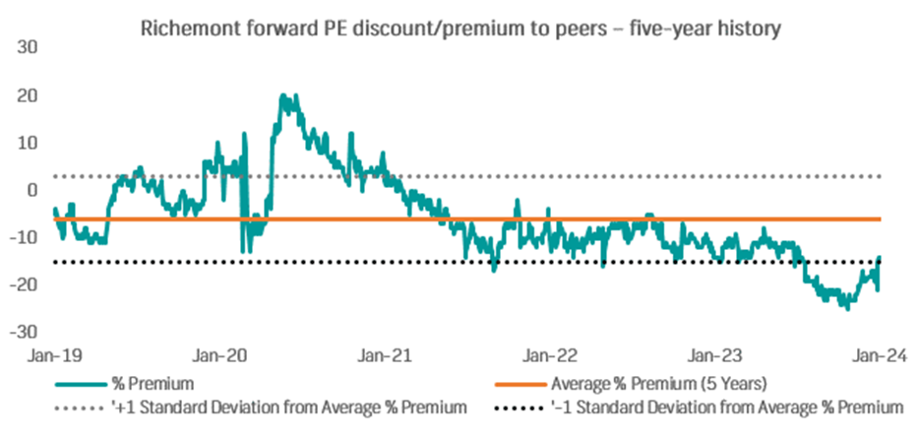
Source: Bloomberg

KAL Group (KAL)

Kal Group, formerly Kaap Agri, was founded over a century ago and has evolved through the years to become an agriculture and lifestyle company specialising in the trade and retail of agriculture, fuel, and other related products. The company provides a diversified range of products and services to the agricultural sector as well as the general public. KAL Group has a large footprint across southern Africa with hundreds of operating points in South Africa and Namibia, with additional expansion plans in the pipeline.

- The company is exposed to seasonality and uncontrollable forces like the weather, climate change, and water scarcity, among other risk factors, through its agriculture businesses. However, we remain positive on the agriculture sector longer term, as it remains well developed, highly diversified and globally competitive, with further R&D investments likely to drive improved crop yields and new sustainable farming technologies. In addition, demographic changes like urbanisation, a growing population, and particularly a growing middle class, means that demand for goods and services within this and related sectors will continue to grow.
- The group’s focus on fuel stations is positively perceived, providing additional diversification which also helps to offset the cyclical nature of the crop/seeds market.
- The company is exposed to currency fluctuations as much of its inventory is imported. A weak rand is negative for the company although this is negated somewhat through hedging.
- For investors seeking income, Kal Group has a consistent dividend payout ratio.

The group’s operating environment has been challenging, marked with negative impacts on farming and building materials sectors’ spending capacity due to tighter economic conditions, weather-related challenges, and load-shedding. However, the financial performance has remained resilient. Top-line growth was particularly strong during FY23, bolstered by significantly higher transactions growth y/y, thanks largely to the recently acquired PEG business which has accelerated growth across retail and fuel as well as quick service restaurant (QSR) channels. The group’s cash generation has also improved meaningfully over the past year, the balance sheet has strengthened and gearing improved.

Overall, we continue to like this company from a sectoral and strategic point of view, supported by its diverse operations. The current historic rating 6.5 times looks undemanding relative to the company’s growth prospects.

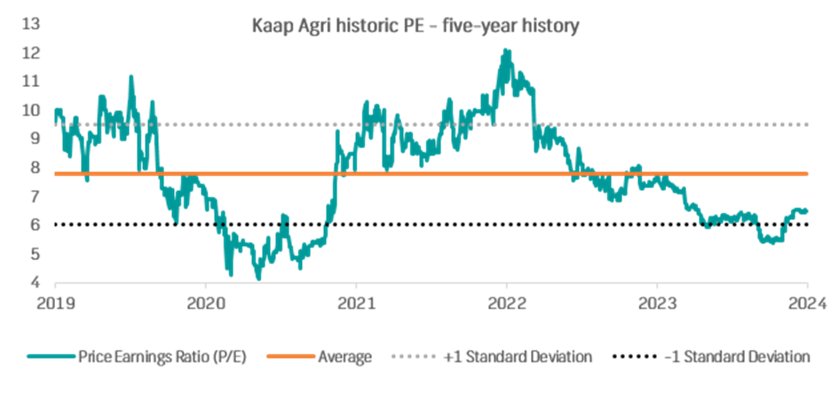
Source: Bloomberg

African Rainbow Capital Investments (AIL)

African Rainbow Capital Investments holds stakes in several companies through the ARC Fund. Notable investments include Rain and TymeBank. ARC’s mandate is to build a leading, black-controlled financial services and investment group by investing in attractive empowerment stakes across industries.
AIL and ARC boast quality management teams with strong track records.

- The assets are well-diversified across multiple sectors and exclude the heavily cyclical resources sector.
- ARC provides B-BBEE credentials and a professional network that allows ARC Investments to access assets not otherwise available for sale.
- There is a large component of unlisted high-quality investments. This means that AIL should, in theory, trade closer to NAV.
- The opportunity to gear up the entity still exists.
- The company’s contentious management fee structure was adjusted with no commensurate narrowing of the discount to NAV.
- As some of the assets mature – the possibility of value unlock exists. There has also been talk in the market that the company could be unlisted – we would expect an offer price to shareholders well below the current depressed valuation.

For FY23 (ended 30 June 2023), the overall portfolio showed resilience despite constrained macros supported by its diverse nature, with several underlying companies achieving key strategic objectives and improving growth prospects during the period. The fund concluded several disposals at attractive IRRs. The company recently concluded a rights offer, with the proceeds to be invested into Rain and Tyme, where we see good runway for growth. It was also confirmed early in January that Tyme Bank reached profitability at the end of last year – a key milestone.

African Rainbow Capital Investments is trading at a discount to NAV of 53% based on the June 2023 print. We expect the discount to unwind to a more reasonable level given the quality of the underlying assets. We continue to like the company’s investment strategy and believe it has the capability of extracting value from the existing portfolio and identifying quality investments in the future.

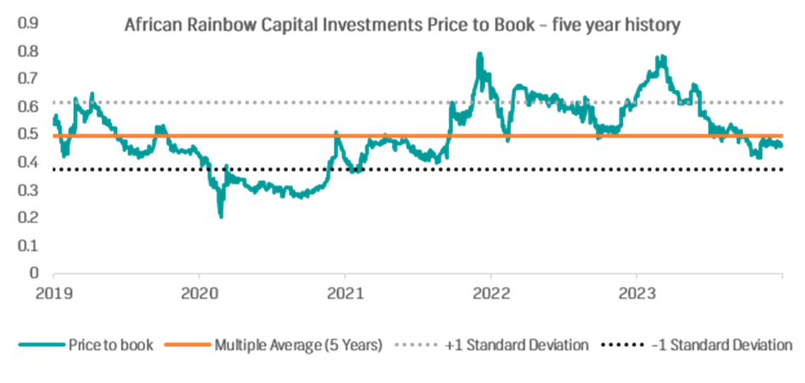
Source: Bloomberg

Afrimat (AFT)

Afrimat was founded by a consortium led by current CEO, Andries van Heerden, in 2006 through the merger of Prima, which mainly supplied aggregates to the Cape construction and road building industries, and Lancaster, which was involved in quarrying and the supply of concrete blocks and bricks in northern KwaZulu-Natal and eastern Free State. The group fully listed on the JSE in November 2006. Since its inception the company has applied a diversification strategy that has ultimately seen it grow through acquisitions and evolve into a multi-commodity, mid-tier miner, which is also able to produce and supply construction materials and high-quality industrial minerals. Afrimat has a wide-ranging geographic footprint, with its end market being both local and international.

- The strategy to diversify between commodities and revenue streams, coupled with stringent capital allocation, has enabled the group to weather economic and commodity shocks.
- Afrimat’s agile nature allows it to service major infrastructure and construction projects for public sector and government-owned enterprises, as well as small private sector contracts.
- An exacting focus on capital allocation and cash conversion has ensured the group’s ability to be a consistent dividend payer over the years.
- Afrimat boasts an exceptionally experienced executive and operational management team that has a superb track record in acquiring, assimilating, and then growing businesses.
- The most recent acquisition of Lafarge, a leading provider of construction materials, is set to create value for Afrimat through the significant operational synergies of its construction materials business with the well-established operations and product offerings of Lafarge. The group will benefit from increased national market share, operational efficiencies, and increased product volumes.
- The balance sheet remains strong, the group remains profitable, is debt free, and is sufficiently cash generative. Afrimat has continued to invest substantially in projects that are expected to yield fruitful returns and further strengthen diversity and provide a competitive advantage in the future.

For the interim period ended 31 August 2023, Afrimat reported resilient results with the group benefitting from its diversified portfolio that acted as an efficient hedge against volatile operating conditions. The Bulk Commodities segment (~48% of revenue) was impacted by lower external sales, but more than benefitted from a significant improvement in domestic sales volumes and a weaker rand. Management expects improved volumes in this segment over the next six months as it ramps up anthracite production at the newly opened underground Nkomati shaft. A notable contribution to performance was Construction materials (~41% of revenue), which saw double-digit revenue growth and triple-digit operating profit growth amid well executed cost-saving initiatives, and increased volumes supported by robust demand for products in roads and building and infrastructure projects.
Afrimat is trading on a forward PE of 7.8 times and EV/EBITDA of 4.2 times which seems compelling given its expected growth trajectory and optionality related to the Lefarge acquisition. Medium term we see upside in the Construction Materials business as gross fixed capital formation locally remains depressed currently and the infrastructure backlog continues to grow. The diversification benefit of Industrial Minerals and Bulk Commodities may provide a buffer to earnings in the meantime.

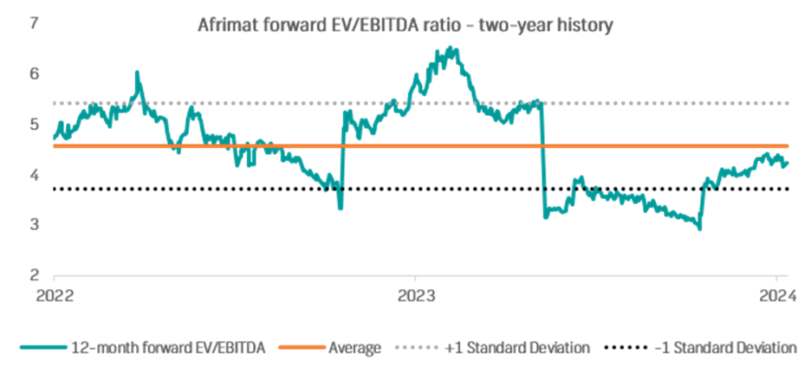
Source: Bloomberg

Bidcorp (BID)

Bidcorp is a market-leading food service product distributor across several geographies including the United Kingdom, Europe, Middle East, South America, the Asia-Pacific region, and South Africa. The company’s business units operate across the food and ingredient manufacturing sectors, such as catering, hospitality, leisure, baked products, poultry, meat, seafood, and processing. The strategy is to grow organically in existing regions and acquisitively in new ones, with improvements in the customer mix and value add opportunities providing further upside potential.

- The group has a well-diversified client base and businesses at different life cycles across developed and emerging geographies.
- Bidcorp is not overly exposed to any specific client or category, boasting healthy diversification across the portfolio.
- The company’s dual strategy of targeting organic (primary focus) and acquisitive growth spreads risk, with the flexible balance sheet offering room for further bolt-on acquisitions, which are under consideration across the group both in geographic expansion opportunities as well as value-add product development.
- The group’s market leading position in many countries of operation provides some pricing power in a low-margin industry.

Despite a challenging economic backdrop, the financial performance has shown resilience across its operating markets. Margins have also remained fairly healthy, against a demanding base, which is noteworthy given the current inflationary environment as most businesses were able to pass through inflation increases. The company remains financially strong, with relatively low levels of gearing and a robust business model with solid diversification and defensive characteristics.

Bidcorp is trading on a forward PE of 18 times, below its long-term average of 20 times. We maintain a favourable long-term view on the counter.

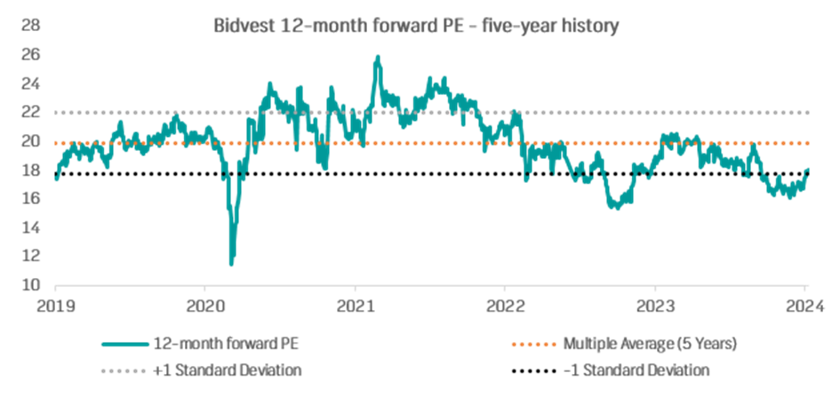
Source: Bloomberg

International Picks

Nvidia (NVDA US)

Nvidia was founded in 1993 by current CEO, Jensen Huang, and operates as a fabless chipmaker that outsources production to third party foundries such as Taiwan Semiconductor Manufacturing Company Limited (TSMC) and Samsung. The company created the Graphics Processing Unit (GPU) in 1999, which was originally used to render graphics in PC gaming but now has multiple applications including in Artificial Intelligence (AI). The GPU can render images faster because of its parallel processing capability, which allows the processor to perform multiple calculations at the same time. Along with GPUs and Central Processing Units (CPUs), Nvidia also develops Data Processing Units (DPUs), which are specialists in moving data around in data centres. The DPU is the third member of the data-centric accelerated computing model.

Nvidia reports across five divisions (Data Centre, Gaming, Professional Visualisation, Automotive, and OEM and Other) with Data Centre being the largest contributor to revenue.

- Nvidia feeds into many secular growth themes (such as cloud computing, generative AI, and vehicle automation), which should contribute strongly to growth for many years to come.
- Nvidia is the market leader in discrete GPUs – vital in the use of emerging technologies such as AI and autonomous systems. Nvidia’s growth will be driven by strong growth in Data Centre as companies invest in the latest technological advancements in AI. Although currently a small portion of revenue, Nvidia’s Automobile division will also likely be a driver of growth for the company as autonomous vehicle development gains traction.
- Nvidia’s higher-margin software should become a larger percentage of revenue, which will lead to higher gross margins over the longer term.

Growth over the past five years has been quite strong. Since FY18, Nvidia has achieved revenue and earnings growth (on a compounded annual basis) of ~23% each, which is particularly impressive considering the impact of the Covid-19 pandemic, geopolitical tensions, and macro-economic uncertainty throughout this period. FY23 (importantly, to the end of January) marked a slowdown in growth for the chip developer despite a strong performance from the Data Center business. The company’s top-line was hampered by the Gaming segment, which suffered weaker-than-expected consumer demand for its latest GPUs amid persistent macroeconomic weakness. The high inflationary environment contributed to a subdued bottom-line performance with the company’s margins also impacted by large inventory write-downs and prepayments to suppliers for fab capacity.

For FY24, however, the outlook is positive following the mass adoption and continued development of AI applications that has resulted in a major increase in demand. Nvidia is expected to report a massive rebound in growth, with triple-figure percentage increases being forecast for most key metrics. The company has also done well to maintain its substantial market position as well as technology leadership in gaming GPUs, despite lingering macroeconomic headwinds which is expected to complement an already very strong print from Data Centre.

Nvidia is trading on a 12-month blended forward PE ratio of 29.2 times, which despite a very strong rally in the share price over the last 12 months, still looks quite attractive compared to its history, with significant earnings growth to come. Compared to other chip developers, the company trades at a slight premium of ~7%, reflecting a strong contraction over the past six months (five-year average premium: 70%).

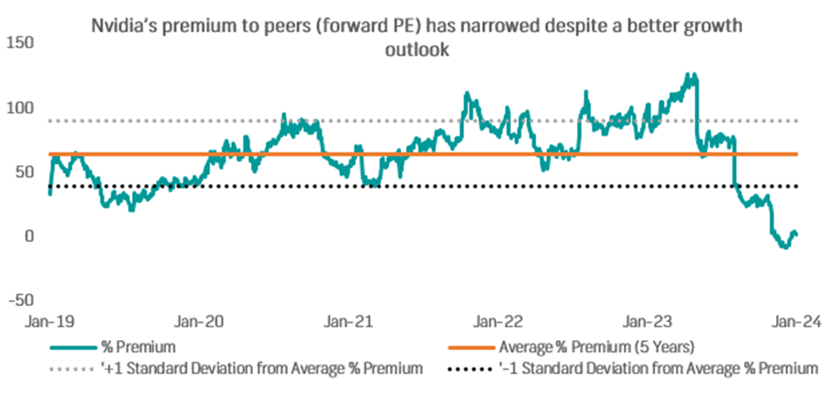
Source: Bloomberg

CVS Health (CVS US)

US healthcare giant, CVS Health, is a healthcare and retail pharmacy services company that offers prescription medications, beauty, personal care, cosmetics, and healthcare products. It also offers leading pharmacy benefit management (PBM) with ~110 million plan members, disease management, and administrative services. CVS has a wide-reaching physical presence across the US, with strong brand recognition and trust among consumers. In addition to its standalone pharmacy operations, the company operates ~1,880 retail pharmacies within retail chains, as well as ~60 clinics inside Target stores.

- CVS is expected to continue to benefit from increased prescription volumes, pharmacy claims (ex-Covid-19 vaccines), and drug price inflation. Within the insurance segment, Medicare Advantage (MA) – for people over 65 and certain people with disabilities, membership growth guidance was upwardly revised to +23% y/y for 2024 (previously +17%), which positions the company well for above-market growth over the medium term.
- This comes on the back of a rebound in Medicare ratings after a surprise drop last year, meaning better performance and quality. The company now expects to have 87% of members in highly rated plans in 2024, which, while neutral to earnings in the short term, should translate into bonus payments that lift revenue in 2025.
- CVS has been undergoing a transition, with several leadership changes announced over the year and a restructuring plan to streamline operations and reduce costs. The group’s extensive cost-cutting program is expected to support the company’s continued transition from being a major drugstore chain to a large healthcare entity.
- In this light, the company has made numerous acquisitions through the years which have transformed CVS into a leader in healthcare services with more diverse income streams, a competitive edge over its peers. Most recently, the group acquired healthcare provider, Signify Health (2022), and Oak Street Health (2023), a leading primary care company for older adults, to advance the company’s care delivery strategy. This, together with continued investment into technology and innovative healthcare solutions should bolster the group’s market position and expand its offering.
- Leadership believes its consumer-centric strategy will drive sustainable long-term growth and deliver value for all stakeholders.
- We like the defensive nature of healthcare/pharma stocks which tend to be relatively non-cyclical, with household spending less sensitive to economic downturns.

Despite prevailing macro headwinds, the group posted better-than-expected results in 3Q23, lifted by strong health services revenue growth. Adjusted earnings per share (EPS) were up 2% y/y at $2.21, while revenue rose 11% to $89.8 billion. The outlook for the year was recently upwardly revised, with adjusted 2024 EPS guided to be toward the upper end of the company’s forecast ($8.50 to $8.70).

In terms of valuation, CVS does not appear demanding on a forward PE multiple of 8.6 times, below its long-term average (9.6 times). It offers an attractive dividend yield of 3.5%.

Alibaba (BABA US)

Alibaba is a Chinese-based technology conglomerate specialising in e-commerce, online financial services, internet infrastructure, and internet content services.

- An enormous customer base as well as an ever-expanding product portfolio make it a formidable player in the e-commerce space, both in China and Internationally.
- The digital businesses have a substantial addressable market – China remains one of the largest countries in the world by population and boasts an internet penetration rate of more than 75%. More specifically, the cloud business is expected to maintain support from AI-related demand, and this remains one of the group’s strongest conviction points.
- While the market has been less than enthused on the Chinese economy post its reopening at the start of last year, economists still expect a further recovery in Chinese GDP growth, which is encouraging for all the businesses within the group.
- China’s regulatory environment encompassing internet companies appears to be easing due to pressure on the state regarding tepid economic growth, although this remains a risk.

Alibaba delivered a decent set of results for 2Q24 (to 30 September 2023) as revenue and adjusted EPS grew 9% y/y and 21% y/y, respectively. Strong profitability (adjusted EBITDA: +14%, margin: +100bps to 22%) was a key highlight, driven by a healthy top-line performance as well as robust cost containment efforts. As a result, cash generation for the company remained solid.

The group is in the process of restructuring its business into six stand-alone entities but recently decided to hold off on a possible spin-off of its cloud business. In any event, we think post-restructuring. each individual business is likely to attract a more appropriate valuation based on a more-specific growth outlook.

Alibaba underperformed the broader Chinese stock market as well as its global technology peers last year. The stock is trading on a forward PE of 7.2 times, which is quite attractive compared to its long-term historical average and implies a significant discount relative to its peers. Most sell-side analysts are still positive on the stock, with the consensus target price remaining well above the current share price.
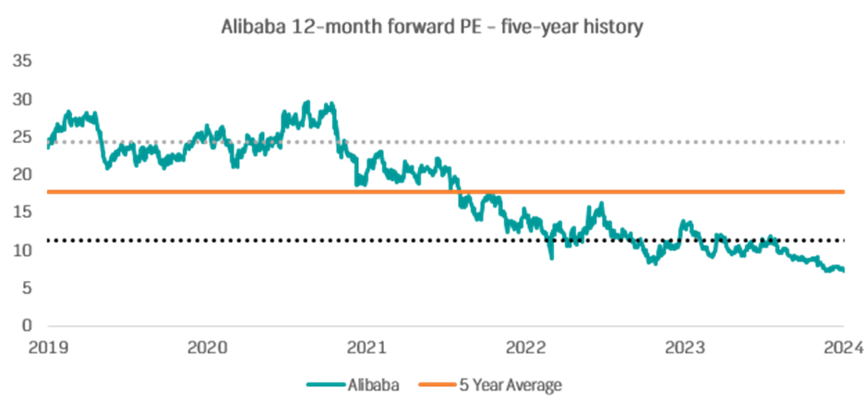
Source: Bloomberg

Global X Cybersecurity ETF (BUG US)

The Global X Cybersecurity ETF aims to invest in a portfolio of listed companies that stand to potentially benefit from the increasing adoption of cybersecurity technology. These may be companies whose principal business is in the development and management of security protocols preventing intrusion and attacks to systems, networks, applications, computers, and mobile devices.

- Thematically, the ever-evolving digital world has seen more sensitive data being exposed to security risks which has ultimately necessitated the growing need for cybersecurity solutions both at a personal and enterprise level. IBM estimates that the average cost of a data breach in 2023 was around $4.5 million, with ransomware related breaches estimated at $5 million on average.
- Per Global X, the outlook on cybersecurity solutions is robust, with spending forecasted to grow from $150 billion per annum currently to over $415 billion by 2030.
- Upside potential exists in the near term for constituents that are shifting from hardware to cloud-based subscription models (e.g., Crowdstrike and Palo Alto) as cloud penetration into cybersecurity continues to accelerate.
- Per Bloomberg intelligence, market-share gains for cloud-security segment leaders CrowdStrike and Zscaler, could expand as enterprises consolidate providers. The trends could help the larger cloud security companies sustain top-line growth around twice overall security spending.

Top 5 holdings
Stock Name | Weight | Proportion of sell-side ‘Buy’ recommendations
CrowdStrike Holdings | 6.7% | 90.2%
Zscaler | 6.6% | 73.9%
SentinelOne | 6.5% | 54.3%
Gen Digital | 6.3% | 55.6%
Palo Alto Networks | 5.6% | 82.4%

Source: Bloomberg

While the thematic has already played out well over the last two years, we think there is long-term support for the major players and are still comfortable taking exposure to the sector. Earnings growth has kept up well with share price appreciation for most of the firms held in the ETF. We think diversified exposure at this point, through an ETF, de-risks the investment case somewhat.

BlackRock Inc. (BLK US)

Blackrock is the world’s largest asset manager, offering both institutional and retail investors a wide range of financial products and services.

- Blackrock is the asset management global market leader and boasts a solid track record with a very attractive service offering.
- The company has shown that it can produce decent fund flows, revenue, and margins regardless of the environment, and offers defensive exposure in any market environment.
- The company came under pressure in FY22 and has somewhat recovered in FY23.
- Investors appear to be returning to the stock market amid rising expectations that the US Federal Reserve may soon enter a rate cutting cycle. We think that this thematic will continue throughout 2024 as investors come out to play in riskier areas. Blackrock is well-positioned to benefit from this cyclical support.
- The acquisition of Global Infrastructure Partners for ~$12.5 billion is expected to unlock value through holistic global infrastructure management across equity and debt solutions. The deal is particularly attractive as it will allow Blackrock to reposition itself in the private market with exposure to some of the fastest-growing segments - energy, transportation, digital, water and waste sectors.

Blackrock recently released decent 4Q23 results. The assets under management (AUM) figure was a notable standout, coming in higher than market expectations. Cost control was impressive and cushioned the blow of softer base fees. Management remains optimistic and confident that strong growth momentum will continue into FY24.

BlackRock is trading on a price to AUM of 1.2%, which is in-line with its history, however, we believe a higher rating is justified by the company’s scale and robust growth outlook.

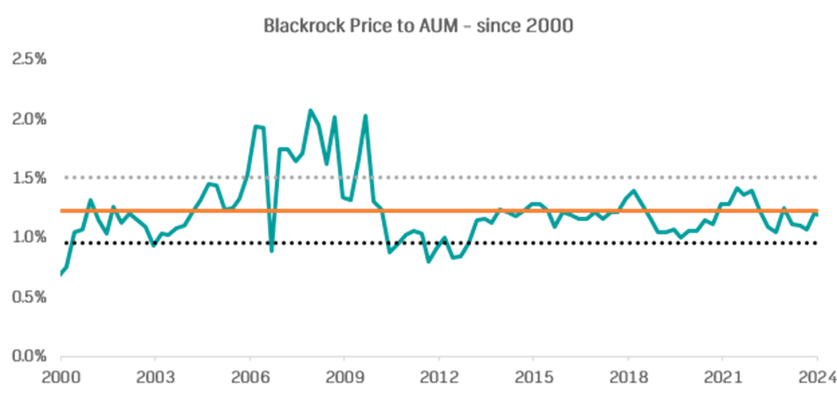
Source: Bloomberg

