  - State of the South African Economy
  - Sectoral insights accompanying the GDP data release
3 September 2019

Table of Contents
Table of Contents 2
1. State of the South African Economy 3
2. Key economic data 3
2.1 Real retail sales supported by low supermarket inflation rates 3
2.2 Wholesale trade boosted by higher fuel sales 4
2.3 Manufacturing environment improves but remains constrained 4
2.4 Mining production improves as iron ore price boost buoys output 4
2.5 Electricity distribution improves after end to loadshedding 5
2.6 Passenger vehicle sales continue recent volatile trend 5
2.7 Private sector credit extension shows continued improvement 5
2.8 Economic transactions no longer hampered by loadshedding 6
2.9 Freight transport gains momentum on increased mineral shipments 6
3. Key indices 6
3.1 Construction confidence drops as contractors struggle 7
3.2 Consumer confidence improves slightly after peaceful elections 7
3.3 Business confidence remains stagnant 7
3.4 Policy uncertainty increases due to debate over SARB mandate 8
3.5 Business climate problematic due to fiscal challenges and structural reforms needs 8
4. Conclusion: what is the State of the South African economy 8
5. Contacts 9

State of the South African Economy
Statistics South Africa (StatsSA) released the country’s latest gross domestic product (GDP) data on Tuesday, September 3. The South African economy expanded by 3.1% quarter-on-quarter (q-o-q) during 2019Q2. This was a much stronger outcome than expected and allowed South Africa to ward off a dreaded recession. The largest contributor to the q-o-q recovery in GDP was a 14.4% q-o-q rebound in mining activity – the first positive q-o-q reading in a year. Based in the q-o-q changes in real GDP, the South African economy was 0.9% y-o-y larger during the second quarter. This was a notable recovery from the 0.0% y-o-y number recorded in 2019Q1.
Many analysts commented ahead of the release that high-frequency data suggested that GDP would be healthier in the second quarter of 2019 compared to the first quarter of the year. The following subsections consider recent q-o-q and year-on-year (y-o-y) growth data for industries covering around 75% of the South African economy. This information gives a perspective on the state of the South African economy alongside the GDP numbers, and provide some context for the official data release.

Key economic data
The following subsections consider key economic data required to better understand the GDP outcome. These include retail and wholesale sales, manufacturing and mining production, electricity distribution, passenger vehicle sales, private sector credit, economic transactions and freight transport.

Real retail sales supported by low supermarket inflation rates
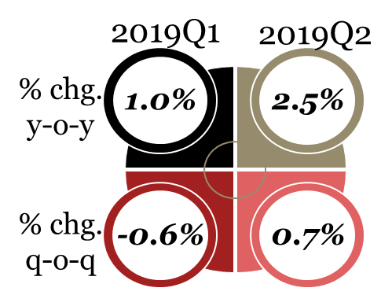
South African real (i.e. inflation adjusted) retail sales increased by 2.3% y-o-y in May and 2.4% y-o-y in June, with an average increase of 2.5% during Q1 of 2019. An improvement was seen in sales from a 0.6% q-o-q contraction in Q1 of 2019 to growth of 0.7% q-o-q in the second quarter.
A key reason for the improvement in real retail sales momentum was the continued inability of retailers to pass on price increases to cash-strapped consumer. Inflation in some supermarkets were below 2% over the past year.

Wholesale trade boosted by higher fuel sales
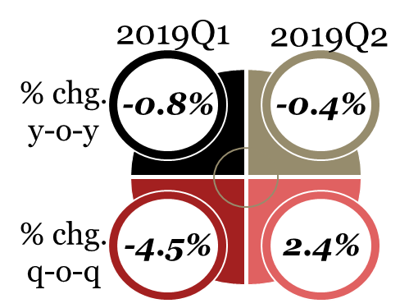
As retail trade conditions improved, wholesalers also experienced a more positive trading environment. Real wholesale trade decreased by 0.4% y-o-y in Q2 of 2019 compared to a decline of 0.8% y-o-y in the preceding quarter. Wholesale trade expanded by 2.4% q-o-q in the second quarter, versus a 4.5% q-o-q contraction in Q1 of 2019.
The main driver of this improvement was notably higher sales in the category “solid, liquid and gaseous fuels. and related products”.

Manufacturing environment improves but remains constrained
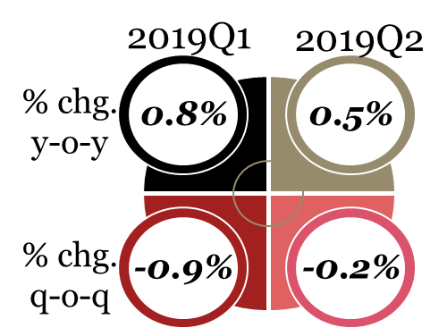
Manufacturing production volumes declined by 3.2% y-o-y in June after an increase of 0.4% y-o-y in May, with an average increase of 0.5% y-o-y during Q2 of 2019. Factory output contracted by 0.9% q-o-q in Q1 of 2019 and declined by another 0.2% q-o-q in the following quarter.
The improvement in manufacturing conditions is largely due to a decline in electricity loadshedding which enabled more stability in production activity. A stronger improvement in the factory sector was limited by the lack of sustained demand. Locally, the consumer remains under pressure, with unemployment sitting at 29%, while globally lingering trade war tensions impede exports.

Mining production improves as iron ore price boost buoys output
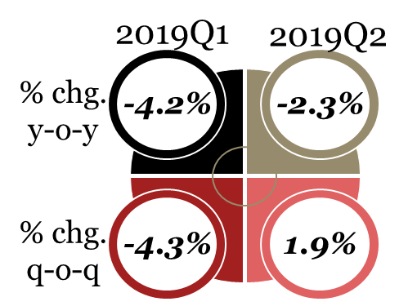
Mining production volumes contracted by 4.2% y-o-y in June after decreasing by 1.5% y-o-y in May, with the second quarter experiencing an average decrease of 2.3% y-o-y. This was however a smaller contraction than seen in Q1 of 2019. A 1.9% q-o-q expansion in production enabled this slowdown in the y-o-y decline.
Mining production has improved from the first quarter’s performance through greater stability in regulatory and operational aspects. Another key factor has been the growth of iron ore production which was helped by the drastic change in the price of the raw material: iron ore prices have increased by more than 75% over the past year.

Electricity distribution improves after end to loadshedding
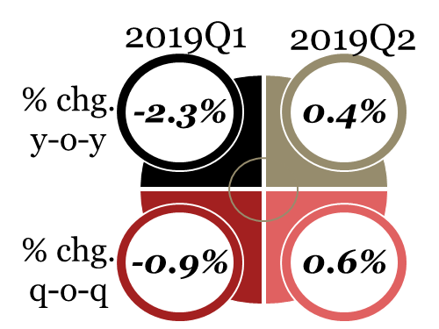
Electrical distribution (measured in gigawatt hours) increased by 0.1% y-o-y in June after declining by 0.6% y-o-y in May, with an average increased of 0.4% y-o-y during Q2 of 2019. On a quarter-to-quarter basis, an increase of 0.6% q-o-q was recorded in Q2 of 2019 compared to a decline of 0.9% q-o-q- in the first quarter
The improvement in electrical distribution was mainly due to the lack of loadshedding that has occurred during the second quarter. The sector has benefitted from support in the form of the government’s nine-point turnaround plan that was implemented since late-2018.

Passenger vehicle sales continue recent volatile trend
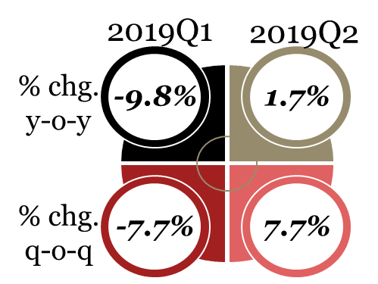
The number of new vehicles sold increased by 0.3% y-o-y in May and declined by 1.8% y-o-y in June. However, due to a 6.6% y-o-y increase in April, sales were an average of 1.7% y-o-y higher during Q2 of 2019. On a quarter-to-quarter basis, vehicle sales increased by 7.7% q-o-q, compared to a 7.7% q-o-q decline in the first quarter.
Vehicle sales have been volatile in 2019 so far, and the only real discernable trend in the market is the continued financial pressure on both consumers and businesses. For example, both segments were planning for increased electricity and other administered pries during Q3 of 2019.

Private sector credit extension shows continued improvement
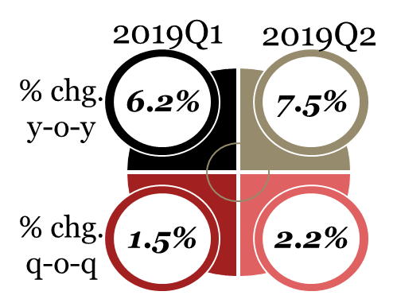
The nominal value of private sector credit expanded by 7.7& y-o-y in May and 6.9% y-o-y in June, with an average increase of 7.5% y-o-y in Q2 of 2019. This was a stronger pace compared to an increase of 6.2% y-o-y in Q1 of 2019. On a quarter-to-quarter basis, private sector credit growth increased from 1.5% q-o-q in Q1 of 2019 to 2.2% q-o-q in the most recent quarter.
Private sector credit growth has seen an upward trend in loans to households and companies. From a corporate perspective, credit demand from the construction and real estate sectors have held up well despite challenges in the industry. Credit to the wholesale and retail trade sector has been under pressure, with disappointing company results in this sector released in recent weeks.

Economic transactions no longer hampered by loadshedding
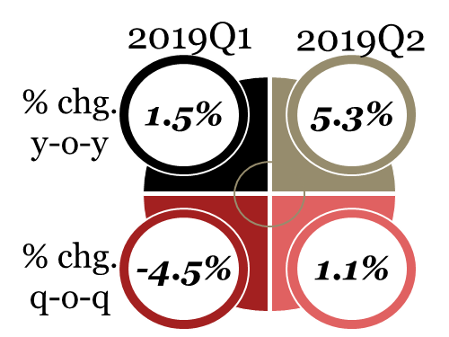
The BankservAfrica Economic Transactions Index (BETI) increased by 8.1% y-o-y in June after declining by 1.2% y-o-y in May, with an average increase of 5.5% y-o-y during Q2 of 2019. On a quarterly basis, a decline of 4.5% q-o-q in Q1 of 2019 was followed by a 1.1% q-o-q increase in the second quarter.
This improvement in the second quarter was largely due to the lack of loadshedding hurting the South African economy and buyers’ ability to conclude electronic transactions. This period showed that the consumer economy was still growing, albeit at a slow pace.

Freight transport gains momentum on increased mineral shipments
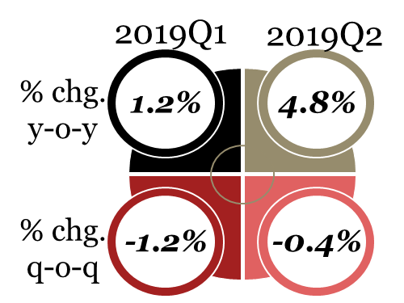
Freight transportation tonnage increased by 4.7% y-o-y in May and 5.2% y-o-y in June, with an average increase of 4.8% y-o-y in Q2 of 2019 being stronger than a figure of 1.2% y-o-y seen in the first quarter. On a quarterly basis, the decline in tonnage transported eased from a 1.2% q-o-q fall in Q1 of 2019 to a 0.4% moderation in the second quarter.
A sharp increase in the transport of mining & quarrying goods was a key driver of the improved freight conditions in Q2 of 2019. The value of mineral sales increased by 12.5% y-o-y during the second quarter, with iron ore and platinum group metals (PGMs) the largest contributors to recent increases.

Key indices
The following subsections reflect on key indices required to better understand the GDP outcome. These include construction sector confidence, consumer and business sentiment, policy uncertainty, and the overall business climate.

Construction confidence drops as contractors struggle
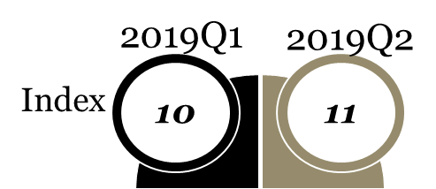
The RMB/BER Civil Confidence Index (CCI) edged higher in Q2 of 2019 to a reading of 11; only one point up than the all-time low of 10 recorded in the first quarter of the year. (The index ranges on a scale of 0 to 100, with a higher score indicating better sentiment). The outcome indicates that about 89% of respondents indicated they are not happy with prevailing business conditions.
Respondents to the BER survey highlighted weak activity growth, thin profit margins and a lack of new projects as their main challenges. Nearly nine out of ten respondents considered insufficient demand in new work as a constraint on their business operations.

Consumer confidence improves slightly after peaceful elections
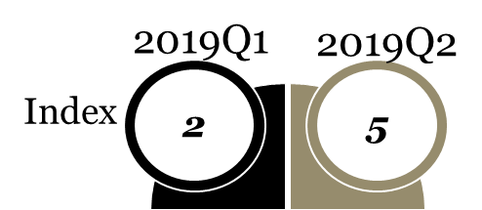
The RMB/BER Consumer Confidence Index (CCI) improved t0 5 index points in the second quarter of 2019 from 2 points in the previous period. A score of zero is considered neutral, with any reading above this level being positive.
This improvement in consumer confidence was mainly boosted by recent elections that concluded peacefully and the stabilisation of the country's power supply due to no loadshedding occurring during the period.

Business confidence remains stagnant
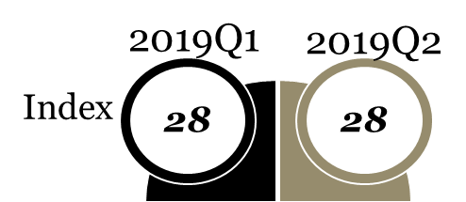
The RMB/BER Business Confidence Index (BCI) remained stagnant at a reading of 28 (on a scale of 0 to 100) during the first half of 2019, which is the lowest since Q2 of 2017. Any reading below 50 is considered pessimistic.
This negative sentiment has mainly been due to confidence deteriorating sharply among new vehicle dealers and manufacturers. Meanwhile, slight improvements were seen in building, retail and wholesale trade sectors during the second quarter that countered the adverse impact of the automotive situation on overall business confidence.

Policy uncertainty increases due to debate over SARB mandate
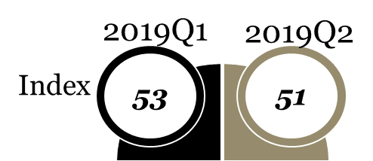
The North West University (NWU) Business Schools' Political Uncertainty Index (PUI) deteriorated from 53 in Q1 of 2019 to 51 in the second quarter, as negative factors outweighed positive indicators. A higher number indicates greater policy uncertainty.
The biggest factor behind the deterioration in policy certainty was the growing debate within the African National Congress (ANC) over the constitutional mandate of the South African Reserve Bank (SARB). Some positive impetus was taken from the second State of the Nation Address (SONA) of the year.

Business climate problematic due to fiscal challenges and structural reforms needs
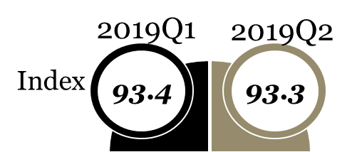
The South African Chamber of Commerce and Industry (SACCI) BCI increased from 93.0 index points in May 2019 to 93.3 index points in June 2019, with an average of 93.3 index points in Q2 of 2019 in comparison to a first quarter mean of 93.4.
The main reasoning for this weaker measurement of the business climate was a depreciation of the rand, the urgent need for structural reforms weighing on the economic outlook, as well as fiscal deterioration and how SOEs and municipalities are led, managed and operated.

Conclusion: what is the State of the South African economy
The above sections reflected on 14 economic indicators in order to gauge the health of the South African economy alongside the GDP data release. Out of the 14 indicators, only three – business confidence, policy uncertainty and the business climate indicator – has shown no improvement or deterioration during the second quarter of 2019. The other 11 indicators all registered some improvement – and notable gains in some cases. This is also reflected in the improved GDP data outcome.

Contacts
 | Lullu Krugel  Chief Economist, Partner  E: lullu.krugel@pwc.com  T: +27 (0)11 797 4929
 | Christie Viljoen  Economist, Manager  E: christie.viljoen@pwc.com  T: +27 (0)21 529 2595



This report is protected under the copyright laws of South Africa and other countries as an unpublished work. This report contains information that is proprietary and confidential to PricewaterhouseCoopers Incorporated, which shall not be disclosed outside the recipient’s company or duplicated, used or disclosed in whole or in part by the recipient for any purpose other than to evaluate this document. Any other use or disclosure in whole or in part of this information without the express written permission of PricewaterhouseCoopers Incorporated is prohibited.
At PwC, our purpose is to build trust in society and solve important problems. We are a network of firms in 158 countries with more than 236,000 people who are committed to delivering quality in assurance, advisory and tax services. Find out more and tell us what matters to you by visiting us at www.pwc.com.
PwC refers to the PwC network and/or one or more of its member firms, each of which is a separate legal entity. Please see www.pwc.com/structure for further details.
© 2019 PwC. All rights reserved

This proposal is protected under the copyright laws of South Africa and other countries as an unpublished work. This proposal contains information that is proprietary and confidential to PricewaterhouseCoopers Incorporated, which shall not be disclosed outside the recipient’s company or duplicated, used or disclosed in whole or in part by the recipient for any purpose other than to evaluate this document. Any other use or disclosure in whole or in part of this information without the express written permission of PricewaterhouseCoopers Incorporated is prohibited.
At PwC, our purpose is to build trust in society and solve important problems. We’re a network of firms in 158 countries with more than 236,000 people who are committed to delivering quality in assurance, advisory and tax services. Find out more and tell us what matters to you by visiting us at www.pwc.com.
PwC refers to the PwC network and/or one or more of its member firms, each of which is a separate legal entity. Please see www.pwc.com/structure for further details.
© 2018 PwC. All rights reserved

This proposal is protected under the copyright laws of South Africa and other countries as an unpublished work. This proposal contains information that is proprietary and confidential to PricewaterhouseCoopers Incorporated, which shall not be disclosed outside the recipient’s company or duplicated, used or disclosed in whole or in part by the recipient for any purpose other than to evaluate this document. Any other use or disclosure in whole or in part of this information without the express written permission of PricewaterhouseCoopers Incorporated is prohibited.
At PwC, our purpose is to build trust in society and solve important problems. We’re a network of firms in 158 countries with more than 236,000 people who are committed to delivering quality in assurance, advisory and tax services. Find out more and tell us what matters to you by visiting us at www.pwc.com.
PwC refers to the PwC network and/or one or more of its member firms, each of which is a separate legal entity. Please see www.pwc.com/structure for further details.
© 2018 PwC. All rights reserved

This proposal is protected under the copyright laws of South Africa and other countries as an unpublished work. This proposal contains information that is proprietary and confidential to PricewaterhouseCoopers Incorporated, which shall not be disclosed outside the recipient’s company or duplicated, used or disclosed in whole or in part by the recipient for any purpose other than to evaluate this document. Any other use or disclosure in whole or in part of this information without the express written permission of PricewaterhouseCoopers Incorporated is prohibited.
At PwC, our purpose is to build trust in society and solve important problems. We’re a network of firms in 158 countries with more than 236,000 people who are committed to delivering quality in assurance, advisory and tax services. Find out more and tell us what matters to you by visiting us at www.pwc.com.
PwC refers to the PwC network and/or one or more of its member firms, each of which is a separate legal entity. Please see www.pwc.com/structure for further details.
© 2018 PwC. All rights reserved

Statistics SA, 2019. Gross domestic product, second quarter. http://www.statssa.gov.za/publications/P0441/P04412ndQuarter2019.pdf
Statistics South Africa, 2019. Retail trade sales (preliminary), June. http://www.statssa.gov.za/publications/P62421/P62421June2019.pdf
Business Report, 2019. SA retail sales lift by 2.4%. https://www.iol.co.za/business-report/economy/sa-retail-sales-lift-by-24-30771672
Business Insider, 2019. This is how much prices increased at Game, Woolworths, Checkers, Spar, and Pick n Pay over the past year. https://www.businessinsider.co.za/food-retails-prices-increases-amid-fierce-competition-2019-8
Statistics South Africa, 2019. Wholesale trade sales (Preliminary), June. http://www.statssa.gov.za/publications/P61412/P61412June2019.pdf
The South African, 2019. Stats SA: Wholesale trade sales decreased by 5,4% in June. https://www.thesouthafrican.com/news/stats-sa-wholesale-decreased-in-june/
The South African, 2019. Stats SA: Wholesale trade sales decreased by 5,4% in June. https://www.thesouthafrican.com/news/stats-sa-wholesale-decreased-in-june/
Statistics South Africa, 2019. Manufacturing: Production and Sales (preliminary). http://www.statssa.gov.za/publications/P30412/P30412June2019.pdf
Fin24, 2019. Manufacturing production for June worse than expected. https://www.fin24.com/Economy/manufacturing-production-for-june-even-worse-than-expected-20190808.
Statistics South Africa, 2019. Mining: production and sales (preliminary). http://www.statssa.gov.za/publications/P2041/P2041June2019.pdf
Fin24, 2019. June mining production drops 4.2%. https://www.fin24.com/Companies/Mining/june-mining-production-drops-42-20190808
Statistics South Africa, 2019. Electricity generated and available for distribution (Preliminary). http://www.statssa.gov.za/publications/P4141/P4141June2019.pdf
The South African, 2019. Electricity consumption in South Africa drops, production improves slightly. https://www.thesouthafrican.com/news/electricity-in-south-africa-things-may-be-looking-up/
South African Reserve Bank (SARB), 2019. Monthly release of selected data. https://www.resbank.co.za/Research/Statistics/Pages/MonthlyReleaseOfSelectedData.aspx
Wesbank, 2019. Volatility presides in new vehicle industry. https://www.wesbank.co.za/wesbankcoza/pressroom/archive/2019/07/01/new-vehicle-sale-commentary/volatility-presides-in-new-vehicle-industry
South African Reserve Bank (SARB), 2019. Monthly release of selected data. https://www.resbank.co.za/Research/Statistics/Pages/MonthlyReleaseOfSelectedData.aspx
South African Reserve Bank (SARB), 2019. Quarterly Bulletin, June. https://www.resbank.co.za/Lists/News%20and%20Publications/Attachments/9328/01Full%20Quarterly%20Bulletin%20%E2%80%93%20June%202019.pdf
Moneyweb, 2019. Long road ahead for SA retailers. https://www.moneyweb.co.za/news/companies-and-deals/long-road-ahead-for-sa-retailers/
BankservAfrica, 2019, Load shedding stops economy in its tracks. https://www.bankservafrica.com/api/public/blogblob/5cc033283724080042e2397b
Fin24, 2019, SA's bank transactions a good sign for growth - maybe. https://www.fin24.com/Economy/sas-bank-transactions-a-good-sign-for-growth-maybe-20190613-2
Statistics SA, 2019. Land transport (Preliminary). http://www.statssa.gov.za/publications/P7162/P7162June2019.pdf
Statistics SA, 2019. Land transport (Preliminary). http://www.statssa.gov.za/publications/P7162/P7162June2019.pdf
Statistics SA, 2019. Mining: Production and sales (Preliminary). http://www.statssa.gov.za/publications/P2041/P2041June2019.pdf
Bureau for Economic Research, 2019. The State of the Civil Construction Industry. https://www.ber.ac.za/BER%20Documents/BER-press-release/?doctypeid=1068
Bureau for Economic Research, 2019. The State of the Civil Construction Industry. https://www.ber.ac.za/BER%20Documents/BER-press-release/?doctypeid=1068
BER, 2019. FNB/BER Consumer Confidence Index. https://www.ber.ac.za/BER%20Documents/FNB/BER-Consumer-Confidence-Index/?doctypeid=1054
Tradingeconomics, 2019.South Africa Consumer Confidence. https://tradingeconomics.com/south-africa/consumer-confidence
BER 2019, FNB/BER Business Confidence Index. https://www.ber.ac.za/BER%20Documents/RMB/BER-Business-Confidence-Index/?doctypeid=1050
BizNews, 2019. Business confidence hits pre-Ramaphoria levels. https://www.biznews.com/briefs/2019/03/13/business-confidence-pre-ramaphoria-levels
NWU Business School, 2019. Policy Uncertainty Index. http://commerce.nwu.ac.za/sites/commerce.nwu.ac.za/files/files/TRADE/Media/Print%20Media/PUI%20-%201Q%202019.pdf
NWU Business School, 2019. Policy Uncertainty Index. http://commerce.nwu.ac.za/sites/commerce.nwu.ac.za/files/files/TRADE/Media/Print%20Media/PUI%20-%201Q%202019.pdf
IOL, 2019. Sacci reiterates call for government to act as SA's July business confidence dips. https://www.iol.co.za/business-report/economy/sacci-reiterates-call-for-government-to-act-as-sas-july-business-confidence-dips-30438633

