South Africa: is the worst of the energy crisis over?

Schroders

This year’s election brings uncertainty, but the private sector has shown it can help solve some of South Africa’s long-term challenges.

• Robert Davy, emerging Market Equities Fund Manager
• Andrew Rymer, CFA, Senior Strategist, Strategic Research Unit
We discussed our favourable view of South Africa in April of last year. While the market has underperformed wider emerging markets (EM) since then, there have been some positive developments in line with our thesis. The private sector response has started to gradually ease the electricity crisis, with both the number of days and severity of loadshedding (energy rationing) falling. Meanwhile, bond yields globally and in South Africa have fallen from peak.
Broader reform has continued to be slow. Meanwhile, the logistics situation has seen deterioration, with ageing infrastructure, inefficiencies and other factors continuing to hamper capacity at Transnet, the state-owned enterprise (SOE) which manages ports, rail freight, and pipelines.
With elections approaching, and a potential pickup in uncertainty, is there reason to be more cautious? We assess the outlook for South Africa.
Why South Africa has lagged EM since April last year
There are various drivers of underperformance since we published our last note in April 2023. Allegations of arms provision to Russia sent equities down by almost 15% in US dollar terms in May last year. The energy crisis saw further deterioration, before seeing improvement more recently. Meanwhile, the market’s sensitivity to US interest rates led to some weakness in Q3 as US rates spiked. Weaker metals prices and performance from the largest index stock, Naspers, which is largely driven by its holding in China’s Tencent, were notable drags on market performance over this period.
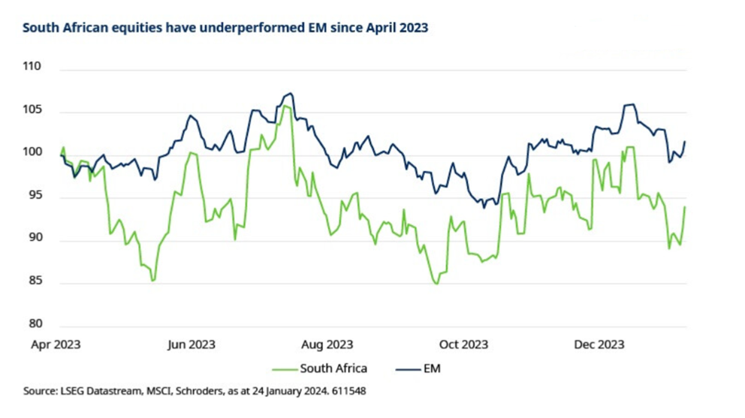
Weakness in the growth outlook to persist…at least for 2024
South Africa’s economy contracted by -0.7% year-on-year (y/y) in Q3 2023, with the Q2 outturn also downgraded, as loadshedding and logistical challenges constrained activity. The central bank estimates that the impact of loadshedding will shave two percentage points from full year 2023 GDP growth, projected at around 1%.
We’ll come on to the energy crisis, but it is our expectation that the worst point has now passed. A rapid recovery is not on the cards, but this drag on growth should gradually ease over the next few years. That said, modest improvement on the power front will be offset by the weaker exports outlook, amid relatively lower platinum group metals (PGM) prices. The IMF anticipates the economy to grow by just shy of 1% in 2024.
Inflation remains within the central bank’s 3-6% target band range, at 5.5% y/y in November. The central bank has held its policy rate at 8.25% since July, having hiked from a low of 3.5% in November 2021. Rate hikes have been rapid, but consensus expectations are that rates have now peaked. Higher rates have added to the burden on households and been a clear drag on consumption over the past 12 months. Also worth noting is the still high rate of food inflation, at 9.0% y/y.
Long-term challenges have not disappeared, but there is incremental improvement
The lack of power continues to be a major impediment to economic growth. Logistics is the other notable challenge, which has hampered the export of coal and iron ore among other commodities. Both sectors of the economy are dominated by troubled SOEs which have been hobbled by historical mismanagement and whose operations have experienced service declines over the past decade.
The thesis for investors in South Africa is that private sector investment can play its part in delivering long term sustainable resolution to these challenges. We discussed the issues around this last year, in that it takes time, given it is partly political, and as it often takes until the SOE operations are in dire straits.
One critical reform that has been implemented is the lifting of private power generation caps. But this action was taken due to emergency rather than proactive reform. South Africa expects that by the end of 2024, four gigawatts (GW) of generation capacity will be added to the grid. This, coupled with operational improvements at state-controlled power company, Eskom, should result in reduced loadshedding in 2024 and 2025.
The move follows a debt relief plan for Eskom of ZAR254 billion in last year’s budget. This was a positive milestone and should enable Eskom to improve transmission and invest in the network to be ready for more renewables roll out. 2023 still looks like it will mark the peak in the energy crisis in terms of loadshedding. There is potential for power cuts to be reduced significantly in 2024 after certain power stations come back online following repairs. Renewables being added to the grid will also help considerably. Meanwhile, an easing in demand from some households and businesses moving off-grid will also help. Around 4.4GW of rooftop solar has so far been added at households and businesses.
The twin deficits increase the sensitivity of South African assets to US rates
South Africa has run a budget deficit for over 15 years, and the government projects that debt-to-GDP will rise to 75% by the end of the current fiscal year ending March 2024. A spike in metals prices over the last few years, specifically PGM, was fiscal positive. However, the windfall tax receipts are now fading as PGM prices have fallen. Lower commodity prices, together with bailouts for SOEs are key drags on the fiscal accounts. Managing the public sector wage bill is a further challenge for the government.
While the fiscal outlook may be somewhat gloomy, the Medium-Term Budget Policy Statement, announced in late October of last year, re-affirmed the government’s commitment to fiscal consolidation. The Social Relief of Distress (SRD) grant, initially introduced during the pandemic, was extended for another year to March 2025 but the Treasury made clear that this would need to be financed from elsewhere longer term. A two-year agreement on public sector wages was also positive. The risk of fiscal slippage cannot be ignored though, given ongoing labour negotiations and the upcoming general election.
The economy posted current account surpluses in 2020 and 2021, for the first time since 2002. However, with the period of high commodity export prices having faded, a deficit has remerged. A deficit of around 2% is projected for 2023.
The twin fiscal and current account deficits amplify the sensitivity of South African assets in US dollar terms for international investors. An improvement in global commodity prices in 2024 would likely provide welcome relief on this front, as would lower US rates and a weaker US dollar.
Does the election pose a risk to the outlook?
National elections are due to be held at some point between mid-May and the end of August this year. The African National Congress (ANC) Party, which has governed the country since 1994, is anticipated to retain power.
Unless there is a significant shift in opinion polls in the run-up to the election, the key question is the scale of a potential ANC majority, or whether the party needs to form a coalition. The strength of a majority might have implications for potential reforms. Equally, the need for a coalition partner could bring a less market friendly change in policy. The key figure is 45% of the vote share, as anything below this would likely require a coalition with a smaller, less market friendly, party.
One additional point to note is a degree of key man risk. President Ramaphosa has been the driving force behind the modest reform progress of recent years, and there is no obvious credible candidate with sufficiently broad support within the party to take over the mantle.
The election naturally creates uncertainty in the outlook. Our base case remains for the ANC to retain power, and for reforms to continue, even if only incrementally. While these are not our expectation, alternative scenarios imply higher risk, given the likely greater degree of potential policy change implied, and the potential for reforms to be stalled or reversed.
What do valuations look like?
Aggregate market valuations for the MSCI South Africa Index are cheap on a composite Z-score basis, when compared to their historical average. This measure captures trailing price-earnings, 12-month forward price-earnings, price-book, and dividend yield.
Average (trailing P/E, P/E, P/B, dividend yield) (z-score¹)
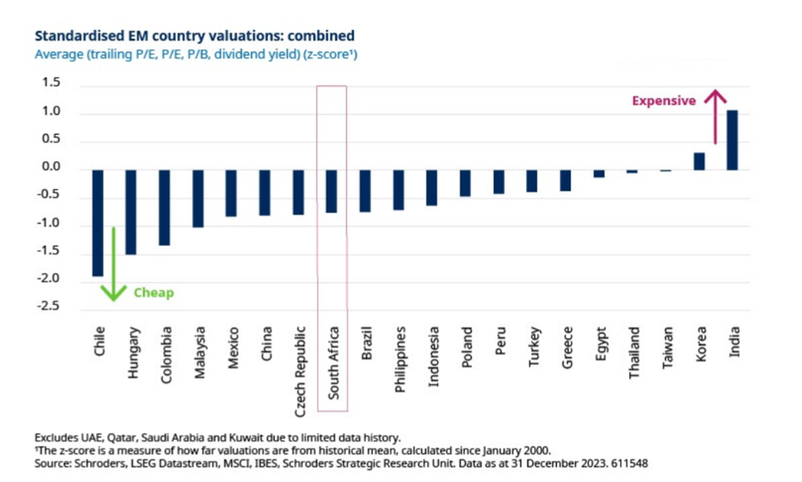
When compared with other EM, South Africa is cheap on a range of measures. On a price-book measure in particular, the market’s premium versus the broad EM average has been completely vanquished, as the chart below highlights.
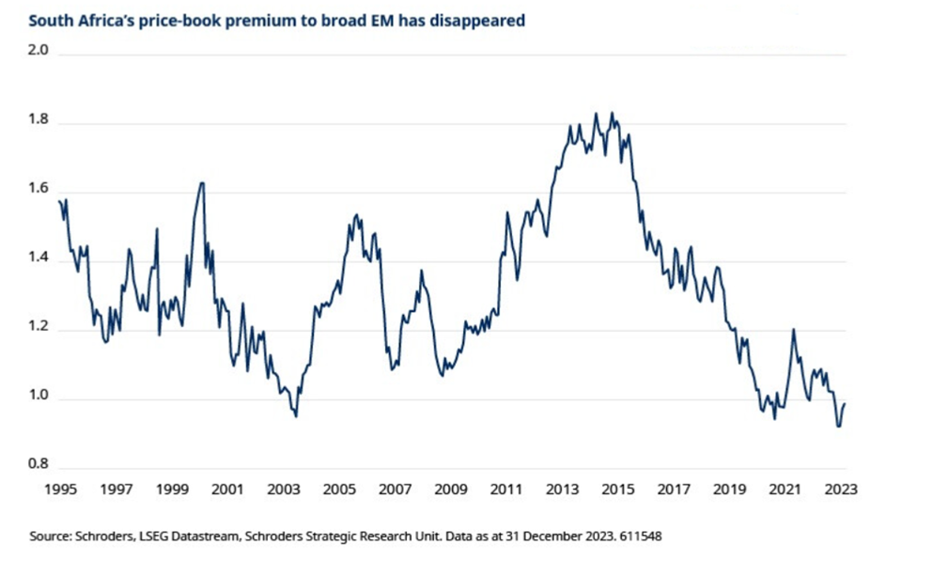
The South African rand remains cheap versus history; only the Turkish lira is further from its long-term average on this basis. The rand is around 30% below its historical average since 1995 on a real exchange rate basis, and 10% on a last five-year basis.
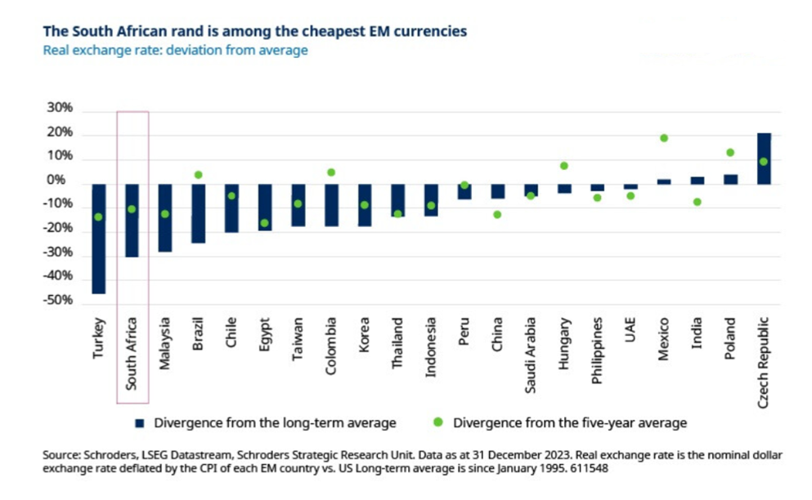
Market performance has been more nuanced than headline figures suggest
While South African assets have lagged wider EM at the headline market level since our last note in April 2023 (to January 2024), it is notable that this masks some market divergence.
Materials, which represents around 23% of the MSCI South Africa, was by far the weakest sector due to declining commodity prices. Communication services, which is around 7% of the index, was also particularly weak. The only other sector to post a negative return was consumer discretionary. This sector is around 20% of the index and is dominated by Naspers, whose main asset is China’s Tencent.
By contrast, financials, 35% of the index, were helped by higher rates, and consumer staples, 8% of the index, posted double digit gains over the same period.
Our view on South Africa
The structural challenges facing South Africa’s economy persist and reform has been slow. There are some signs of the private sector stepping up to resolve challenges, for example in the energy and logistics sectors. Indeed, there has been some improvement in the energy sector, with reduced loadshedding, albeit this will remain an issue for some time. Even so, significant uncertainty continues to overhang the longer-term growth outlook.
In the near term, falling global interest rates should also benefit South African assets if these follow through later this year. In addition, we continue to identify attractive, high-quality bottom-up opportunities within the market. Indeed, among the domestic companies in particular, the earnings outlook is projected to improve this year, after the negative impact from loadshedding and higher rates in 2023.
However, a general election is due to be held between mid-May and August. This creates uncertainty over the already slow reform outlook, with a risk that the ruling ANC loses its majority. We maintain a favourable view on the market but are more cautious given this backdrop.

