Saving for the future: why cash won’t cut it

Philip Robotham, Head of Intermediary at Schroders

Cash deposits might seem a safe way to save. But if you hold onto cash for long periods, it can pose a serious risk to your wealth.

Cash savings accounts are extremely useful ways of setting aside money to use for short-term spending or emergencies. They are also familiar and reassuring: after all, the cash is somewhere secure.
But in fact, for longer-term goals – such as buying property, paying for education or saving for retirement – cash is not so smart. Over time, cash savings are riskier than other forms of investment. This is because cash is less likely to keep pace with inflation, meaning your overall wealth could fall.
For the past 30 years inflation around the world has averaged at well over 5% per year¹. With inflation at 5%, a bunch of flowers which cost $20 one year would cost $21 the next.
Unless your savings deliver returns of 5% or more, you are losing money.
Inflation is only one enemy of cash: time is the other
Many countries aim to keep inflation low, for example at a target of 2%. A low figure like 2% or 3% may not seem harmful over the short term. But over longer periods the harm to your wealth can be great, even where the inflation rate is modest.
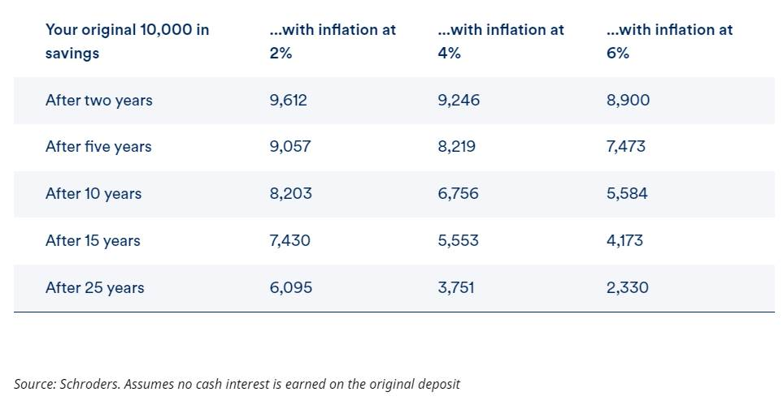
In real life, the rate of inflation is different for all the different goods and services that you buy. In many parts of the world the costs of healthcare and housing, for example, have gone up faster than the prices of other items.
Cash savings? You could be vulnerable if everyday essentials rise sharply in price
If inflation is especially high for essentials, then savers who depend on cash for their future spending could face difficulties.
In 2022, a difficult year when world trade was being disrupted by the aftermath of the pandemic and the outbreak of conflict in Ukraine, global inflation averaged 8% across all goods measured.
But the 8% figure concealed some more unpleasant truths. Food inflation averaged 12%, and energy inflation averaged 14%¹. In some countries it was far higher.
With food inflation at 12%, the amount of food you can buy for every $1 will be almost halved in five years. After 10 years your $1 will buy just one third of the original amount.
But surely if I earn a good rate of interest on my cash I can beat inflation?
Cash earns interest on deposit and that can help in the fight against inflation. However not all accounts pay attractive rates of interest all the time. And during periods when savings rates are high, inflation tends to be higher too.
So just how easy is it to beat inflation with cash? We looked back over almost 100 years of historical returns to discover exactly what the likelihood is that your cash will beat inflation if you saved for ANY period of one year, three years, five years or ten years. And this is what we found.
% chance of beating inflation if you save in either cash or shares – over different timeframes
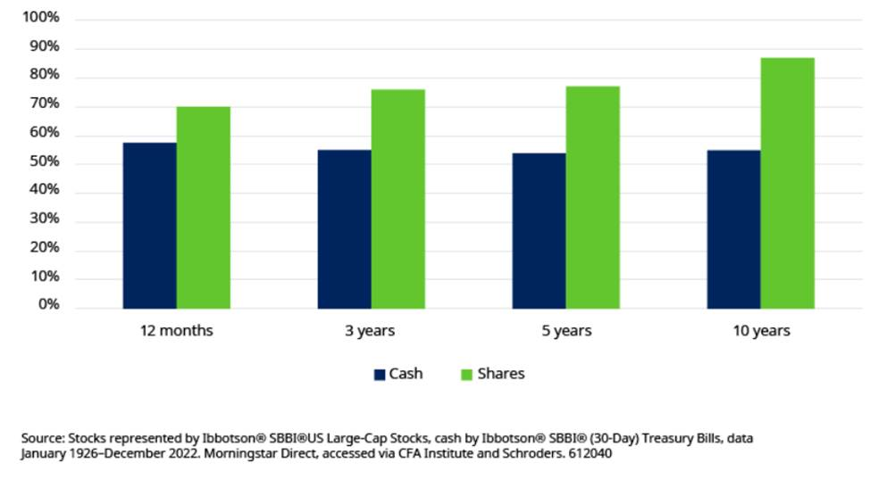
The chart shows that cash has an approximately 60:40 chance of beating inflation, however long you save for. By comparison the likelihood of stock market investments beating inflation increases quickly the longer you invest.
In fact, the likelihood of stock market investments beating inflation reaches 100% for any time period of 20 years.
If cash savings pose a threat to my long-term wealth, what can I do to protect myself?
As the chart shows, not all investments are equally likely to lose out to inflation. So one way to safeguard your wealth could be to expose your savings to a range of investments such as shares, bonds, real estate and other alternative assets.
These all generate returns in different ways, and all offer a good opportunity – but not a guarantee – to beat inflation.
¹Source: The World Bank. A Global Database of Inflation (worldbank.org)

