How climate change and higher inflation have affected our 30-year return forecasts

Schroders

Climate change and shifts in return forecasts underline how investors will need to work harder

• Tina Fong, Strategist at Schroders
• Samar Khanna, Environmental Economist at Schroders
• Irene Lauro, Environmental Economist at Schroders
Each year Schroders’ team of economists helps investors take a truly long-term view with 30-year return forecasts for a range of asset classes around the world.
These forecasts are unique because they include the effect of climate change, which is added on top of a set of building blocks to produce our estimates.
In Part 1 of our paper, we outline the methodology used to incorporate climate change into our return assumptions.
In Part 2, we discuss our 30-year forecasts for cash, bonds, credit, equities, and real estate, incorporating the impact of climate change and explain what has changed from our previous analysis.
This year, we are expecting higher returns across most asset classes in real and nominal terms, particularly among the fixed income markets.
Policymakers are likely to keep interest rates higher in response to inflation being more persistent. This has been driven by major shifts in the three areas of decarbonisation, demographics and deglobalisation known as the 3D Reset.
As higher cash returns drive up returns on all fixed income assets, the risk premium for owning equities will be lower. So, equity investors will need to work harder given the challenges of making equities a more attractive prospect than cash and sovereign bonds.
Meanwhile, the impacts of climate change on asset returns are uneven with winners and losers in different geographies. Despite the substantial downgrades in emerging market returns from the incorporation of climate change, they are still expected to deliver higher returns than most of the developed markets.
Investors will need to work harder
Our cash return forecasts, particularly for the developed economies, are expected to increase driven by our higher central bank policy rate forecasts. This is because central banks are likely to keep interest rates higher in response to inflation being more persistent.
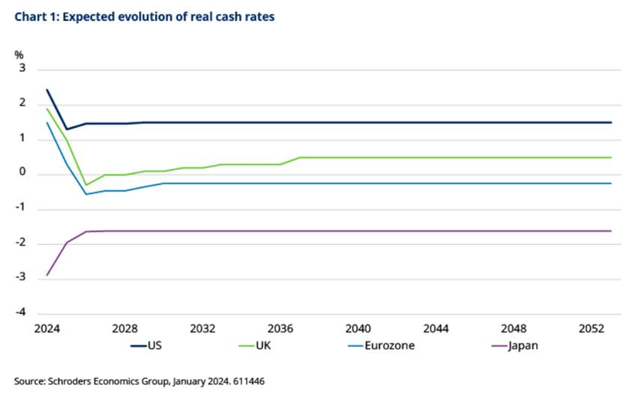

In the near term, the tightness in the labour market is likely to keep prices and wages elevated for longer. Over the medium term, inflation could prove to be more persistent in the aftermath of the Covid pandemic and the 3D Reset.
By contrast, our global equity return forecast has moved marginally lower this year. This is primarily driven by weaker expected returns in the emerging markets and a marginal downgrade to the US equity forecast. This is on back of the decline in dividend yields in these markets.
Overall, our forecasts the risk premium for owning equities versus the major government bond markets has narrowed this year. So, equity investors will need to work that bit harder.
How we’ve incorporated the impact of climate change
We adopt a three-step approach to incorporate climate change in our macroeconomic assumptions.
- Step 1: Physical impact: We focus on the physical risk of climate change by examining the impact of temperature rises on output and productivity.
- Step 2: Transition impact: We consider the transition risk by evaluating the economic impact of actions taken to mitigate climate change and reach net zero targets.
- Step 3: Stranded assets: Lastly, we account for the effects of stranded assets - where we factor in losses resulting from the write-off of coal, oil and gas reserves that can no longer be exploited and hence remain in the ground.
Our three climate scenarios then describe how physical risk, transition risk and stranded assets interact to collectively impact productivity, economic growth, and inflation for different economies. These are crucial for estimating long-term asset returns.
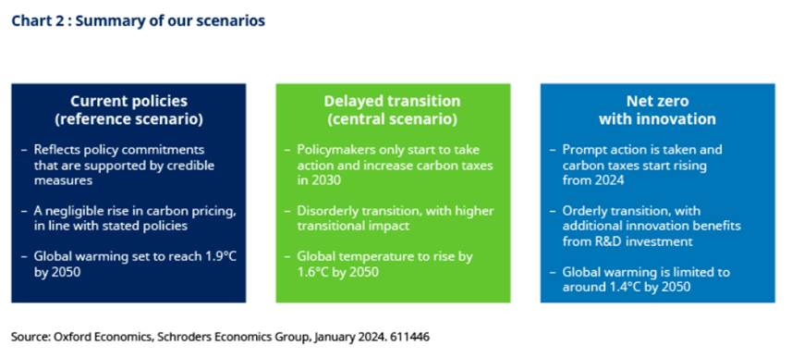
We believe that the Delayed Transition scenario is the most likely of the three scenarios presented and forms our central scenario. Under this scenario, policymakers delay climate action until 2030 and then introduce aggressive policies over a short span of time to limit temperature increases to 1.6°C by 2050, resulting in a disorderly transition.
Our Net Zero with Innovation scenario examines the upside to this central scenario – where proactive policies spur greater innovation and productivity, resulting in an orderly transition to limit global warming to 1.4°C with comparatively lower economic pain.
In our scenarios, policymakers induce the transition to a low-carbon economy by raising carbon prices and internalising the cost of emissions. Carbon prices can be considered as a proxy for mitigation policy ambition and effectiveness, as shown in chart 3.
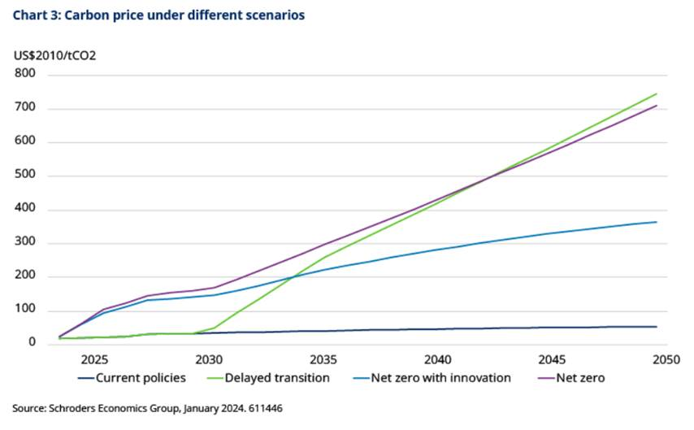
Efforts to mitigate climate change will also have uneven impacts
While we anticipate investors will still be rewarded for taking more risk and investing in equities over the next 30 years, and particularly so for emerging market equities (see table, below), the effects of policies to decarbonise economies will create challenges for the asset class, rewarding those best placed to unpick them.
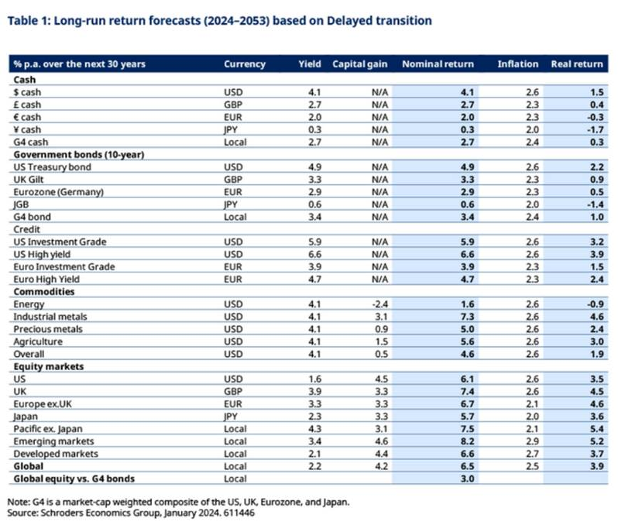
Due to the costs involved, decarbonising economies will be inflationary. This is because carbon pricing is widely seen as the main policy approach required to incentivise the transition to renewable forms of energy. The impact of climate change will also have more direct economic costs. Some fossil fuel reserves will simply need to be left in the ground, for instance, becoming “stranded assets.”
At asset class level, we expect a delayed transition will generally mean less growth and lower corporate earnings, productivity and so equity returns would be lower than otherwise.
This will offset some of the benefits to equity returns from the higher inflation premium, and prove particularly consequential for emerging market equities, where the potential for losses from stranded assets is also greater (chart 4). Overall, the impact of climate change on asset returns are uneven with both winners and losers.
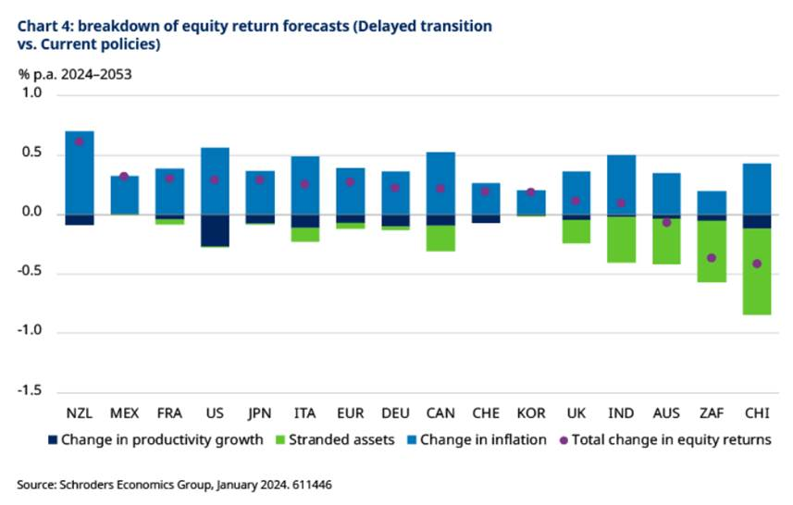
The full papers are available here:
- Part 1 30-year return forecasts: How climate change will impact asset returns
- Part 2 30-year return forecasts (2024-53)

