Headwinds and tailwinds

Old Mutual Wealth Investment Strategist, Izak Odendaal

South Africa’s economy posted negligible growth in the final quarter of last year. The only bit of good news is that 0.1% real quarterly growth means that a technical recession – two consecutive negative quarters – was avoided. This is not a hugely important distinction, but it might have dealt yet not another blow to sentiment. The bad news is that growth for 2023 as a whole was only 0.6%. The underlying growth in the domestic economy has therefore been weak, no matter how you look at it. Why?

Chart 1: South African real economic growth

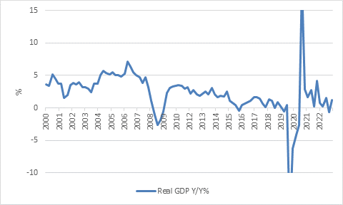

Source: StatsSA

Shed happens
By now everyone knows that loadshedding is a major obstacle to economic growth, and 2023 was a record year for power cuts. The recent Budget noted that more than 16,000 gigawatt hours of power were shed in last year, twice as much as in 2022 which in turn was four times as much as in 2021. A modern economy needs a reliable electricity supply, period. However, modern economies are also flexible and adaptable, and we’ve seen a degree of resilience in the case of South Africa. After all, growth was positive, even if only barely so, and economic activity did not go into reverse.

Chart 2: Loadshedding by stages

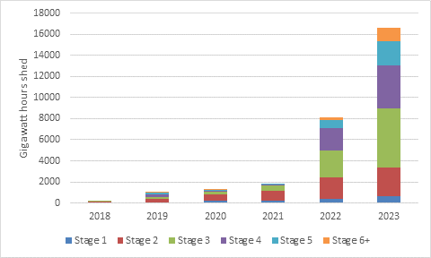

Source: National Treasury

Logistics bottlenecks also intensified during the past year, with both railway and port volumes under severe pressure. Again, a modern economy needs an efficient means of transporting goods, and South Africa is severely lacking. Businesses can move goods by road, but this is much more expensive. Sending goods overseas by plane rather than ship is even more expensive, and completely unfeasible for low value bulk items like coal and iron ore.

As an example, Kumba Iron Ore recently announced that it would lower production over the medium term, resulting in 490 job losses. The reason is simply that it cannot get enough iron ore from its mines to the ports on Transnet’s struggling trains and needs to cut output to match the limited rail capacity.
The common factor in both the electricity and logistics crises is of course two underperforming state-owned monopolies. Years of bad policymaking led us to this point.

Another major headwind last year was the cost-of-living squeeze on consumers. The repo rate hit the highest level in 15 years last year, while consumer inflation averaged 6% in 2023. This ate into the disposable income of households, weighing on consumer spending.

Indeed, South Africa faces the unusual but uncomfortable combination of weak growth and high interest rates. Normally, a weak economy will exert downward pressure on policy and market-based interest rates (bond yields). For instance, China’s 10-year bond yield hit a record low of 2.3% last week. While the Chinese government has announced a 5% growth target for this year, the bond market is not buying it, and rather signals years of sluggish growth and low inflation ahead.

But in South Africa, sub-par economic growth means government tax revenues disappoint, leading to higher levels of borrowing. As the market worries about the South African government’s creditworthiness, it charges a higher interest rate. This higher interest rate in turn lifts borrowing costs for the private sector, further depressing growth. This is a vicious cycle that must be broken, and the recent Budget has taken steps to achieve it.

Finally, commodity price moves haven’t helped. In particular, the dollar palladium price has fallen 30% over the past year, while coal is down 20%. Platinum and iron ore are roughly 10% lower. It helps that the gold price is near record levels at $2178 per ounce, but South Africa is no longer the powerhouse producer it once was. Meanwhile, the price of oil, the country’s main export, has traded between $72 and $96 per barrel over the past twelve months. The current level of $82 per barrel is uncomfortably high for South African motorists, who’ve just seen retail fuel prices jump.

Can these headwinds turn into tailwinds?

Tails, you win
Inflation has already started declining and is likely to be lower on average in 2024. This means consumers’ income can grow in real terms this year. The economy’s wage bill grew by 6.7% year-on-year in the fourth quarter. If this pace is maintained and inflation declines, real income growth can support a higher rate of real spending growth.

Lower inflation also implies lower interest rates. However, the Reserve Bank is likely to remain cautious. Expectations for rate cuts internationally, particularly in the US, have been scaled back recently and will influence the monetary policy committee’s thinking. It will also be mindful of the rand’s ongoing weakness, and nervously eye the recent jump in maize prices. This suggests modest rate cuts, which will help consumers. The government’s borrowing cost will likely remain elevated until there is greater progress on stabilising and reducing debt, as noted above.

In terms of electricity, already 6000 MW of private electricity capacity has been registered with Nersa and will come on stream in the next few quarters. This number is set to rise over time. Given that each stage of loadshedding is equivalent to 1000MW, this could significantly reduce strain on the grid, though solar and wind power output is subject to variability. Whether Eskom’s ageing fleet of coal-fired power stations can ever return to operating at full capacity is an open question, but even small improvements can slice off a stage or two of loadshedding. However, not everyone will be able to turn to private power. Small businesses and low-income households will continue to rely on Eskom and probably still be subject to electricity interruptions.

Chart 2: Cumulative capacity registered and rooftop PV installed during 2023

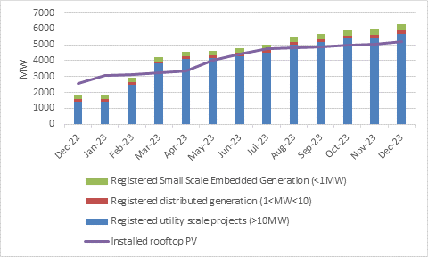
Source: National Treasury, NERSA

The logistics chaos should also ease over time. The freight logistics roadmap was adopted by Cabinet in December 2023, outlining steps to improve Transnet’s operational performance, but more importantly, to allow for third-party access to Transnet’s railways. This means private companies will be able to run trains on Transnet’s infrastructure, increasing rail freight capacity and efficiency.

Chemicals group Sasol recently announced a deal with Transnet Rail Freight whereby Sasol will pay for the maintenance of a fleet of specialised ammonia tankers. Future partnerships of this nature can also further improve the overall logistics.

Reforms in the issuing mining licenses, water licenses and work permits for skilled workers will also help speed up business investment.

Commodity prices are not something local policymakers or business leaders can control. The only positive thing we can say here is that, following big declines, prices are more likely to rise in future than fall (the reverse is also true).

In a nutshell, the outlook is better. We shouldn’t expect a repeat of the 0.6% growth registered last year, though we also should not expect miracles. It will take time for private investments into energy and logistics to make an impact on economic growth, and while some forms of red tape are being cut, others remain. Poor public service delivery in general, but particularly at local government level, still adds significantly to the cost of doing business. Absent deeper structural reforms, South Africa’s long-term potential growth rate will not be more than 2% to 3%.

Prescriptive
Then there is the question of whether there is enough funding available to support economic growth and development. Specifically, the notion of ‘prescribed assets’ – that pension funds should be forced to invest in certain assets – is back on the agenda.

The ANC’s election manifesto mentions that it will “engage and direct financial institutions to invest a portion of their funds in industrialisation, infrastructure development and the economy, through prescribed assets.”

This is a fairly vague statement. It does not say how big ‘a portion’ could be, while financial institutions including retirement funds clearly already invest in ‘the economy’. It is certainly not a precise enough statement for any pension fund member, financial adviser or trustee to base an investment decision on.

The 2022 change to Regulation 28 of the Pension Funds Act means pension funds can already invest up to 45% of their assets in infrastructure. At the time, it was hoped that the change would put to bed the prescribed assets debate, but apparently not.

The same amendment also allowed pension funds to invest up to 45% of their assets offshore. In practice, therefore, the trend over time has been for retirements funds to have more investment freedom, not less. Though the finance minister recently said this move was a “mistake”, there is no evidence that it has been to the detriment of the local economy. In fact, having a large international asset base is a very useful buffer against exchange rate volatility. It doesn’t just benefit individual members, but the economy, broadly speaking.

Let’s put it very simply: South Africa’s economic woes do not stem from a lack of funding.

Very few new companies have listed on the JSE to raise capital in recent years, for instance. And when it comes to infrastructure, the issue is not the appetite of pension funds to invest but rather the lack of bankable projects. In fact, internationally, infrastructure is a very attractive asset class for pension funds, because it tends to deliver stable long-term returns. Many local pension funds would happily increase exposure. But the pipeline of projects remains thin.

This is partly because of the complex nature of many of these projects that often require approvals at multiple layers of government and across many agencies and departments. Moreover, until recently, the state monopolised many aspects of key infrastructure delivery, notably in electricity, rail and port. This is starting to change, as discussed above, while the Budget Speech presented further proposed changes to public-private partnership (PPP) regulations as well as new infrastructure funding mechanisms to crowd in private capital.

It is also important to note that private funding of infrastructure is only feasible where there is a profit to be made. Pension funds, banks, private lenders and so on want return of capital and return on capital. There is a long list of potential investments that meet these criteria including rail, ports, electricity, pipelines, bulk water supply, toll roads, airports and so on. Many other forms of infrastructure do not have associated cash flows and are therefore not ripe for private investments. We’re not going to see suburban toll roads, for instance, or pay-as-you-go streetlights.

It is a long road from something appearing in an election manifesto to it becoming law, and along the way there will be opportunities for the financial sector and others to provide input. Therefore, though prescribed assets is a bad idea, people should avoid making hasty choices with their retirement savings based on speculation that it may or may not be implemented.

Not alone
It should also be noted that South Africa is not the only country grappling with the question of funding growth. In last week’s UK Budget, the Chancellor announced an individual savings account (ISA) where savers can invest ₤5000 tax-free but only into British shares and bonds. Like South Africa, UK equities have long underperformed the US, but also like South Africa the problem is not fundamentally a shortage of funds. Share prices are first and foremost a reflection of investors’ perception of value, not of the amount of money coming and going.

Chart 3: US, US and SA equities in dollars
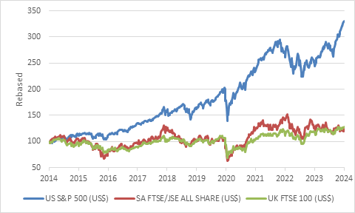

Source: LSEG Datastream

South Africa and the UK belong to a class of markets that include most of Latin America and other parts of Europe, that is ignored by global investors because there is no exiting growth story. At the other end of the spectrum, the US and India remain markets where investors are paying up for growth, possibly a bit too much with forward PE ratios in the low 20s.

There is still value across the board in SA equities. To unlock this value will require progress in implementing the reforms discussed above, but also commodity price improvements, and a global rerating of these unloved markets. All this will probably take time.

