news release

Credit active consumers remain under strain - Experian Report

Johannesburg, 12 March 2024 – The Experian Consumer Default Index (CDIx) for Q4 of 2023, has revealed a deterioration from 3.97 to 4.68 – a relative change of 18%.
The CDIx, which measures the rolling default behaviour of South African consumers with Home Loans, Vehicle Loan, Personal Loan, Credit Card and Retail Loan accounts, also highlights that all product-specific CDIx metrics changed for the worse year-on-year, with Home Loans and Credit Cards showing the most significant deterioration. This suggests that mid-to-high affluence consumers, who typically qualify for these high-end credit products, are finding it increasingly difficult to repay debt and continue to make extensive use of their credit cards.
Furthermore, the report reveals that the higher-affluence consumer groups have been under increasing pressure to honour their debt commitments, leading to a surge in Debt Review applications. This indicates a growing demand for financial counselling and debt management services.
“These findings have significant implications for financial institutions operating in South Africa. With an increased risk of defaults, particularly in home loans and credit cards, banks and other lenders may need to reassess their risk management strategies and lending criteria,” says Jaco van Jaarsveldt, Experian’s Head of Commercial Strategy and Innovation.

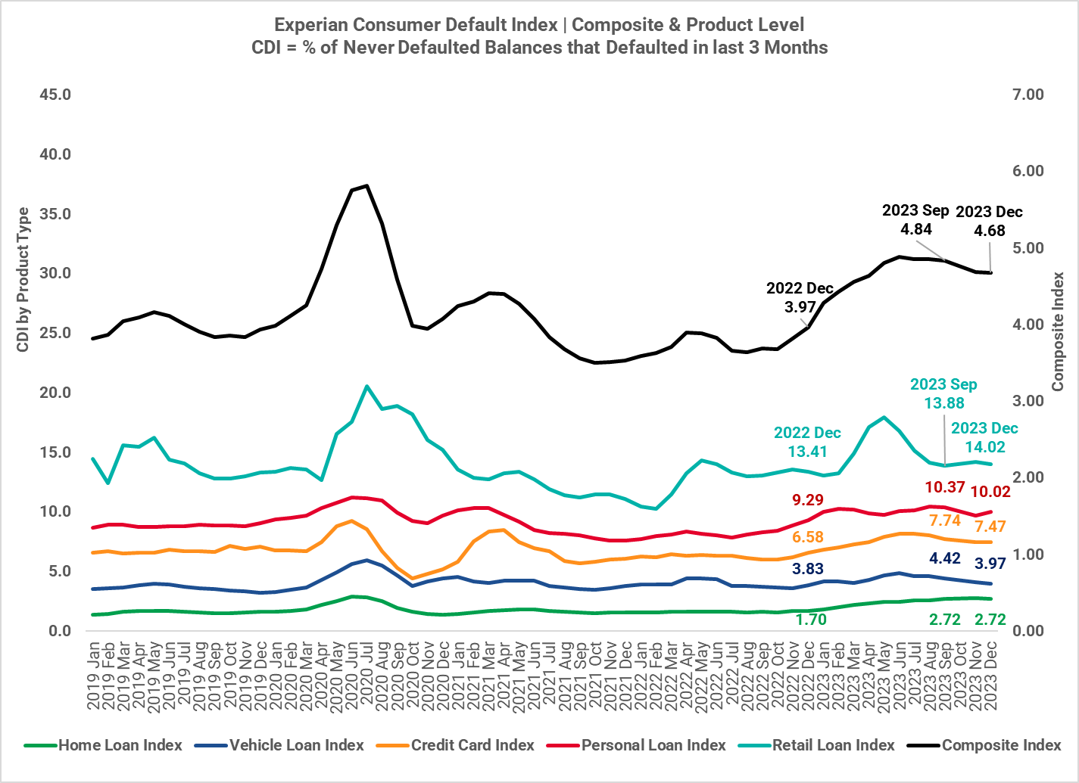

CPI remains under 6% threshold
The Consumer Price Inflation (CPI) has remained within the South African Reserve Bank (SARB)’s target band of 3% - 6%, since June 2023 following the 13 preceding months where the CPI exceeded this target band. During this period, CPI reached a peak of 7.8% in July 2022. The December 2023 decrease in the CPI coincided with a drop in food inflation, which was good news for the cash-strapped South African consumer base.
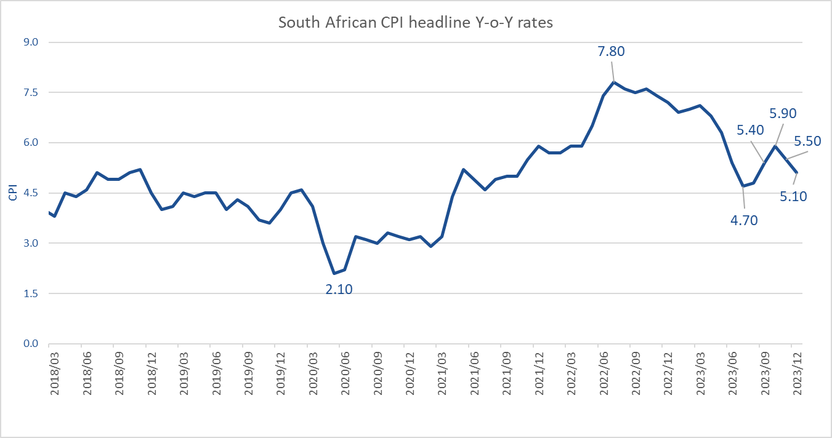
Van Jaarsveldt adds, “One of the significant points regarding the cost of living has been the costs associated with electricity – both from an Eskom tariff perspective and an alternative electricity perspective like generators and solar – which are becoming increasingly prevalent in the face of continued loadshedding.”
Higher-for-longer interest rates take toll on credit active consumers
The prime lending rate has remained unchanged since 1 April 2023. Through sustained high interest rates, the South African Reserve Bank aims to get the CPI back to 4.5%. “The rapid rate at which interest rates have increased and have now been sustained for the last 10 months, has been putting immense strain on credit-active consumers – particularly those consumers with exposure to secured credit, like homes and vehicles. This pressure has also been felt by younger consumers who are relatively new to the credit world, for whom having to navigate through times of sustained high interest rates is new territory,” he says.
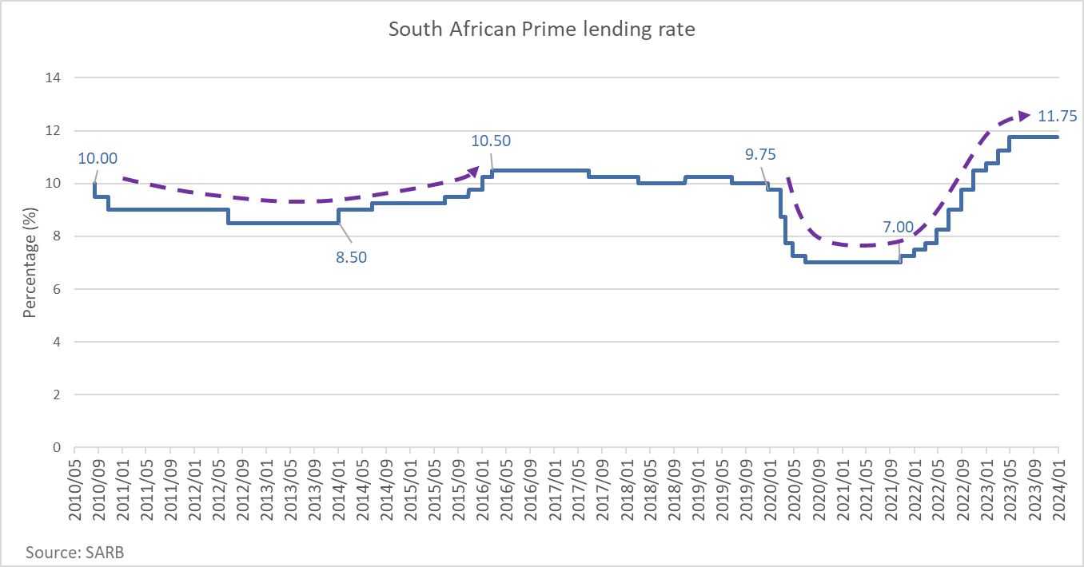

Market appetite remains very high while approval rates remain low
The appetite for consumer credit has shown an increase in 2023 Q3 (as per data prepared by the National Credit Regulator). The sustained high application levels suggest that consumers are looking for credit to cover the shortages in their cost-of-living expenses. Approval levels remain low (31.1% in the latest data) which means that more than two-thirds of applications are rejected. This non-approval partly stems from consumers’ inability to afford additional credit commitments, considering the cost-of-living pressures consumers are facing.
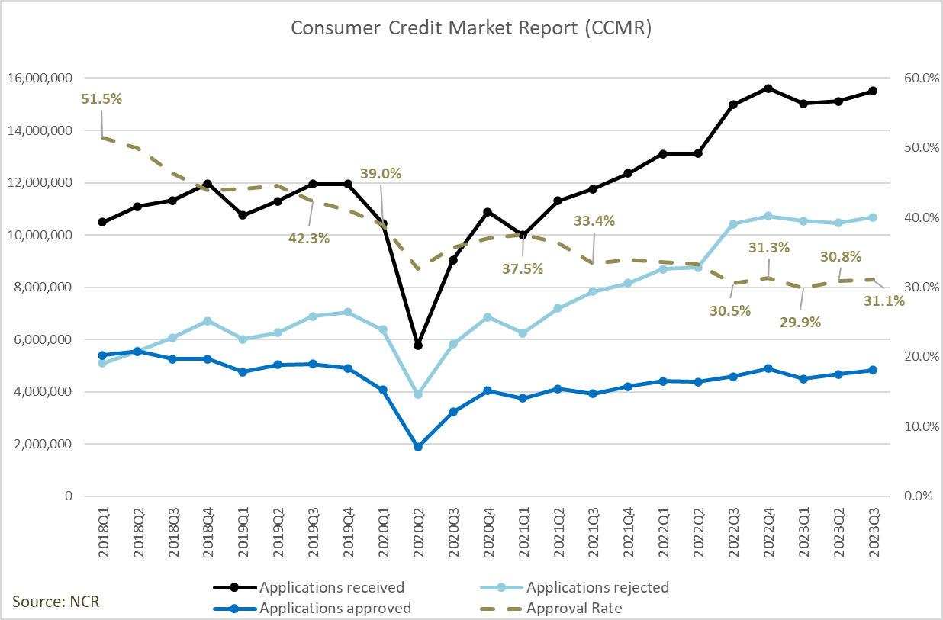

“Experian advises consumers to exercise caution in this challenging financial environment. It is more important now than ever before that consumers carefully consider their ability to repay before taking on additional credit and seek advice from financial institutions who granted the facilities, if they find themselves struggling to meet their debt obligations,” concludes van Jaarsveldt.
Experian recently launched Up, a web-based app that enables consumers to manage their financial wellness through gamified credit and financial education, budgeting, and the ability to track and manage their credit scores on a regular basis. With the required permission, consumers using the Up app can also build an alternative credit score using a number of alternative data points.
Access Up, powered by Experian, for FREE from www.up.experian.co.za

[679 words]
***ENDS***

Notes to the editor:

The Experian Consumer Default Index (CDIx) is designed to measure rolling default behaviour of South African consumers with Home Loan, Vehicle Loan, Personal Loan, Credit Card and Retail Loan accounts.

On a monthly basis, lenders typically classify their consumer accounts into one of several predetermined payment categories to reflect the level of arrears. When a lender deems the statement balance of a consumer account to be uncollectible due to being in arrears 90 or more days or statuses such as repossession, foreclosure, charge-off or write-off, the consumer account is said to be in default.

The index tracks the marginal default rate as it measures the sum of first-time (accounts that have never) defaulted balances as a percentage of the total sum of balances outstanding.

The CDIx is published quarterly with a two-month lag, the indices include a balance-weighted composite index, as well as the five product-specific sub-indices. Two grouped indices are also provided:
- Home Loans, Vehicle Loans and Credit Cards (these products typically are held by the traditionally banked market segments), and
- Personal Loans and Retail Loans (these products are usually used as entry products into the credit market).

The indices are also determined at FAS type level to provide further insight into the dynamics faced by specific consumer affluence-related segments that are experiencing different stress due to macro forces such as unemployment, interest rate changes and economic growth.

¹ Experian’s Financial Affluence Segmentation (FAS) is a consumer lifestyle segmentation system that classifies the South African population and enumeration areas into 6 primary groups each with variable exposure to secured and unsecured lending products. The 6 primary segments are described as follow:

- FAS Group 1: Luxury Living (2.5% of credit active population) - Affluent individuals representing the upper crust of South African society with the financial freedom to afford expensive homes and cars
- FAS Group 2: Aspirational Achievers (9.3% of credit active population) - Young and middle-aged professionals with the resources to afford a high level of living while furthering their careers, buying property, and establishing families
- FAS Group 3: Stable Spenders (7.2% of credit active population) - Young adults with that rely on financial products to assist in making ends meet or to afford specific necessities such as clothing and school fees, or seasonal luxuries
- FAS Group 4: Money Conscious Majority (40.0% of credit active population) - Older citizens that are conscious of where and how they spend their money; often seeking our financial products to cover basic needs or for unforeseen expenses
- FAS Group 5: Labored Living (24.6% of credit active population) - Financially limited as salaries are below national tax thresholds, they spend their money on basic living necessities such as food and shelter
- FAS Group 6: Yearning Youth (16.4% of credit active population) - Very young citizens that are new to the workforce; this mix of labourers and possibly working students earn low salaries and are limited to spending on non-essential goods

Contact:
Taryn Stanojevic
Experian South Africa
+27 11 799 3434
Taryn.Stanojevic@experian.com

Gomotsegang Motswatswe
BCW Africa
+27 11 480 8620
gomotsegang.motswatswe@bcw-global.com

About Experian

Experian is the world’s leading global information services company. During life’s big moments – from buying a home or a car, to sending a child to college, to growing a business by connecting with new customers – we empower consumers and our clients to manage their data with confidence. We help individuals to take financial control and access financial services, businesses to make smarter decisions and thrive, lenders to lend more responsibly, and organisations to prevent identity fraud and crime.

We have 22,000 people operating across 32 countries and every day we’re investing in new technologies, talented people, and innovation to help all our clients maximise every opportunity. With corporate headquarters in Dublin, Ireland, we are listed on the London Stock Exchange (EXPN) and are a constituent of the FTSE 100 Index.

Learn more at www.experianplc.com or visit our global content hub at our global news blog for the latest news and insights from the Group.

