Is China set to export deflation – and trade tensions – once again?

David Rees, Senior Emerging Markets Economist at Schroders

There are signs that the recovery in exports is being driven by Chinese manufacturers slashing prices which has the potential for unintended consequences.
The turnaround in the goods cycle that we anticipated earlier this year has so far been borne out in the data. Manufacturing output from Asian economies has generally beaten expectations in recent months, while exports from the region have also picked up.
Leading indicators continue to point to a further improvement in Asian exports into the middle of 2024. For example, while the recent headline ISM manufacturing index from the US remained subdued at 47.4 in December, new orders minus the inventories subcomponent remained consistent with growth in China’s nominal exports accelerating towards 10% year-on-year (y/y) by the middle of 2024.
China’s exports are on course to accelerate into mid-2024
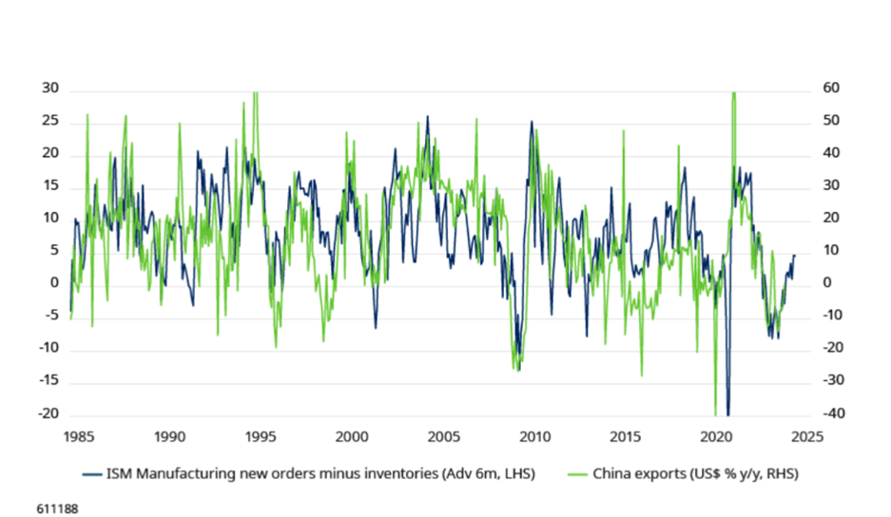
Source – LSEG Datastream, Schroders
Data implies manufacturers are having to discount
However, while China’s exports recovered in the second half of last year, there are signs that firms in some sectors have been forced to discount goods in order to clear spare capacity. For example, nominal export growth has only limped back to growth, but exports have been expanding rapidly in volumes terms – by our reckoning up by 15-20% y/y in November.
The value of China’s exports is lagging far behind growth in volumes
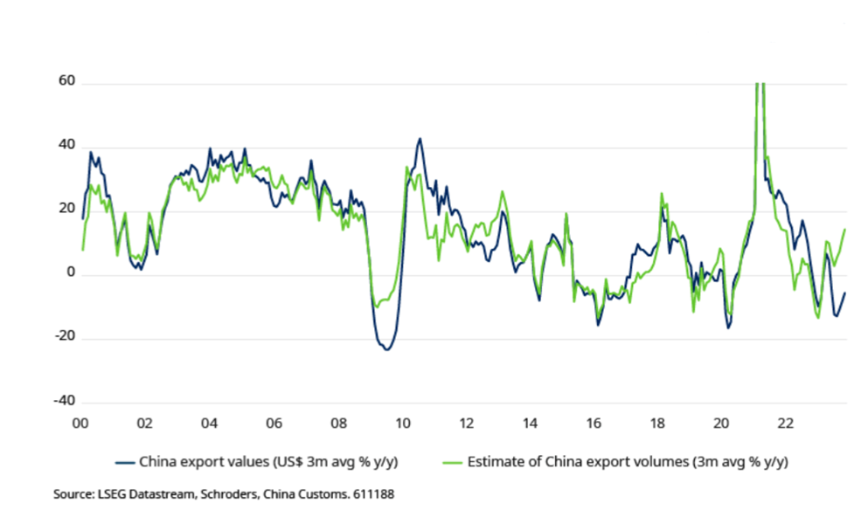
Source – LSEG Datastream, Schroders
Part of the discrepancy between the volume and value of exports appears to be due to the effect of commodity prices. As the chart below shows, China’s export prices have historically been well correlated with commodity prices, notably energy. This makes sense given that China relies heavily on imports of commodities, making them a key swing factor for the cost of production – there is an equally close relationship with PPI.
The gap between export and commodity prices hints at discounting
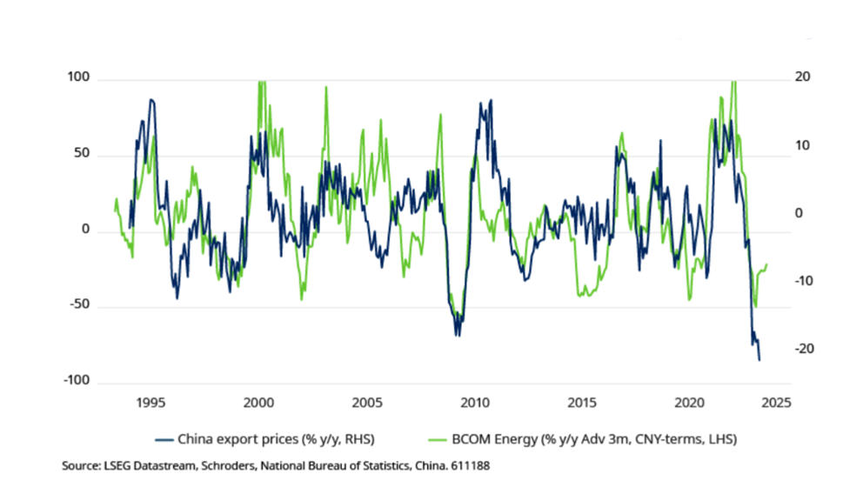
Source – LSEG Datastream, Schroders
If commodity prices remain at current levels China’s export prices will start to turn around in the months ahead as base effects wash out. However, there is currently an unusually large disconnect between commodity prices and export prices that implies manufacturers, faced with insufficient domestic demand, are having to discount prices in order to generate enough external demand to take up excess supply.
The deepest discounts appear to be in sectors such as steel, where the ongoing bust in the housing market will have reduced domestic demand. But other sectors may need to start discounting more aggressively if global growth does slow.
Forecasts for sluggish global growth over the next couple of years suggest that more firms may be forced to slash prices. We expect only sluggish world GDP growth of 2.2% in both 2024 and 2025 as the global economy continues to disinflate and developed markets largely stagnate. “Exporting deflation” would help to anchor goods price inflation around the world, to the potential benefit of the global economy as central banks pivot towards interest rate cuts in the months ahead.
The resurgence of goods price inflation in the immediate wake of the Covid-19 pandemic was a watershed moment. It further cemented the conditions for what we’ve now come to see as a new economic regime of more persistent inflationary pressures.
Discounting by exporters could backfire for China
However, while discounting by Chinese exporters could take some of the heat off the major global central banks as they fight to restore price stability it could backfire in the long run. After all, discounting in order to dispose of excess capacity will result in a chronic squeeze on the profit margins of Chinese firms and weigh on equity returns.
What’s more, if an increasing number of firms are forced to dump cheap goods on global export markets then it is likely to whip up anti-China sentiment during the US election race and accelerate the deglobalisation element of what we’re calling the “3D Reset”.
Deglobalisation perhaps plays the pivotal role of the 3Ds that we see as resetting economic regime (demographics and decarbonisation being the other two Ds). As a result of rising levels of protectionism, reshoring and “friendshoring” trends are testing the globalised model of extended supply chains.
China Inc’s manufacturing sector sits at the heart of the model and had contributed to a long-term decline in goods prices. This occurred for a large part of the last three decades and resulted in the global economy’s Non-Inflationary Consistently Expansionary, or “NICE” era.

