How did EM stocks perform in 2023?
Andrew Rymer, Senior Strategist, Strategic Research Unit at Schroders
2023 was a bitter-sweet year for EM stocks. The MSCI Emerging Markets Index rebounded from a 20% decline in 2022, delivering a gain of 10%. However, EM stocks lagged developed market (DM) peers by a wide margin, for the third year in a row, with the MSCI World advancing 24%. Relative performance epitomised what has been a tough decade in which US stock market exceptionalism has dominated.
US exceptionalism has dominated for a decade
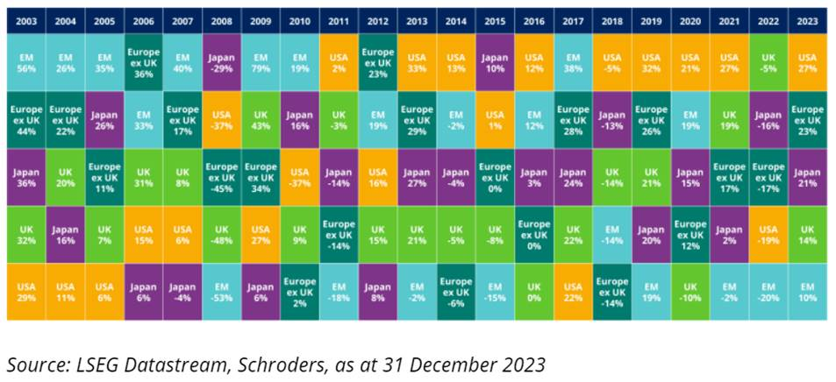
While the US stock market regained global leadership, performance in China failed to live up to the optimistic expectations of early 2023 as Covid re-opening disappointed. The MSCI China Index posted a third consecutive year of double-digit falls and the largest market in the index was also the weakest in performance terms.
In fact, divergent US and China market performance explains EM’s underperformance versus DM. EM excluding China outperformed the World ex US, as shown below.
Divergent US and China performance dominated 2023
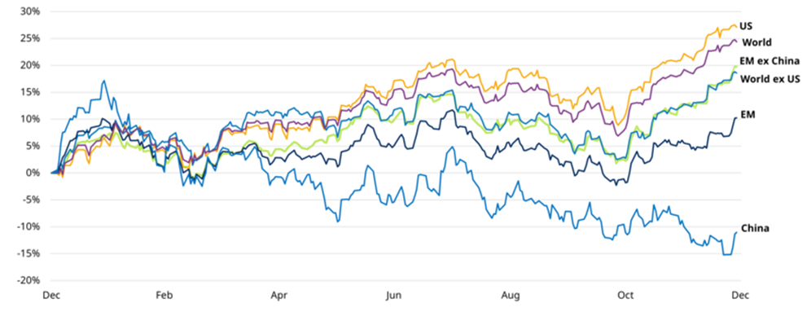
Past performance is not a guide to future performance and may not be repeated.
Total return, US dollars. Source: LSEG Datastream, MSCI, Schroders Strategic Research Unit, as at 31 December 2023.
How did EM bonds perform in 2023?
Emerging market (EM) bonds registered robust gains in 2023. The asset class benefitted from a strong rally in the final quarter of the year, as US bond yields fell sharply, having rallied for much of the year, and the US dollar weakened on optimism towards a US soft landing scenario.
Over the full year, a firm disinflation cycle took hold in many markets and real bond yields turned positive in an array of local debt markets. Many EM central banks proceeded cautiously with interest rate cutting, waiting for the US Federal Reserve (Fed) to signal a peak in rate hikes. The dovish tones from the December FOMC meeting subsequently provided the green light for EM central banks to ease.
EM local debt generated the strongest returns, amplified by US dollar weakness. Hard currency debt outperformed EMD corporate, driven by standout performance from the high-yield component.
EM bonds generated positive returns in 2023
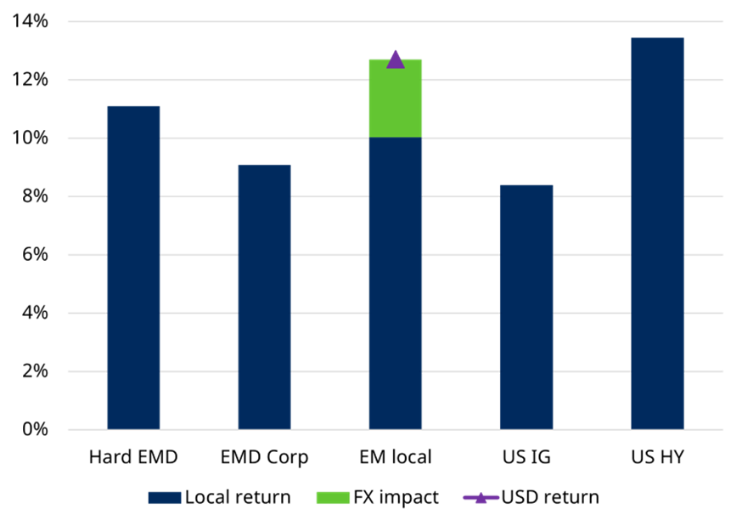
Note: Local currency = US dollar for all apart from local EMD which is in the relevant local EM currency. Source: Schroders, LSEG Datastream, JP Morgan, Schroders Strategic Research Unit. Data as at 31 December 2023.
What do valuations look like at the start of 2024?
Equities
EM equity valuations are close to their historical median (since 1995) on 12-month forward price-earnings (P/E) and price-book measures, but cheap on dividend yield.
EM stocks in aggregate are cheap when compared with DM, as shown in the chart below. On a 12m forward P/E basis, the discount to the US is now below its global financial crisis low.
EM equities are cheap compared to DM equities
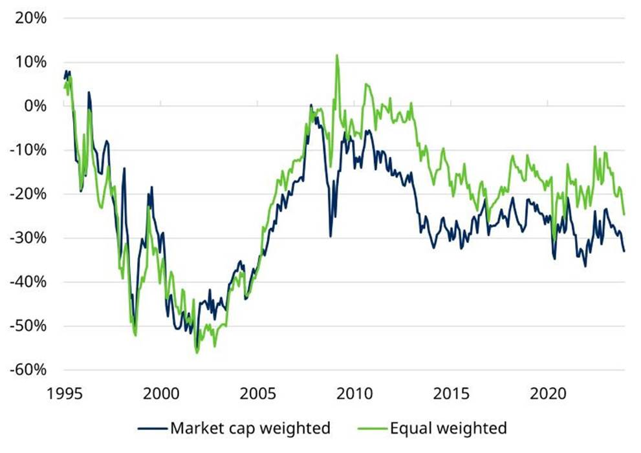
Source: LSEG Datastream, MSCI, IBES, Schroders Strategic Research Unit. Data as at 31 December 2023.
On a standardised composite valuation measure, most EM markets ex India, and on some measures South Korea, are cheap versus their own history and are not significantly changed versus 12-months ago.
Most of EM is cheap but the degree varies
EM valuation heatmaps – current z-scores¹
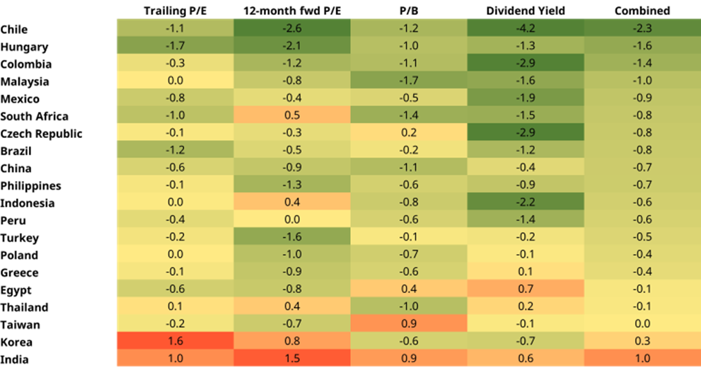
¹The z-score is a measure of how far valuations are from historical mean, calculated since January 2000. Excludes UAE, Qatar, Saudi Arabia and Kuwait due to limited data history. Combined figure is an average of trailing P/E, 12-month forward P/E, P/B, and dividend yield. Source: Schroders, LSEG Datastream, MSCI, IBES, Schroders Strategic Research Unit. Data as at 31 December 2023.
Bonds
At the headline level, illustrated below, spreads among local EMD, and to a lesser extent corporate EMD remain below their historical average. Hard currency valuations are now only slightly above their historical average.
As we show in the full pack, there is more to this story and it is worth digging below the headline figures. The spread on the hard currency index is driven by the high yield (HY) component. The spread on the investment grade (IG) sovereign market is below its historical average and at a 15-year low.
EMD headline valuations
Spread percentiles - Spreads of key EMD indices (basis points)
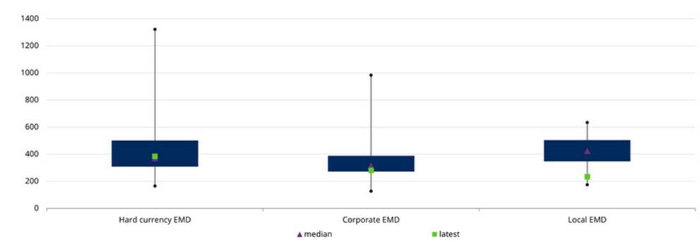
Source: Schroders, LSEG Datastream, J.P. Morgan. Data as at 31 December 2023. Percentiles shows where the current spread is relatively to the historical range of spreads, within a range of 0 to 100. The greater the percentile the higher the spread compared to history. Hard EMD =stripped spread, Local EMD =Spread to 5 year UST, Corporate EMD = spread to worst.
There are undervalued currencies in all three EM regions, but the degree of value varies significantly…
Some currencies are significantly undervalued
Real exchange rate: deviation from average
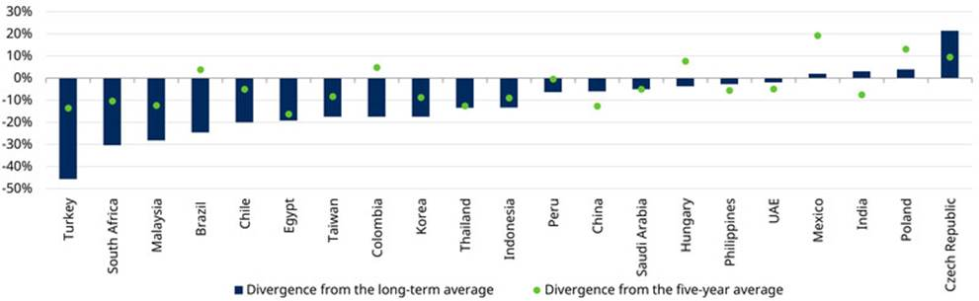
Source: Schroders, LSEG Datastream, Schroders Strategic Research Unit. Data as at 31 December 2023. Real exchange rate is the nominal dollar exchange rate deflated by the CPI of each EM country vs. US Long-term average is since January 1995.
Keep one eye on geopolitical risk…
Geopolitical risk is inherent in EM investing, but this is a heavy election year which naturally adds to uncertainty.
Long term strategic competition between the US and China has led to ongoing tensions in recent years and bears ongoing monitoring. Russia’s invasion of Ukraine and the current conflict in the Middle East are further watchpoints, with global significance.
Within EM, national elections which account for over 50% of the MSCI Emerging Markets Index weight are scheduled for the coming 12-months; timings are shown in the pack.
EM elections will be followed by the US presidential election in November, which is also key for EM investors.
Read more here…
More detailed analysis of EM equity and bond market valuations can be found in the dedicated EM equity and EM Lens packs. These are available via the links below.
Emerging Markets Equity Lens
Emerging Markets Debt Lens

