What happens to waste in a circular economy?

Schroders

Waste is but a lack of imagination - much of what we throw away today has value and can be reused.

Jack Dempsey, Fund Manager at Schroders.
Paul Lamacraft, Head of Sustainability Private Equity at Schroders.
Samuel Thomas, Sustainable Investment Analyst at Schroders.

We believe investing in the circular economy offers a multi-decade structural growth opportunity. It enables investors to gain exposure to those companies that not only offer attractive growth and returns, but that also have long-lasting positive outcomes for both people and planet.
The circular economy is a change in economic system. It means moving away from “take-make-waste” practices, where we buy things, use them, and throw them away. Instead, a circular system is one where products and materials are kept in use and production follows a sustainable path that reduces consumption of raw materials.
The key aim of the circular economy is to decouple economic growth from virgin resource consumption. The simple reason being that the world is running out of resources.
We already use 1.7x the resources that the planet naturally regenerates each year and this figure is only going to grow as the global population expands. We are living way beyond our means.
Why waste is a valuable resource
Waste is generally defined as “material or resources that are discarded, unused, or considered to be of no value”.
However, waste is but a lack of imagination. There is very little ‘waste’ in the modern world that is of no value; it is more about having the right infrastructure, regulations and will to capture that value.
This gives us hope that we can improve current waste management practices. On a global level, we currently sit at a powerful intersection of forces – affordable and efficient technology, supportive regulations, and consumer and business demand – that will work to improve circularity, albeit at differing speeds at a regional level.
There are many sources of waste. In this piece we will focus on municipal solid waste given it’s the area of the waste industry with the best data and which often receives the most attention.
What is municipal solid waste (MSW)?
MSW is rubbish that comes from households or businesses (restaurants, hotels, offices). It typically consists of papers, plastics, discarded food, garden waste and other discarded items.
The world generates c.2 billion tonnes of MSW annually. This is the equivalent of 111 million rubbish trucks per day. As economies and incomes grow in emerging markets, this number is increasing rapidly.
By 2050, with a global population of c.10 billion, it is expected that the world will produce 3.4 billion tonnes of MSW annually (a 70% increase from today).
This, however, doesn’t tell the entire story, as averages often hide the underlying dynamics.
On one end of the spectrum, you have the North American region with c. 530kg per capita per annum and at the other you’ve got 168kg per capita in sub-Saharan Africa.
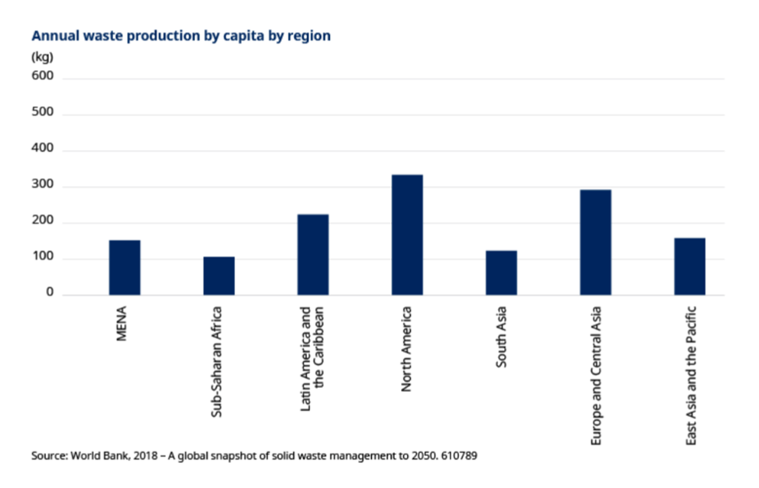
The issue therefore is that if everyone in the world produced waste at the same rate as the average person from North America, then global waste production would hit c. 4.1 billion tonnes p.a. (or 210 million rubbish trucks per day).
Waste generation per capita is very highly correlated with income levels. It is a problem if we cannot decouple economic growth from resource consumption. Countries low on the income scale have ambitions to move up, and it is these countries that tend to see the highest growth in populations as well.
Why is waste a problem?
The biggest issue is how waste is disposed of because that can generate negative impacts on climate change, pollution and biodiversity. There is also the issue that by not properly recycling our waste, we are creating demand for more virgin resources at a time when we are already over-consuming.
We can see from the below chart that the vast majority of waste globally is either openly dumped (c. 33%) or landfilled (c. 37%) with only 19% being either recycled or composted. About 11% of waste is disposed of via incineration (known as waste to energy).
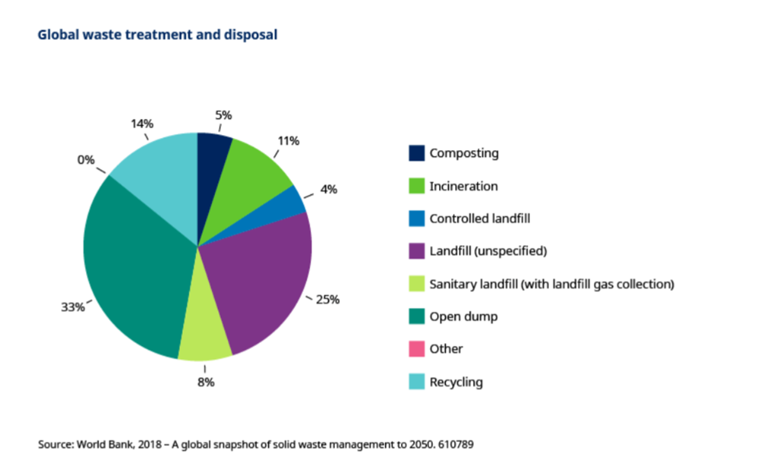
Landfills alone account for c. 8-10% of human activity related greenhouse gases via the release of methane gas as waste decomposes. This is before considering the other negative externalities like water pollution, soil degradation and the impact on local wildlife and biodiversity. There is also the issue of resource wastage, as a lot of what goes to landfill is of value.
The best way to reduce the negative impacts of landfill is to avoid using them. However, this isn’t always possible. The next best thing is to ensure that the methane emissions aren’t released freely into the environment.
There is increased focus in regions such as the US for this approach by capturing these landfill gases and converting them into renewable natural gas.
Regulations are forcing change in the industry
We are seeing increasing ‘polluter pays’ regulations in order to increase the costs of poor disposal methods (e.g. landfill). There is also the further development of ‘extended producer responsibility’ across many sectors of waste, which puts more of the burden of the cost of physical collection and disposal on the producer.
For example, the roll-out of deposit return schemes across the EU and parts of the US will help to improve recycling rates for single-use containers (e.g. plastic bottles, aluminium beverage cans).
We’ve also seen the EU set binding obligations for member states that a minimum of 60% of MSW should be prepared for reuse or recycled by 2030.
China has set targets under its Five-Year Circular Economy Action plan to improve the recycling rates of MSW (as well as agricultural and construction waste) and to increase the output value of their resource recycling industry by c. RMB 5 trillion (c. $770 billion) by 2025.
Regulations around waste management in the US tend to come more at the state and municipal level rather than federally. The likes of California, Colorado, New York, Iowa and Maryland have enacted legislation around more onerous ‘polluter pays’ policies, higher requirements for recycled content in materials and the banning of many single-use products.
The aim of a lot of regulation is to either reduce waste at source (i.e. by being more efficient) or to increase the use of recycled, recyclable or bio-based materials. This is creating a supportive regulatory environment for companies who can supply products based on sustainable biomaterials or ones that can offer a high degree of recycled materials.
We’ve also seen countries like China implement bans on the import of certain types of waste to ensure they are only importing higher quality waste streams. No longer can countries as easily ‘export’ their waste problems.
Both of these factors are resulting in the need for more developed waste management infrastructure in much of the developed world, with a particular emphasis on recycling capabilities.
Locally, the amended Extended Producer Responsibility (EPR) regulations, which became effective in late 2020, requires manufacturers and product importers in the packaging industry to contribute towards the recycling of product packaging, with a significant impact on waste levels thus far. One area yielding positive outcomes has been the implementation of a 50% organic waste ban to landfill in the Western Cape, which is set to rolled out countrywide by 2027 and further increased to 100%. According to a recent article, the Department of Forestry, Fisheries and the Environment has included the ban as part of the licencing requirements of the landfill, to ensure compliance.
Waste management industry - a $1.3 trillion investment opportunity
As investors in the circular economy, across both the listed and private markets, we recognise the enormity of the challenge that the global economy faces in changing our linear waste management practises to more circular ones. However, we are extremely excited by the significant investment opportunities arising from this challenge.
As of 2022, the global waste management industry was valued at $1.3 trillion and is expected to grow significantly over the coming decade.
The expansion in both recovery and recycling is creating growth opportunities for a wide range of companies across the industrial spectrum.
For example, Republic Services Group, a leading listed waste management company in the US, has opportunities to expand its recycling capabilities. This is especially around plastics where the demand from large consumer staples firms for recycled plastics can ensure healthy profits while improving recycling rates.
Republic Services Group is also one of many waste management firms investing in renewable natural gas opportunities. The legislative backdrop from both the Renewable Fuel Standard and the Inflation Reduction Act (tax credits) makes these investments very profitable, with returns on investment expected to be in the 30%+ range.
Companies like Norsk Gjenvinning (NG), a private firm, in Norway have already shown the growth and profitability on offer for those that can achieve improved recycling rates. NG processed over 2.3 million tonnes of waste in 2022, with c.58% of that waste recovered back to its core raw materials, and 96% recycled through material or energy recovery which culminated in over 1.3 million tonnes CO2 emissions avoided.
These are just a few companies that highlight the exciting opportunities investors in the space can tap into, driven by the structural need to make the planet a more circular and sustainable place.
Any reference to regions/ countries/ sectors/ stocks/ securities is for illustrative purposes only and not a recommendation to buy or sell any financial instruments or adopt a specific investment strategy.

