Runway in view

Old Mutual Wealth Investment Strategist, Izak Odendaal

Fifteen years ago, in January 2009, US Airways Captain Chesley ‘Sully’ Sullenberger landed an Airbus A320 in the Hudson River in New York City. It was an iconic moment in the history of aviation. The forced landing was necessary after both engines were knocked out by a bird strike – the plane hit a flock of Canadian geese. With all 155 people on board surviving, it rightly made Sullenberger a hero, and he was later played by Tom Hanks in a film based on the events of that New York winter’s day.
Sullenberger downplayed the hero angle and put his actions down to his many years of experience as a pilot. “One way of looking at this might be that for 42 years, I've been making small, regular deposits in this bank of experience, education and training. And on January 15, the balance was sufficient so that I could make a very large withdrawal." It is less well known that in his many years as a pilot he was extensively involved in researching aviation safety, worked as an air accident investigator, and studied the psychology of how a cabin crew functions in a crisis. He knew a thing or two about crashes, and he managed to pull off the softest of all soft landings.
The big question now is whether central bankers can pull off something similar, achieving sustained lower inflation without the economy going into recession.
Inflation is often a sign of an overheating economy, and therefore getting it under control means cooling down the economy. However, given the lags involved, central banks often overtighten, and a ‘cooling down’ ends up as a recession. The US Federal Reserve has only achieved a soft landing three times (depending on how exactly you define it) in 14 post-war rate cycles.
Chart 1: Not many soft landings: US interest rate cycle and recessions
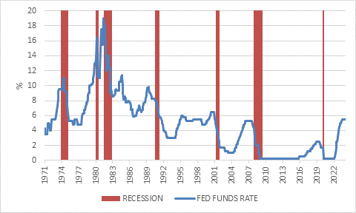
Source: LSEG Datastream
An airline with this safety record would not have any customers. However, unlike an airplane that responds directly to the instructions given by pilots (unless something is broken), the economy does not immediately respond to changes in interest rates, nor does it do so in a predictable manner.
In fact, one of the reasons “the miracle on the Hudson” generated so much attention is that it was a cheerful diversion from the fact the US was in the longest and deepest recession of the post-war era. The point here is not so much that the Fed’s rate hikes between 2004 and 2006 caused the 2008 Great Recession and Global Financial Crisis – it was the massive build-up of debt that did it – but rather that the Fed believed things were under control almost right up to the point of collapse. Economic growth seemed solid throughout most of 2007, though fragilities were building below the surface. The first rate cut came in September 2007, but by December the economy was in a recession that would last two years (of course the start date of the recession was only confirmed much later).
Back to the present, the US economy has performed much better than expected throughout the last year. It grew by 3% in 2023, an outcome few expected. In fact, the consensus was that a recession would take place because of the Fed’s rapid rate hikes. Meanwhile, the Fed’s preferred inflation measure, the core personal consumption expenditures (PCE) deflator, declined to 2.9% year-on-year in December, compared to a cycle peak of 5.5%. On a shorter-term basis, say over the last six months, the inflation rate is only 1.8% below the Fed’s 2% target.
Chart 2: US Core PCE inflation rate
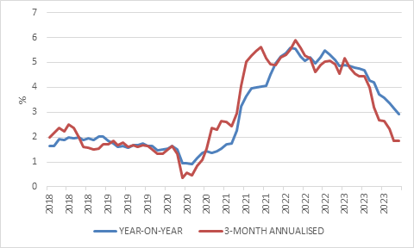
Source: LSEG Datastream

This looks awfully like a soft landing. So why does the Fed not declare victory and start cutting straight away?
Balance of risks
After all, this week’s policy meeting is not expected to result in any interest rates changes. The answer lies in the balance of risks. Does the risk of cutting too early outweigh the risk of cutting too late? Reducing rates before inflation is well and truly under control means the central bank will have to raise rates not long after. There is a great reluctance to do this. Even Paul Volcker, legendary Fed chair and inflation-slayer of the 1980s, cut rates prematurely, only to hike them soon after and cause a double-dip recession.
Either way, the cuts are coming. Both hawkish and dovish policymakers understand that interest rates need to be reduced as real rates keep rising as inflation falls. It is just a question of when and how much.
A soft landing in the US is what is priced into markets now, with six 25-basis points cuts still discounted. The landing has been much harder in Europe, while in China the problems are largely unrelated to high interest rates and the People’s Bank of China has been easing policy for several months now. But it is the US that really matters, given the dollar’s outsized role in financial markets.
Arguably the greatest risk for markets is therefore if rates were kept too high for too long, in other words, if Fed officials turned to be too cautious and too worried about sticky inflation. It would amount to the plane hitting a flock of hawks.
Looking over their shoulders
Some central banks have the additional challenge of not making policy purely based on domestic factors. Where a country pegs its exchange rate to the US dollar, it has little choice but to follow US rates up and down. For instance, one of the reasons why the People’s Bank of China has been so reluctant to cut rates meaningfully in response to domestic economic weakness is that it also tries to manage the yuan-dollar exchange rate. Cutting Chinese rates further will make it more likely that capital flows to the US and puts the yuan under further pressure.
Even in cases where there is no peg, central banks in emerging markets must still look over their shoulders at what the Fed does.
This is certainly the case in South Africa. The South African Reserve Bank targets domestic inflation but considers a broad range of global factors in its decision making, including international oil prices. The rand-dollar exchange rate is another key variable of the inflation outlook, and it depends on the outlook for the US dollar, which in turn is greatly impacted by projected US interest rates.
Unchanged
The Monetary Policy Committee left the repo rate unchanged at 8.25% in a unanimous decision. This was widely expected.
The MPC’s tone is still on the hawkish side, however, noting that “serious upside risks to the inflation trajectory from global and domestic sources are evident.”
But the MPC is probably not too far away from cutting rates either. Headline consumer inflation declined to 5.2% in December, while core inflation (excluding food and fuel prices) was 4.5%. The Reserve Bank expects inflation to average 5% this year and 4.6% next year. Despite its protestations to the contrary, this is sufficient progress on the inflation outlook to warrant lower rates. Once the Fed’s cutting cycle is more clearly in view, the MPC should have the comfort to reduce the repo rate by around 100 basis points this year, and perhaps a bit more next year.
Chart 3: South African inflation and interest rates
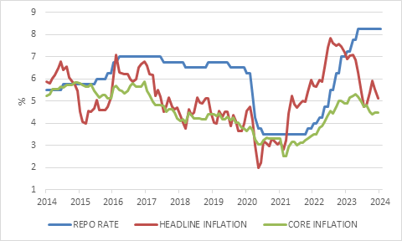
Source: LSEG Datastream
Will the SA Reserve Bank pull off a soft-landing? The reality is that that high interest rates and inflation are probably not as big obstacles to growth as Eskom and Transnet are. Moreover, market-based interest rates will remain high irrespective of what the Reserve Bank does, since they incorporate a large fiscal risk premium. Repo rate cuts later this year will give consumers some breathing room, but the economy needs a meaningful improvement in its supply-side performance. As the MPC statement put it “achieving a prudent public debt level, increasing the supply of energy, keeping administered price inflation low and real wage growth in line with productivity gains” would strengthen economic conditions.
Still, the Reserve Bank itself projects growth of 1.2% for this year, hardly exciting, but positive. The South African economy is not collapsing, despite the common narrative that it is.
Putting this all together, the implication for asset allocation is that we can be cautiously optimistic about the year ahead - the runway is in view - but investors should not get carried away. Given that there is so much uncertainty on so many terrains – policy, politics, geopolitics – investors should always be prepared for a bumpy ride. Sullenberger described the final moments before his famous landing as “the worst sickening, pit-of-your-stomach, falling-through-the-floor feeling." Market volatility is not going to feel as bad, as long as you have patience and an appropriately diversified portfolio.

