Are The Magnificent Seven Valuations Justifiable?

Andrew Dittberner, Chief Investment Officer at Private Clients by Old Mutual Wealth

The Magnificent Seven’s (M7) valuations have generated considerable attention, with the companies’ share prices skyrocketing since the end of 2022. Critics argue that these companies’ valuations are unjustified, with some drawing comparisons to the Dotcom era’s exuberance. Taking a step back and looking at the fundamentals of these businesses, as well as what the market expectations are for growth in the years ahead, allows one to arrive at a more balanced view.

The advent of generative AI language models, like ChatGPT have provided the catalyst for the surge in the M7 companies’ share prices. At Nividia’s recent results, CEO Jensen Huang remarked that “AI is at the tipping point”, suggesting that the widespread use of AI technology is just beginning. If this is true, then perhaps there is significant runway ahead for a number of the M7 companies. A more cynical view would be that he is talking his own book.

Over the past 11 years[1], the collective market capitalisation of the M7 companies has grown from just over US$1 trillion to well over $13trillion. This represents a remarkable compounded annual return of 24.3% – doubling the S&P 500’s capital return of 12% over the same period. Unsurprisingly, this growth has seen the M7’s contribution to the S&P 500’s market capitalisation soar from 10% to over 30%.

Graph 1: Market Capitalisation Q4 2012 – Q1 2024

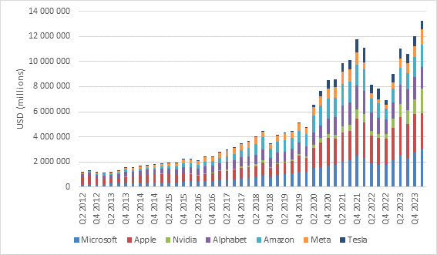

Source: Refinitiv Datastream, Private Clients by Old Mutual Wealth (2024)

A closer look at the fundamentals
While this market capitalisation growth is impressive, the key question is whether the companies’ fundamentals have kept pace. As shown in graph 2, the M7 companies’ earnings have grown from US$9.8 billion in 2012 to $53.1 billion today. While impressive, this earnings growth has notably lagged the expansion in market capitalisation. Basic analysis suggests that collectively, when using earnings multiple, these businesses are considerably more richly priced today than they were in 2012. We acknowledge that this growth number will be heavily weighted to those companies generating the lion’s share of earnings. However, the narrative remains unchanged.

Graph 2: Earnings Q4 0212 – Q4 2023

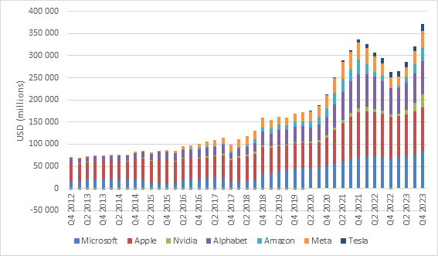

Source: Refinitiv Datastream, Private Clients by Old Mutual Wealth (2024)

For a more concise view, we calculated the 10-year earnings per share (EPS) growth for each business independently, as shown in table 1. Some companies have undergone significant share buyback programmes, which will further boost earnings on a per share basis, which we believe to be more relevant for shareholders given that they own shares in the business, rather than the business outright.

Table 1: 10 Year Annualised Earnings Growth 2013 – 2023
Company | 10 Year Annualised Earnings per Share Growth
Microsoft | 14.1%
Apple | 15.4%
Nvidia | 50.1%
Alphabet | 21.4%
Amazon | 44.4%
Meta Platforms | 38.4%
NB: Tesla is not included as the company did not generate a profit 10 years ago.

Source: Refinitiv Datastream, Private Clients by Old Mutual Wealth (2024)

Amazon’s 44.4% EPS growth needs to be viewed with caution as the business is more focused on generating cash and redeploying it back into the business, as opposed to appeasing shareholders with bottom-line earnings growth. Therefore, earnings are not the best measure of value for Amazon. Nevertheless, the EPS numbers vary widely, with the well-established businesses showing more modest growth compared to their younger counterparts still ascending the J-curve towards higher earnings levels.

Combining this data, graph 3 shows how the M7 companies have traded collectively relative to the S&P 500 from a trailing earnings multiple perspective (price earnings ratio). A ratio above one indicates that the M7 companies are valued higher than the S&P 500, commonly referred to as trading at a premium. A rising ratio therefore indicates that the M7 companies are getting more expensive on a relative basis, while a declining ratio indicates the opposite.

Graph 3: Relative Price Earnings Ratio 2012 – 2024

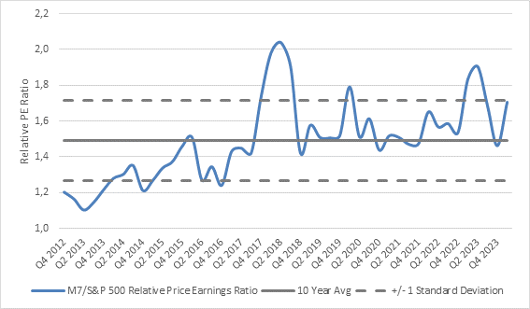

Source: Refinitiv Datastream, Private Clients by Old Mutual Wealth (2024)

It is clear that the market has placed a premium rating on M7 companies. Therefore, arguing that they are more expensive than the market is a moot point. These companies rightfully command a premium valuation for several reasons, some of which have already been highlighted. At their current valuations, they trade at a one standard deviation above the 10-year average relative PE ratio.

Are the valuations justified?
The final question now lies in whether these valuations are justified. Naively looking at the historic earnings from a valuation perspective has many flaws, particularly for fast growing businesses. Instead, one must assess what the market is pricing in for the future, and then determine whether the companies can meet those expectations.

For this analysis, we used a 10-year high growth period before reverting to a more stable long-term growth rate. To calculate a suitable discount rate for each company, we used current 10-year US treasury yields as a proxy for the risk-free rate (although we appreciate that US treasuries are not completely risk free). We then posed two questions: Firstly, how much potential upside or downside exists from the current share price if the company replicates its past 10 years’ earnings growth? Secondly, what earnings growth is the market expecting the company to generate over the next 10 years in order to justify its current valuation? The results are summarised in table 2.

Table 2: Justifiying Current Valuations

M7 Company | Potential Upside / Downside  (Expected EPS Growth = Past 10 Year EPS Growth) | Market Expected Annualised EPS Growth
Microsoft | +44.3% | 9.1%
Apple | +60.6% | 8.4%
Nvidia | +518.6% | 22.7%
Alphabet | +56.7% | 13.2%
Amazon | +54.6% | 35.7%
Meta Platforms | +355.1% | 13.9%
Tesla | - | 6.3%

Source: Private Clients by Old Mutual Wealth (2024)

It is clear from column 2 that the market is not extrapolating the prior years’ earnings growth into the future, as all M7 companies would be trading significantly higher if that were the case. More importantly, column 3 shows the market’ expectations (based on today’s market values) for these companies’ earnings growth over the next decade before reverting to a stable growth assumption.

Overall, the results show that the majority of M7 companies are not priced for exorbitant future growth. In fact, the growth assumptions for the two largest companies – Microsoft and Apple – are in the high single digits, a seemingly achievable target. A caveat is that all these valuations are highly sensitive to changes in the discount rates, which are influenced by US treasury yield changes.

Current discussions around Nvidia are focused on whether the company can in fact achieve the demanding growth rate that the market expects. This is the critical question, and if Jensen Huang is to be believed, it can. Many analysts remain sceptical though.

Challenging, yet achievable
We view comparisons between the M7 and the Dotcom era as an exaggeration given two key differences in the current landscape. Firstly, the M7 companies are all highly profitable, unlike many of the Dotcom era counterparts that were built on mere hopes and dreams (not to mention a name). Secondly, M7 company valuations do not seem to be based on completely unrealistic future earnings growth expectations. While it is easy to argue that some expectations are indeed demanding, they may not be entirely unattainable. And so, in closing, we would urge investors not to look at the M7 as a collective, but rather on an individual company basis.

[1] The 11 year period was selected as all M7 companies have been listed over this period, with Meta being the last to list in 2012.

