Great Expectations

Old Mutual Wealth Investment Strategist, Izak Odendaal

There is a simple equation for happiness that not everyone quite grasps. Contentment is the difference between expectations and reality. Lower your expectations sufficiently, and almost any experience turns out to be pleasant or at least bearable. But when expectations are too high, there is room for disappointment even if the actual outcome is fine, or even good. This is of course relevant at this time of year when people are making plans for their professional and personal lives, having spent time on the beach or around the campfire engaged in introspection. It is also particularly relevant for financial markets, where the known is priced in immediately, and therefore the surprises cause big moves.
As we reflect on last year, it is worth remembering that it started on a very pessimistic footing, with a widespread expectation of a recession, particularly in the US, but also in other major developed economies due to the rapid rise in interest rates. The only country where the outlook was for an improvement on the prior year was China, which was finally exiting lockdowns.
Defying predictions
Instead, the US economy defied the gloomy predictions and activity actually accelerated during the year, so much that third quarter GDP growth surpassed 5%! Despite this, inflation steadily declined to the point where rate hikes were no longer needed. The US Fed’s preferred inflation measure, the personal consumption expenditure (PCE) deflator excluding food and energy, printed 3.1% year-on-year in November but only 1.8% on a six-month annualised basis. It is moving in the right direction, in other words, and has not been achieved by pushing the US economy into recession and raising unemployment. Even in Europe where the economy is struggling, unemployment is still low even as inflation is declining.
The net result: the global benchmark MSCI All Country World Index returned almost 23% in dollars in 2023. Instead of a correction, we got a bull market. Global bonds also ended the year on a positive note despite suffering a big drawdown midway through. Ditto for listed property.
If nothing else, this is a reminder of how wrong the consensus can be, and how difficult it is to predict the future. The best strategy in most cases is simply to be diversified but to stay invested, irrespective of the noise.
Chart 1: Global asset class returns in US dollars
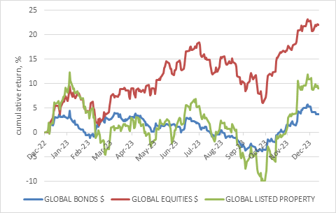
Source: LSEG Datastream from 1 Jan 2023 to 12 Jan 2024
At the start of 2024, the overall macro-outlook seems more benign. Inflation should continue to ease (though not necessarily in a straight line). Major central banks, including the Fed, should start cutting rates at some point, and global economic growth should hold up though it will be slower than last year.
The problem is that this soft landing or Goldilocks (not too hot, not too cold) outlook is pretty much priced in. Markets could be disappointed if things don’t pan out this way. Again, it is all about how expectations and reality line up 2024.
There is a after all a long list of things that can go awry.
What could possibly go wrong?
Top of the list is that inflation could remain sticky, with the ‘last mile’ of deceleration towards the 2% target of the Fed and ECB (others) slow in coming. This could delay rate cuts into the second half of the year, instead of the second quarter as is currently priced. Last week’s US consumer price index (CPI) print in the US gave us a hint, coming in a bit hotter than the consensus forecast, and indicating that there are areas in the US economy where prices are rising at an uncomfortably high pace. (Side note: the US has two mainstream measures of consumer inflation, CPI and PCE. The latter is the one the Fed targets and tends to run a bit lower for a number of reasons. At the moment, that includes the fact that the weight of housing costs is much higher in CPI than PCE, and housing inflation is still elevated though it too should decline in the months ahead).
Secondly, rates can fall for good or bad reasons. A good reason would be if inflation eased enough for central banks to take their feet off the brakes. A bad reason would be if economies were slipping into recession. If it is the former – and that still appears to be the case in the US – rates might not fall as much as markets anticipate. But just because the US avoided an expected recession in 2023 doesn’t mean we should be complacent in 2024. While the US economy has been surprisingly resilient, there are areas of softness that bear watching. Meanwhile, China’s economy is still struggling to get into gear, and much will depend on Beijing’s stimulus efforts. Europe, as noted, is already struggling.
Thirdly, there are politics and geopolitics. The past few days have seen Iran-backed Houthi rebels stepping up attacks on the key Red Sea maritime channel. The US and its allies have retaliated with airstrikes against Houthi targets in Yemen. Ships are being rerouted around the Cape of Good Hope (unfortunately with little benefit to South Africa) at great expense. The oil price has increased to around $80 per barrel, but this level still suggests markets are not too worried about a regional war.
As for politics, this year will see more people voting in elections than in any other year, largely because three of the four most populous countries on earth are going to the polls, namely India, Indonesia and the US. It is the outcome of the latter that has the most market-moving potential, as former president Donald Trump could win a tight contest to retake the White House, leading to a change in US domestic and particularly foreign policy.
Taiwan’s election, held over the weekend, would normally go virtually unnoticed. The winner of the president race, Lai Ching-te, is a proponent of Taiwanese sovereignty, raising fears that China would not accept the outcome. However, the initial comments from Beijing appear to have focused on the fact that Lai’s party failed to secure a parliamentary majority. Either way, the tensions over Taiwan’s future as a separate state are likely to continue simmering, as they have for years.
These are just the known risks. It is usually the unknowns that catch us off guard and shake up markets.
What if it goes right?
But things could also go better than expected. We could see another year of resilient economic growth in the US and elsewhere, which would boost earnings (though probably stand in the way of early rate cuts).
We could end up with a quiet year geopolitically. In fact, it is worth noting that geopolitics is usually at the top of most lists of “risks for the year ahead”. Most years, nothing happens that is serious enough to move global markets. Regional conflicts simply do not matter on Wall Street, other than causing some short-term jitters. As an example, remember that two days into 2020, the US assassinated a top Iranian military leader. Instead of going all out, Iran responded with a few token missile strikes. Most countries don’t want war! It is costly, destructive and ultimately, unpopular, as Vladimir Putin is finding out.
Politics could also be a damp squib.
Low expectations
What about South Africa? Where do we stand in the expectations versus reality equation?
Although the local economy generally performed better than expected in 2023, it was still a bleak year (apart from the euphoria of retaining the William Webb Ellis trophy). Economic growth, as measured by real gross domestic product, probably came in below 1% (we’ll only get the final numbers in March).
This is by no means the catastrophic outcome many expected but is clearly not much to write home about. The SA economy remains deeply constrained by unreliable infrastructure and inefficient public services and crawls along – but it is not collapsing. It will struggle to beat 2% growth on a sustained basis until there is meaningful progress in crowding in private sector participation in rail, ports and electricity. Eskom’s own projections show loadshedding will be a reality again this year, though the intensity won’t necessarily be as bad (there is a big difference between stage 2 and stage 6). In the meantime, however, businesses and households are likely to continue taking steps to insulate themselves. The numbers on rooftop solar installations are really impressive, and likely to continue this year. The one thing we have going for us (apart from rugby) is ample sunshine.
One silver lining: with the domestic inflation outlook generally improving and the global interest rate environment turning, the SA Reserve Bank is also likely to start cutting rates in mid-2024.
The election (probably in May) is a risk event, and it is quite possible that many local and foreign investors will sit on the sidelines until they know what the outcome is. However, we are probably going to end up with more of the same. The ANC should be able to secure a slim majority or retain power with the help of small coalition partner. Therefore, the outlook is largely one of broad policy continuity, and ongoing gradual progress in tackling the pressing concerns of loadshedding, a crumbling logistics network, crime, corruption and excess government debt.
Despite the looming election (probably in May), the February Budget Speech is likely to continue the emphasis on fiscal consolidation with little by way of pre-poll populist giveaways. This is unlike other emerging markets, where elections often distort fiscal policy as governments spend to remain power. Notably, despite a deteriorating fiscal outlook in 2023, bonds still returned a very respectable 9.7% in 2023. Most of this return was generated from interest income, illustrating the benefit of a high starting yield.
Chart 2: Local asset class returns, rand
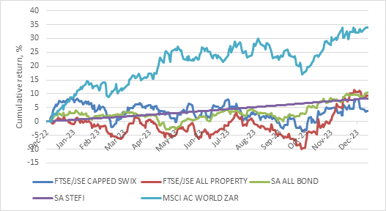
Source: LSEG Datastream from 1 Jan 2023 to 12 Jan 2024
What to expect when you are investing
Finally, what should our expectations be for investment returns in 2024? The simple reality is that nobody knows. In a given year, equity markets can deliver anywhere between -30% and +70% (the range of the last 30 years of annual returns for the JSE All Share Index). Only cash returns offer a predictability, and even then, it will depend on how much the Reserve Bank cuts interest rates by. The more relevant question is whether asset classes are priced to deliver decent returns over a longer horizon.
When an asset class is cheap relative to history, it tends to deliver better subsequent real returns, provided investors are patient. In contrast, asset classes with above average valuations tend to deliver below-average returns.
Chart 3: Selected asset class valuations, %
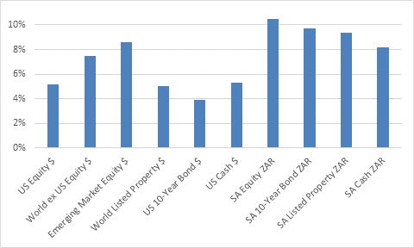
Source: LSEG Datastream as at 31 Dec 2023
Chart 3 summarises the valuations of various asset classes by expressing the yield of each (earnings yields in the case of equities, which is earnings expressed as a percentage of price). All else equal, investors should prefer higher yields. Outside of US equities, these are all reasonably attractive and, in South Africa, quite high relative to history.
The trick of course is that investing in these asset classes requires a patient, long-term approach. In the short term, anything can happen. In fact, the one thing we shouldn’t be surprised about is that there will be surprises in 2024. Keep your expectations grounded, your eyes on the long term and your portfolio diversified, and you should be fine this year.

