JSE Index Harmonisation

Michael Dodd, Senior Fund Analyst at Morningstar South Africa

Striking the right chord

In March 2024 the Johannesburg Stock Exchange (JSE) will implement the first phase of its Index Harmonisation project. The first phase will, initially, align the weighting methodologies of what the JSE are calling their ‘vanilla’ indices [which includes the FTSE/JSE All Share Index (ALSI) and the FTSE/JSE Top 40 Index] with those of their Shareholder Weighted (SWIX) variants. The second phase of the project will see the termination of the SWIX indices and the effective collapse of the vanilla and SWIX indices into one set of benchmark indices. It has not yet been announced when the second phase will be implemented.

How did we get here?

The changing dynamics of both the South African equity market and regulatory environment have seen the local asset management industry shift its preferred benchmark a few times over the last two decades. Initially, most South African equity managers benchmarked themselves against the ALSI, which is the longest-standing South African equity market index. However, the strong run of Resource companies in the mid-2000s saw the weights of those companies increase significantly in the ALSI at that particular point in time. At around this time, the preferred industry benchmark shifted from the highly concentrated and Resource-heavy ALSI to the SWIX.

The SWIX followed a different weighting methodology to the ALSI that was seen to be more representative of the investable universe for South African equity managers. The SWIX’s free float weighting methodology (as opposed to the gross market capitalisation methodology followed by the ALSI) means that the weights are determined by a free float adjustment factor determined by the portion of that company’s stock that is freely tradable in the South African market.

The SWIX generally worked as a suitable South African equity market benchmark up until the meteoric rise of Naspers saw the concentration risk in the SWIX increase. At its peak in 2017, Naspers’ weight in the SWIX reached roughly 25% of the index. In response to requests from the South African asset management industry, the JSE launched the Capped SWIX in 2016 to address the concentration risk present in the SWIX index. The Capped SWIX restricted shares to a maximum weight of 10% of the overall index, and so alleviated some of the concentration risk present in the SWIX index.

As can be seen in Exhibit 1 below, the Capped SWIX became the preferred industry benchmark for the South African equity market and is currently used by 39% of South African General Equity funds as their stated benchmark. However, the chart below also highlights that its adoption has not been universal, with many managers still benchmarked to the ALSI and the SWIX.

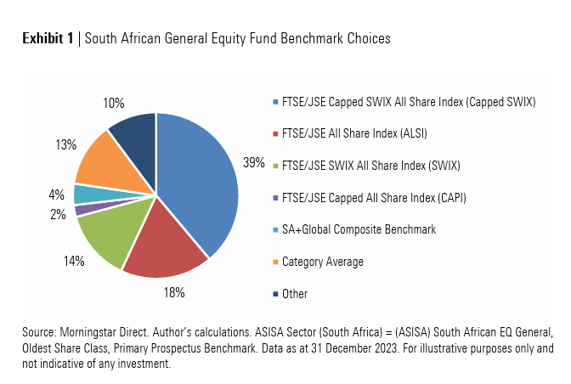

Recent changes to regulations and the fact that ASISA’s South African General Equity category allows managers to invest up to 45% offshore has resulted in several funds in this category changing their benchmarks from domestic-only benchmarks to composite benchmarks of South African and Global equity benchmarks to better reflect their new, broader investable universe.

The different weighting and capping methodologies across these indices have resulted in some vastly different return outcomes over the years. This can be seen below in Exhibit 2. The simple question of “How did the South African equity market do last year?” has not had a straightforward answer for several years.

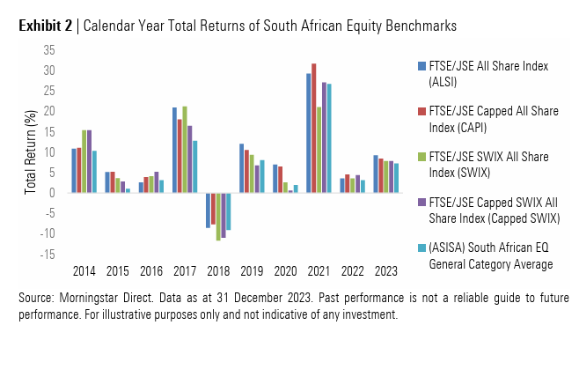

Why is the Index Harmonisation happening, and what is its impact?

In its communications about the pending changes, the JSE noted that the process of harmonisation has naturally occurred over the last few years. A significant contributor to the weighting differences between the ALSI and the SWIX has been the ‘grandfathered’ companies that form part of these indices.

‘Grandfathered’ companies refer to local companies that moved their primary listing offshore before October 2011, and these companies are weighted differently in the two index variants. However, the number of grandfathered companies has declined over the years. Corporate actions in many of these previously grandfathered companies have seen their weightings converge across the vanilla and SWIX indices. Examples of these previous grandfathered companies where corporate actions have taken place include SABMiller, Old Mutual, BHP Group and, most recently in 2023, Richemont.

As a result, there are only a handful of remaining grandfathered companies that are constituents of these indices, and so the JSE now sees it as an opportune time to align the weighting methodologies of the vanilla and SWIX indices without too much disruption. These companies include Anglo American, Mondi Plc, Investec Plc, Thungela Resources, Netcare and Attacq.

At the March 2024 quarterly index rebalance the remaining grandfathered shares in the vanilla indices will adopt a free float weighting methodology consistent with that used currently in the SWIX indices. Effectively, the ALSI and SWIX will align. There will be weighting changes in the vanilla indices, while there will be no change to the SWIX indices.

From the perspective of the ALSI the most significant impacts of the Index Harmonisation at a single-stock level will be on Anglo American and Mondi, who will see their index weights adjusted downwards in March. This will, in turn, fund upward adjustments in all the non grandfathered constituents on the index.

At a sector level the Basic Materials and Industrials sectors, the respective homes of Anglo American and Mondi, will see their ALSI weightings fall, with the Financials sector being the largest beneficiary of the change.

For illustrative purposes, Exhibits 3 and 4 below demonstrate the differences between the ALSI and the SWIX using their index weights as of 31 December 2023.

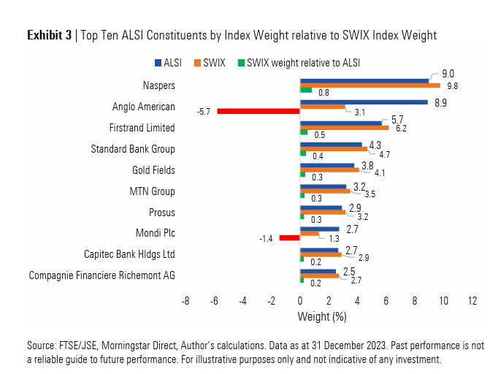

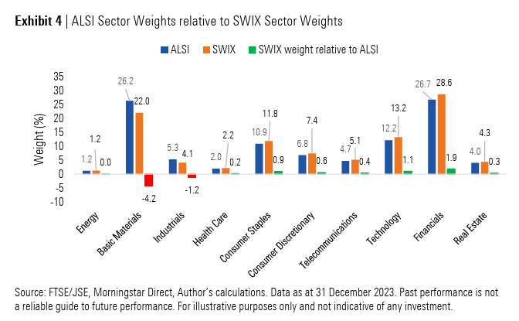

Why is this a good thing?

At the culmination of the Index Harmonisation project the JSE will have a single set of headline indices all following a consistent weighting methodology and a single representative benchmark index for the South African equity market.

This is important for the industry for several reasons:

Uniformity: The outcome of having a single domestic equity index will reduce the confusion among investors regarding equity market performance. Having a universally agreed-upon industry benchmark for the South African equity market should also result in an alignment of benchmark selection among South African equity managers.

Consistent and comparable performance: Having a standard industry benchmark also makes the comparability of domestic-only South African Equity fund performance more consistent. Out/underperformance of peers should no longer be able to be explained away by benchmarking differences. Unfortunately, at an ASISA fund category level, there remains a comparability challenge between domestic-only South African Equity funds and those funds that are making use of the offshore allowance that the category permits.

Reduction in the number of products: With a standard industry benchmark comes a universally agreed upon proxy for market ‘beta’. Index Harmonisation should result in a reduction in the number of index-tracking products being offered on different JSE indices. It provides the opportunity for product providers to improve economies of scale and potentially lower fees by merging existing strategies.

In Conclusion

At Morningstar, we see the Index Harmonisation project as a significantly positive development for the industry. The changes will go some way to alleviating investor confusion regarding local equity benchmarks. The improved transparency will also improve market integrity by allowing investors to better understand market returns and compare relative performance across South African Equity funds. As always, as a portfolio management team we are also vigilantly monitoring the upcoming changes for any potential impact it may have on client portfolios.

