Schroders Global Investor Study 2023: SA investors eye optimistic returns despite inflation and geopolitical uncertainties

Schroders

Wealth investors globally have been forced to re-evaluate their investment strategies in response to the new economic reality and ongoing inflation and geopolitical uncertainty, Schroders Global Investor Study 2023 has found.
Schroders’ flagship study which has surveyed over 23,000 wealth investors[2] who invest from 33 locations globally – including 400 South Africans, has identified that almost 80% of investors now believe that we have entered a new era of policy and market behaviour as a result of higher inflation and interest rates.
With higher inflation and interest rates, are we witnessing a regime shift for policy and markets?

Strongly agree 31%
Agree 47%
Neither agree, nor disagree 18%
Disagree 3%
Strongly disagree 1%

This is in stark contrast to last year’s study, when some respondents believed the market challenges to be a blip and predicted a quick return to the more benign, low inflation, low rates environment. As a result, more than half of global respondents have already adjusted their investment strategies and a third intend to do so. South African wealth investors, while a bit slower to do so, also plan to adjust their strategies.
Are respondents adapting their investment strategy for this new era?

Global SA
Yes 54% 45%
No, but I intend to do so 34% 47%
No 12% 8%

Our research shows that South African respondents who rated their investment knowledge as ‘expert’ were the quickest to react with 60% having already adapted their strategy.
Our study also highlights the importance of active fund management for many investors globally, while private assets were recognised as an essential diversifying tool with the democratisation trend continuing to gather pace. Interestingly, South Africa showed a heightened interest in digital assets and cryptocurrency as compared to global respondents.
What investments have become more attractive over the last six months?

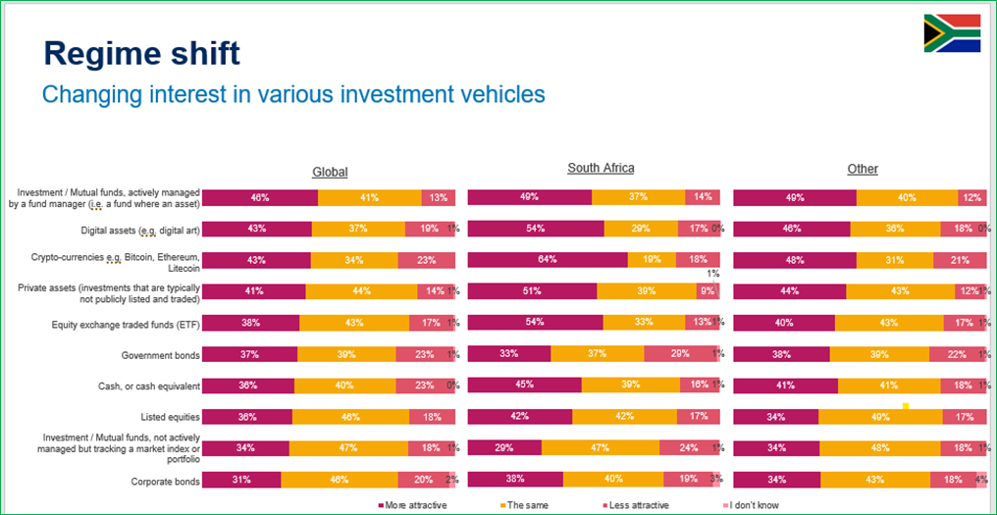
Despite an extremely difficult environment, the vast majority of investors globally remain optimistic, with almost 90% expecting returns to be either identical to or higher than last year.
How people think their returns over the next 12 months will compare with the previous 12 months

Global SA
Significantly higher 18% 16%
Higher 42% 48%
No change 28% 19%
Lower 9% 15%
Significantly lower 1% 2%
I don’t know 2% 1%

This was particularly the case amongst ‘expert’ investors, with only 4% expecting next year’s returns to be lower.
Strikingly, the majority of investors globally expected annual returns of 11.5%, similar to last year’s results. Specifically, South African investors were the most optimistic, having identified a 16.8% return. This is substantially higher than the 9.46% annualised return of the MSCI World Index of global stocks between 1987 and September 2023.
Johanna Kyrklund, Schroders’ Group CIO and Co-Head of Investment, said:
“In an investment landscape being increasingly shaped by the ‘3Ds’ of deglobalisation, decarbonisation and demographics, investors are still getting used to the fact that higher inflation and higher interest rates are here to stay. Every asset has had to reprice to compete with a yield on cash in the bank. Valuation matters once again. Compared to the last 15 years, you may now need to be more flexible and active in the way you invest. The results of the study show that some investors are adjusting quicker than others.”
Private assets as a hedge in a rocky economic environment
In recent years, regulators and asset managers have been actively working on democratising private assets, notably with the launch of structures such as LTAFs in the UK or ELTIFs in Europe. In South Africa, interest is also increasing, particularly following the amendments to Regulation 28 of the Pensions Fund Act, which now allows local pension funds to invest up to 15% of their assets into private investments.
However, almost 70% of South African respondents cited costs and expenses as the largest perceived barrier for the asset class; with transparency (63%) and experience with/knowledge of the asset class (61%) as runners up. Global investors were most concerned with transparency (65%), followed by experience with/knowledge of the asset class (64%) and then illiquidity (63%). The findings indicate greater education is required to support the continued growth of these investments.
Nevertheless, almost 48% of South African respondents said they would consider allocating 6% - 20% of their portfolios to these assets. On average globally, investors admitted they would consider allocating 16.4% of their funds into private assets. For more ‘expert’ investors, this rose to 23.1%.
Specifically, South African wealth investors are most attracted to real estate (75%) followed by both private equity and infrastructure and renewable energy (both 64%). Interestingly, global respondents were almost 20% less likely to invest in real estate than South African respondents.
People's top choice of private asset if they could invest
SA Global
Private equity 64% 59%
Real estate 75% 58%
Infrastructure and renewable energy 64% 68%
Insurance-linked securities 42% 45%
Microfinance and investment that aim to help society or sustainability 23% 28%
Private debt (loans to companies) 25% 19%

Overall, respondents see private assets as an important way to boost portfolio performance with both global and South African respondents indicating this as the most attractive quality of investing in this asset class.

Interestingly, while global respondents saw diversification as the second most attractive quality of private asset investment at 51%, only 47% South African respondents cited the diversification aspect – favouring sustainability and/or impact investing considerations instead at 55%. Meanwhile, 40% of global respondents are attracted by the perceived sustainability credentials of private assets.
Nils Rode, Schroders Capital’s Chief Investment Officer, said:
“A few years ago, a typical private assets investor would have been what asset managers call “institutional”. These are big investors like defined benefit pension schemes, or large endowment funds. As this year’s GIS shows, the picture is likely to change a lot in the next few years.
“The range of options to access private markets is widening, and smaller investors are taking note. It’s a challenging time to be interpreting markets, and investors are looking for every available tool to achieve their desired outcomes. Private assets represent an incredibly varied set of opportunities, and a huge number of return drivers.
“We believe the widening of options for smaller investors is a very positive development. We also believe that the case for including a private asset allocation – where appropriate - is arguably stronger than ever.”

Sustainable investment: time to engage
Investors are attracted to investing sustainably because of the potential to generate positive environmental impact and align investments to their societal principles.

Whether people are attracted to sustainable funds and why
SA Global
Yes, because of the wider environmental impact 57% 55%
Yes, because of my societal principles 37% 42%
Yes, because they are more likely to offer higher returns 36% 34%
No, because they won't offer higher returns 4% 6%
No, because they don't align with my principles 1% 2%

Importantly, more than a third of South African investors (36%) said that sustainable funds are likely to offer higher returns. Furthermore, on average, the proportion of all investors shunning sustainable investing due to performance concerns has fallen by half compared with last year’s survey.

A key element of sustainable investing is active ownership - engaging with companies directly to improve business outcomes with the ultimate aim of supporting investment returns. The vast majority of South African respondents (79%) have heard of the concept of active ownership. Interestingly, South African investors are more confident in the long-term value creation of sustainable funds, than their global counterparts.

Whether encouraging companies to act sustainably helps them generate long-term value

SA Global
Strongly agree 56% 38%
Agree 36% 45%
Neither agree nor disagree 8% 14%
Disagree 1% 2%
Strongly disagree 1% 1%

Specifically, the key active engagement topics for global investors are climate (33%), natural capital (26%) and the treatment of workers (20%). For local investors, the focus is slightly different with the treatment of workers coming out as the biggest priority (32%), followed by climate (24%) and natural capital (19%). The focus on human capital management demonstrates the intricate labour relations environment in South Africa and the complexity of a just transition to a sustainable future.

Andy Howard, Schroders’ Global Head of Sustainable Investment, said:
“This year’s results underline the widespread and growing recognition of the importance of active ownership to sustainable investment. Companies across industries face a wide range of challenges and opportunities, and intensifying pressures to adapt and evolve. As active managers with a long term and fundamental focus, using our voice and influence to encourage companies to build healthier, more sustainable business models has long been important and is becoming more so as those trends intensify.”
For much information about the Global Investor Study and to view the full report and findings in more detail, please click here.

[2] ‘Wealth Investors’ are defined as those who will invest at least €10,000 (or the equivalent) in the next 12 months.

