Active vs passive: concentrated markets swing the pendulum back in favour of active

Duncan Lamont, CFA, Head of Strategic Research at Schroders

The data which suggests passive strategies could come unstuck.
Global stock markets have become increasingly top-heavy. At the end of October, the 10 biggest stocks in the US S&P 500 index made up a record 31% of the market (Figure 1).
This is clearly a problem for investors trying to build diversified portfolios as a significant proportion of their risk is being driven by a relatively small number of companies.
Our new research also shows that, historically, investors passively tracking the US stock market would have lost out on returns in the years following high levels of index concentration.
At a time when investors are increasing allocating to passively managed strategies at the expense of active, the tables could be set to turn.
This is not just an issue for the US stock market. The US has grown to be 63% of the global market at the end of October (MSCI All Country World Index (ACWI) index) so international investors have ended up with a lot in US stocks and, with that, a lot in just 10 stocks. Those 10 make up nearly 18% of the global market, the same as Japan, the UK, China, France, and Canada combined.
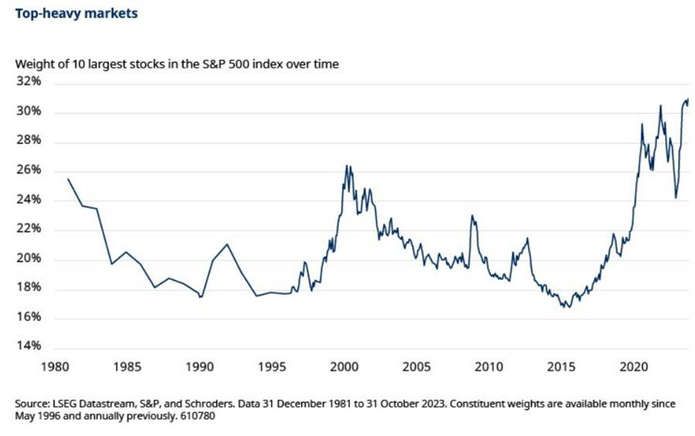
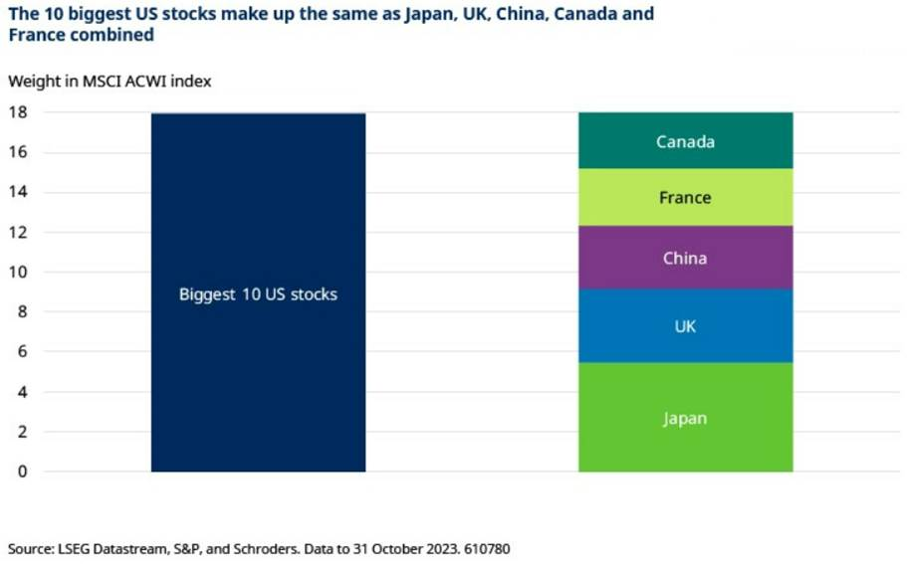
Should investors worry about index concentration when it comes to future returns?
One way to assess this is to compare the performance of a standard market cap-weighted index and its equal-weighted cousin.
For those less familiar, the equal-weighted version of the S&P 500 has 1/500 = 0.2% in every stock in the index. It has 2% in the 10 largest stocks rather than 31%. It is a more diversified version of the market.
If the equal-weighted S&P 500 is outperforming the standard S&P 500, that means that the bigger stocks are underperforming the smaller stocks within the index – and vice-versa. It means investors would be better served by allocating money away from the biggest stocks that most passive portfolios have the greatest exposure to.
Deviating from the market has been a winning strategy when concentration has been high
Our new research finds that, in the past, there has been a strong, statistically significant, relationship between the degree of concentration in the S&P 500 and how the equal-weighted S&P 500 has performed relative to the S&P 500.
The higher the concentration, the greater the outperformance of the equal-weighed S&P over the next five years (Figure 3). Deviating from the market has been a winning strategy when concentration has been high. The relationship has been weaker, though still positive when assessed over shorter investment horizons.
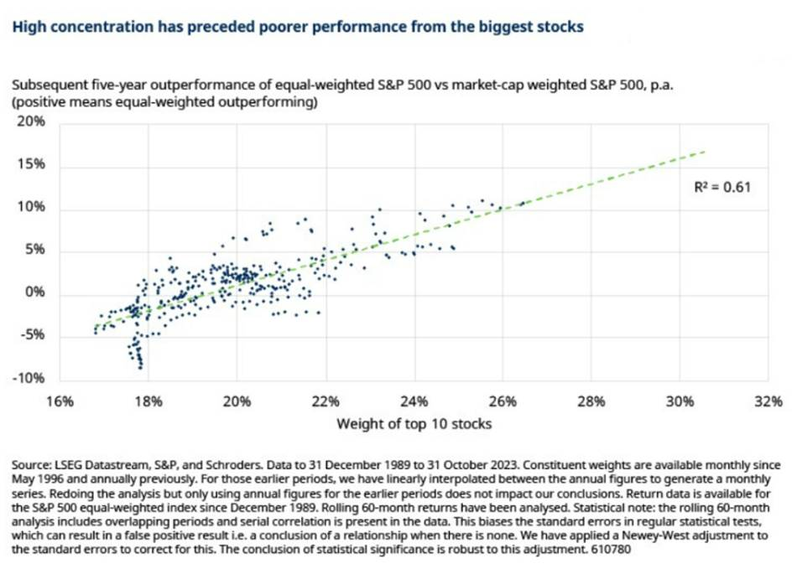
Based on today’s 31% weight for the 10 largest stocks, this relationship suggests that the equal-weighted S&P 500 could outperform by more than 15% a year over the next five years.
This is a strong argument that the passive, market cap-weighted, strategy favoured by many could struggle compared with others which have more freedom to deviate from such concentrated exposure.
Now, of course, this time may be different. And we are in uncharted territory to an extent. There are no data points to corroborate whether the gradient of the line will remain the same as we get further over to the far right hand side of the chart.
However, even if the magnitude is up for debate, the broad conclusion appears more robust: when the market has become very concentrated in a few stocks, investors have done better by allocating away from those stocks. The tables could be set to turn in favour of more actively managed strategies at last.

