The digital divide also persists in developed nations

Ben Forster, Equity Analyst, Global Real Estate & Lazaro Tiant, Sustainable Investment Analyst at Schroders

Around 2.7 billion people globally still don’t have access to the internet. While the problem is well articulated in emerging economies, a surprising number of advanced nations have low rates of digital accessibility. Schroders examines how digital infrastructure investors can help to level this social inequality, stimulate economic growth and make a profit.

A surprising number of advanced nations fall short of the digital infrastructure needed to support an inclusive and thriving digital economy. Data from the ITU estimates that one-third of us are still offline globally (2.7 billion people), with people on low incomes and in rural areas disproportionately affected.
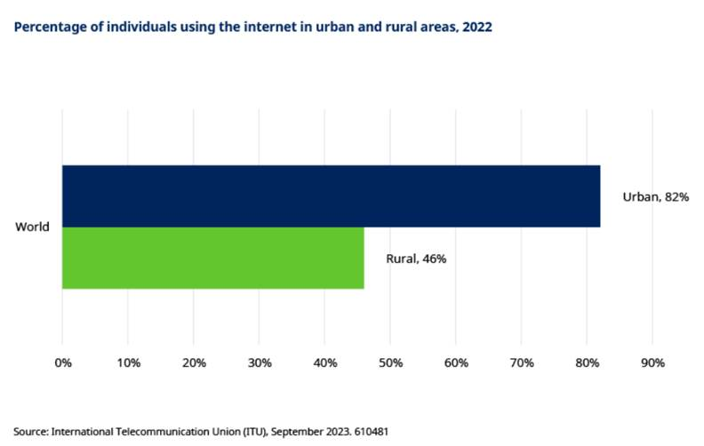
Policymakers have therefore identified bridging the digital divide as a signature infrastructure policy to help level social inequalities and stimulate growth. The UK government describes the digital divide as “the gap between people in society who have full access to digital technologies (such as the internet and computers) and those who do not”.
Policy cures typically focus on extending high-speed fibre broadband connectivity into underserved communities, often in rural locations that are uneconomical for the free market to connect without subsidies.
In the US, the Biden administration’s 2021 Infrastructure Investment and Jobs Act committed $65 billion of funding with the objective of providing Internet For All by 2030. The initial $42.5 billion of funds was allocated to US states in June 2023 via the Broadband Equity Access and Deployment (BEAD) Program, with further announcements since.
According to the National Telecommunications and Information Administration, a staggering one in five households in the US is not connected to the internet, with only 58 million US homes passed with high-speed fibre optic broadband lines (two in five households). US construction services firm Dycom estimates that BEAD grants could add a further 30 million homes to the high-speed fibre network, taking the total to three in five, prior to additional privately funded projects.
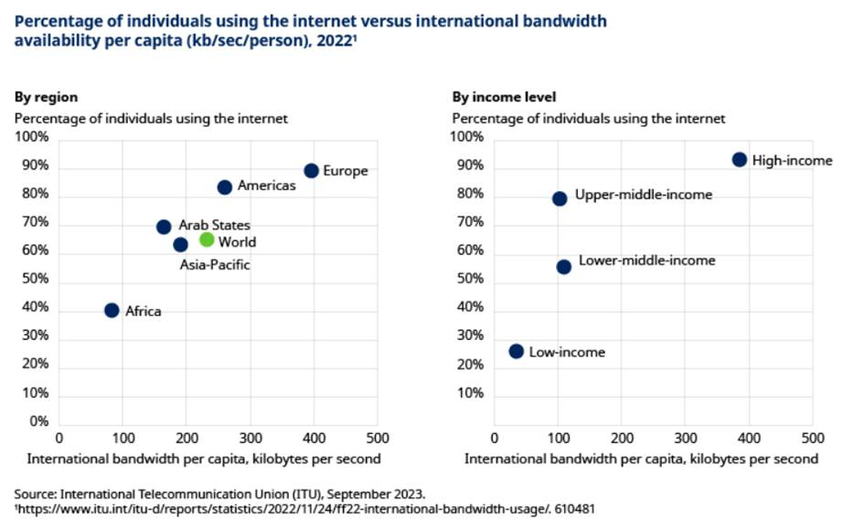
Why politicians are right to care
World Bank analysis found that a 10% rise in broadband penetration increases GDP per capita growth by 1-1.5%, highlighting that a failure to bridge the digital divide may leave countries less competitive on the world stage. In a post-pandemic world, reliable high-speed internet access has become the gateway to key building blocks of society – good healthcare, education and jobs.
Increasingly powerful software programmes using artificial intelligence look set to change the landscape of innovation and will require even greater data transfer capacity.
Employers and employees will need to upgrade their computing capacity and learn the skills required to harness these technologies. The National Skills Coalition has found that 92% of jobs available today require digital skills, and 23% of jobs that require even one digital skill can earn an average of 23% more than jobs requiring no digital skills.
How digital infrastructure investors are playing their part
The tech bubble of the early 2000s saw telecommunications businesses sink significant capital into broadband projects that were ahead of their time, leaving many investors wary of the industry. More than 20 years on, the consumer demand and investment payback period is much clearer, bringing investors back to the table.
Average monthly broadband data consumption is now approaching 600GB in the US, a 2.5x increase since 2018, highlighting that our need for speed is beginning to exceed the limits of legacy copper and coaxial cable broadband connections. These locations will need upgrading, while unconnected locations can jump straight to fibre.
Consumers and businesses appear willing to pay a premium for the superior performance of superfast fibre over other technologies, meaning higher revenues for operators. The financial and environmental costs to operate fibre are also lower. According to Canadian fibre operator Telus, fibre consumes 85% less electricity than copper and 75% fewer ‘truck rolls’ are required to maintain equipment, meaning that returns are further enhanced once upgraded.
US operator Frontier is earlier in its copper-to-fibre conversion process than Telus and believes it has identified more than 10 million locations in its existing markets where it can achieve mid-to-high teens internal rates of return on investment, even before taking account of government subsidies.
The main hurdle to bridging the digital divide is the large sums of capital needed to lay fibre in the ground or hang it on street poles. Consensus estimates for five of the largest US fibre builders, including Frontier, suggest that around $20 billion per annum is required to roughly double their subscriber base to 30 million homes over the next five years.
We believe that recent policy support will help to unlock more expensive projects in rural areas, enlarging the opportunity set and improving visibility on future growth.
Other risks to manage include competition from ‘over-builders’ and construction cost inflation. We favour larger ‘first-mover’ companies with strong balance sheets and brands that can achieve critical mass (typically 40%+ market penetration of homes passed).
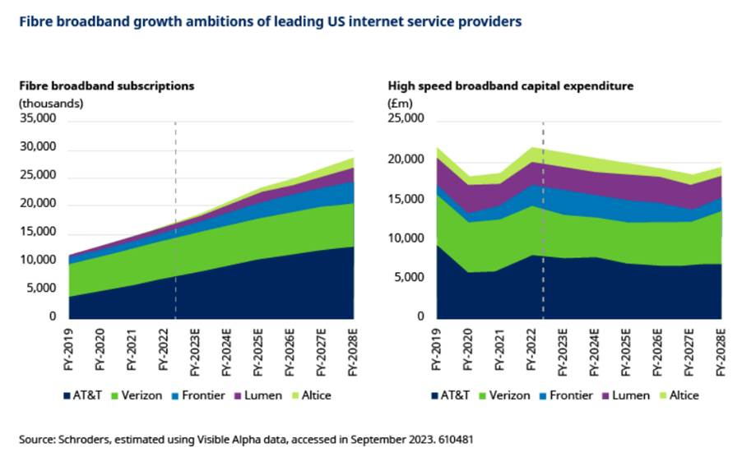
What role can active owners play in this theme?
Investors looking to support this theme need to consider which companies are best placed to maximise positive social outcomes. The Schroders Digital Infrastructure team actively engages with fibre operators on social issues. We are interested in their ambitions to reach underserved communities, target an affordable price point and maintain high service standards. We have also engaged on cyber security and data protection policies given the critical nature of this infrastructure.
We see encouraging evidence of operators setting ambitious targets here. US operator AT&T has targeted a $2 billion investment in bridging the digital divide between 2021 and 2023 through low cost broadband provision. They also plan to provide 1 million people with digital resources by 2025, including refurbished devices and digital literacy skills training[1].
South Korean operator SK Telecom plans to implement a digital competency programme for 400,000 people by 2025, seeking to close the information gap for the digitally vulnerable[2].
The Digital Inclusion Benchmark is one way to track their progress, with Spanish telecommunications operator Telefonica topping the table in 2023. The World Benchmarking Alliance cites Telefonica’s Internet for all programme in Peru as an example of providing connectivity to rural households, alongside strong scores for cybersecurity, data privacy and child online safety.
Skilful management teams that can navigate both economic and social challenges when extending connectivity should find that the digital divide turns into a digital dividend for both their investors and society.
