Pandas, Pegasus or the Chimera

Old Mutual Wealth Investment Strategist, Izak Odendaal

Heads of state meet all the time, without investors paying too much notice. Last week’s meeting between US President Joe Biden and his Chinese equivalent, Xi Jinping, was different. Tensions between the world’s two superpowers have been rising in recent years to such an extent that it is no longer an exaggeration to talk about a second Cold War. Some go further, believing that a military ‘hot’ war is inevitable over the future of Taiwan.

This deterioration in the relationship between the two biggest economies is a worry not just for the health of the global economy, but also for humanity. The fight against climate change requires their cooperation, while it is also crucial for containing regional conflicts such as the wars in Ukraine and the Middle East

To be clear, the talks between Xi and Biden in San Francisco delivered little by way of concrete outcomes, and fierce competition and mutual suspicion between the two countries is likely to continue. However, the mere fact that this face-to-face meeting took place is important and suggests that some of the more extreme scenarios are much less likely (at least until next year’s US presidential election). Afterwards, Xi met with US business leaders, also a sign that he wants to shift the growing view that China is ‘uninvestable’ from the point of view of Western capital. Foreign direct investment into China has fallen sharply since the pandemic. Xi also promised to send new pandas to an American zoo, a symbolic act of friendship China has occasionally engaged in since 1972 when bilateral relations were first normalised.

Chimerica
Historian Niall Ferguson and economist Moritz Schularick coined the term ‘Chimerica’ in 2006 to refer to the increasingly symbiotic relationship between the two countries, with China being the low-cost manufacturing hub for American businesses, while becoming the largest buyer of US government debt, effectively lending the Americans money to buy from them. The term is a clever reference to the Chimera, the fire-breathing monster from Greek mythology with a lion’s body, a snake’s tail and the head of a goat on its back. She is ultimately killed by the hero Bellerophon. He was ordered by the king of Lycia to slay the Chimera, not knowing that the king secretly hoped that the monster would kill Bellerophon. But riding the winged horse Pegasus, Bellerophon easily shot down the beast.

A chimera is also a term describing hoped-for but illusory things. The evolving relationship between the US and China is indeed turning out to be chimerical. It was expected to bring growing peace and prosperity to the world, and greater liberalism to China. It did not quite pan out that way. While China managed the incredible feat of lifting hundreds of millions out of poverty, the impact of the ‘China shock’ on American jobs has belatedly become apparent (and not just in America or Europe; South Africa’s own manufacturing base was hollowed out, particularly the clothing sector).

This in turn destabilised American politics and contributed to the rise of Trumpism. As for China, since Xi’s coming to power in 2013, hopes for a more open society have vanished as he has increasingly consolidated power in his own hands.

After spending much of the 21st century deepening trade ties and interweaving supply chains (China joined the World Trade Organisation in 2001), the last five years have seen an unpicking of many of those arrangements, starting with the imposition of import tariffs by President Trump. These largely remain in place. In the wake of the pandemic, many Western multinationals have taken steps to reduce reliance on China. The US government has also restricted exports of key high-tech items to China, notably semiconductors.

The result is already visible in the data. Chart 1 shows how the value of US imports from the Chinese quadrupled in the first 18 years of the millennium but have declined substantially since. Meanwhile, countries like Mexico and Vietnam have benefited. In other words, it is not so much a retreat in globalisation as a reorientation. But ‘reshoring’ is also definitely happening. Construction spending on manufacturing facilities in the US has shot up from a pre-pandemic average of around $80 billion per year to almost $200 billion, supported by US government subsidies and the need to manufacture critical items such as batteries and semiconductors closer to home.

Chart 1: US imports
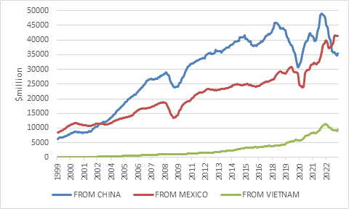
Source: US Census Bureau

Cruising and crawling
Apart from geopolitical tensions, there is a different, more immediate economic context at play: the US economy is cruising along, while China’s is crawling.

Markets cheered last week as October US consumer price statistics showed inflation falling to 3.2%, while core inflation, which excludes food and fuel prices, fell to 4%. This points to ongoing progress in the fight against inflation and suggests that the Federal Reserve would not need to hike rates any further. However, in China headline inflation was negative in October, while core inflation has been stuck below 1% for more than a year.

Chart 2: US and China core consumer inflation, %
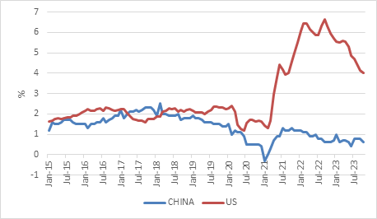
Source: LSEG Datastream

Inflation is often a temperature gauge for an economy, surging when it overheats and falling as it cools. The US is still warm but no longer overheating; China is decidedly chilly.

The decline in inflation in the US has been remarkable for not being associated with substantial economic pain. While price pressures have eased during the year, the US economy has hummed along, creating new jobs every month. Economic growth is likely to slow in 2024, partly due to the lagged impact of higher interest rates, but a recession does not seem inevitable, and if it happens, is unlikely to be severe.

In contrast, while a recession by any standard definition was never on the cards in China, the economy has still experienced something of a shock and the path forward is uncertain. Instead of rebounding following the end of extended Covid lockdowns, the Chinese economy has spluttered along. As is well documented by now, the property slump is a big reason. This is bad in any country, but in China, property was the major growth driver in recent years. According to economists Ken Rogoff and Yuanchen Yang, real estate activity and infrastructure construction account for an incredible and unmatched 30% of GDP (only Spain at the very peak of the 2007 housing bubble has come close).

Large developers are going bankrupt, building activity has collapsed and home prices are falling. Since real estate forms the main store of wealth for Chinese households, they are decidedly downbeat. Crackdowns on technology companies, large employers of graduates, have not helped sentiment and youth unemployment is so high, the government has stopped publishing the statistics.”

Meanwhile, since local governments, many heavily indebted, relied on land sales as a major source of income, the property crash has fiscal implications too. These local governments in turn have been spending big on infrastructure projects to boost growth in their regions. But despite there being only so many airports, highways or rail systems a province or city needs or can sustain financially, going overboard in their construction has become common. These are hard habits to shake, and Rogoff and Yang note that China continues to build high speed rail at a pace that exceeds the growth in passenger numbers.

The central government in Beijing has announced several initiatives to stabilise the property sector, and while these might find traction, it is safe to say that real estate will not be the major driver of economic activity in the years ahead. It will take a long time to work through the debts associated with the two-decade long boom, as well as the overbuilding. All this at a time when demographic headwinds are coming closer into view. Last year was the first where deaths exceeded births.

It is a challenging mix of problems for Xi’s government to deal with, not least because poor policy choices are a source of many of them.

Deficient demand
One option could be to turn to exports to make up for the lost growth from property. To an extent this is happening. Exports surged during Covid as China was the key supplier of items the world desperately needed. More recently, China has overtaken Germany and Japan as the leading exporter of vehicles, including electric cars. The yuan is trading near record lows against the dollar, supporting Chinese exports while also placing downward pressure on global goods prices. But will the world absorb ever-growing volumes of Chinese exports voluntarily? The Americans have already said no, and other countries could follow. Exports offer China a short-term way of dealing with domestic overcapacity and sluggish growth, but not a sustainable one.

Ultimately, domestic demand will need to take up the slack. This means that a greater share of national income should go to households, who in turn should spend more and save less. Household spending is low compared to other countries (38% of GDP in China, compared to 68% in the US), and the savings rate still high. Such a rebalancing would see faster growth in household spending and present great opportunities for domestic Chinese companies as well as global multinationals. It is easier said than done, however, and faces political and institutional obstacles, not least a deficient social safety net, ironically for a communist country.

Having said that, China’s economy is not falling off a cliff. The most recent data shows improvement in non-property sectors. The country will probably continue to post growth rates that South Africa can only dream of – the IMF forecasts around 4% per year over the medium term – though this is probably on the optimistic side. It is certainly considerably slower than the expectations of the future many had. It is particularly problematic when people have borrowed vast amounts of money to make investments on an assumption of a particular growth rate that fails to materialise.

Chart 3: Real economic growth (forecasts for 2023 and beyond)
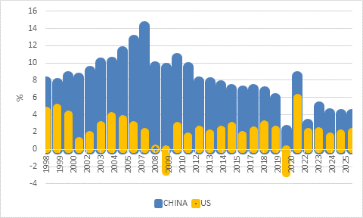
Source: International Monetary Fund

Taking stock
Finally, the stock market performance of the two countries has also diverged since the end of the Global Financial Crisis, and particularly over the past two years.

Chart 4: US and Chinese equities in dollars
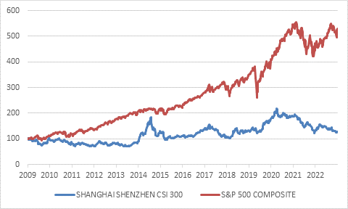
Source: LSEG Datastream

You might think that sustained higher rates of economic growth would have favoured Chinese shares. But raw economic growth does not translate into equity earnings when the government takes a large share of national income and when companies are not run for the benefit of shareholders and capital misallocation is common. Investors must also contend with higher levels of policy uncertainty and a lack of rule of law. Chinese shares therefore carry a governance discount. Nonetheless, from time to time, sentiment can widen this discount excessively. Sentiment – or more precisely, excitement – can also push valuations on US equities above justifiable levels, which appears to be the case today, thanks to the ‘Magnificent Seven’ large tech companies. Elsewhere in the US and across the world equity valuations are reasonable and return prospects for patient investors good.

It remains to be seen whether long-term US-China relations will ultimately be symbolised by the Chimera (uneasy symbiosis), the Panda (friendship) or Pegasus (war). For now, however, some of investors’ major fears , including a runaway oil price, a Federal Reserve hiking the US economy into the ground, and tensions between the world’s two superpowers spiralling out of control, seem unlikely to materialise.

