Santa Claus or the Grinch?
Old Mutual Wealth Investment Strategist, Izak Odendaal
The year may be winding down as we head into November, but things seem to be heating up on markets. Global equities and bonds have rallied over the past two weeks as investors price in the end of the central bank interest rate hiking cycle, particularly in the US. Can the cheer last all the way to Christmas, or is there a market Grinch lurking somewhere? After all, it has mostly been a disappointing year as far as investment returns go.

A good place to start is to ask where the sudden optimism comes from. Markets had been under pressure since July, so a rebound was always likely. There are always rallies in bear markets and drawdowns in bull markets. Things never move in a straight line, and that is one of the reasons why timing the market is so difficult. Therefore, November may be a good month so far, but it tells us very little about what lies ahead. We need to think about whether the fundamental picture has changed.

Chart 1: Global equities and bonds in 2023 (US$)
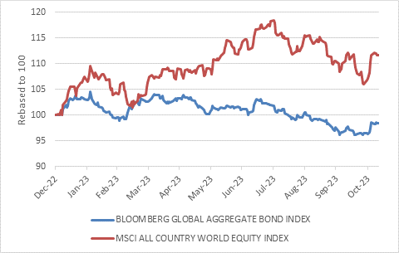
Source: LSEG Datastream

As has been the case for the last few years, it comes down to the global inflation and interest rate outlook. There is good news and bad news.

The good news is that the major central banks are mostly done hiking interest rates. Investors’ bogeyman for the past year or so is leaving the scene.

The central bank we care more about than the others, the US Federal Reserve (the Fed), rapidly raised its policy rates to 5.25% in the space of the past 18 months in response to a sudden and sustained surge in inflation. However, it can now afford to sit back and see how the economic and inflation outlooks evolve before taking further action, if at all. Inflation has already declined meaningfully, so the pressure to respond reactively is largely gone. It can shift to a more proactive stance, setting policy based on the outlook.

Its preferred inflation measure, the annual change in the core personal consumption expenditure price index (or simply core PCE) was 3.7% in September, down from a cycle peak of 5.6% in February 2022. In fact, it was not just the highest point of the cycle, but also in the past 40 years. This is substantial progress, but clearly inflation is still above the Fed’s 2% target.

Chart 2: US interest rates and inflation
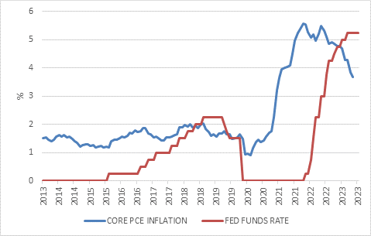
Source: LSEG Datastream

No recession needed
Unexpectedly, this decline came without any severe cost to the US economy. Many prominent economists argued that it would take a nasty recession to wring inflationary pressures out of the system. For instance, Harvard economist and former US Treasury Secretary Larry Summers was one of the few to correctly predict the inflation surge. But when it arrived, Summers said it would take several years of an unemployment rate above 5% to bring inflation down again. Instead, unemployment has remained below 4% for 18 straight months, the longest stretch in 50 years, with the latest reading at 3.8%.

This looks and smells a lot like the soft landing (lower inflation without a recession) or Goldilocks (not too hot, not too cold) environment that is so supportive of risk assets, and perhaps explains the recent rallies. There are caveats, though. As noted upfront, there is good news and bad news.

Caveat emptor
Firstly, there is no certainty that inflation will continue to decline in a quietly and orderly fashion down to the 2% target. And while the argument can be made that the targets are arbitrary and can be approached flexibly, that is not how central banks see it. From their point of view, the targets are fixed and must be achieved.

At the very least, this means that rates could remain elevated for some time. There is also a chance of further increases, as in the case of the Reserve Bank of Australia’s recent unexpected hike, which was a reminder not to be complacent while inflationary pressures are still around.

Fed chair Jerome Powell reiterated this point in a speech to the IMF last week, saying that the Fed “is committed to achieving a stance of monetary policy that is sufficiently restrictive to bring inflation down to 2% over time; we are not confident that we have achieved such a stance…We will continue to move carefully, however, allowing us to address both the risk of being misled by a few good months of data, and the risk of overtightening.”

Powell spoke about the possibility that falling inflation could be a “head fake,” an American sporting term that we might call a “dummy” or a “sidestep”.

Secondly and more importantly, the economic impact of rate increases to date is yet to be fully felt in the US while it is already felt elsewhere. Interest rate changes are like a slow-release medicine for the economy, taking months and months to change the behaviour of firms and households. And like some medicines, the side effects can be unpleasant.

The main reason it is taking longer in the US is because of the far greater use of fixed-rated loans. Most mortgages have interest rates that are fixed for the lifetime of the loan, while a greater percentage of companies borrow in the bond market at fixed rates, as opposed to borrowing from banks at variable rates as is the case in Europe.
Economic activity in the Eurozone economy has already slowed substantially and it might already be in recession. It is not only about higher interest rates, since Germany in particular is hard hit by the slowdown in global manufacturing activity and the dislocations in energy markets following the Russian invasion of Ukraine. But higher interest rates are certainly part of the story and demand for credit has declined notably. It is safe to say, therefore, that the European Central Bank is done hiking.

However, it would be a mistake to think that all American businesses and households are completely immune to higher rates. Anyone wanting to take out a new mortgage must pay around 7.5%. This severely limits the affordability of housing and, therefore, housing activity. The same is true for car or other consumer loans (including credit card rates). Smaller businesses are far more reliant on short-term loans with variable interest rates, and these rates have risen sharply as per chart 3.

Chart 3: US small business borrowing costs
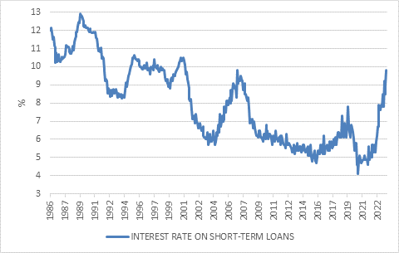
Source: National Federation of Independent Businesses

In other words, while the US backward-looking economic data has been much stronger than expected, the forward-looking data is much less rosy. Both inflation and unemployment, for instance, are usually lagging indicators of economic activity. The forward-looking indicators like new orders are generally soft.

A potential canary in the coalmine is the oil price, which declined to $81 a barrel last week despite Saudi Arabia and Russia announcing that they will expend current production cuts of 1,3 million barrels a day. The Israel-Hamas war has entered its second tragic month, but investors have taken the collective view that the conflict will not escalate into something much bigger. The risk remains that it will, of course, but we saw a similar pattern after Russia’s invasion of Ukraine, though the energy markets took longer to stabilise.

A lower oil price is always helpful, taking further pressure off the global inflation and interest rate outlook. Record US oil production is part of the story here, but so is weakening demand.

Against this backdrop, it makes sense why bonds are rallying (lower yields imply higher prices). If interest rates have peaked, inflation is likely to decline and economic activity to slow, you want to own bonds, and the longer-dated the better.

However, softer economic activity is not normally associated with stock market rallies, since it implies weaker earnings growth. This cycle might be a bit different, since earnings declined sharply last year, ahead of the broader global economy, as listed company earnings are far more skewed to the goods sector than the overall economy is, and global manufacturing has been in recession. The question is whether the upturn in earnings that is projected by consensus can materialise against a backdrop of slowing economic growth. There is reason to be cautious.

Chart 4: 12-month forward expected earnings
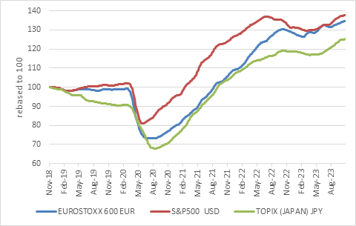
Source: LSEG Datastream, IBES

However, while things have been particularly uncertain in the wake of the pandemic, a cloudy investment outlook is normal, for the simple reason that there are always things to worry about and that the future is always unpredictable. What matters is whether markets are discounting a future that is excessively rosy or upbeat. Valuations across a broad range of asset classes are in attractive territory following the weakness earlier in the year. Not necessarily Black Friday-Sale cheap, but attractive. The outlier remains those mega-cap US technology companies, often called the “Magnificent Seven” that still seem expensive not only relative to their own history, but also given that no investment trades in isolation, relative to developed markets bonds and cash. The latter, of course, offer the prospects of decent returns for the first time in several years. Non-US equities are trading below long-term averages. South African investments look particularly cheap, even when accounting for the lacklustre growth outlook. So, while 2023 has so far been a disappointing year for investment returns, the future outlook for a diversified portfolio is much better.

