Kicking the can, not the bucket

Old Mutual Wealth Investment Strategist, Izak Odendaal

Compared to the euphoria of the Springbok’s victory tour, the Medium-Term Budget Policy Statement (MTBPS) was always going to be a comedown. But even by less ecstatic standards, it was still bleak. The good news, if there is any, is that the finance minister and National Treasury are acutely aware of the seriousness of the problem. This was a face-the-music Budget with no attempt to sugar-coat things. A few months before an election, this is admirable and important. Minister Godongwana certainly talked the talk, but the question is whether he can walk the walk, especially given the many decisions that are outside his control.
The reason this was not a feel-good Budget is because tax revenues for the current fiscal year are expected to be R56.8 billion lower than projected in February. This is a massive undershoot, largely due to lower corporate tax revenues and higher VAT refunds. Lower commodity prices and increased spending on combatting loadshedding have resulted in pressure on corporate profits, especially in the mining sector, and ultimately, tax payments. Meanwhile, spending has run a bit ahead of plan, mainly due to the larger than budgeted public sector wage increase.
Debt and deficits
As a result, the budget deficit, the gap between spending and revenues that must be funded by borrowing, will be 4.9% of GDP this year, instead of the 4% that was projected in February. Next year’s deficit is projected to narrow somewhat, as is the case in the year thereafter. However, the ratio of government debt to GDP will now only stabilise later and at a higher level, as illustrated in chart 1, if everything goes according to plan.
Chart 1: SA gross-government debt-to-GDP ratio
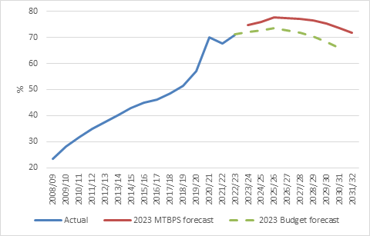
Source: National Treasury
These numbers are based on conservative economic growth forecasts. Treasury expects growth of 0.8% this year, 1% next year and 1.6% in 2025. The big question is whether spending discipline can hold, and also whether there will be any unforeseen shocks, given that the rainy-day funds in the Budget (the contingency reserve) are now largely depleted.
Of interest
South Africa’s debt levels are not high by global standards. Instead, what we have is an interest problem. The South African government pays a high interest rate to borrow from the bond market. This means that government now spends more on interest payments than most other line items in the Budget, and this number is growing rapidly. In the current fiscal year, debt service costs are expected to be R354 billion, a staggering amount equal to 5% of GDP. Other important spending areas are squeezed out when around 20 cents out of every tax rand collected goes towards interest payments.
Spiralling away
It gets worse, however. Because investors are acutely aware of this fragile situation, their perception of the creditworthiness of the South African government has deteriorated markedly in recent years, with higher bond yields and generally wider spreads over the borrowing costs of developed economies. Higher borrowing costs mean the interest burden grows. A growing interest burden further deteriorates perceived creditworthiness in a vicious spiral. Credit ratings agencies have also downgraded the South African government on several occasions, but it is the market’s assessment that matters, and this changes in real time, unlike the scheduled announcements of Moody’s and co.
Chart 2: Holdings of South African government bonds
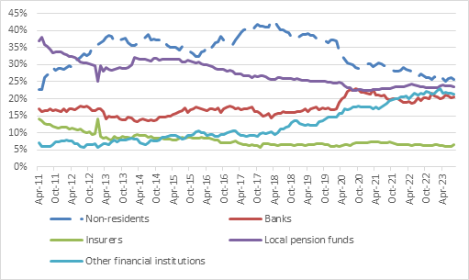
Source: National Treasury
Foreign investors have cut their holdings of South African debt (and emerging market bonds in general) as chart 2 shows. The slack has largely been taken up by local banks and the category of “other financial institutions” that includes unit trusts such as the popular income funds. South African investors still have a strong demand for high income paying assets, but it is clearly not infinite. In particular, bank holdings of government securities have already doubled in the past five years and it is unlikely that it can increase further without increasing risk for banks to unacceptable levels. Stronger economic growth would imply more money going into pension funds as more people work and salaries rise, thereby supporting demand for government bonds.
Need growth
So, what can be down to arrest this spiral? It is very simple in theory, but devilishly difficult in practice. Tax revenue needs to rise, and spending growth needs to slow such that the gap between the two disappears and is flipped around into a surplus.
On the revenue side, there are certain measures the government can take that don’t involve tax rate increases, notably making sure that SARS is functioning optimally. But it is hard to escape the conclusion that some form of tax rate hike won’t be on the cards in the years ahead. The MTBPS pencilled in a modest R15 billion of tax increases that can easily be accomplished by not adjusting tax brackets for inflation (bracket creep). But there is a limit to how much more of a tax burden the economy can stomach. Tax revenues as a share of GDP are already on the high side for a developing economy.
Of course, faster economic growth can deliver more tax revenues. This is the ideal solution, but will require substantial reforms, some of which are fortunately on the cards. The electricity sector has been deregulated, and private investment is pouring in. The same needs to happen in logistics and water and other sectors.
Achieving faster growth is a big focus of the MTBPS and National Treasury does a lot of work on this, including through Operation Vulindlela. Notably, infrastructure spending was largely spared from spending cuts However, much of the delivery sits outside National Treasury with other government departments not exactly known for efficiency.
Moreover, growth is not something the government can control directly. It can lay the groundwork, but it is up to market forces to deliver. What the government can control is its own spending. And for better or for worse, this is where most of the hard work of fiscal consolidation must lie.
Up to now, the process has been to slice away departments’ spending allocations. But this approach is running out of road. What is needed, and what has been promised, is a wholesale restructuring and reprioritisation of government. No one can argue that the various government departments and agencies we have now are an optimal configuration. Many have overlapping responsibilities; others are spending money on low-priority areas.
If implemented, this could be a major step not only to more sustainable levels of spending, but also improved delivery. Clearly, however, little is going to happen on this score before elections. The promises in the MTBPS remain just that, for now.
Nonetheless, the fact that a government will go into an election promising spending cuts (and mild tax increases) instead of gimmicks and populist give-aways, is important and shows how seriously it views the situation. The pandemic-era SDR grant will remain in place for another year, but this was expected.
Unfavourable global backdrop
The seriousness of the situation is not just due to domestic factors, but also because the global climate has turned unfavourable. Borrowing costs for most major economies have increased sharply over the past two years.
Chart 3: Developed market 10-year government bond yields, %
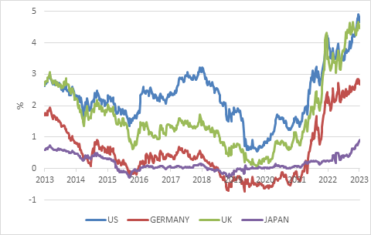
Source: LSEG Datastream
Moreover, while debt levels increased globally in the wake of the Covid-pandemic, the most important economy of all, the US, has no plan to reduce borrowing over the next decade (unlike South Africa). As noted, reducing debt involves some combination of faster growth, higher tax rates and lower spending levels. The Biden administration has borrowed and invested billions to achieve faster growth in targeted sectors, though we will have to wait and see what exactly the impact on broader economic growth is. However, there is absolutely no bi-partisan agreement on the horizon to raise taxes and cut spending levels. Hence large deficits as far as the eye can see.
The risk is that, because of its special status in the global financial system, sustained high levels of US borrowing can put upward pressure on global borrowing costs in the years ahead, even if the current interest cycle subsides. This could make things difficult for countries like South Africa and reinforces the need to get our own fiscal house in order, to not depend on the proverbial kindness of strangers.
Investment implications
Finally, how should investors think about this? South African government bonds offer very attractive real yields across the yield curve. From 9.5% for 1-year bonds to 13% for 30-year bonds, even with pessimistic assumptions of future inflation investors can earn a substantial real income. With a conversative Reserve Bank in charge of inflation management, inflation should remain well behaved in the years ahead.
Chart 4: South African government bond yields, %
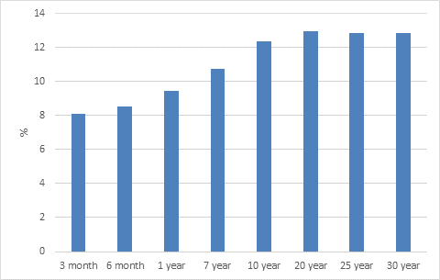
Source: National Treasury
Treasury also maintains a debt management framework to reduce the risk of a default. This includes limits on the amount of short-term and foreign currency denominated debt. However, despite prudent management of the debt structure, the simple reality is that there is just too much of it. The market knows this, and therefore yields can be expected to remain elevated until there is evidence that debt is stabilising due to restructured government spending and stronger economic growth. It is therefore likely to be a bumpy ride for investors, with returns coming from interest income, not capital gains. South African government bonds still have an important place in portfolios, but there are risks attached that should be managed through diversification, including global assets.

